Analyzing customer expectations towards financial services of mobile: A study on bKash Limited
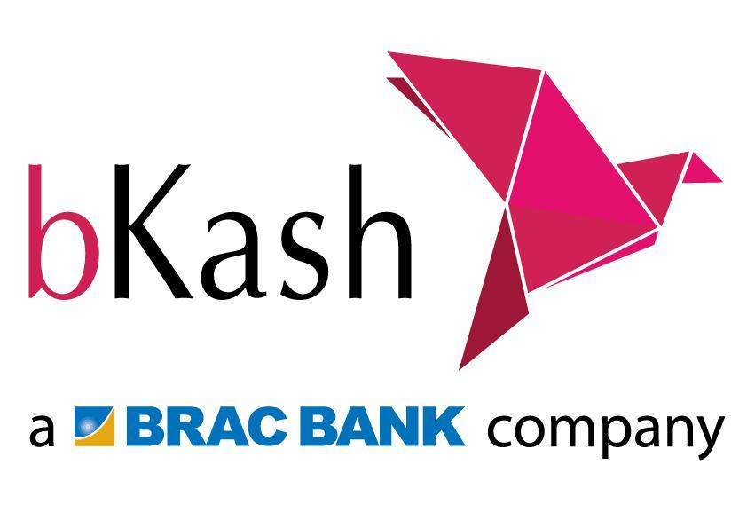

Prepared By
Shaadman Ahmed
ID- 111 142 095
BBA Program
United International University

Supervised By
Dr. Md. Shariful Alam
Associate Professor
School of Business and economics
United International University

Date of submission:
August 21, 2020

ACKNOWLEDGMENT

The whole report was based on “Analyzing customer expectations toward financial services of mobile: A study on bKash Limited” in the light of my Internship, results from considerable intellectual and moral support given by our honorable course teacher, Dr. Md. Shariful Alam, School of Business in United International University. He has been my guide from whom I got the inspiration and guidance to learn. We strongly believe works like this one will surely help us to develop & make us better adapted as well as capable to cope with the issues & practical exposures in this field as well as to the whole of the Legislative tools that are being extensively exploited in today’s world.
Also, I would like to remember the almighty Allah for blessing me with the strength, ability and patience to do this task.
Finally, I want to thank my bosses and colleagues, to share personal expertise, struggled with difficulties, passed away many awaked night to design the report and to collect the information.

LETTER OF TRANSMITTAL

August 21, 2020

Dr. Md. Shariful Alam
Associate Professor, United International University
Subject: Submission of Internship report.
Dear Sir,
I am gratified to enclose you the copy of my Internship report on “Analyzing customer expectations toward financial services of mobile: A study on bKash Limited” which I have prepared under your guidance as a part of our academic purpose and now I want to submit it to you.
Within the limited period of time; I have tried my best to write an assignment on this issue on the basis of internet, journals, and magazines etc. which has made me aware of this practice in real life situation. Thus I honestly admire you for giving me the opportunity to work on this issue and for allowing us to explore this field for the sake of profound knowledge.
I would be highly obliged if you kindly accept my report on this purpose.

Yours Obediently,
Shaadman Ahmed
111 142 095

Table of Contents

Executive Summary…………………………………………………………………………………………..v
1. Introduction………………………………………………………………………………………………….1
A brief introduction of the organization……………………………………………..….…………2
Objectives of the Study…………………………………………………………………………………….2
Rational of the study…………………………………………………………………………………………2
Scope of the study…………………………………………………………………………………………….3
Limitations of the study…………………………………………………….…….….……………………3
2. Methodology of the Study………………………………………………………….………………….4
Data design…………………………………………………………………………………….………………….5
Sample design………………………………………………………………………………….………………..5
Analytical tools……………………………………………………………………………………….………….5
3. Organizational Background and Industry Perspective………………………...………….6
Industry Scenario……………………………………………………………………………………………….7
Background of industry………………………………………………………………………………………8
Historical Background of the organization………………………………………………………….8
Operational activities of the Organization………………………………………………………….8
Product or service line, departments…………………………………….……….………………….12
SOWT analysis of the organization…………………………………………………………………….16
4Findings and Analysis of the Study……………………………………………………………………19
5. Conclusion and Recommendations………………………………………………………………..31
Conclusion………………………………………………………………………………………………………….32
Recommendation……………………………………………………………………………………………….32
6. Appendix…………………………………………………………………………………………………..…….32
References…………………………………………………………………………………………………………..32
Questionnaire……………………………………………………………………………………………………..33

Executive Summary

bKash limited is a mobile financial service which started its operation from 2011 with the help of BRAC BANK Limited. Its main purpose Is to transact money safely using telecommunication network. Rural areas where banks are scarce bKash has played a massive role as money transaction service. So that is why bKash has become more popular to the rural people than the urban people.

This report contains information about the expectations of the customers regarding bKash and its different features and also its App as well as the after sales service or in another words the customer service. It also contains about the history of the organizations and background. Additionally it has analysis on the basis of some question related to the organization and its different offerings for the customers. It also has information about its different divisions who works for the well-being of bKash limited

Chapter 1: Introduction

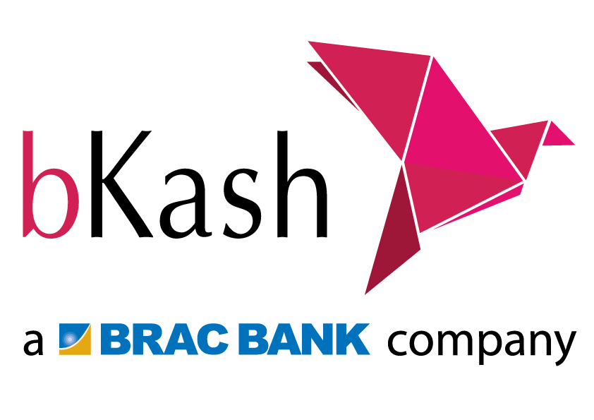

- A brief history of the organization
bKash is a mobile financial service which started its operation from 2011 and is now the leading mobile financial service in Bangladesh ahead of Nagad and Rocket. It provides various services like sending money in seconds, mobile recharge, depositing as well withdrawing money.
- Objectives of the study
The broad objective is to analyze the customers and how they see bKash as and how its services affect them in their usage of the mobile financial service.
Specific objective is it will enhance how bKash is both helping them as well the difficulty (if any) they face will using this mobile financial service.
- Rationale of the study
bKash can be gained accessed through all the telecommunication networks which are currently operating in Bangladesh. bKash agents are operating in Dhaka as well as the urban and rural areas of Bangladesh. bKash is the largest mobile financial service in Bangladesh as of a report if 2018.
bKash can be accessed via several telephone networks in Bangladesh. bKash's agent network covers both urban and rural areas in much of Bangladesh.
As of 2018, bKash was the largest provider of mobile financial services (MFS) in Bangladesh.

As of March 2019, there are 16 providers of mobile financial services (MFS),[10] but the two largest, bKash and Rocket, had a combined market share of over 99%.[11]As of May 2019, they have 3.1 crore active users. In May 2019 total MFS transactions were in excess of Tk 42,236.23 crore.

- Scope of the study
The area of concentration of this study is confined in discussing
- Role of compliance department in bKash
- Importance of compliance activities for the Mobile Financial Service market and contribution to that as well.
- This study will also discuss about how these activities are implemented and how these activities keep the market transparent. Along with External and Corporate Affairs Division, there are some other departments who work together to reduce fraudulent transactions and to maintain market integrity.

- Limitation of the study
While conducting this study following limitations are encountered:
- There was a lack of face to face communication with the sample
- Many people backed out due to breach of privacy
- Extremely scarce or no secondary data at all

2. Methodology of the study

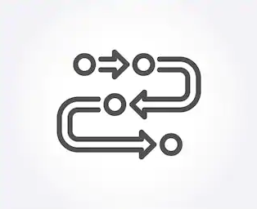

- Data Design – Collecting data mainly through online and a little amount of data through offline one to one communication.
- Sample size - 50
- Analytical Tool - Microsoft Word and Microsoft Excel

- Organizational Background and Industrial Perspective

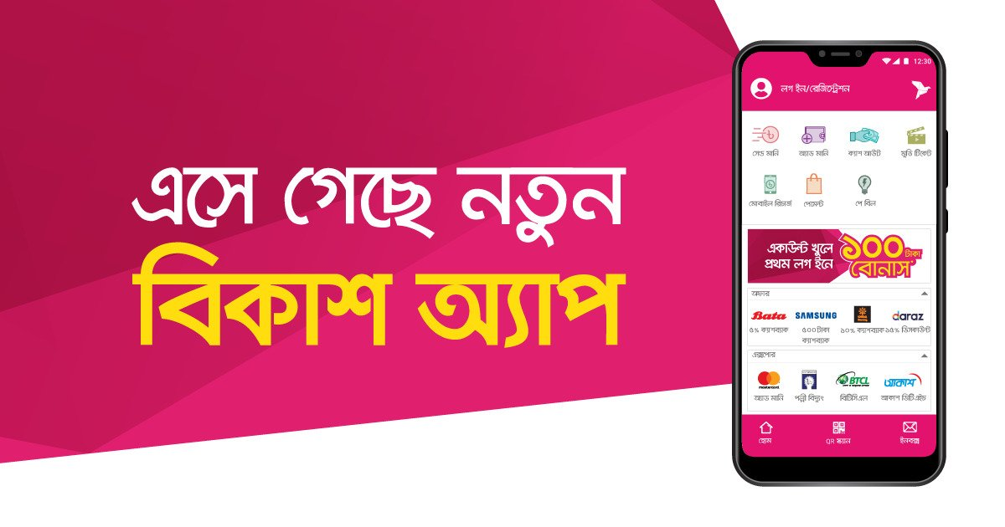

- Industry Scenario:
Bangladesh has a rapidly growing mobile financial services industry, with at least 10 providers already offering services on the market, and more than 8% of the total registered mobile money accounts globally. All this has happened in less than four years since the launch of the first mobile financial service products in 2011. After launching in July 2011, bKash has achieved tremendous growth in the following years. It reached the milestone of 11 million accounts by the end of 2013, just 30 months after its launch. It is now the world’s largest mobile financial services (MFS) company with almost 28 million users, which is very impressive since only legally adult people, who are at least 18 years of age, can be enlisted as a bKash user. It stated out only as a money transfer channel, but now it offers diversified services such as making payments, buying airtime, and receiving remittance along with sending and receiving money. In the few years since the launch of the MFS guidelines, the sector has shown significant growth. As Bangladesh is a banked model, all of the MFS products on the market are run by banks or their subsidiaries. Bangladesh Bank has allowed 28 banks to offer MFS, of which 19 banks have already started to work on their MFS products in some capacity. Detailed discussions with the majority of those banks, however, have revealed that only 10 of them have gone operational and are providing MFS on any sort of scale (as of 2015). The remaining banks are still working on finalizing their transaction platforms, terms of engagement with partners, business model, and strategies.
bKash was established in 2011 to provide ‘convenient, affordable and reliable’ mobile financial services to unbanked segments of the Bangladeshi population. A significant portion of Bangladeshis living in urban and rural areas are excluded from availing formalized financial services due to a lack of financial literacy and numeracy skills, high cost of financial product

access and infrastructure and institutional inefficiencies in the financial sector. Bangladesh has consistently recorded more than 6% GDP growth over the last decade. Strong economic growth performance coupled with migration from urban to rural areas has resulted in urban wage earners needing to send money to their families in rural areas. This has created an unmet need for fast, low-cost and convenient means of urban-to-rural domestic money transfers.

With a view to turning mobile technology opportunities into real world solutions for addressing financial sector challenges, bKash was established by BRAC Bank Ltd in collaboration with Money in Motion, a USA-based financial services company. As a subsidiary of BRAC Bank Ltd., bKash started its journey in 2011 providing mobile financial services in Bangladesh. In 2013 the International Finance Corporation (IFC), a member of World Bank Group became an equity partner in bKash, followed by the Bill and Melinda Gates Foundation. The leading mobile financial services provider of Bangladesh, bKash Limited (“bKash”) and Ant Financial Services Group (“Ant Financial”), operator of Alipay, today announced a strategic partnership to promote financial inclusion for the unbanked and under banked communities in Bangladesh.

Currently there are more than 50 million people in Bangladesh deriving the benefits of mobile financial services and, bKash accounts for approximately 49 per cent of this user base. MFS users are increasingly using bKash for value added services such as topping up their mobile phone balance, paying merchants for daily grocery, as well as paying hospital bills and insurance premiums. Receiving remittance from abroad is also being facilitated through legal channels directly into bKash accounts in local currency. bKash is also being utilized by businesses, government and non-government agencies as a low-cost, last-mile delivery mechanism for salary and social welfare payment disbursement.
- Historical Background of the organization
Company Mission
“By providing financial services that are convenient, affordable and reliable, bKash aims to widen the net of financial inclusion. bKash wants to provide a solution for Mobile Financial Services, built on a highly scalable Mobile Money platform, allowing the people of Bangladesh to safely send and receive money via mobile devices.”
Vision- which is to become the number one mobile banking brand in Bangladesh

- Operational Activities of the organization
Execution team of bKash:
bKash total execution is divided into 5 team division.
- Marketing divison
- Commercial division
- Customer Care
- Human Resource department
- Finance

Marketing Divison:
i. Marketing division is a big part at bKash. Marketing division’s major responsibility is doing all promotional activity. Marketing department can create strong brand value.
Marketing department has five teams:
i. Development team: Development team they are main work is to find out the new scope and improve the promotion place. Beside this they are doing survey to find out the market position. They also did survey after every event to find out the success rate according to their cost.
ii. Media team: The main work of this team is monitoring the media, doing events and taking care of the sponsorship, outdoor branding.
iii. Outdoor Team: The work of outdoor is to managing all the vendors who are related with the outdoor branding. In addition of this monitoring the entire outdoor branding element such as billboard, wall paint, boat branding.
iv. Event Team: In the event team they are looking for the opportunity of branding in any kind of events. Event such as University Seminars, participating in various fair and they have particular work for the special days such as Pohela Boishakh, New Year, Victory Day, ‘Eid etc. They are promoting the brand through various kind of events in the whole country.
v. Creative team: This team is doing very important and sophisticated work for the marketing division. Their main work is to prepare all the design for branding such as billboard design, events poster, festoon, agent point branding element. Beside this they are also give direction to the vendors about the branding item color and design. They are very much aware about the brand color.

Commercial Division:
Commercial division is one of them. Commercial division always faces challenge. Commercial division’s major work is monitoring. They strictly follow the Bangladesh bank’s guideline. bKash connect to the customer through commercial division. Commercial division has more than 300 employees. The entire employee is skilled and experienced. They are capable to take the challenge. Commercial division also divides in five parts:
a) Business strategic development team b) Sales department c) Channel Management d) Cash management
a. Business strategic development team: This team is very importance for bKash. This team does researchable work. They always look after the performance of all activity of all the merchants.
b. Sales department
Sales department is very important part of commercial division also for bKash. Sales department divided in two parts:
I. Channel management II. Cash management
Channel management Channel management main responsibility is agent KYC form (know your customer) management. Their key text is,
I. Receiving KYC form II. Quality check III. Archiving.
Cash management Cash management’s major job is balancing the actual money and virtual money.

Agent:

Agents are the root level members of bKash. Though agents are not directly connected with bKash. They are not employee of bKash. Any individual can become agent of bKash. For that he/she needs to apply to the distributor of bKash. Then distributor will take all the information of that individual and make the cost benefit analysis, and if the analysis becomes positive only then they approve that individual’s request to become an agent. Agents are given a special merchant wallet number. With that merchant wallet number agents can do more cash in cash out than any individual customer of bKash.

bKash’s agents are in less risk. As the other mobile banking agents have to go to distributors or near bank branches to bring money to their outlets to reset their cash in cash out limits or even day to day transactions outcome. But bKash agents have the opportunity to get this at their doorstep and agents here are in more risk as now they have to transport the cash from the agent’s outlet to bKash distributor’s house or nearby bank branches.

Sometime you will get the news that a distributor was attacked while he was delivering bKash’s money. But here bKash is not liable for that. They just hire that distributor as a third party. Distributor should have arranged extra security for them. Because a distributor not only deliver bKash’s money he simultaneously distributes others money too. Not only money a distribution channel can distribute many things like SA Paribahan.

Customer Care Divison:

bKash’s customer care is like after sale service. Their main customer office is located in Mohakhali. Customers can file a complaint in three ways 1. Face Book page 2. E-mail 3. By calling customer care. But bKash customer care service is not that much efficient. It seems most of the time the critical complaints need to be solve from their central customer care office Mohakhali and the customer himself or herself have to go there in person. As transferring money is a very sensitive issue, and it’s very hard to prove involvedness bKash doesn’t give any solution to customer mistakes. And they directly cannot handle agent issue. All they can do is they can tell their distributor channel to cancel the agent ship of a particular agent. Similarly if an agent files a complaint against any dealer, only then bKash can take direct action as bKash has direct authority over dealers. They simply will try to resolve the problem first, and then if necessary they will hire a new dealer
Human Resource Division:
The human resources department handles many necessary functions of your business. It is instrumental in providing labor law compliance, record keeping, hiring and training, compensation, relational assistance and help with handling specific performance issues. The human resource division is responsible in handling many functions of the business. They help in implanting Labor law compliance, keeping records, recruiting and giving adequate training to new as well on demand training to existing employees, building relationships with employees and measuring and handling performance of the organization as well the employees.
Finance Division:
Financial division of bKash approves the amount of money for the make virtual money. Then they create virtual money to distribute it to Distribution house. They also maintain the money supply of the market.

Products and Services line:
bKash provides six types of services. They are:
1) Cash- In 2) Cash-Out 3) Send Money 4) Payment 5) Mobile Recharge 6) Remittance 7) Pay Bill
The detail of these services is given below:

Cash- In:

This is a process of deposit money to bKash account. This service is providing in the agent Point. For cash-in there is no charge will be given by customer. Customer can cash in money in their bKash wallet at free of cost.

Cash-Out:

If bKash users have sufficient balance in their bKash Account, users can withdraw cash anytime. There is two way of withdraw money from bKash account, one option is from agents and another is from BRAC Bank ATM Booth.

Send Money:

Send Money allows you to transfer money from one bKash Account to another bKash account. Go to any bKash Mobile Menu by dialing *247#. Choose “Send Money”. Enter the bKash Account Number who want to send money to enter the amount who wants to send. Enter a reference about the transaction. Now enter the bKash Mobile Menu PIN to confirm the transaction.

Payment:

Anyone can make payments from bKash Account to any “Merchant” who accepts “bKash Payment”. Suppose a person buy something from a shop who accept bKash payment then if the customer wish then he or she will pay the money though bKash.

Mobile Recharge
Buy Airtime allows you to recharge Mobile Airtime from your bKash Account. You can buy airtime for your own mobile phone or for someone else's mobile phone. This is very helpful feature for the people. Because in case of any emergency it will help the customer any time.

Remittance:

Bangladeshis living abroad can send their remittance in the easiest and most convenient way to the nominated registered bKash Account Holders in Bangladesh through enlisted Bank and Exchange Houses.

- Go to a participating enlisted Exchange House/Bank branch. b) Let the enlisted Exchange House/Bank branch Agent know that you want to send remittance to Bangladesh through bKash. c) Fill out the bKash related information correctly on the Remittance Request Form available at the enlisted Exchange House/Bank branch. d) The enlisted Exchange House/Bank branch Agent will help you to complete the process.

Pay Bill :

There is a new feature in bKash called pay bill, from where you can pay your Electricity, Telephone & Water supply bills. So now users will be able to pay from their homes.

Applicable Transaction Limits for sending/receiving International Remittance through bKash:
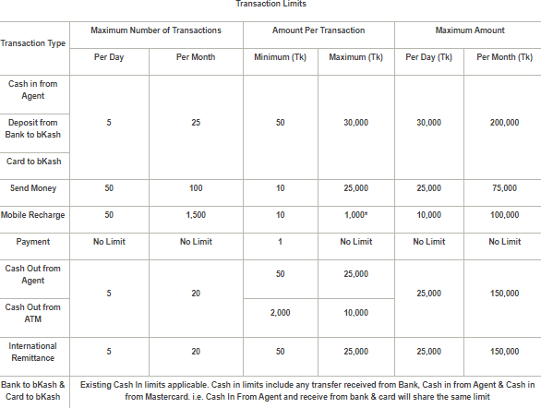

- SWOT Analysis of the organization
A SWOT matrix is usually done to identify the inner strengths and weaknesses, additionally external opportunities and threats of the organization. Below shows the strengths, weaknesses, opportunities and the threats of bKash limited.

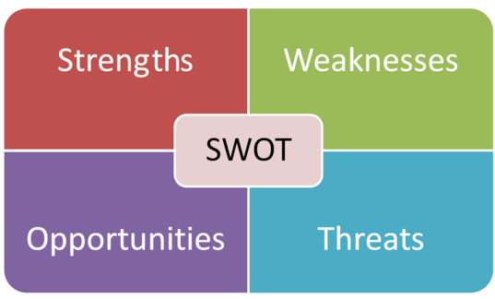

Strengths
- bKash is the first mobile financial service (MFS) in Bangladesh operating from 2011. This first mover advantage helped them not only get the highest number of customers but also to set the field on how a MFS should be.
- bKash can be run using all the major to minor telecommunication mobile networks. In this way bKash gives offers to different telecommunication on different levels. No one misses out on offers as bKash operates in any mobile network.
- bKash has the best technological support compared to the mobile financial services which helps them to function and assist their customers in the most minimum time possible.
- bKash is the market leader of the mobile financial services in the country.
- With the number of agents highest and availability is in both urban and rural areas makes it easy to do transactions

Weaknesses
Cash out charge of 1.85% - Unless a user is using the App the cash out (money withdrawal) charge is 1.85. This means for every 1000 BDT almost twenty taka is spent cashing out the money. This is a lot if you think of the rural people where their income is low, 1.85% is a lot.
Discrimination between App users and USSD users – App users get a lot of offers starting from a different lowered cash out charge to the different mobile recharge offers, Cashback offers etc, As internet data is still quite expensive here in Bangladesh a lot of people fail to use the app and do not get the offers. Apart from the internet, the app runs on smartphones only(Android and iOS) only. Many people still do not have the buying capacity to afford a smartphone and hence cannot run the App resulting in the failure of enjoying the benefits of bKash.

Opportunities:
Enormous population of Bangladesh – The growing as well as the present enormous population is blessing because it helps to build up more and more customers and additionally it helps in the profitability from current customers.
The booming E-commerce scenario – Websites such as Chaldal, Daraz, Pickaboo and other e-commerce sites are taking online payment as well as cash on delivery. Not everyone can afford to have a credit card but bKash can be opened by anyone who has a valid NID card. The online payment channel of bKash will enhance more transactions through bKash. Plus, bKash can give out several offers like Cashbacks, special discounts and vouchers.
Crossing the national boundary – bKash transactions are still within the national boundary. If bKash can find a way to cross the national boundary and go international. That will be a huge boost because people can send money abroad without having to go to banks or brokers.

Threats:
Sudden changes in policies – When bKash limited first started its operation a single person could have multiple accounts but suddenly they policy was changed to a single person can have one account. When it was changed the multiple accounts of a single person was closed down by bKash where a lot of money was stored. Customers had to go through a lot recovering the money. They had to visit the customer service offices and had to go through a lot of formalities to ensure they get back the money from their closed accounts.

- Finding and Analysis of the Study


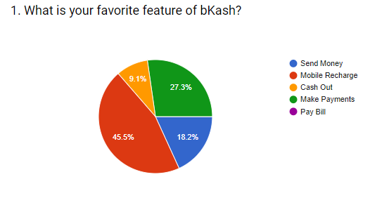
This was the introductory question to the people who were surveyed results were pretty much dominant with 45.5% on the ‘Money Recharge’ option. It refers to mobile balance recharge for all telecommunication networks. It covers both the Pre-paid and Post-paid Sims. The next dominant option that was chosen was ‘Make Payment’ which refers to payment through bKash app. This shows how people are relieved to have an option to pay through their phone by themselves rather than using cash. This is a small indicator to show that cashless transactions are becoming quite popular here in Bangladesh. The third one with 18.2% is the “Send Money’ which means the transfer of money from one bKash to another. This was quite low compared to what I assumed before the survey, but I came up with an explaination is people my sample mostly lives and is settled in Dhaka. They use send money no doubt but they have to talk on the phone more and buy a lot of stuffs so their favourite feature lies between Mobile Recharge and Make Payment. Plus Send Money is used once a month whereas Mobile Recharge and Make Payment can be daily occurrence.

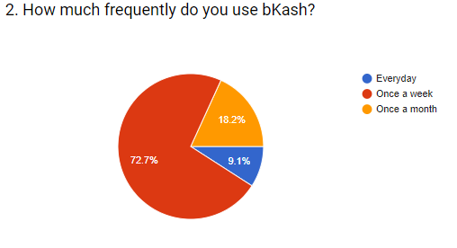

This shows much bKash has an impact upon a user on the basis of usage. 72.7% percent says they use it once a week which means that bKash comes to use every week. This indicates that bKash is slowly becoming a favorite tool to use. Just like we do bazar every week, people use bKash now. Second comes ‘Once a month’ with 18.2% which means that they use it once a month and which predicts they may transfer money once a month to their dear and loved ones living far away. And the remaining 9.1% use it everybody which is a positive note for bKash as it shows and a class of people has taken bKash to the level of necessity as they use it daily.

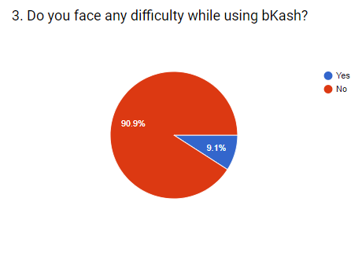
This is one of the simplest question yet one of the most important questions. This show that a staggering 90.9% says using bKash is easy and user friendly. Anyone can use bKash easily, It requires just a few simple steps to use it. This is a very positive note for bKash because sometimes we often see users backing out of services for their inability to use it or too difficult to use. Only about 10% says it is difficulty to use which is usual nothing can be perfect and there will always be a room for perfection.

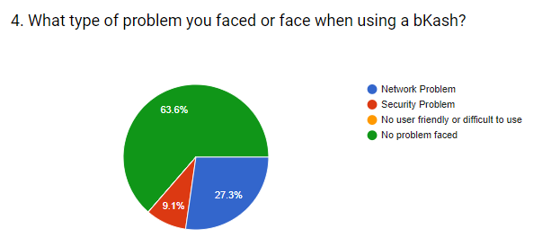
63.6% users answered that they face no problems at all while using bKash which is extremely beneficial for the organization. This again proves the user friendliness and the ease to use bKash. The actual problem they face is the network issues which is not in the hands of bKash as it solely depends on the telecommunication networks. And a small 9.1% people suffer from security problems which refers to fraud calls and taking away the money. This is low because in recent time bKash has increased the social awareness of not believing in fraud calls. bKash announced that bKash will never call their customer to know personal information such as their available balance or their PIN codes. Lastly, 0% or no one
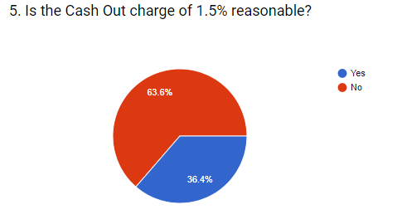
This question was mainly on the basis of the App users because the 1.5% charge is applicable when cashing out the money from the App. As we can we majority selected ‘No’ which clearly indicated that bKash should further take into consider about their cashing out charge. People are not feeling satisfied at all with the cash out charge. This is a major threat for bKash because people switch to other mobile financial services if they see that their cash out charge is lower than bKash. Lastly, a moderate 36.4% people chose ‘Yes’ which indicated that they are content with the 1.5% by bKash.
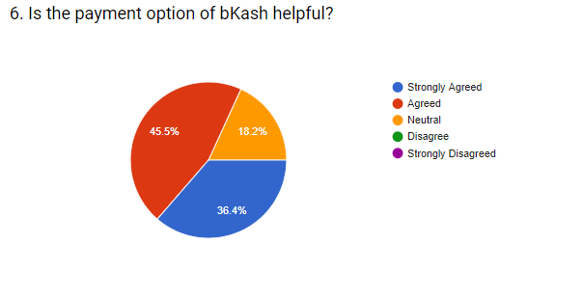
This question had answers which can be related to one sided vote win. Reason for saying that approximately 80% of the response is positive and they reacted that they love the payment option of bKash. This is very positive for bKash as well as the Bangladesh economy as we can see a small trailer of how people are adapting to the cashless payments instead of paying through raw money. Approximately 20% are neutral which indicates that to them the purchase neither liked nor disliked. 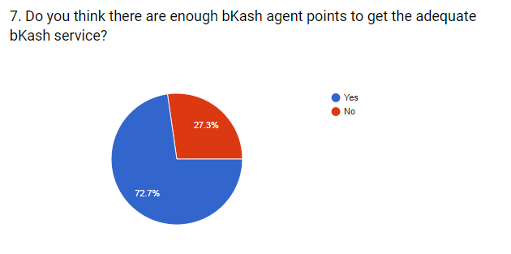
72.7% of the respondents are content so they gave ‘Yes’ as an answer. While the remaining 27.3% responded ‘No’ which means there are not enough bKash agents in their area. Dhaka city has a lot of agents almost everywhere but the frequency is quite low in some areas of Dhaka too. Places like Cantonment, DOHS and inner Mohammadpur and Mirpur lacks adequate amount of agents.

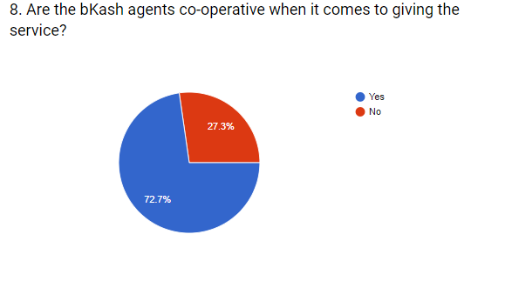
72.7% respondents are content with the service provided by the bKash agents. Services mainly include giving the cash to the customer who has cashed out the money or sometimes agents help in cashing in the money in the account of the customer. Agents also help in paying bills like BTCL, Electricity card recharge etc. So it means that most customers find the agents helpful to their desired needs. But being said that approximately 30% is not content rather disappointed with the agents. 30% is not less by any means. This means bKash has to take notes of making their agents more helpful so that 30% goes a lot lower like 5 to 10 percent.
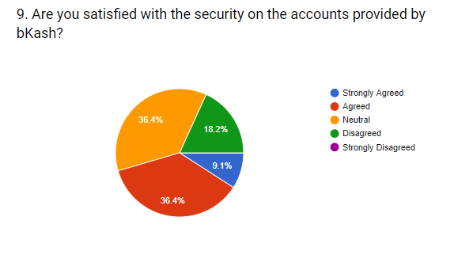
Security here refers the security of the account or in short how the money stays safe and out of the hands of fraudulent activities. 36.4% responded with neutral which is quite alarming for the fact that it means they are not content neither discontent. But this is not a good sign although 9.1% and 36.4% responded with Agreed and Strongly Agreed but still the neutral and Disagred part takes up over 50% which shows bKash has to further tighten up their security. The PIN code used to be 4-digit in the past but the new users has to give 5-digit PIN code. bKash is working extravagantly to stop the fraudulent activities by Banners, Poster, Digital media etc.
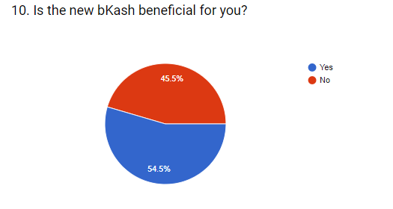
New bKash here refers to the new outlook of bKash app. Features are same but the outer look of the App has completely changed. Hence, as the pie chart shows that the new outlook of the App was not well appreciated. It was a close call as “Yes’’ and ‘No’ are 54.5% and 45.5% respectively. Though the features are same but 45.5% of the people did not like the new outlook even though bKash gave offers if the customers updated the App to the new outlook. This in one dimension proves that resistance to change is high of Bangladeshi people.
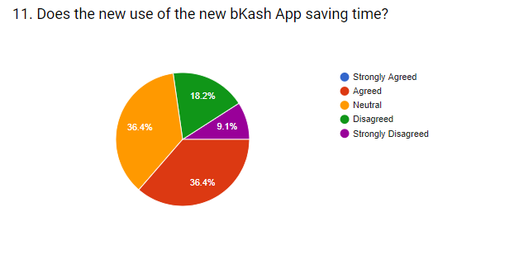
This question is like a follow up to the previous question as I asked a question about the new outlook of the App. With nobody answering ‘Strongly Agreed’ proves how people are not fully liking the new App. 36.4% responded with ’Agreed’ which proves that this percentage are quite content and agreeing to the face that the new outllook is actually saving time. On the other hand, 36.4% ticked off ‘Neutral’ which means to them the new outlook is the same as the last the last outlook. Almost 30% with 18.2% and 9.1% has responded with ‘Disagreed’ and ‘Strongly Disagreed’ which indicated they are not happy and is not liking the new outlook off the App at all.
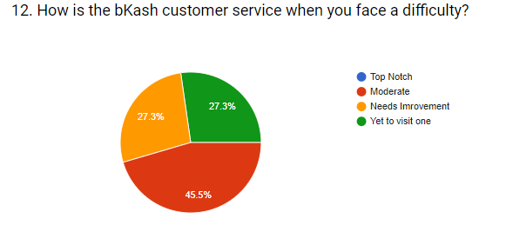
This question was based upon the customer service where people usually go for any sort of problems regarding the bKash account. Problems include PIN lock(multiple times wrong PIN entry), closed accounts, opening new accounts, App not running on Smartphones etc are some common problems faced by the customer. No one responded as ‘Top Notch’ which gives a clear picture that the customer service needs serious improvement. And if that did not show the full picture then 27.3% gives more emphasis as they clearly voted that it ‘Needs Improvement’. Another 27.3% did not even need to visit the customer service as they responded with ‘Yet to visit one’ which means that they have still not faced any problem regarding their account.
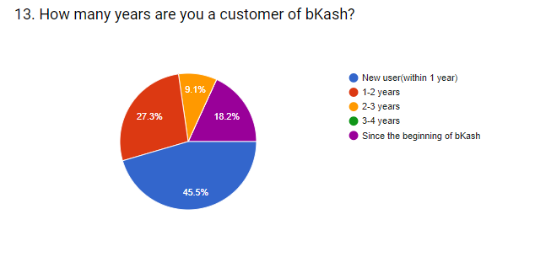
This was the concluding question with a general question that how long are they associated with bKash. 45.5% responded they are new to bKash as they are using bKash within this year. 27.3% voted that they are using bKash for a couple of years while 9.1% voted that they are using it for more than 2 years and less than 3 years. And a good 18.2% voted that they are using from the very beginning from 2011 when bKash started its operation.

- Conclusion and Recommendation


Conclusion:
It was an absolute delight to finish my report for my internship program but I am extremely sorry to my supervisor. I delayed this report for a year and I would like to thank him for the patience he has showed upon me. I made the maximum effort as I could have to get the necessary information. I consider myself extremely fortunate and blessed that I had the opportunity work as an intern in a company as good as bKash. The work environment was really friendly and learning was really high for the time I was there. Though I was an intern the work pressure was really high which I enjoyed as I was always learning something new every moment.
The mobile financial industry is a booming industry. bKash reached 3 million customers within the first 2 years of its operation while Rocket could only capture 1 million customers within their first 2 years in the market. bKash is currently the market leader of all the mobile financial services in the industry. If they keep on growing like this they are now, they have a prosperous future ahead of them.
Recommendation:
- bKash needs to improve their server casue quite often servers are down for hours as mobile financial services are heavily dependent on servers and digital technology
- The payment service is still very urbanized so bKash needs to promote the payment service more into the rural areas of Bangladesh
- Remittance system of bKash is very vague and it needs to be promoted more so that people are more educated about this as remittance is a major source of income for Bangladesh.
- Agents need to be more sincere and well trained about their duties and responsibilities so that people get the right service at the right time
- bKash needs to tighten up their security on the accounts and aware more people off the fraudulent activities so that they do not get cheated
- Transaction limit should be further increased to boost more transactions
- Just like credit cards bKash can offer credit services

- Appendix


Reference:
- Adminstrator(2014), Information on Mobile Banking
- Bangladesh Bank(2019),Mobile Financial Service(MFS) comparative summary statement August 2019, September 2019
- Muhammad Zahidul Islam(2017), Daily Transaction reach 1000cr, The Daily Star
- Muhammad Zahidul Islam(2019),App-based wallet boost transaction, The Daily Star

Questionnaire:

Analyzing customer expectations toward financial services of mobile
1. What is your favorite feature of bKash?
• Mobile Recharge
• Send Money
• Cash Out
• Make Payments
• Pay Bill

2. How much frequently do you use bKash?
• Question Type
• Everyday
• Once a week
• Once a month

3. Do you face any difficulty while using bKash?
• Yes
• No
4. What type of problem you faced or face when using a bKash?
• Network Problem
• Security Problem
• No user friendly or difficult to use
• No problem faced
5. Is the Cash Out charge of 1.5% reasonable?
• Yes
• No
6. Is the payment option of bKash helpful?
• Strongly Agreed
• Agreed
• Neutral
• Disagree
• Strongly Disagreed
7. Do you think there are enough bKash agent points to get the adequate bKash service?
• Yes
• No
8. Are the bKash agents co-operative when it comes to giving the service?
• Yes
• No
9. Are you satisfied with the security on the accounts provided by bKash?
• Strongly Agreed
• Agreed
• Neutral
• Disagreed
• Strongly Disagreed
10. Is the new bKash beneficial for you?
• Yes
• No
11. Does the new use of the new bKash saving time?
• Strongly Agreed
• Agreed
• Neutral
• Disagreed
• Strongly Disagreed
12. How is the bKash customer service when you face a difficulty?
• Top Notch
• Moderate
• Needs Improvement
• Yet to visit one
13. How many years are you a customer of bKash?
• New user(within 1 year)
• 1-2 years
• 2-3 years
• 3-4 years
• Since the beginning of bKash

