Internship Report
On
“A Case Study on Recordkeeping Method for a Retirement plan at Data-Path Ltd”



Course Title: Internship
“A Case Study on Recordkeeping method for Retirement plan at Data-Path Ltd”
Submitted to
Ishrat Jahan
Assistant Professor
School of Business & Economics
United International University

Submitted by
Anamul Haq Aminul
ID: 111 151 166
Major in Accounting
School of Business & Economics
United International University

Submitted Date: 04.07.2020

Letter of Transmittal
July 04, 2020
Ishrat Jahan
Assistant Professor
School of Business & Economics
United International University
Subject: An approval letter for accommodation of Internship Report.
Dear Madam,
Here is my internship report on the “Recordkeeping method for Retirement plan at Data-Path Ltd’. Under your caring supervision as a prerequisite for finishing the level of BBA program. I have attempted my best to set up this report with the greatest standard under your bearing.
I am giving my best efforts reveal the veritable experiences in this report. I trust and supplicate that my exertion and work will satisfy your expectation.
At long last, I trust that you will appreciate experiencing this report. I shall be constantly accessible to translate any issue in view to this report.
Thanking You
Yours Sincerely,
___________________
Anamul Haq Aminul
ID: 111 151 166
Major in Accounting
School of Business & Economics
United International University

Acknowledgment
I wish to recognize immense beauty and significant consideration of the Almighty Allah, the incomparable leader of the universe who empowers us to make my dream in a reality.
My affirmation starts by saying thanks to my honorable supervisor Ishrat Jahan, Assistant Professor who has given me proposals for making this last entry-level position report and furthermore gave me the organization to anchor up this last report. I would like to give genuine thankfulness for her motivation, direction, significant recommendations, thoughtful exhortation and eager consolation all through my study work. I feel incredible delight to set up the internship report on “Recordkeeping method for Retirement plan at Data-Path Ltd." under her supervision.
It is hard to complete such work without the sponsorship of others. From the most punctual beginning stage, my seniors, partners, Team pioneer, General Manager, International Relationship director and the President of Data-path Limited helped me by present with their important time to give me recommendations, responding to my inquiries and helping me with various archives and materials. My extraordinary appreciation goes to Mr. Jim Hudson (President, Data Path Limited) for allowing me to do my transitory situation in the affiliation. I additionally prefer to recognize Mr Adam Barker, International Relationship Manager, July Business Services and Ashfaqur Rahman, General Manager, Data Path Ltd. for precious help constantly. At last, I might want to thank my companions for their co-activity and legit proposals.

Abstract
In this report describes various parts of Retirement plan affair in USA and Bangladesh. The government of USA is very conscious and profound about ensuring the privilege of the resigned individuals and verifying them monetarily in resigned life. The IRS (inward Revenue Service) and the Department of Labor gives rules to the business to deal with the retirement advantage intend to give their representative retirement advantage which is known as "Plan" in the retirement business. The retirement plan additionally encourages the business to have Tax investment funds on the benefit of the association in the event that he keeps up the arrangement as per IRS and DOL rules. Inability to agree to the guidelines will bring about preclusion of the arrangement and it will be dependent upon punishments.
The Government of Bangladesh is beside concern in addition to valid regarding guaranteeing the surrendered people benefit. USA and Bangladesh retirement approaches differ in some basic core interests. Our country has the methodology for organization affiliation and outstandingly to the separate groups and the organization deals with, people's rights, pledge to the economy, dependence, advantage entirety, etc furthermore shifts. The laborers are getting insufficient entirety, no exacting way to deal with lessen irregularity among significantly and non-very reimbursed delegates, no proficient relationship for retirement course of action, along with others have the liable to alter. I think that, this statement shall be help Bangladesh upgrade their retirement fortunate hold too.

Table of Contents
Table of Contents vi
Chapter One ix
Introduction ix
1.1 Background 1
1.2 Company Overview 1
1.3 Objective of the study 2
1.3.1 Explicit Targets 2
1.3.2 Wide Purpose 2
1.4 Reasonable Investigation 2
1.5 Constraint 3
Section Two: Technique of Study 4
2.1 TECHNIQUE 5
2.1.1Key Origin: 5
2.1.2 Subordinate Origin: 5
2.1.3Sorts of Data Collected: 5
Section Three: 6
Organizational Background and Industrial viewpoint 6
3.1 Hierarchical Analysis 7
3.2 History 7
3.3Getting Initiated 7
3.3.1 Vision: 8
3.3.2 Statement of purpose 8
3.3.3 Guiding principle 8
3.4 Authoritative Design 9
3.4.1 Bookkeeping Department 10
3.4.2 Allocation Department 10
3.4.3 Distribution Department 10
3.4.4 ERISA Consulting 10
3.4.5 Human Resource Division 10
3.4.6 IT Division 10
3.4.7 New Business 11
3.4.8 Re-appropriating Division 11
3.4.9 Record keeping Division 11
3.5 Operational Tasks of DP 11
3.5.1 Plan Setup 12
3.5.2Plan Documents 12
3.5.3Plan Setup & Conversion 12
3.5.4 Plan Administration 12
3.5.5Plan Operation Support 12
3.5.6 Recordkeeping 13
3.5.7 Member Services 13
3.5.8 Venture Advice 13
3.6 Bookkeeping Procedures DP (The Record Keeper) 13
3.7 Day by day Activity 14
3.7.1 Refreshing Prices 14
3.7.2 Settling Trades 15
3.7.3 Checking Money 15
3.7.4 Checking Loan Status 16
3.7.5 Exchange handling 16
3.7.6 Commitments 17
3.7.7 Member Already Paid Out 17
3.7.8 Moves/Exchanges 17
3.7.9 Dispersions, Withdrawals and Loans 18
3.7.10 Withdrawal & Distributions 18
Title: Contribution Processing 20
Distribution Transaction Posting 23
Chapter Four: Findings and Conclusions 25
4.1 Discoveries 26
4.1.1 Organization Recognition 26
4.1.2 Organization behavior 26
4.1.3 Progress individual aptitudes/basic leadership: 26
4.1.4 USA based industry retrial 26
4.2 Suggestions 27
Conclusion 28
References 29

Chapter One

Introduction

1.1 Background
As this report is a part of outsourcing industry and attempt to portray bookkeeping methodology in which they pursue retirement issues. In any case, it additionally pertinent how these sorts of the industry offer the office to the resigned individuals as pursues the US government approach
To advance the physical, money related and mental prosperity of representatives and household, organizations ordinarily extend points of interest, prosperity along with additional reliability, powerlessness reward along with retrial plan. Laborers in like manner have commonly expected points of interest despite their compensation rates, agent preferred position plan routinely gave as opposed to supplementary currency portions as well as indispensable bit of a combined repayment pack.
The recordkeeping method arose in each organization and industry. Each part is not quite the same as the different segments. They manage different root and data

1.2 Company Overview
DPL is a Bangladeshi join endeavor organization working for July (commerce gives administration on retrial idea and finance). Data Path works perseveringly accompanied by bosses and monetary accomplices to construct tweaked administrations to reach their company objectives. The counsels of DP give practical clarifications to design usage and progressing plan activity. They have numerous long periods of business involvement with customers coming to from private companies to huge organizations, contending in the worldwide economy.

1.3 Objective of the study

1.3.1 Explicit Targets
The targets of this exploration are to distinguish how an Outsider Organization works retirement strategy arranging and recording techniques. How they fulfilled their customers and retain their data for more distant assist.

1.3.2 Wide Purpose
The wide goals of this exploration like:
- To think about the American Retirement plan entrepreneurs.
- .To thinks about the administration and straightforwardness of their retirement policy.
- To think about the strategy kept up by the business to tight up the segregation between the profoundly remunerated representative and non-exceptionally repaid workers when they are executing the business commitment.
- To think about the IRS and the DOL (Department of labor) omission capacity to improve the straightforwardness in the retirement plan.
- To know how RK work as per the customer planned

1.4 Reasonable Investigation
Section degree position initiative is an under-graduation essential for all the BBA understudies. The Internship initiative has been consolidated BBA instructive fixable for conveying capacity, a possibility to realize the earth of a determined alliance. Impermanent employment infers expanding managed contribution. Section degree position initiative extends an opportunity to realize the identity of a affiliation. Theoretical data is not adequate to be incredible. Section degree position initiative for me is a perfect become different amid speculation and exercise in the link of the inner commerce globe. Section degree position initiative grants a phase to replacement to build certifiable involvement in about masterwork and adapt new object along with develop new capacity at same time.
The statement will depict my understanding and involvement I have gathered casing Data Path Ltd.

1.5 Constraint
Regardless of the way to prepare the report got palatable assistance from Educator and the documentation gathering, there were not many requirements expected to go up against. There are:
- Because of classification, some related data and models are excluded.
- Not available of disclosure with respect to the retirement plan industry.
- Because of work pressure it was hard to get enough time from interviewees to assemble data from them.
- As the congress change the principles and guidelines consistently relying on the monetary and financial approaches so it is hard to incorporate all refreshed standards and guidelines.

Section Two: Technique of Study

2.1 TECHNIQUE
I have gathered the data for this report from both essential and auxiliary sources.

2.1.1Key Origin:
- Perception of the distributed department.
- Dialog with various division representatives for more data.
- Information from workers.
- Self-encounters.

2.1.2 Subordinate Origin:
- Various articles, assortments, web and so on IRS, RPF, ERISA.
- Checking different reports from earlier terminated plan.
The investigation requires a methodical technique from choice of the theme to definite report readiness. For implement the examination, data origin to be perceived and accumulated. They are to be arranged, examined, translated, and introduced in a methodical way and key focuses are to be discovered.

2.1.3Sorts of Data Collected:
- Primary information
- Secondary information
Information assortment Method:
For Primary Data:
- Personal meet
- Personal perception
For Secondary Data:
- Data-path and July Database
- Printed productions
- ERISA online CD
- Internet

Section Three:

Organizational Background and Industrial viewpoint

3.1 Hierarchical Analysis
DPL is a Bangladeshi join endeavor organization working for July (commerce gives administration on retrial idea and finance). Data Path works perseveringly accompanied by bosses and monetary accomplices to construct tweaked administrations to reach their company objectives. The counsels of DP give practical clarifications to design usage and progressing plan activity. They have numerous long periods of business involvement with customers coming to from private companies to huge organizations, contending in the worldwide economy.

3.2 History
Jim Hudson started his retirement plan specialization in the mid-1980s while seeking after his profession as a Certified Public Accountant. During this time, Jim got known as a master in this profoundly specialized field. He was legitimately answerable for creating and dealing with a huge retirement plan practice before establishing July in 1994. John Humphrey additionally started his vocation as a Certified Public Accountant, furnishing charge counseling administrations with an enormous bookkeeping firm before spending significant time in retirement plan organization. John helped to establish July Business Services in 1994.

3.3Getting Initiated
July Business Services started tasks in 1995, without any customers and a little expert office suite. During the early years, the executives attempted to create vital business organizations, enlist key workers, and make business procedures and strategies. The company's promoting endeavors brought about significant referral connections, including speculation guides, shared store organizations, banks, and financier firms. These connections made unobtrusive development over the initial quite a long while. Before the finish of 1996, JBS had more than 250 retirement plan customers and 5 workers. Today its supervisory crew brings has more than 40 consolidated long periods of industry experience, and its representatives incorporate experienced experts with affirmations from driving industry associations. It as of now serves in excess of 3,900 Retirement Plans in 48 states and to do these plans on an auspicious and effective way it included total Plan organization redistributing for national retirement plan suppliers, including changes of huge quantities of existing customer connections. Information Path is filling in as Branch Office to give the full working help to July Business Services to meet its objective effectively.

3.3.1 Vision:
The aim of DPL is to pick up the highest situation in the re-appropriating company and to transform into a customary BPO to the cutting edge BPO.

3.3.2 Statement of purpose
DPL central goal is to deliver customers proficiently along with assistance of most recent innovations. Adjustment and advancement is the center of the association.

3.3.3 Guiding principle
Guiding principle empowers practices all through our organization that will enable us to satisfy our central goal, aim and objectives' (Jim Hudson, CEO, July Business administrations.)
Some fundamental beliefs are basis to progress:
- Accountability
- Praise achievement
- Promise to magnificence
- Promise to individuals
- Creative arrangement
- Effective correspondence
- Embrace assorted variety
- Focus on a genius dynamic arrangement
- Integrating extraordinary administration
- A Positive frame of mind
- Results-arranged change
- Teamwork

3.4 Authoritative Design

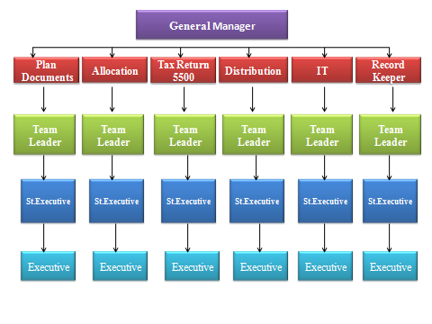

3.4.1 Bookkeeping Department
In Record-keeping segment, accounting gathering hand over full accounting and cash related assistance for DPL. It tackles different challenges like involve all of the works alternative offices, evidence of inventory, remuneration for the agents, commercial description etc.

3.4.2 Allocation Department
The goals of parceled offices are to assign each arrangement member’s investment frequently and give info to work process 5500. As July is the joint endeavor company, the majority of their work is recovering by portion gather and plans diverse records to hand over all the important info to other administration.

3.4.3 Distribution Department
Circulation office manages the administering of the cash for each one trader when he/she is in the phase of retirement or moving investment starting with one arrangement then onto the next. To process this, they need a program known as RELIEUS. The administration guarantees the cash move to their customers.

3.4.4 ERISA Consulting
ERISA division gets ready arrangement records from the data given by the deals and establishment office. Plan records resemble Earning Allocation arrangement, 401 (k) plans, Safe Harbor Plan, Safe Harbor 401 (k) plan which generally contains at least 40 pages with law, guidelines, and guidelines and how these will influence the arrangement. They guarantee the correct data which will be trailed by different divisions.

3.4.5 Human Resource Division
In Data Path, HR regulatory aim keeps up the quality of the relationship. HR administration continually required to ensure the security of the relationship of its laborers.

3.4.6 IT Division
As DP obliged hand over advantage through the latest professional, it similarly need IT strengthen regular basis. IT administration manages the framework dynamic of the affiliation and keeps up the system effective to maintain the electronic devises.

3.4.7 New Business
New Business dept updates overall information into the database and assertion the attention of the information. Every one of the information is provided by the business administration of DP.

3.4.8 Re-appropriating Division
In DP the vast majority of the divisions are associated with July however redistributing office activity is distinctive TPA as opposed to July. All group of re-appropriating office works with various TPA by giving distinctive administration like arrangement audit, plan development, accommodate and so forth. Presently this office has a few TPA customers.

3.4.9 Record keeping Division
RK is the most essential administration in Data Path for July Business. The movement of this office is to follow who's in the game plan, what speculations they possess, and manage the movement of the money in the company.

3.5 Operational Tasks of DP
Capacity of DP
July Business Services and for their sake, DP is giving the accompanying administrations to its USA business customers
- Plan structure
- Plan arrangement
- Plan Administration
- Participant Services
- Plan Design
It makes retirement intends to meet the exceptional objectives of every business. Regardless of whether the goal is representative enlistment and maintenance or augmenting benefits for key workers, it has the mastery to structure the best arrangement for customers.

3.5.1 Plan Setup
It gives most of the administrations to effectively arrangement retrial program or to change over actual arrangement from the present supplier.

3.5.2Plan Documents
It offers comprehensive plan documents prepared by experienced ERISA consultants. Its capabilities include:
- Prototype Plan Documents
- Volume Submitter Documents
- Loan Policies
- QDRO Procedure
- Other Required Forms

3.5.3Plan Setup & Conversion
Data-path’s dedicated setup team provides hands-on services to coordinate all aspects of plan setup or conversion. Our services include:
- Prepare Enrollment Materials
- Prepare Setup Paperwork
- Contribution Submission Procedures
- Coordinate Transfer of Assets
- Prepare Letter to Previous Provider
- Coordinate Information Needed for Takeover

3.5.4 Plan Administration
Data Path's advisors have more than eight years of plan organization experience and are specialists in this exceptionally specialized field. A committed record delegate serves the customer's arrangement, upheld by a group of professional experts.

3.5.5Plan Operation Support
It provides everything client needs to maximize the value of plan, including telephone and e-mail access to its consultants. Its services include the following:
- Eligibility Calculations
- Contribution Allocations
- Vesting Calculations
- Distribution & Loan Processing

3.5.6 Recordkeeping
Data-path and July provide automated recordkeeping services through their alliance partners and through July’s daily valuation recordkeeping platform:
- Daily Valuation of Accounts
- Plan Sponsor Account Access
- Quarterly Participant Statements

3.5.7 Member Services
Through its union organizations with money related suppliers, July makes accessible fantastic apparatuses for members to get ready for and accomplish a safe monetary future.

3.5.8 Venture Advice
A large number of retirement items additionally incorporate member access to online venture counsel and direction. The capacity for members to get online speculation counsel builds their odds of accomplishing a safe money related future, and therefore, can lessen plan support trustee risk.

3.6 Bookkeeping Procedures DP (The Record Keeper)
Who is a Record Keeper?
The record attendant who manages the value-based procedure those make day by day valuation. They handle the accompanying capacities:
- Cash in (Contributions, credit reimbursements, move or rollovers);
- Cash out (moves, conveyances, advances or different withdrawals);
- Balancing asset positions
- Modifying frameworks with every day speculation evaluating; and
- Reporting the two members and plan supports.
These capacities happen each day for each arrangement. The perfect manager or record-guardian is a conscientious individual, yet comfort with innovation is particularly critical to the record attendant. Each part of the record-guardian's work manages PCs.

3.7 Day by day Activity
Record-guardians play out different assignments in an assortment of ways on some random day. Contingent upon a company's activity, the request where these obligations are performed will without a doubt change, yet atypical day incorporates a large portion of the accompanying capacities:
- Updating costs.
- Settling exchanges.
- Releasing exchanges.
Refreshing values for member correspondence (for example live administrator, mechanized reaction units (ARU).
- Reviewing exceptional exchanges.
- Reconciling asset positions.
- Monitoring money, advances and adjusting asset shares.
- Distribute exchange orders; and
- Operating reinforcements and other support capacities.
The first capacity given consideration in quite a while is the refreshing of present venture costs. We should start there and stroll through the majority of the capacities recorded above, remembering that the request should change contingent upon the authoritative design and framework abilities of the corporation taking care of these exercises.

3.7.1 Refreshing Prices
The entire thought behind every day valuation is the idea that record parity esteems can be kept present by catching regular business cost for every speculation. Offer costs are refreshed for all assets consistently. The cost speaks to the end cost from a specific trade day.
Refreshing the costs is a day by day action. Notwithstanding, the hour of day that the costs are stacked into the documentation framework might fluctuate starting with one retrial plan organization firm then onto the next.
There are a few factors that may influence the planning.
- The time that the exchanging accomplice sends the electronic value document to the retirement plan organization firm. This may fluctuate between exchanging accomplices.
- The staffing level of the retirement plan organization firm give a night team that updates the costs at night; others update before anything else.
- Still others have robotized occupations that permit value refreshes, paying little respect to staffing level.

3.7.2 Settling Trades
Settling exchanges is a capacity that commonly happens following the most recent costs is input. The subsequent offers and currency bought or sold are accounted for in the mechanized exchange record. For instance, when commitments are prepared on the record-guardian's framework, the exchange is recorded to every member's record in currency as unsubstantiated or undecided exchanges, however the exchange has not really happened and the quantity of offers obtained is obscure. At the point when the exchange is settled, the exchange is affirmed on the product, and offers are presented on the member's record and can be acquired on the ARU.

3.7.3 Checking Money
Checking money positions can be an incredible apparatus in constraining risk, guaranteeing standard due dates are met and distinguishing zones of shortcoming in an everyday activity. Retirement plan overseers become familiar with their activity's resilience for money and are constant in answering to the fitting gatherings at whatever point money sits in the record for more than the satisfactory period (e.g., two days).
Subsequent to recognizing the exchange that is causing the error and the date it was started, heads catch up with the fitting gatherings. The following are a couple of instances of circumstances that may be revealed:
- Contributions stored however reserves not exchanged, so money is non-contributed.
- Payment was composed however not changed.
- Fees charged to an arrangement however not dispensed to member adjusts, causing money or offer deficiencies.
- Shares offered to cover another member credit however no check was cut, so the money is still in the trust; or
- Shares sold because of an exchange mentioned by a member that made money. The relating buy incidentally does not get made, coming about in non-contributed money.

3.7.4 Checking Loan Status
As members are expressed new advances, they become an advantage of the trust. They make a few kinds of exchanges that must be followed and accommodated: some all through the reimbursement time of the credit. To start with, the closeout of resources for give the money to the credit is observed and after that the money circulation of the advance continues to the member is additionally checked, to finish the exchange. The advance at that point turns into another benefit in the framework with customary installments of money back to the arrangement to square away the member advance head and gathered premium. Every installment sum is checked that it concurs with the amortization plan, is made opportune and applied to the fitting advance. Commonly, advance reimbursements are put over into other arrangement resources dependent on the member's present speculation decisions.

3.7.5 Exchange handling
Numerous exchanges happen in the recordkeeping of an everyday plan, albeit specific sorts are prepared more oftentimes than others. The quantity of members in the arrangement, recurrence of payrolls handled, profit installment plans, the kind of plan and the arrangement alternatives accessible all work together to impact the quantity of exchanges to be prepared on some random day.

3.7.6 Commitments
Businesses retain pre-charge elective commitments, assigned Roth commitments, make up for lost time commitments, after-charge worker commitments or credit reimbursement sums from representative checks and forward those dollars to the trust for speculation as per every member's bearings. A few businesses present every commitment document as it finishes its finance preparing, while others present the information on a month to month premise, despite the fact that payrolls and stores of the commitments into the trust happen all the more much of the time.
The business as a rule wires the cash or sends a payment to the trustee for store to the trust. Money record is some of the time set up to be utilized as a holding represent the stores. The stores are contributed when the information record can be accommodated and if the assets inside the money record are adequate. A few businesses enable the record manager to demand a programmed charge of the commitment from the business' record into the arrangement account upon voucher and survey of the information document to limit any mistakes between the store sum and the information record. A portion of those issues are missing speculation political race structures, ineligible members, members officially paid out, handling commitments when the sum on the record doesn't coordinate the store and negative commitments.

3.7.7 Member Already Paid Out
The day by day condition fundamentally accelerates the time by which an appropriation can be made to an ended member. Confirm that all finance reasoning’s are recorded on the day by day framework before any appropriation is made to the member so expensive second (and ensuing) circulation installments can be maintained a strategic distance from. Commitments that are submitted after a member has fired work and as of now taken an appropriation of the all-out vested equalization are called as trailing commitments and can be dismissed by the framework.

3.7.8 Moves/Exchanges
Moves include development of the cash previously put resources into the member's record. This kind of exchange consistently includes a two-advance procedure:
- The selling of offers; and
- The purchasing of offers.
A few plans enable exchanges to happen whenever and as frequently as the member needs. Different plans restrict the quantity of exchanges permitted during a year or potentially force a holding up period before another exchange can be mentioned.

3.7.9 Dispersions, Withdrawals and Loans
Dispersions, withdrawals and advances are work serious sort exchanges that require more Record-guardian association than some different exchanges that are practiced effortlessly using mechanized programming capacities. For circulations, withdrawals and advances, most plans keep on requiring some administrative work that must be looked into to be certain it is finished.

3.7.10 Withdrawal & Distributions
Appropriations might be mentioned to fulfill full or halfway installment of advantages because of ended members, recipient, or substitute payee. Dynamic members may make withdrawals if the arrangement licenses. Withdrawals might be mentioned for an assortment of reasons:
- Hardship withdrawal.
- In-administration withdrawal.
- Required least appropriation at age 70½.
- Refund to profoundly repaid representatives because of plan's disappointment of the real deferral rate and additionally genuine commitment rate nondiscrimination tests; and
- Refund of elective deferrals in overabundance of the IRC §402(g) limit.
The record attendant ought to check that a kind of installment is permitted under the provisions of the arrangement. There might be extra necessities to be met before the installment might be made.

Title: Contribution Processing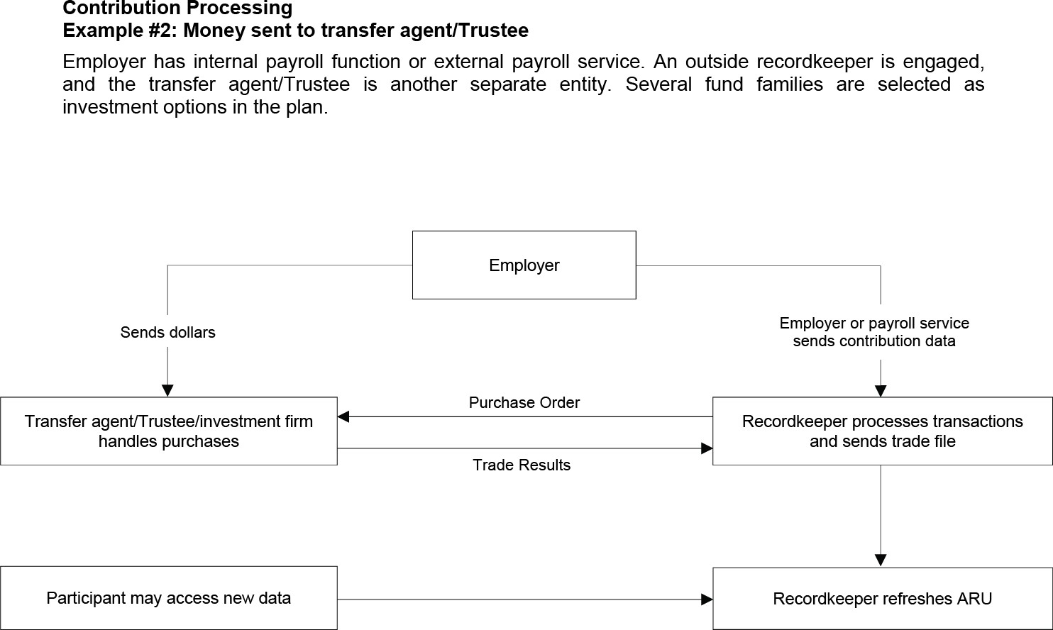

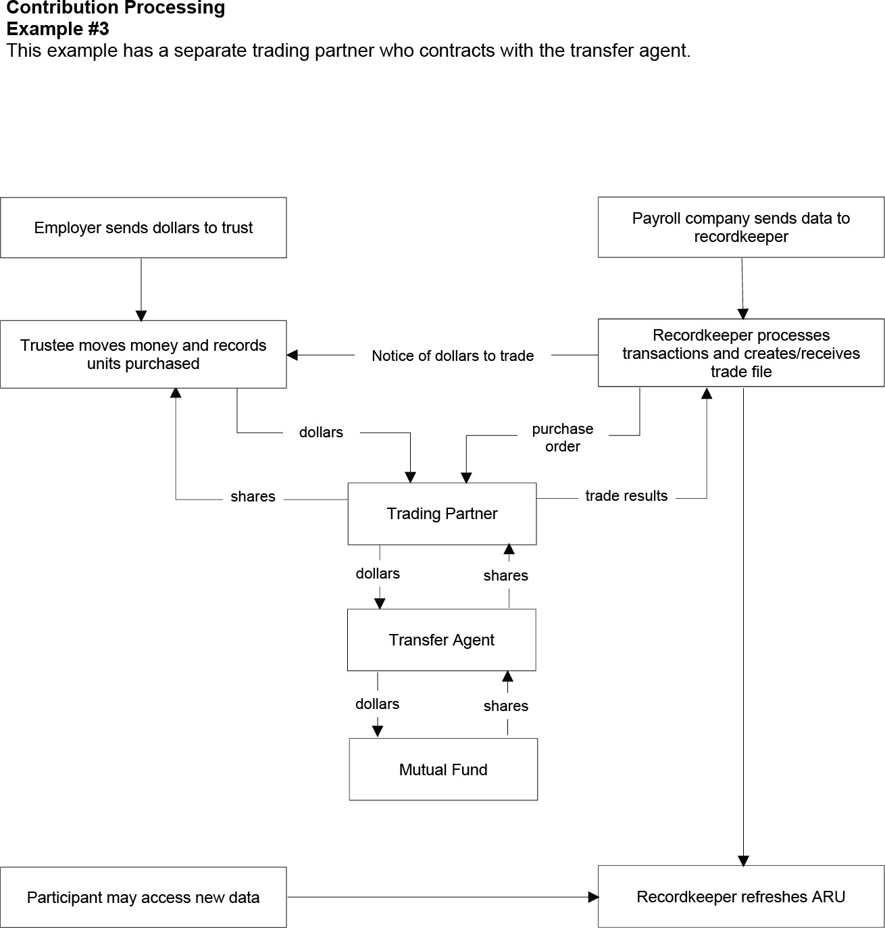

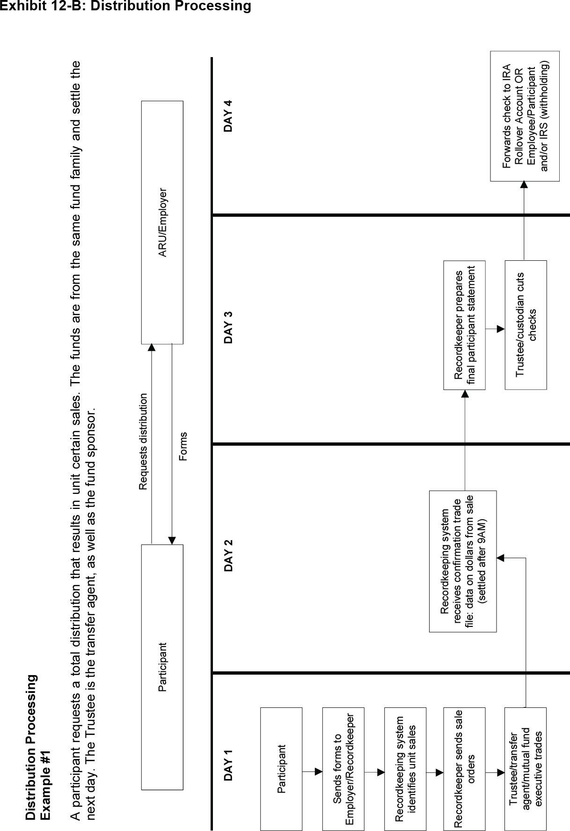

Distribution Transaction Posting
- Distribution Transaction Tab
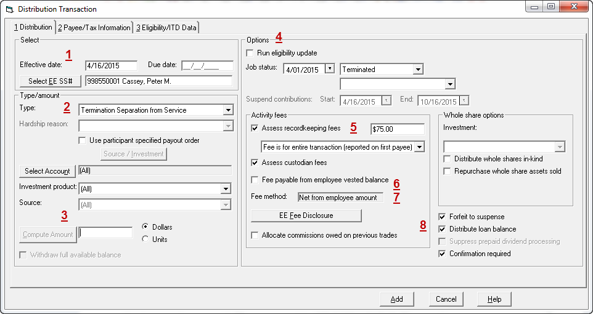
Payee/Tax Information
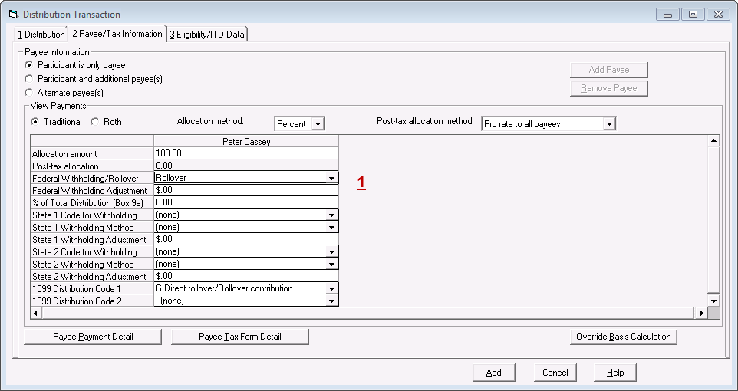

Payment Data
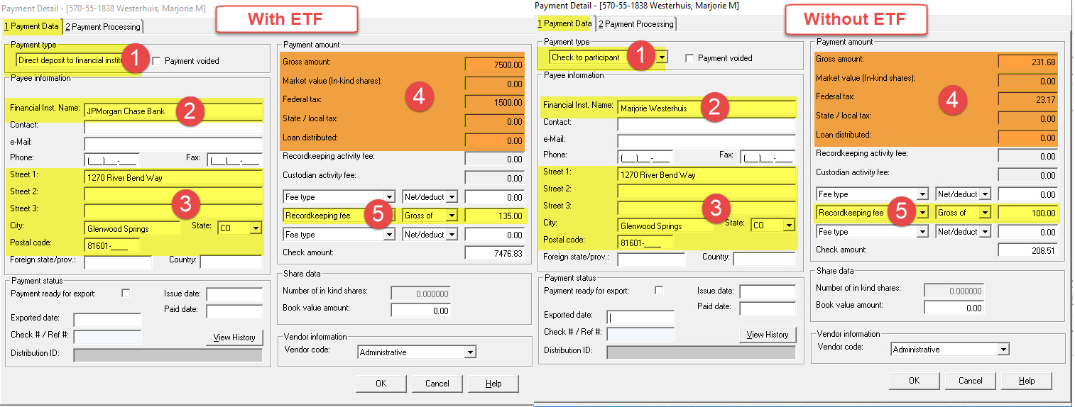

Payment Processing
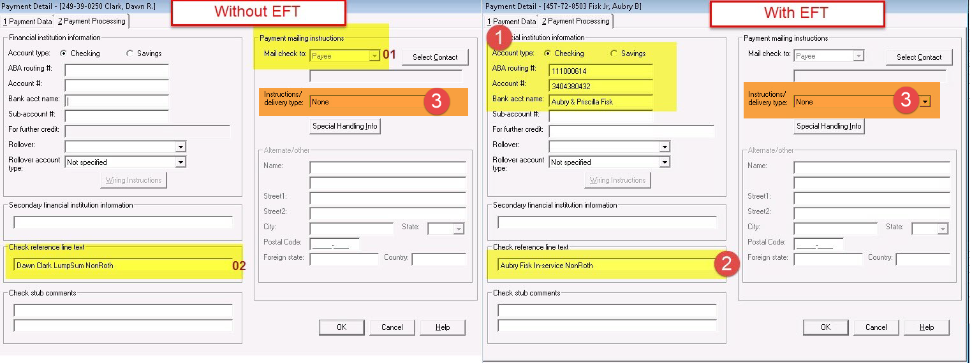

Chapter Four: Findings and Conclusions

4.1 Discoveries

4.1.1 Organization Recognition
I have also amassed some finding out about how an affiliation does its standard capacity. I saw how to record the reports, how to maintain their day to day activity and how to maintain and complete regular tasks However I also developed a sentiment of expert working environment.

4.1.2 Organization behavior
For any kind of business, direct is amazingly basic. So I am trying to figure out the convenient attitude with various kinds of people of the affiliation. The agents of the affiliation are neighborly.

4.1.3 Progress individual aptitudes/basic leadership:
During my brief employment residency, I have improved an extensive measure on my capacities including the data of fulfilling a task and my pined for work way. I have improved my present capacities just as have expanded some new aptitudes likewise, which will empower me to encourage in my calling, for instance, fundamental thinking during extraordinary condition.

4.1.4 USA based industry retrial
Data path is a redistributing association tackling USA retrial project. I am trying to understand the complexities between our retrial form companies looking at USA. As I would see it the USA retrial form company is considerably extra convoluted those industry

4.2 Suggestions
To eradicate the above problems Data-path and July can do the following things:
- Give employees thought regarding the business: Organize industry direction sessions for new students to give them thought regarding the business and the association.
- Blend Theoretical Training in with Practical/Technical Training: The instructional course ought to be structured such a way that consolidates both hypothetical and specialized preparing.
- Make a Planned preparing program: The instructional meetings ought to be appropriately arranged and booked to expel confusion.
- Group work: Form group of trainees, so that they can share and learn.
- Utilize Visual guide: Use of visual guides, for example, PowerPoint and video introductions can enable the preparation to process.
- Utilizing local language where required: Sometimes it is important to explain some troublesome issues in local language and let students examine in Bengali.
- Giving Breaks at Regular Intervals: Regular breaks ought to be given during sessions to decrease pressure and increment fixation.
- Reduce the volume of information: Do provide necessary information and training. Both trainees and trainers will understand the content.
- Include the learners more and take inputs: Take visit criticism and recommendations from students, to change preparing as per the need of the learners.
- Take a superior Internet Connection: For proficient activities and preparing a quicker web association is fundamental.
- Worker Retention: With the above advances some extra advances like expanding pay and different advantages, guaranteeing vocation development and so forth will lessen representative turnover and along these lines encourage preparing

Conclusion
In the wake of investigating the Internal Revenue Service rules and guidelines it might be presume that the American retirement advantage plan is urging the American resident to set aside cash for their older age. In our country, we are aspect noteworthy number of matters concerning to representative's retirement reserves. For a wide range of retirement advantage plan revealing the IRS and DOL has the distinctive deadline to present the report which must be kept up by the arrangement support. Yet, we do not have that kind of association to ensure representative is correct. So, we have to progress the overall situation framework than it will be a gigantic accomplishment for the entire nation. The American retirement advantage plan is making commitment to their securities exchange and makes individuals intrigued about the financial exchange and contributing the general economy. This report may improve the retirement advantage arrangement of Bangladesh.

References
ASPPA Retirement Plan Fundamentals (RPF) Examinations to Replace PA Examinations Effective Midnight. (2008, September 10).
broadridge. (2018, September 12). Retrieved from www.broadridge.com: https://www.broadridge.com/financial-services/asset-management/retirement- services/optimize-trade-processing/trust-and-custody-services
Data-path. (2018, September 08). Retrieved from www.data-path.net: https://www.data- path.net/services-outsourcing/?temp=outsourcing
julyservices. (2018, September 05). Retrieved from www.julyservices.com: https://www.julyservices.com/about-us/philosophy/
macg. (2018, September 05). Retrieved from www.macg.com: https://www.macg.com/company/overview/
schwab. (2018, September 07). Retrieved from schwab.com: https://www.schwab.com/

