

Janata Bank Limited

Internship report on Automation of MIS Department in Janata Bank: A study on Motijheel head office, Dhaka

MD. Zayedi Hossain

This report is submitted to the school of Business and Economics, United International University as a partial requirement for the degree fulfillment of Bachelor of Business Administration


Internship report on Automation of MIS Department in Janata Bank: A study on Motijheel head office, Dhaka

Submitted to:
Ahmed Imran Kabir
Adjunct Faculty
School of Business & Economics

Submitted by:
Name: MD. Zayedi Hossain
Id: 111-151-343
Major: Management Information System
Trimester: Fall
School of Business and Economics

Date of submission: 1st January, 2020
Letter of Transmittal

15th December 2019

Ahmed Imran Kabir
Adjunct Faculty
School of Business & Economics
United International University

Subject: Request for approval of Internship Report.

Respected Sir,
I am a student of BBA department of United International University. I have completed all my courses in last trimester. In Fall 2019 trimester I have completed my Internship in Janata Bank Limited and I have finalized my report named as “Automation of MIS Department in Janata Bank”. I have tried my level best to cover adequate information.
Therefore, I would like to submit my report on your very concern. I hope you will be kind enough to discover my observation during the internship period in Janata Bank Limited. Rather, in case if you have any further clarification, I would welcome the opportunity to consult with you to explore how my findings could best meet your needs.

Your Sincerely,
MD. Zayedi Hossain
ID: 111 151 343
United International University.

Acknowledgement

At the very beginning, I would like to express my deepest gratitude to All-powerful Allah for giving me the strength and the patience to complete my BBA courses and prepare this report within the scheduled time.
Successfully completion of any type of project requires helps from a number of persons. I have also taken help from different people for the preparation of this report. Now, there is a little effort to show my deep gratitude to that helpful person.
I want to thank my honorable faculty “Ahmed Imran Kabir”, Adjunct Faculty of Business & Economics School, United International University, for helping me and providing me all the necessary supports for the completion of this report and I am very thankful to him for guiding me through this report writing.
I owe my deep gratitude to my supervisor Mr. Zahirul Islam, Senior officer of MIS department, Janata Bank. He has helped me enormously through this period of internship.
I respect and thank Mr. Ramjan Bahar, DGM of MIS Department, Janata Bank Limited, who has given me the opportunity to do internship in the MIS dept. and also provided a lot of required information for the compilation of my internship report.
I would not forget to remember Mr. Rihajul Islam, Mr. Naser, Mr.Imroj who has practically showed me how to operate the OMIS software in Janta Bank Limited. Without their help and support it would have been impossible to complete this report.
Finally, my sincere feelings go to my family, friends, classmates and colleagues who helped me whenever I was in need.

Declaration of Student

I, Md. Zayedi Hossain, hereby declare that this report on “Automation of MIS Department, Janata Bank Limited” has been prepared as a part of my internship formalities. It is an obligatory part of our BBA program to submit an internship report. I also want to declare that this report is only prepared for academic purpose and no confidential data of the bank has been revealed in this report. Moreover, I was encouraged and instructed by my supervisor, Ahmed Imran Kabir to prepare this report.

Executive summary

This report starts with the heading “Automation of MIS Department in Janata Bank”. In this report I’ve covered the study objective and also the scope and limitation of the study. After completing those part, I showed a full analysis on the Banking industry of Bangladesh. In this analysis, I tried show the present situation of the banking system in Bangladesh and growth of the industry and also how is that developing day by day. After that I showed the organization analysis of Janata Bank Limited. In that part I put more emphasize on the MIS department of Janata Bank; as my report’s topic is Automation of MIS department. In that part I tried to bright out what process are Janata Bank using in their system, to collecting data of all branches, how they process those data and how they make report using those data. I also discussed about, Overview & History of JBL, Product and Services of Janata Bank Limited, Branches list of Janata bank, Corporate Information of Janata Bank Limited, Functional Hierarchy of Janata Bank, Board of Directors, Personal Management Information System. After completing that part, I discussed about my internship experience in MIS department of Janata Bank Limited. In that part tried present the information about my training, experience and all the this that I learned from them. Finally, I will put some recommendations from my point of view and will pull conclusion.

Table of Content
List of Figure & Table: 1
CHAPTER 1: 2
INTRODUCTION 2
1.1 Background of the Report 3
1.2 Objective of the study 4
1.3 Scope & Limitation: 5
CHAPTER 2: 7
INDUSTRIAL ANALYSIS 7
2.1 Industrial Analysis 8
2.2 History of MIS in Banking Industry in Bangladesh: 11
2.3 Size, Trend and Maturity of the Industry: 13
2.4 Factors of Banking Industry 15
2.5 Barriers to Entry: 16
CHAPTER 3: 18
ORGANIZATIONAL ANALYSIS 18
3.1 Overview & History of JBL: 19
3.2: Automation of MIS department in Janata Bank: 25
3.3: PMIS (Personal Management Information System): 26
3.4: OMIS (Operations and Management Information System): 27
3.5: Data input and Report Creation by Branches and MISD: 28
3.6: Report Creation by MISD: 30
3.7: SOWT analysis: 31
CAHPTER 4: 32
INTERNSHIP EXPERIANCE 32
4.1 Position, duties and responsibilities: 33
4.2 Training: 35
4.3 Contribution and Departmental Function: 39
4.4 Evaluation: 39
4.5 Skills applied: 40
4.6 Skills Developed: 41
4.7 Application of Academic Knowledge: 42
CHAPTER 5: RECOMANDATION & CONCLUSION 43
5.1 Recommendation: 44
5.2 Conclusion: 45
Reference: 46

List of Figure & Table:

List of Figure & Table:
- Figure2.1: List of Banks and their Establishment in Bangladesh
- Figure 2.2.1: Computerization of Bank Branches
- Figure2.2.2: Trends in Technology Adoption, 1998-2015 (Source: BIBM)
- Figure 2.2.3: Classification of Banking Software (% of Banks)
- Figure 2.3.1: Number of Bank Branches per 100,000 adults
- Figure 3.3: PMIS faction in HRD of JBL
- Figure 3.4: Inflow & Outflow of information
- Figure 3.5: Home page of MISD portal
- Figure 3.5.1: CDMIS home page
- Figure 3.5.2 Data Entry page
- Figure 3.6: CDMS Report
- Figure 3.7: SWOT Matrix
- Figure 4.1.3: Systems execute by MIS department
- Figure 4.2: Home page of OMIS software
- Figure 4.2.1(a): QRR Form

Abbreviation:
- PMIS = Personal Management Information System
- OMIS = Overview Management Information System
- SQL = Structure Quarry Language
- BB = Bangladesh Bank
- MF = Ministry of Finance
- SOCB = State Owned Commercial Banks
- SDB = Specialized Banks
- PCB = Private Commercial Banks

CHAPTER 1:

INTRODUCTION

1.1 Background of the Report

Automation in the banking system has played a significant role in the age of modern civilization for the improvement of the economic system. The activities of banking which took several hours or even days; now can be done within a few seconds. This is only possible for the computer and the internet; which means an automatic system. The Management Information System has added an extra booster in the banking sector. With the help of Automation and MIS banking has become very easy and customers oriented.
In this report, the automation in the MIS department of Janata Bank Limited has been discussed. Janata Bank Limited is one of the oldest banks in Bangladesh. It was a great pleasure to do my internship in this reputed bank. Customer gratification is the topmost priority of the bank. Bank has mentioned in their object that customer’s expectancy will be visible through creative financial products and services. As an intern in the MIS department of Janata Bank Limited, I am preparing this report titled "Automation of MIS Department of Janata Bank". An internship report contains various types of rules, regulations, and policies related to different actions of banking; all of them have been considered here.

1.2 Objective of the study

The major objective of preparing this report is to show a detailed analysis of how the automation of the MIS department is helping the whole banking system of Janata Bank Limited. As I am an intern in Janata Bank my own experience will also be shown in this report.
The specific objective of this report is to analyze how OMIS software is facilitating the data related work of the banking system. This analysis will clearly show how data from all branches are collected and how final reports are prepared from them. My internship experience and the learning gathered here can also give some knowledge about the internship to others.

1.3 Scope & Limitation:

Scope:
The scope of this report is limited to the MIS department of Janata Bank Limited. In this report the industrial analysis of Banking sector in Bangladesh has also been discussed with the main topic “Automation of MIS department in Janata Bank”. A full analysis on how MIS department is getting automated has been shown in this report.
Methodology:
This report has been prepared on qualitative type of study. As this is a report based on internship experience; this is different from all the conventional reports. This report is mainly containing the practical experiences which I gathered in my internship period in Janata Bank Limited.
Source of Data:
- Primary Source:
- Training.
- Face to Face conversation with employees.
- Practical experience gained in the internship period.
- Secondary Source:
- Annual report of JBL.
- Different Websites.
- Report of BIBM.
- Bangladesh Banking Sector Analysis reports.
- Bangladesh Bank reports.
Limitation of the Study:
There were many difficulties which I faced while preparing this internship report. They are shown below:
- Time Limitation.
- Lack of Information sharing by the organization.
- Difficulties in gathering information; as the authorities did not want to share all data because of confidentiality.
- The executives of the bank couldn’t manage adequate time because of their work.
- Only three months’ internship period was not sufficient to collect all required data for preparing this report.

CHAPTER 2:

INDUSTRIAL ANALYSIS

2.1 Industrial Analysis

An industry has some group of companies that performs almost similar business activities. For competition, these firms affect one another and does rivalry also because they serve the same basic customer needs.
In this report, we are discussing "Practice of MIS in Janata Bank". So, we will analyze the banking industry of Bangladesh and mainly focus on the MIS departments of those banks.
Bangladesh Bank is the central bank of Bangladesh. Bangladesh Bank (BB) issues currency, maintains foreign exchange reserve and also provides transaction facilities of all public monetary matters.
In Bangladesh, the Banking industry started with six nationalized commercial banks, two state-owned specialized banks, and three foreign banks after independence of the country in 1971. Some of the well-known banks in Bangladesh are: Sonali Bank, Janata Bank, Dutch-Bangla Bank, HSBC, Islami Bank Bangladesh Limited etc. Janata Bank is one of the largest and oldest banks in Bangladesh. Types of Banks in Bangladesh:
There are two types of Banks in Bangladesh. They are:
- Scheduled Bank:
The banks which get license to operate under Bank Company Act, 1991 are termed as Scheduled Banks. They operate under supervision and full control of Bangladesh Bank.
There are 59 scheduled banks in Bangladesh. And those scheduled banks can also be categorized.
- SOCBs (State Owned Commercial Banks): The banks which are owned by the Government are known as State owned banks. There are 6 banks which are owned the Govt. of Bangladesh.
- SDBs (Specialized Banks): There are some banks which are running for some special purposes. Most of them conduct developmental works for the people of the country. There are 3 specialized banks in Bangladesh.
- PCBs (Private Commercial Banks): The banks which are owned by private entities are called as Private commercial banks. In Bangladesh there are 48 PCBs. These Private commercial banks can also be categorized. There are two types of PCBs:

- Conventional PCBs: In the banking industry of Bangladesh; there are 33 conventional PCBs. They operate the interest based operations.
- Islami Shariah Based PCBs: Islami Shariah based banks are those; which operate their banking activities according the rules of Islami Shariah. They follow the Profit-Loss sharing mode.
- Non- Scheduled:
Non-Scheduled banks run for special purposes. They cannot perform all tasks of the Scheduled banks. There are 5 non-scheduled banks in Bangladesh. They are:
- Ansar VDP Unnayan Bank,
- Karmashangosthan Bank,
- Grameen Bank,
- Jubilee Bank,
- Palli Sanchay Bank.
- List of Banks and their Establishment in Bangladesh:
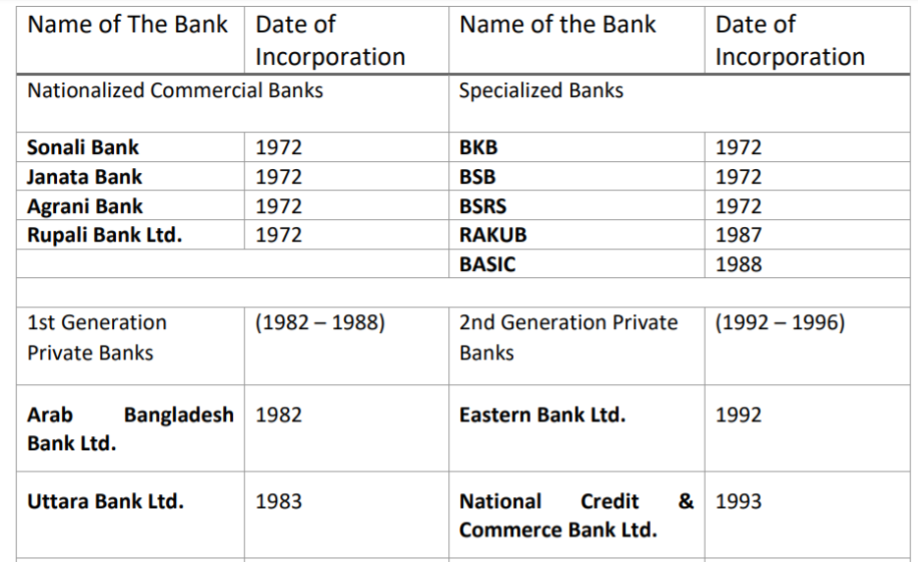
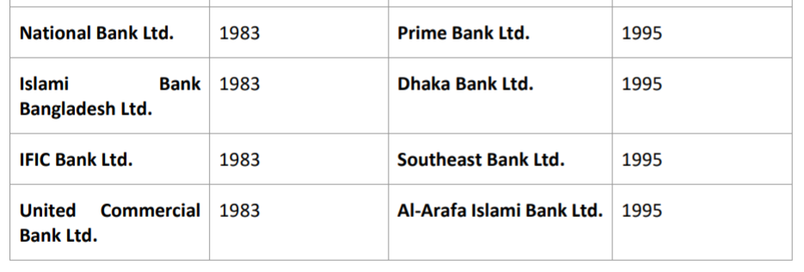

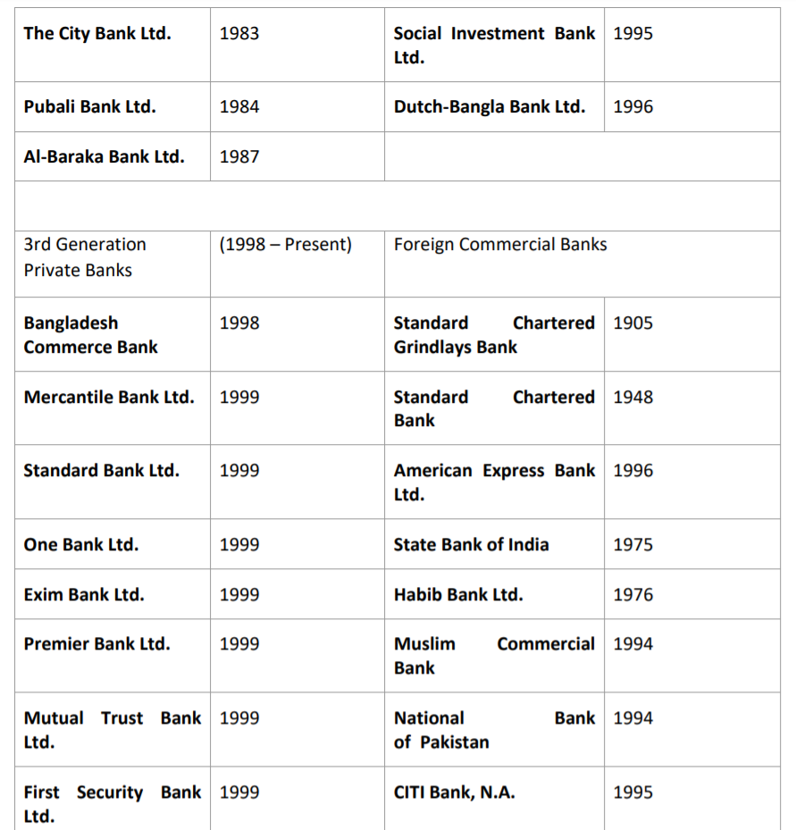

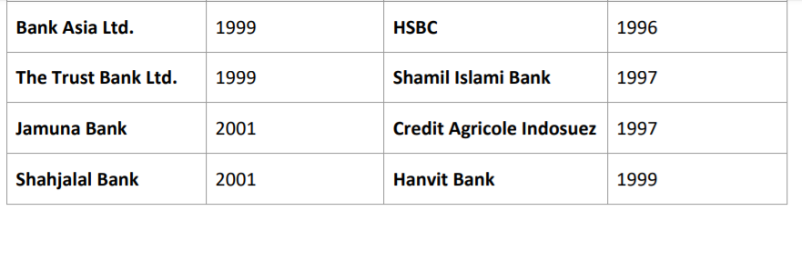

Figure2.1: List of Banks and their Establishment in Bangladesh

2.2 History of MIS in Banking Industry in Bangladesh:

We have already seen that, there are 64 Scheduled and Non-Scheduled banks in Bangladesh. Most of those banks now run their operation digitally. In the era of internet and other modernization all banks work online. They keep their data in their database. Every bank has huge numbers of branches; those branches has huge amount of data. All of those data are handled by their MIS departments. They record those data and creates important reports and all are this with those important data.
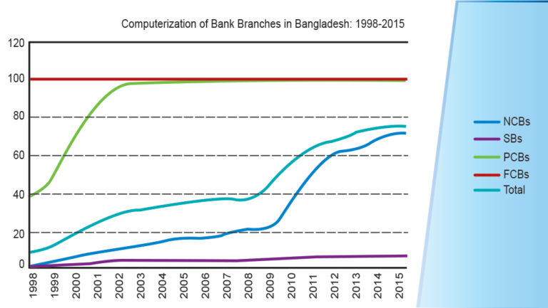
In the early days the, Bangladesh wasn’t very developed. In the rural areas internet were not available. Also the operators in bank, didn’t know how to operate computers. So, it was very difficult and time consuming for the banks. The customers had to wait a long time to transfer their money and other important documents. It was also very difficult to send money from one city to another. But when banks started to work with computer the works became easier. After that most of the banks started providing training to their employees in their rural branches about computers. It helped the employees very much. When internet got available in most of the rural areas; the whole scenario changed. All of the operation began to get easier. Because with just some clicks they could transfer money from one branch to another and could exchange information very easily and swiftly.
Figure 2.2.1: Computerization of Bank Branches

When this big change took place; importance of experienced people begun to arise for handling those special software and equipment. So, huge amount money was invested in the IT sectors of the banks. This helped to speed up the digitalization of the banks. lot of new software were introduced to the employees to facilitate their works.
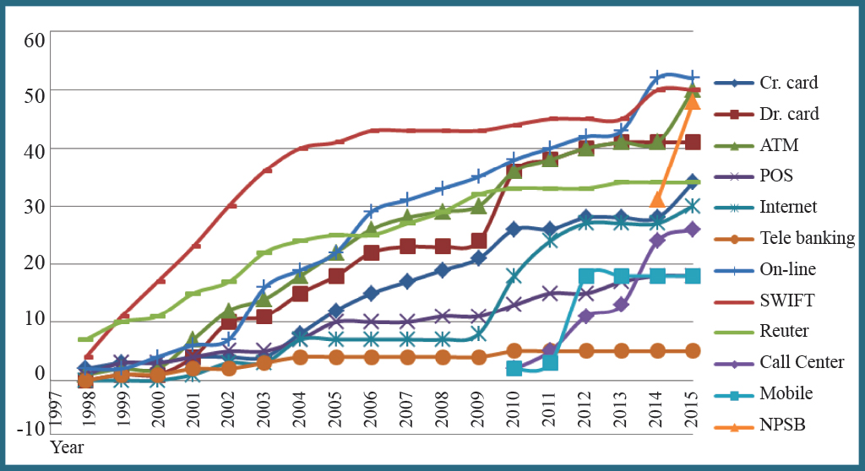
Figure2.2.2: Trends in Technology Adoption, 1998-2015 (Source: BIBM)

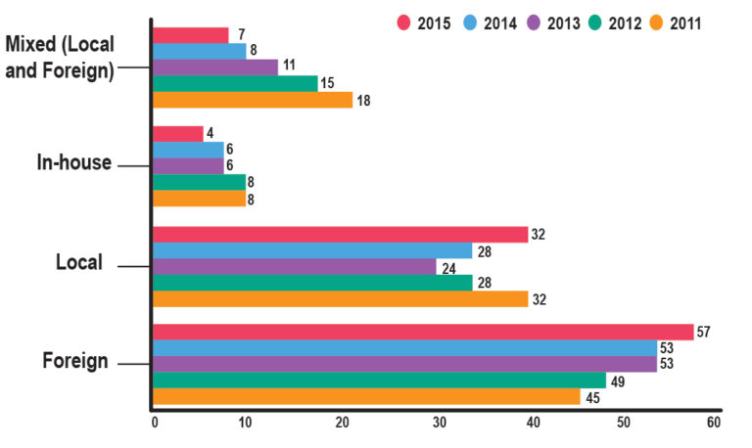
To operate those software banks stared to look for people. In that particular time, IT and Management based students operated those departments for the particular banks. But after more development the works got differentiated. MIS department emerged in the banks. People knew that it is very important for the banks to have this department for handling huge amount of data because the number of huge customers. So, most of the well-known and developed banks created their MIS department. The employees of MIS department have to work with the data of the whole bank. They collect all data of the branches, process those data, makes reports with those data and also keeps record of those data with the help of banks personal software.

Figure 2.2.3: Classification of Banking Software (% of Banks)

With the help of MIS department in the banks, all data of the customers and employees are in safe hands. Because with their expertise; the required data can be fetched with just some clicks. Record of any branch or any customer can be presented at any time. That helps the bank a lot to operate their activities. Any customer can get his data from any branches at any time. This has made life of the customer and employees very easy. The weekly, monthly, quarterly and yearly data helps the bank to know the reliability of the data. It helps the banks to get competitive advantage over others. Banks like Eastern Bank LTD., The City Bank LTD., Brac Bank, Janata Bank, Krishi Bank has very powerful MIS department. It helps them to improve customer service, reducing operating cost and create new products and services.

2.3 Size, Trend and Maturity of the Industry:

2.3.1 Size:
Size of an industry can be calculated in many ways. The banking industry has become developed and bigger very much in this days. Over 3000 branches of banks were established in last 10 years. And with the growth of the banks; growth of MIS departments has also increased in a rapid way. Now in most of the rural areas banks are facilated with computers and internet. They provide all information of the transactions with their own banking software. So, we can say that size of the industry is in the growth stage.
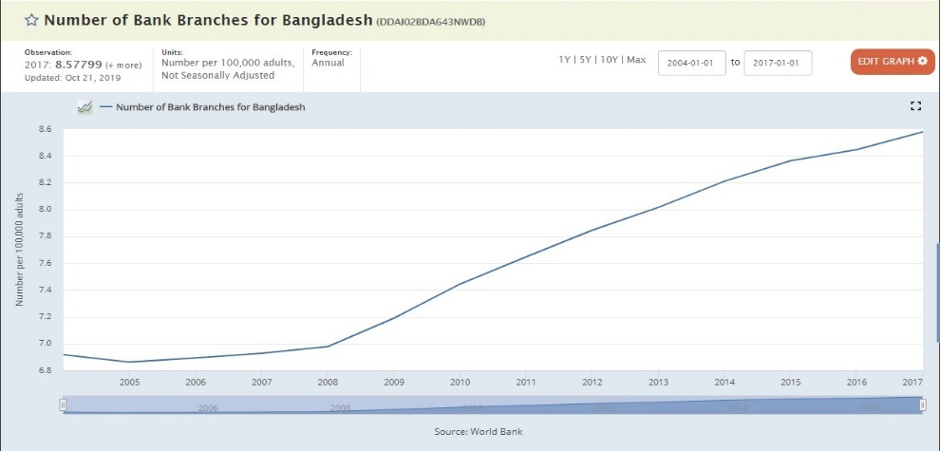

Figure 2.3.1: Number of Bank Branches per 100,000 adults
2.3.2 Trends:
Day by day banking sector is developing and adapting new technologies. In previous years’ banks ran in the analog system. But almost every bank run their operation in digital ways. Paper based work is still present but those work are also done with the help of computerized system. MIS department helps a lot in the data related works of the banks. Most of the banks now have their own software to run their operation. Some of banks also buy software from outside companies to run their operation smoothly.
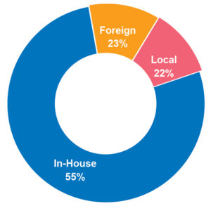
Figure 2.3.2: Technology adoption rete.

2.3.3 Maturity:
In Bangladesh, banking industry is still in the growing stage. Day by day it is getting more and more developed. They are always ready for adopting new technologies. The analog to digital transformation in the banking industry is visible to everyone. But everyone knows that, there is still huge space for development in the banking sector and the MIS departments. if every bank starts practicing MIS properly the banking industry will get more developed.

2.4 Factors of Banking Industry

There are 3 economic factors of banking industry, describing bellow:
- External Economic Factors:
Banking industry and The economy are related with each other. MIS is a department of the banks. So, if a country is facing any kind of economic crisis, it effects its banks. so all the departments also get effected. MIS department is mainly technology based. So it needs economical support. When a country faces any economic problem; banks are not ready for any more investment for new technological support. Then the growth of the banks development gets effected. So, we can say that external economic factors affect the banks a lot.
- Technological Factors:
Scientific researchers are working day and night for the development of the technologies. As the population of the world is rising, people are more and more becoming depend on technology. They need their works to done very fast, because they have become very busy. So, technology has become the helping hand for everyone. Now people needs online support in almost every aspects of life. This technological factor has also affected the banking system in a very positive way. Now people don’t have to wait long time in the line for transaction, they can pay their bills online, they can transfer money online and even with their mobile phone. Banks can keep record of their customers in their computers and servers. The introduction of MIS department was because of this technological development. This technological development is supporting their work every day and turning the hard works into easy work. The further development of technology will help the growth of the MIS in the banking sector a lot.
- Political & Legal Factors:
- Political Factors:
Political factors play an important role in the banking industry. Government has a huge influence in the banking system. As the government can intervene in the banking laws anytime; so there are huge chances of corruption. Laws like labor laws, trade restrictions, tariffs, quotas help the people to misuse of the banking system. Political influence sometimes creates huge problem in the banking sector. Many banks in the Bangladesh are doing corruption because of this political influences.
- Legal Factors:
All of the countries in the world has their own laws and regulations. Every banks in their particular countries are bound to obey those laws. They have to follow proper laws regarding privacy, consumer laws and also trade formation to confirm same structure within the industry. MIS department of the banks also have to follow those rules and regulations about sharing the customer’s data and information. They are always conscious about the laws regarding the customer’s privacy.

2.5 Barriers to Entry:

Bangladesh bank is the central bank of Bangladesh. It controls the entry and exit rules of the banks operating in the country. There are some barriers to enter in the banking industry such as; licensure laws, capital requirements, access to financing, security concerns etc.
There are also some other barriers like, gaining the trust of the customers, having the required sum of money to start a bank, maintaining proper support for the customers etc. By maintaining all these things, a bank can survive in the industry.
- Supplier Power:
The Primary resource for any bank is “Capital”. Every bank needs a huge amount of money to run their day to day operations. They collect this capital from sources or suppliers. They are:
- Customer deposit,
- Mortgages and Loans,
- Mortgage-backed securities,
- Loans from other Financial institution.

After collecting these resources banks perform their operations. By using this capital properly banks maintain a proper and healthy environment in the banking system. By gaining profit from this resource banks maintain all their costs.
- Buyer Power:
The main buyers of banks are Creditors. People keep many things in mind while opening a bank account or the time of switching an account from one bank to another. The switching costs are also very high.
But with the help of internet banking has become very easy for the customers. This has lowered the switching costs of the customers. Internet has facilitated the time and cost of transferring money from one place to another. But big amount of creditors has still got power to make effect in the industry. Sometimes they can determine the interest rate of the industry.
- Threat of Substitute:
Banking is essential for people. Without keeping money in the bank it very hard to keep hard cash in their own houses or other places. Also it is not possible for any company to run their business without having any bank account.
There is no other option without banks any people. So, there are no such threat of substitute in this industry. The banks are substitute for each other.
- Industry Rivalry:
As we already know that individual banks are only threat to each other. So we can say that there is presence of extreme competitiveness in this industry. Every banks try to give extra benefit than other to stay ahead in the competition. They also try to improve customer support, number of branches, fast services, and also try to improve the power of the departments of the bank. With this they try to keep their customer satisfied and tries to make them loyal customers.

CHAPTER 3:

ORGANIZATIONAL ANALYSIS

3.1 Overview & History of JBL:

Janata Bank is one of the largest and oldest bank in Bangladesh. In 1972, this bank was established under the presidency order of Bangladesh Bank. United Bank and Union Bank are the two banks which were operating separately; were merged and started operating Janata Bank. After the independence of Bangladesh, Janata Bank started mass banking activities in all over the country. Janata Bank operated as a nationalized commercial bank in Bangladesh. But on 2nd April 2001, it became a Private Commercial Bank under the act of 1994. It got authorized with the capital of 16 hundred million dollars which has been divided into five million general shares of 100 shares on 3rd June though the initial capital of 390 million takas were authorized which was paid by stakeholders.
The main operation of any bank in the world is dealing with money. There are many kinds of banks in the world. The types of banks are, Central Bank, Commercial bank, Industrial Bank, Specialized Bank etc.
From above mention we already know that, Janata Bank is a commercial bank. It’s head office is located in Motijheel Commercial Area Dhaka. Janata bank plays a huge role in the collection of overseas remittance and foreign exchange business. Citi bank, Finance wholesale, Retail Banking awarded Janata Bank for their excellent performance.

3.1.1: Mission of Janata Bank:
Janata Bank Limited will be an effective commercial bank by maintaining a stable growth strategy, delivering high quality financial products, providing excellent customer service through an experienced management team and ensuring good corporate governance in every step of banking network.
3.1.2: Vision of Janata Bank:
To become the effective largest commercial bank in Bangladesh to support socio-economic development of the country and to be a leading bank in South Asia.
3.1.3: Product and Services of Janata Bank Limited:
Janata Bank is a Financial Institution. For any institution their main asset is their product and services. JBL offers specialized banking facilities for their customers around the country. The following banking activities are offered by JBL:
- Scheme of Special Deposit
- Credit Scheme of consumer
- Scheme of Saving Insurance
- Scheme of Saving Monthly
- WUM (Western Union Money) Transfer
- Provides Credit card & Debit card
- JBL Power Card
- ATM Service of JBL

3.1.4: Branch List of Janata Bank:
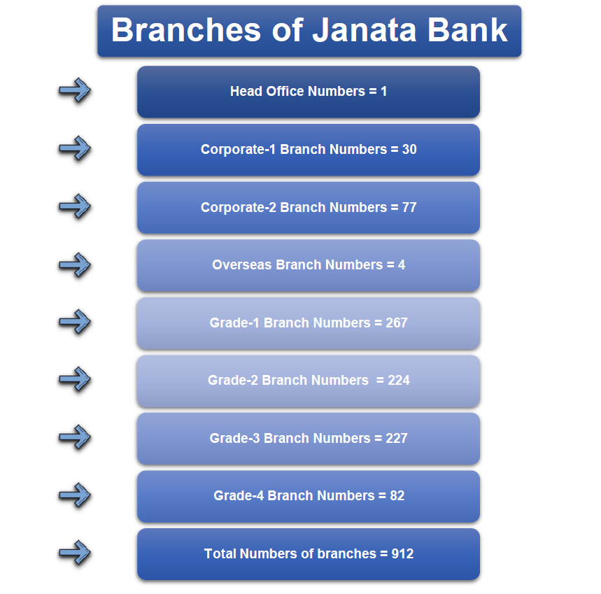
Janata Bank is one of the Largest and Oldest Bank in Bangladesh. They have 912 branches. The list of the branches is given below:
Figure 3.1.4: Branch List of Janata Bank

3.1.5: Corporate Information of JBL:
The corporate information of JBL is shown in the below table:
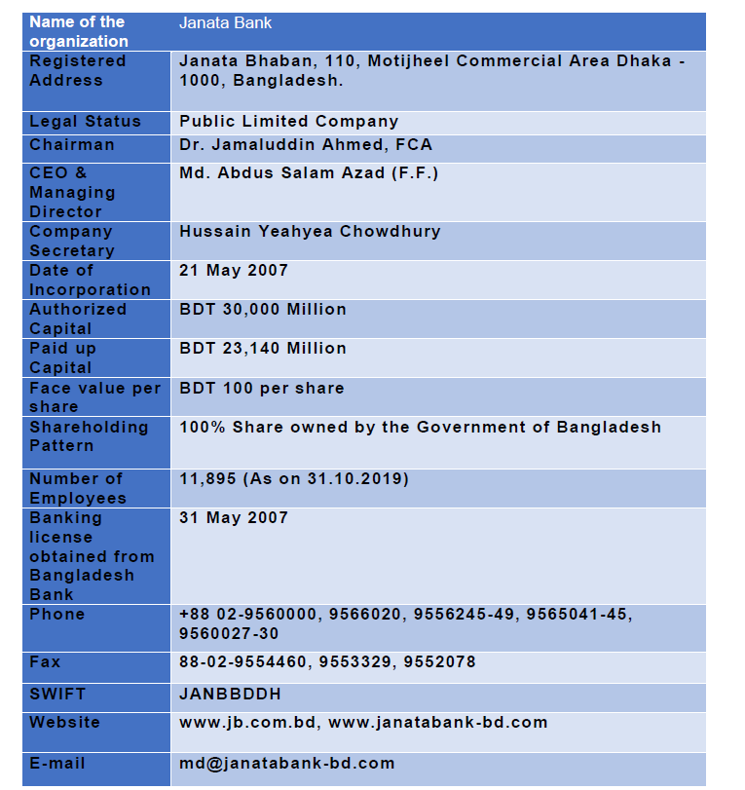
Figure 3.1.5: The Corporate information of JBL

3.1.6 Functional Hierarchy of Janata Bank:
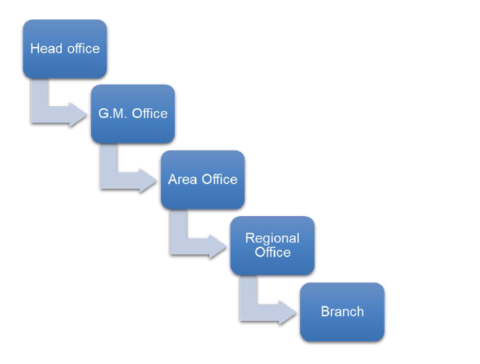
Figure 3.1.6: Functional Hierarchy of Janata Bank

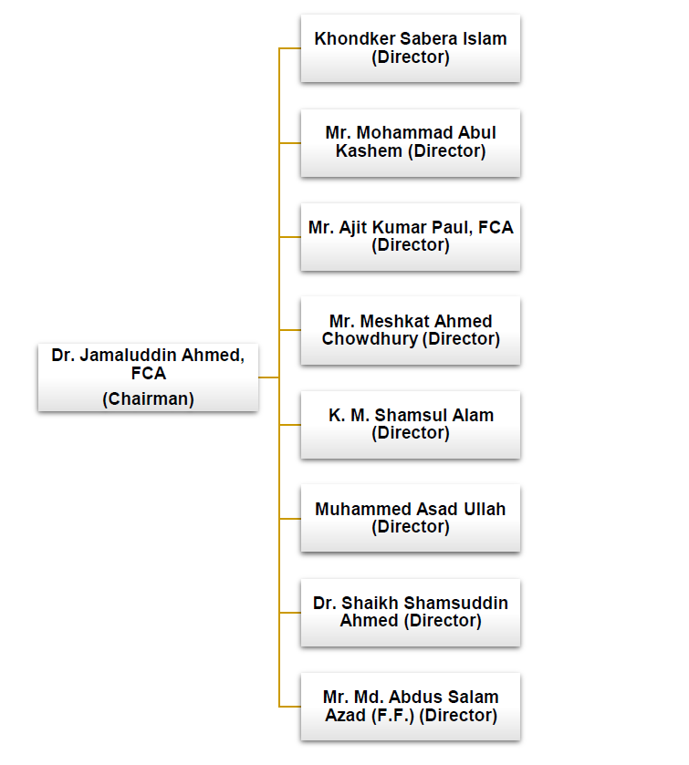
3.1.7: Board of Directors:
Figure 3.1.7: Hierarchy of Directors

3.2: Automation of MIS department in Janata Bank:

Bank is a financial institution. Activities like granting deposits and creating links for lending are their main task. In Bangladesh banking sector is in the growth period. Comparing to other similar countries with the same level of development and per capita financial gain; Bangladesh has a larger economy. For a country with a per capita financial gain of solely concerning US$370 is commensurately massive because The total size of the sector at 26.54% of gross domestic product dominates the national economy. For a country with a per capita financial gain of solely concerning US$370 is commensurately huge because The total size of the sector at 26.54% of gross domestic product dominates the national economy. In order to the banking sector, the non-bank monetary sector, as well as capital market organizations is far smaller because those are only 3,22% of GDP (according to Sayeed et al.2002). Banking sectors playing the key role by contributing in the GDP of other sectors and also service sector contributes about 50% of total GDP.
Every institution has different departments. All departments perform their own specific works. By combining all works of all department an organization runs smoothly. Janata bank also has many departments, which helps the organization to run their operation smoothly. MIS department is one of those department that help to combine information of the whole banking system. Because they handle all the data of the bank. MIS plays a vital role in the modern banking system. Banking system in the whole world has went through a developmental period, because of the improvement of the technological sector. Now a day’s banks perform all of their work online. Banks have their own servers, own software and many other new machines to work smoothly. To facilitate the customer service MIS keeps record of all data, they process those data, and also creates report from those data. Janata bank is also working hard to make their MIS department full automated. They have already been practicing their automated software “OMIS” but now they are planning to move to a more improved software named “T24” which is more powerful.

3.3: PMIS (Personal Management Information System):

One important task of MIS department is handling the employee records. They do this important task with the help of PMIS software. With the help of PMIS software, the MIS department keeps the record of the employee’s information such as, training, posting, personal record, promotion date, retirement date etc. Every employee has their own ID and password to login to their own account. So that they find their own information and they also can find some information about other employees. PMIS boost up the authenticity, reliability and efficiency of the information. Whenever any employee gets appointed in the bank all of his information gets recorded in the software. So PMIS contains a huge amount of employee record for the Janata Bank which facilitates the work of Human Resource Department of JBL.
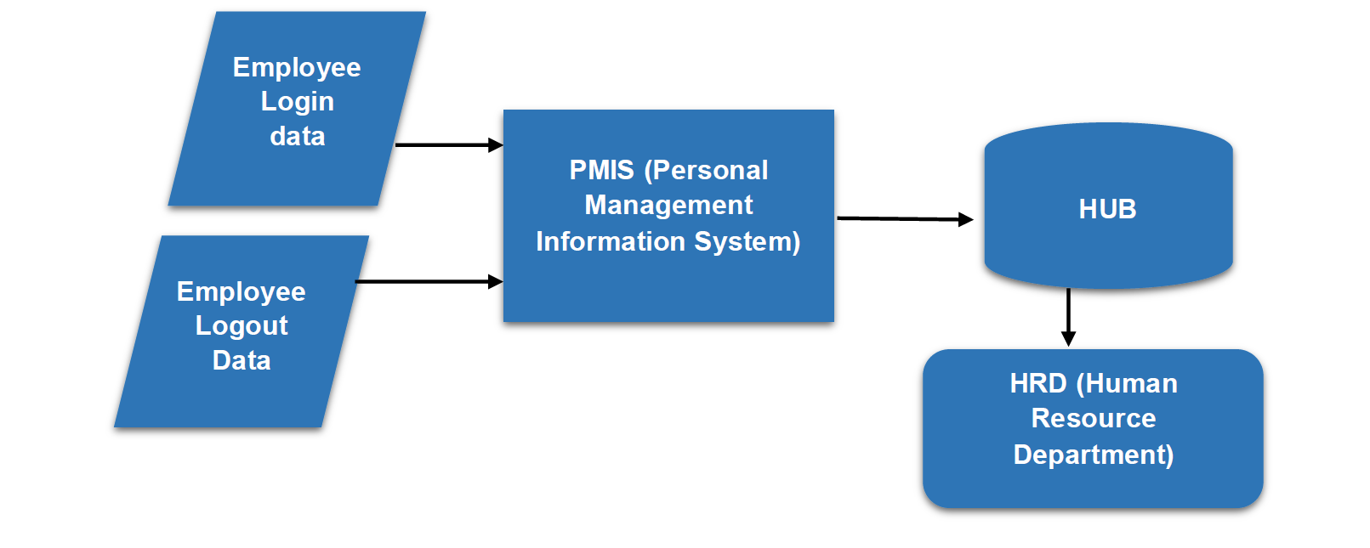
Figure 3.3: PMIS faction in HRD of JBL

3.4: OMIS (Operations and Management Information System):

The OMIS software is the principal software for MIS department of JBL. With the help of this software they perform most of their operations. MIS department handle all data of the bank. Janata bank has 912 branches. So it is a huge task to handle all the data of those branches. Mainly when JBL started using this OMIS software the automation process of the MIS department started. because with the help of this software they can find all sorts of data of the system. Every branch has this software installed in their system. They input all of their data in daily, weekly, monthly, quarterly and yearly basis. MIS department in the head office collect all of those data from the server. Then MISD creates all the required reports from those data. All those reports are sent to the Ministry of Finance and Bangladesh Bank. The process is shown below:
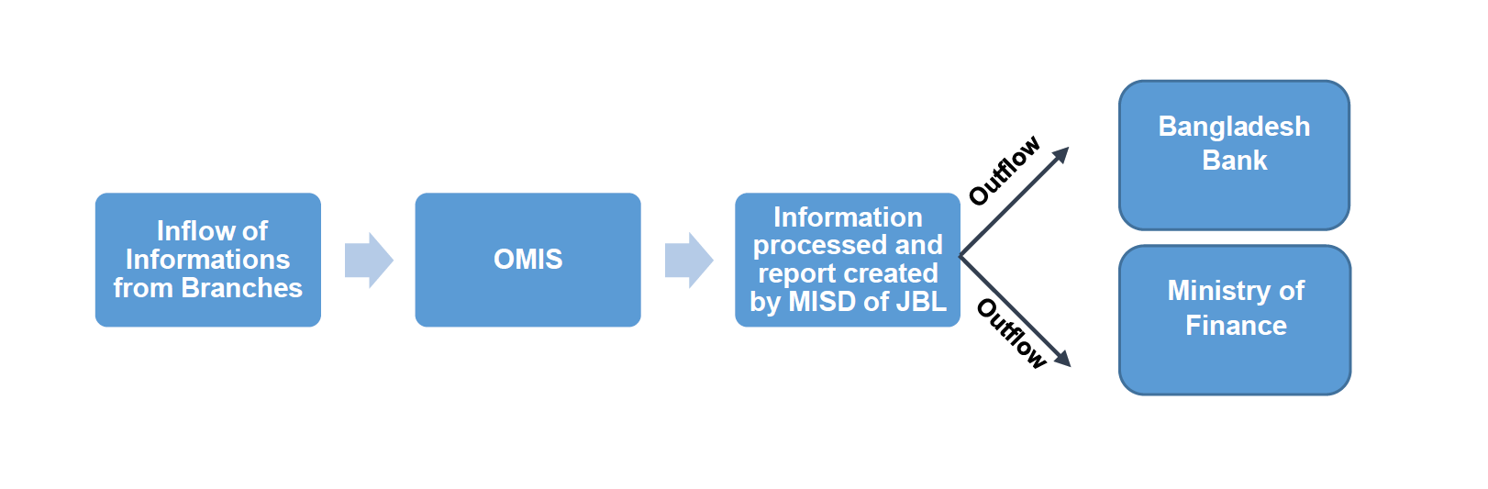
Figure 3.4: Inflow & Outflow of information

From the picture above we can easily understand the process of data input, process and output flow of data of the bank. Janata bank helps other financial institution and other surveying companies by sharing some of their data. They sometimes send their data to BIBM and other ministries also.

3.5: Data input and Report Creation by Branches and MISD:

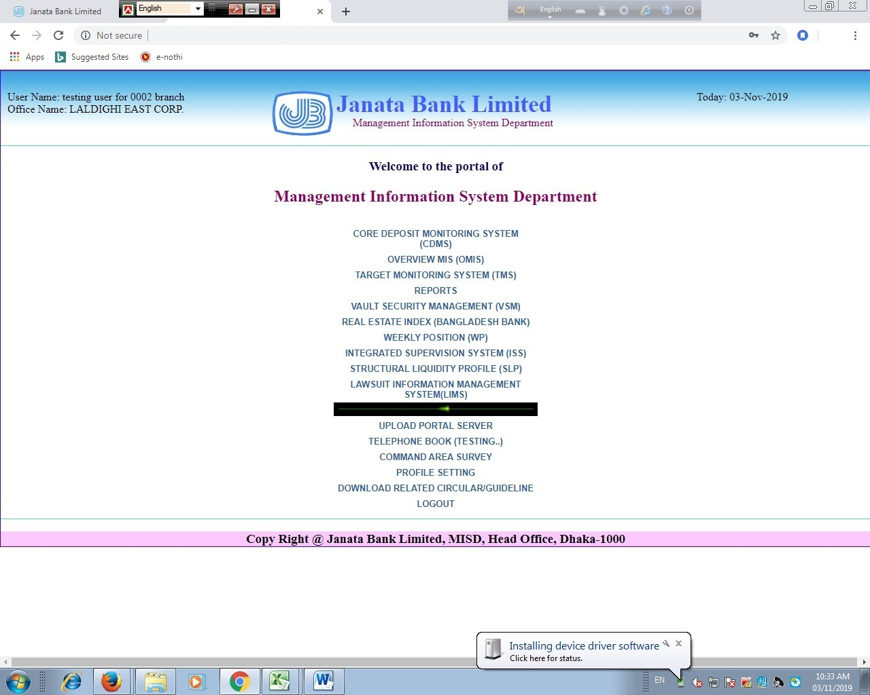
There is a process in which all branches of Janata Bank Limited provides data to the MISD. From earlier discussion we already know that, branches update their data on a daily, weekly, monthly, quarterly and yearly basis. Then MISD process all those data. Every branch has OMIS installed in their system.
Figure 3.5: Home page of MISD portal

This is the home page of OMIS. Branches selects the form from this home page and fill up those form with their branch information.

3.5.1: Data Entry Method:
All of the sections has different data entry forms. Branches selects from those forms and enters the required data. Some examples are given below:
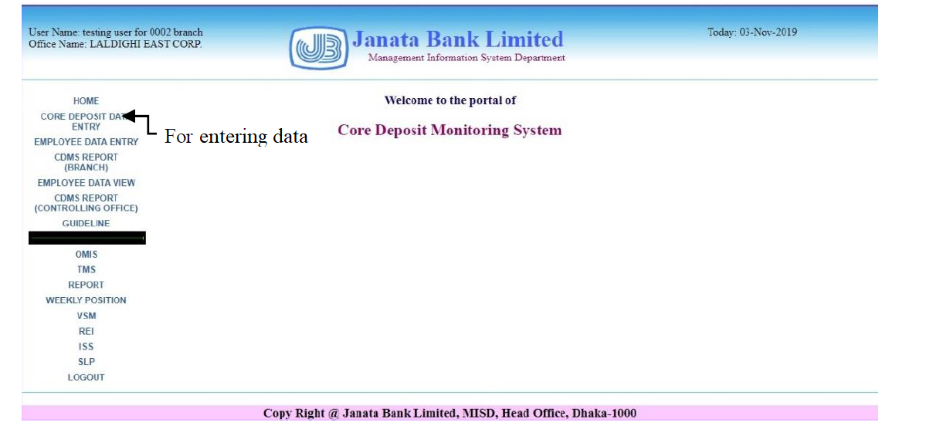Figure 3.5.1: CDMIS home page
In this method braches enters their CDMIS data. From this data, MIS department can know “Core Deposit” ratio of that particular branch.
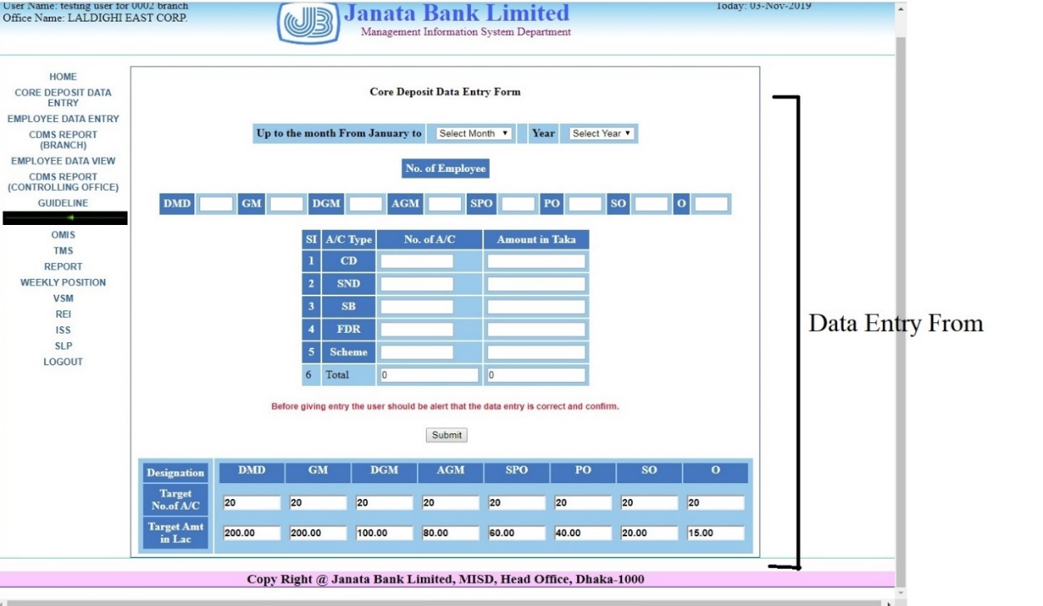
Figure 3.5.2 Data Entry page

Braches fill up all blank spaces in the form. And MISD creates report from those data.

3.6: Report Creation by MISD:

After getting all the information in the server, MISD heads toward making the report for the Bangladesh bank or Ministry of Finance. They can make report on a particular branch and also they can make report selected branches and also on all braches together. An example is shown below:
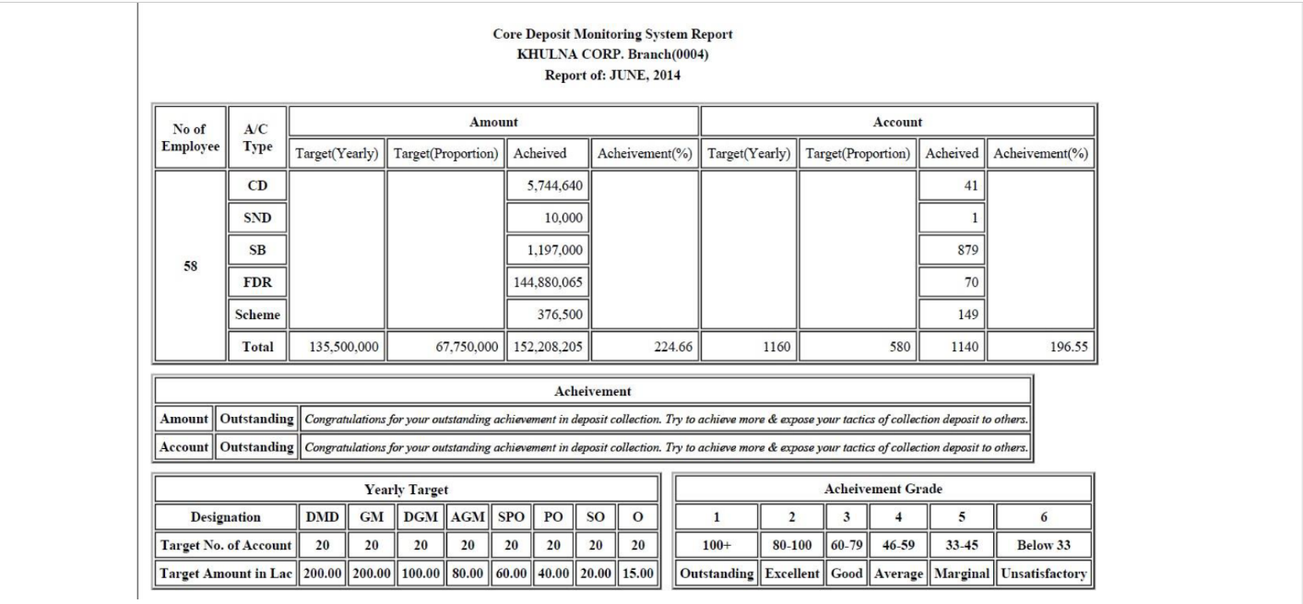
Figure 3.6: CDMS Report

MISD creates various kinds of reports in the same process and submits those in the required organizations.

3.7: SOWT analysis:

SWOT analysis is a technique to evaluate the 4 aspects – Strength. Weakness, Opportunity and Threat. SWOT analysis helps an organization to know about its internal and external factors. This factors helps the organization to run its operation in a profitable way. SWOT analysis provides the way of handling worst situation of the organization, what will help the organization to gain advantage from rivals, which things should be eliminated from the organization, and what should be included in the organization from the better performance. SWOT analysis of JBL is shown below:
Strength  - JBL has highly qualified employees  - It has a huge amount of asset.  - It has huge number of loyal customer.  - Their database and server is very strong.  - Their regulatory system is also very strong. | Weakness  - Their customer service should be more strong  - They should increase their manpower.  - Their employees should be more motivated.  - Their remuneration structure should be more strong.
Opportunity  - There are still areas of investment.  - JBL has opportunity to make its self more technologically advance.  - JBL has opportunity opening more branches abroad.  - It has the opportunity to get the assistance of government in any crisis | Threat  - Weaker flexibility in adopting the changes.  - All policies of JBL are not executing properly.  - Increasing competition in the banking sector becoming a great threat for JBL.  - Now a day newly established & well equip private and foreign banks are accelerating faster. So they are also a threat.
Figure 3.7: SWOT Matrix

CAHPTER 4:

INTERNSHIP EXPERIANCE

4.1 Position, duties and responsibilities:

4.1.1 Position:
I worked as an intern employee in the MIS department of Janata Bank. MIS department performs data collection, data analysis and data processing work of the bank. They collect data from different branches; then process the data and sends it to the necessary destination. They also maintain the reliability and efficiency of the data. So, to learn how they perform their tasks in the department; I always tried to be present and observe their work. My instructor and all other employees helped me a lot throughout the internship period. But I also faced some constraints while working in there; because access of all data was not given to me. But I gained a lot of experience while doing internee in there. The works that I've learned in the organization are:
- How collect weekly report of different branches through OMIS software.
- How to collect Monthly report of the branches.
- How to make reports for the Bangladesh Bank.
- How to input data while creating the forms for the Ministry.

4.1.2 Duties and Responsibilities:
The works that I’ve performed in the MIS department while Internship period are written below:
- Learning how to operate the OMIS software.
- Fetching different types of data of different branches.
- Form fill up with the data of the branches.
- Collecting Weekly data and creating report.
- Collecting monthly data and creating report.
- Creating report for Bangladesh Bank.
- Creating report for Ministry.
- Writing forms and uploading them on the website.

4.1.3 Experienced gained from some of the system:
OMIS software helps Janata bank to perform its data related works. By using this system, all of the works gets smoother and faster. This software also helps decision making easy and reliable.
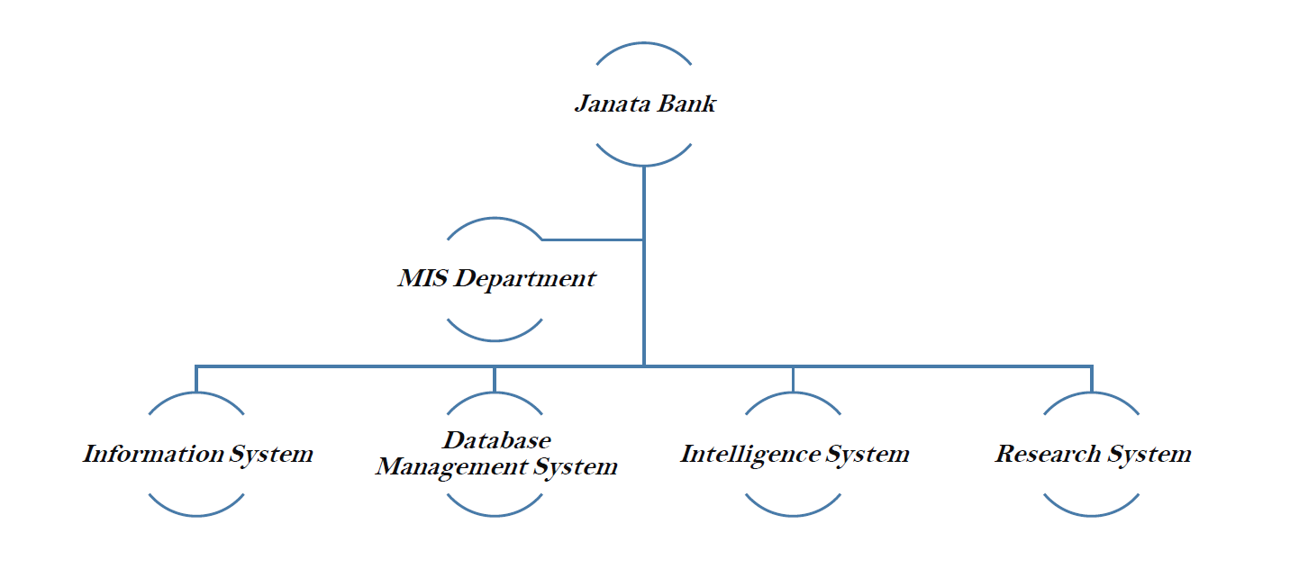
Figure 4.1.3: Systems execute by MIS department

4.2 Training:

Janata Bank arranged some training session for the interns of the MIS department. Attending those training session were compulsory for all the interns. In those training session they tried to give us practical example of how they work. They gave a brief about their office decorum. Then they introduced us with OMIS software. All of the Data of the bank is handled by this OMIS software. They showed us how easily this software can collect, analyze, and process data of the bank. This introductory training session helped us a lot. After this training; my instructor also gave me some personal training so that I can use OMIS software more efficiently. Then my instructor also showed me; how to fill up form of Bangladesh Bank and Ministry; how to upload information in the Website of the bank etc. Some photos of the training are shown below:
- Introduction to OMIS.
Figure 4.2: Home page of OMIS software

- Process of Creating CDMS forms in OMIS.
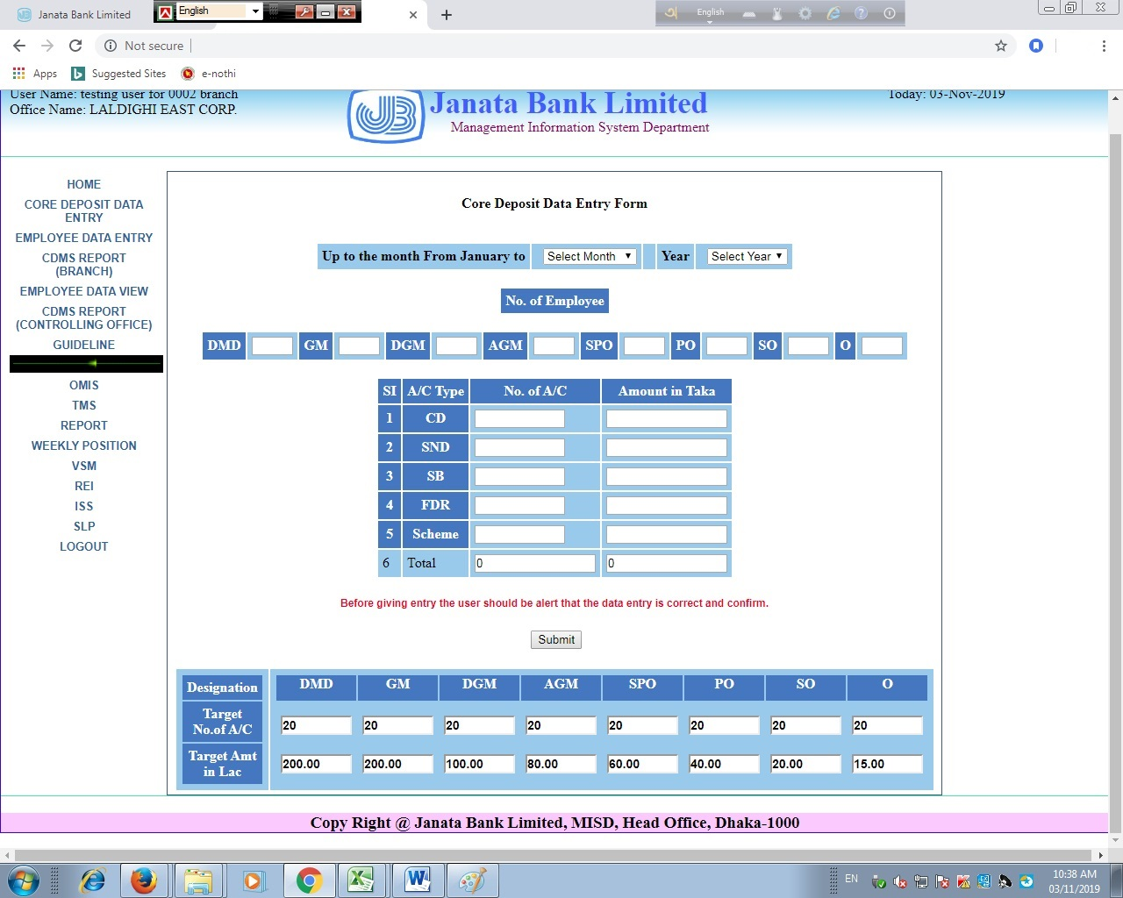
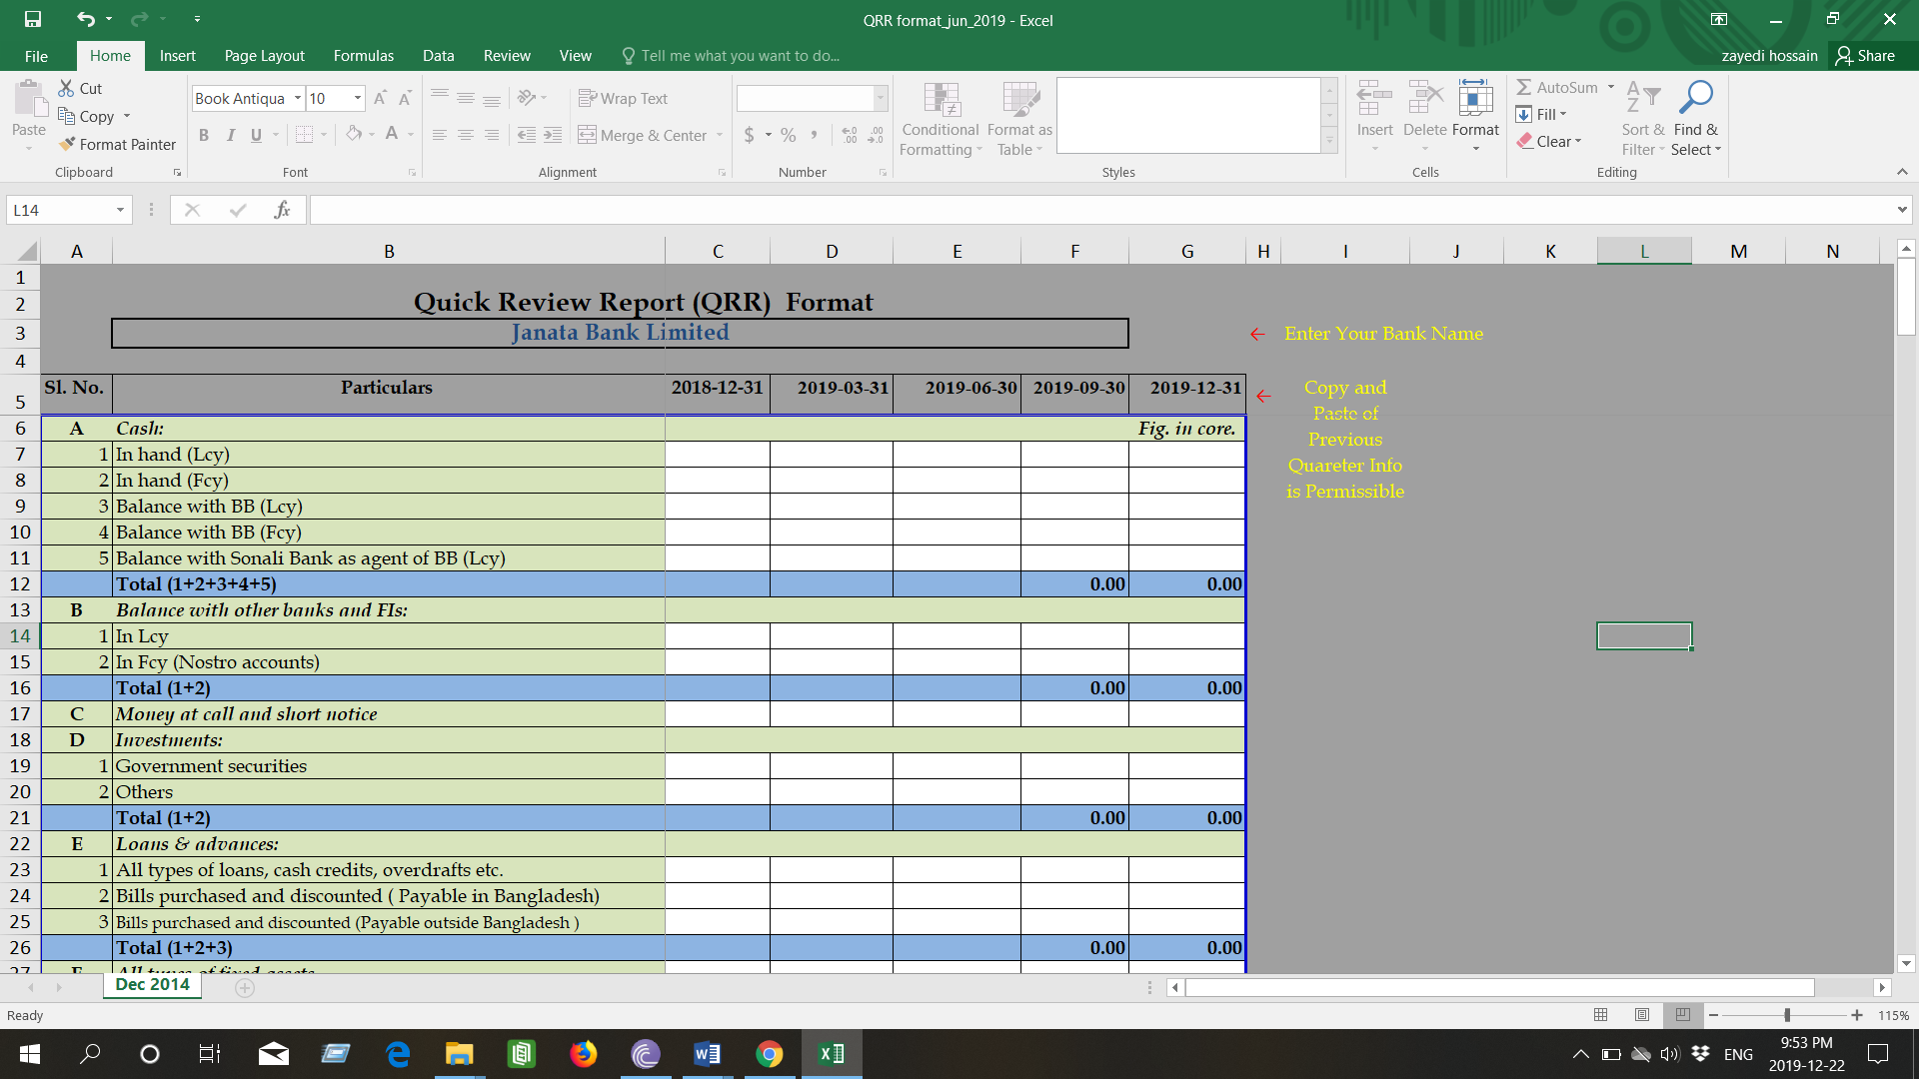
- Creating QRR form:
Figure 4.2.1(a): QRR Form
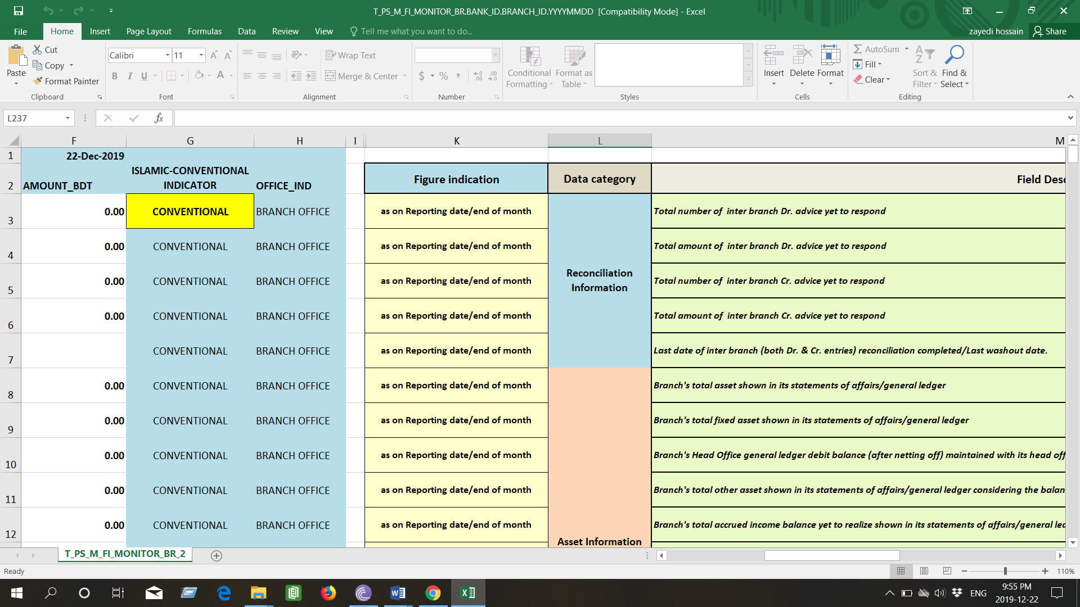
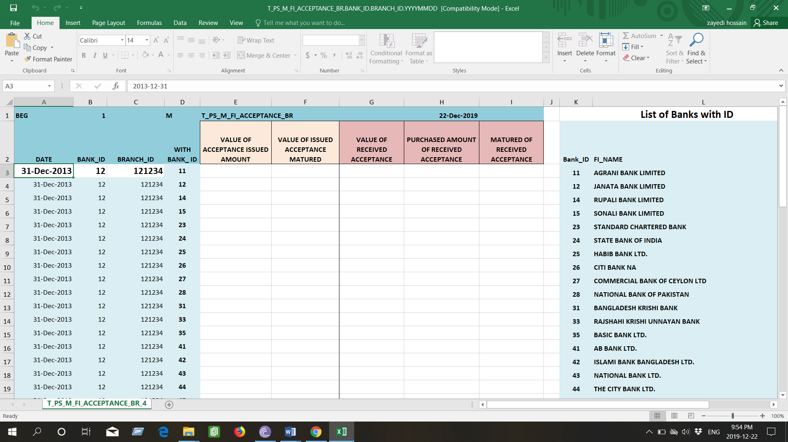
- Creating other requested forms:
Figure 4.2.1(b): Form

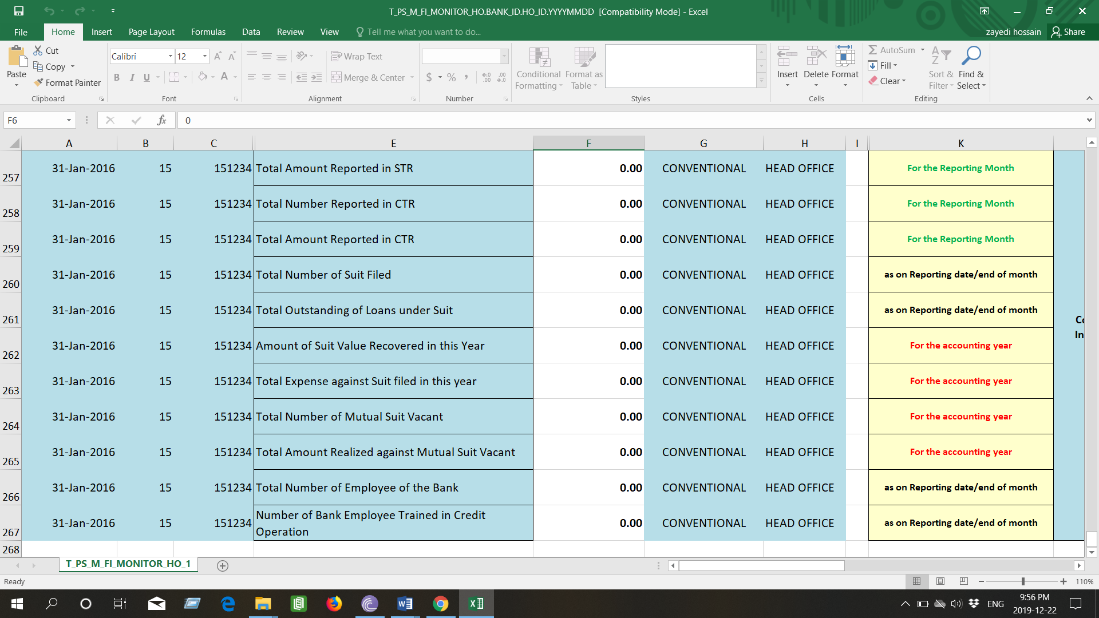
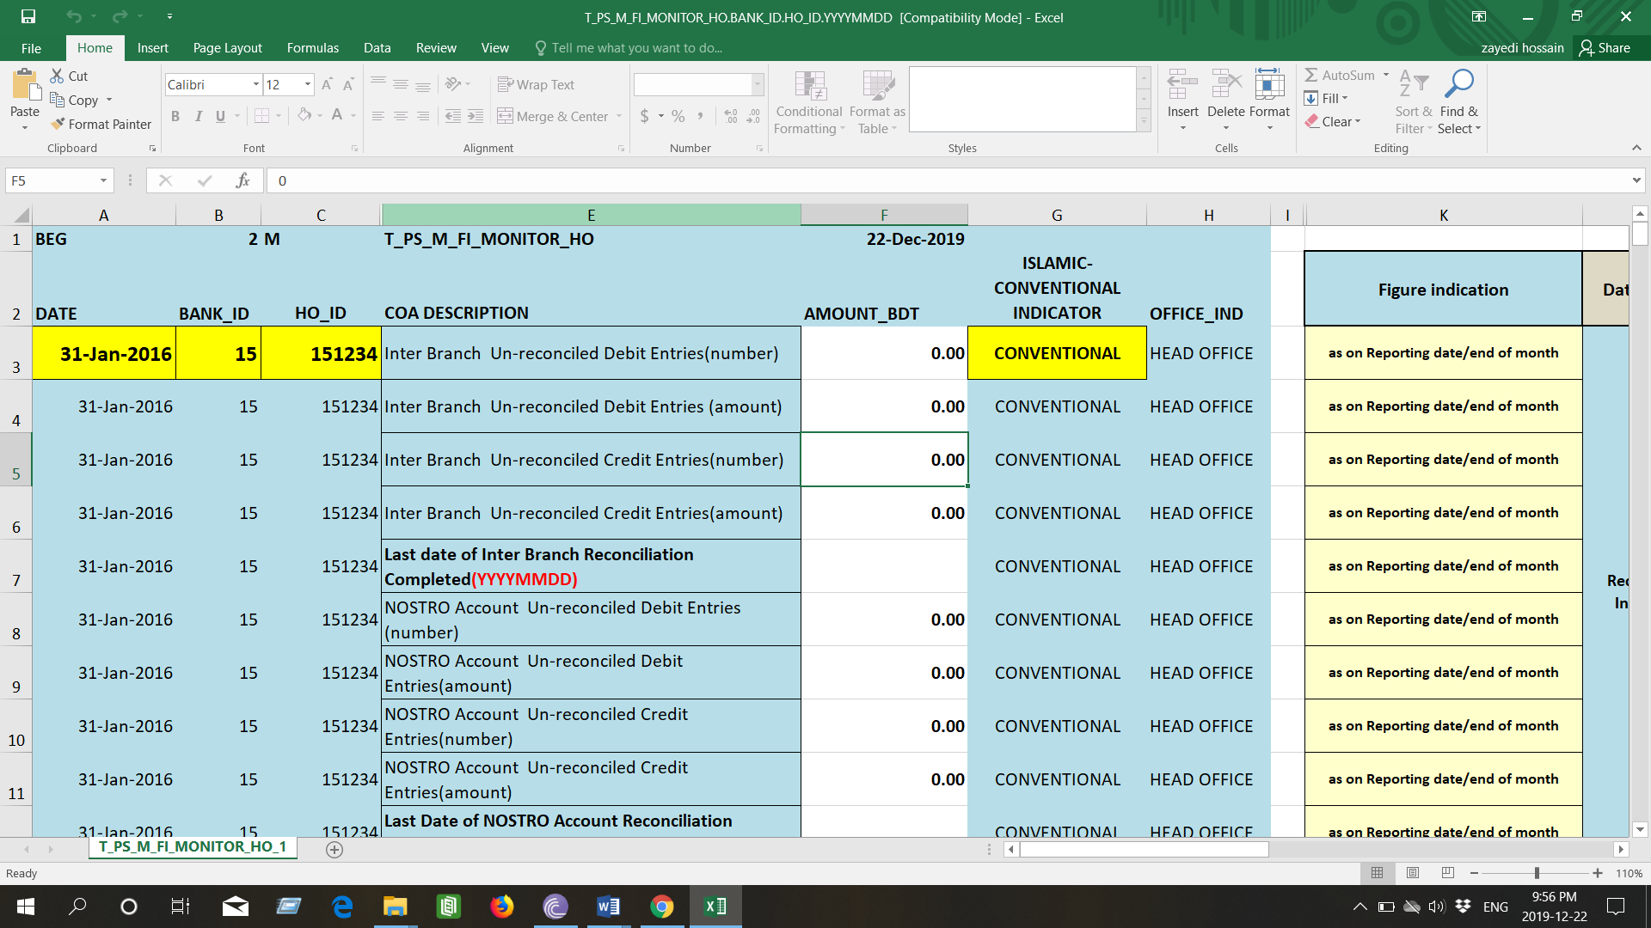

4.3 Contribution and Departmental Function:

As an intern I also putted some contribution in the MIS department of Janata Bank. Those contributions are written below:
- Data input:
MIS department is all about handling data from several sources. Inputting data for the creation of many reports and forms was one of my contribution for the department. I tried my level best to properly input data and make reports from them.
- Paper Based Work:
Most of the works are done in the server, OMIS, Excel and Word in the MIS department. But there are also some paper based works also.
- Web Management:
Uploading notices and some information in the Janata Bank website was also a part of my work.
- Provide Assistance:
As an internee I always tried to be present there and help them whenever they needed me. I helped them while making the full report of the branches. I helped them to fill up forms of Bangladesh Bank and also Ministry.

4.4 Evaluation:

To evaluate my performance during the internship period I had to ask myself some questions. And with the answer of those questions I am able to evaluate my performance.
- Am I good in time management?
- How capable am I in completing my given tasks?
- Can I communicate properly with others?
- How good I’m in taking responsibilities?
- Am I keen in learning new things?
- Am I good enough to make any contribution in the organization?
- Am I good in brain storming?

4.5 Skills applied:

“Schooling doesn't assure employment but skill does.” The skills which I’ve learned in my whole student life; I tried to implement those skills in the organization. The skills are described below:
- Skill of Communication:
In the period of my internship, I tried to implement the communication skills that I have learned in my graduation period. I also tried to learn better skills from my supervisor and other employees of the organization.
- Management of Time:
Time management is always a crucial work in every work field. Without time management people cannot finish their given tasks properly. So it is very important to do proper scheduling. I tried to show my skills of time management in my internship period. I tried to be present in the office at the correct time and also tried to finish all my works within the given time period.
- Skill of technical Proficiency:
A lot of technical skills were taught in our university classes, so that we could implement them in our professional life. I tried to show of those skills in Janata Bank Limited. Those skills helped me a lot in my internship period. I also learned while training was given in the bank.
- Skill of Professionalism:
Any person can make a huge impact on one’s mind with his impression. So, I always tried to be present on the right time in the office. And always tried to remain decent and communicate in a sober way.

4.6 Skills Developed:

During my internship period I developed a lot of skills from Janata Bank Limited. A lot of training were given for different software uses and also to handle many type of tasks. Those skills added some value to my future professional life. Those skills are written below:
- Skills of taking Responsibility:
During my internship period in Janata Bank I had to a lot of tasks. I had to handle a lot of data and also tasks like; making report for the clients and others. Doing those works properly were a great responsibility for me. So, I learned this great skill from them.
- Skills of critical thinking:
Brain is storming is not an easy task to do for anyone. But in the professional life, everybody has to do this task. Employees of the bank faces a lot of critical problem while making the big reports and many other works. In that time brain storming helps them to complete that hard part of the work. I improved this great skills during my internship period.
- Skills of analytical & Problem solving:
In MIS department a lot of analytical works are done. In my internship period I learned a lot of analytical skills from the employees of Janata bank. They taught me how to do the quick thinking in the critical time.
- Ability of Working Under Pressure:
While working in Janata bank I learned a very important skill; and that is working under pressure. There is a lot of time when the employees have to work under enormous pressure because of the time period they are given to complete their given task. I learned this great skill from them practically.
- Ethical activities:
The most important thing that anyone has to learn from their childhood is that how to work ethically. Every company tries to maintain an ethical working environment in their office. This helps their employees work with a peaceful mind. So I also tried to very honestly during my internship period.
- Real life working Knowledge:
Every student learns a lot of skills during their educational life. But those skills are implemented in their professional life. They gather practical knowledge from their office. I learned this practical knowledge from Janata bank limited during my internship period.

4.7 Application of Academic Knowledge:

A lot of academic knowledge which I gathered from my university, were implemented in my work. Most of the work that I learned from my MIS classes helped me a lot during my internship period. The skills are described below:
In office, sometimes I had to use some programming language to make some quarry in database system. I learned those skills from my MIS classes.
- In our university we had a lot of training classes on Microsoft word, Excel, Access etc. That knowledge helped me a lot in the bank, while making reports.
- Learning about SQL was one of the most interesting task in our university life. Those skills created a great impact the work field. Because a lot of works are done in the Bank with the help of SQL.

CHAPTER 5: RECOMANDATION & CONCLUSION

5.1 Recommendation:

- Though the MIS department of JBL is automated but still some work has to be done manually, so they should try to make it fully automated service.
- Day by day the world is getting more technologically advanced, so the number of hackers and intruders are also getting increased. That’s why JBL should also make their servers more secure and updated.
- JBL should invest more for IT and MIS department to facilitate customer services in the rural areas.
- They need to move to T24 software as fast as they can.
- JBL needs to increase their number of ATM booths.
- JBL needs to improve their online banking system.
- They need to train their employees to the new software versions.

5.2 Conclusion:

Banks play a great role for the development of a country. All the organizations of the countries also help the growth of the countries economy. The public and private companies are contributing in the same pace that’s why their competition is also increasing. Janata Bank Limited is one of the largest and oldest bank in Bangladesh. It has helped the growth of the economic system in many ways. As it is one of the pioneer banks of Bangladesh that’s why JBL is also role model for many banks in the country. It was a great experience to do internship in JBL. In the report I tried to express my experiences as much as I could. I mainly tried to cover the activities of MIS department of JBL and how it became automated. A full discussion of OMIS software has also been shown in this report. After that I tried to cover the strength and weakness of JBL. Then from my practical experience I tried to provide some recommendation for the betterment of JBL. The employees of JBL are working hard and soul for the improvement the bank. At the very end I would like to write it’s a great honor for me as I got the chance to be a part of MISD in JBL, I have learned a lot from that department and I will try my above best to imply that knowledge in my future work area.

Reference:

Rahaman, M. M. (August, 2015). Management Information Systems in Practice: An Exploratory Study On Banking. University of Dhaka, MIS. Dhaka: University of Dhaka. Retrieved from http://repository.library.du.ac.bd:8080/xmlui/bitstream/handle/123456789/1373/MIzanur%20Rahman.pdf?sequence=1&isAllowed=y
Villalobos, V.S., Blanco, G. & Bassett, L. (2010). Management Information Systems for Conditional Cash Transfers and Social Protection Systems in Latin America: A Tool for Improved Programme Management and Evidence based Decision-Making. Social Protection Unit, World Bank. http://siteresources.worldbank.org/SAFETYNETSANDTRANSFERS/Resources/mis_ctt_english_full_rep ort.pdf
Saha, A. (October 9, 2018). Analysis of Banking Industry & Janata Bank Limited. United International University, Finance. Dhaka: United International University.
Noor, F. H. (Jun 23, 2017). Allied Bank Management Information System. University of Central Punjab, MIS. Panjab: Business Student at University of Central Punjab. Retrieved from https://www.slideshare.net/FaHadHassanNooR/allied-bank-management-information-system-allied-bank-mis

- Website Reference:
Janata Bank Limited: https://www.jb.com.bd/

