The project report on
The concept of Green Human resource management (GHRM) for Bangladeshi Banking Sector
Supervised to
Nasrin Akter
Assistant Professor
School of Business and Economics
United International University
Dhaka, Bangladesh

Prepared by
Farzana Akter Mithila
ID: 111 121 086
School of Business and Economics
United International University

Submission Date
20th December 2018
Letter of transmittal
To,
Nasrin Akter
Assistant Professor,
School of Business and Economics
United International University
Subject: Submission of the Project Report.
Dear Madam,
You will be glad to know that to know that I have recently finished my project report which is one of a pre-requirement to complete my BBA degree. My topic was on ‘Green Human resource management in banking organization’. In my report, I have shared the use of green human resource management policies to promote the sustainable use of resources within banking as well as business organizations.

I have learnt a lot while completing the report. I have tried to share my university learnings to enrich the report with some practical information. Gathering information was not an easy task though, I have used my business communication knowledge, internet literacy, sincerity, honesty all along to get all the information that are highly needed to catch the objectives of my project report.

All the guidance, I have received from you were highly appreciable. And I would like to ensure you, I have followed all the guidelines, that you wanted to see in my report.

I, therefore, pray and hope that your honor would be kind enough accept my project report and oblige there by.

Your obedient student,
Name: Farzana Akter Mithila
ID: 111 121 086
School of Business and Economics
United International University

Acknowledgement

I want to start my project report by thanking my Almighty Allah for his all the blessings to me. This project report would not be possible for me without the guidance, knowledge, and direction provided by our honourable faculty and my project supervisor Nasrin Akter, Assistant Professor, United International University. Thank you so much sir for all the supports that worked and helped me a lot to complete this report.
As I haven’t done project inside a company, I didn’t have any single manager, or a group of colleagues. But while collecting information, I had to meet a lot officials of different banks and I get to know some banking organizations are already using Green HRM policies and there I had met a lot of employees and staffs, who supported me with a lot of valuable inside information. Additionally, they also requested me of some confidential data should not come into light. There are also a few employee of different organization involved those to lead me to complete my report.
I would love to thank them all.
Executive Summary
The Project report is a pre-requirement of achieving the Bachelor of Business Administration (BBA) degree from United International University. A student who successfully completed to the total of 123 credits courses from United International University (UIU), has to choose between Internship and project program. Project program is a three months long course. I have chosen project program so that I can get freedom to observe any particular sector or company and prepare a report based on my major area. My University also assigned me a project supervisor to show guidelines of how to choose an informative and important project report topic. The topic, I have chosen is ‘The concept of Green Human resource management (GHRM) for Bangladeshi Banking Sector’. And my honourable supervisor gladly accepted the topic and motivated me to work on it.
Green human resource management (GHRM) is the positive utilization of HRM functions to encourage the sustainable use of resources in business organizations and, in general, to assist the cause of environmental sustainability. The goal of ecology is to use products, services, and methods that do not harm the environment through pollution or the depletion of natural resources. GHRM, therefore, uses environmentally friendly human resource policies and functions, helps organizations to achieve their monetary goals with an environmentally positive image, and protects the environment from many bad impacts that may be caused by previous policies and practices performed by organizations.
After observing all the necessary information of green Human Resource management, I is so hopeful as well as delightful that if it can be implemented by the Bangladeshi banking sector, it can also work for the betterment of the environment as well as the banks objectives and goals. In my report, I will share an introduction of the report at chapter 1 what includes the basic ideas of this project report. At chapter 2, I will share the literature review of this report, what includes the basic knowledge of some of new terms what can help the reader to understand the report better. Next, in chapter 3, I will share the main discussion of the report that includes Green HRM vs Traditional HRM, Green Banking in Bangladesh, Objectives of Green Banking, Process, Policies and procedures of Green Banking, Challenges of Green Human Resource Management and so on. Finally, I will provide some suggestions for the banking industry in brief for the better utilization of the Green Human Resource Management.

Table of Content

Chapter One: Introduction
1.1 Origin of the Report 2
1.2 Scope of the Report 2
1.3 Objectives of the Report 2
a. Primary Objectives: 2
b. Specific Objectives: 3
1.4 Methodology of the Report 3
1.4.1 Data collection: 3
1.5 Limitations of the Report 3

Chapter Two: Literature Review
2.1 The Concept of Human Resource Management (HRM) 7
2.2 The Concept of Green Human Resource Management (GHRM) 7
2.3 The Concept of Green Banking (GB) 7

Chapter Three: Green HRM Practices in Bangladesh Banking Sector
3.1 Green banking in Bangladesh 9
3.2 The Activities of Green Banking in Bangladesh. 9
3.2.1 Banks in-house green practices: 9
3.3 Objectives of Green Banking 10
3.4 The Role of Bankers in Green Banking 11
3.5 Importance of Green Human Resource Management. 12
3.6 HRM VS GREEN HRM 13
3.7 Green Human Resource Management Process 14
I. Green Recruitment: 14
II. Green Training and development: 14
III. Green Performance appraisal: 15
IV. Green Employee Relations: 15
V. Pay and Reward: 15
3.8 Impacts of Green HRM in Organizational Development. 16
3.9 Reasons for using Green Human Resource Management 16
3.10 Challenges of Green HRM in banking sectors of Bangladesh 17
a. Leadership development: 17
b. Change in Management Process: 17
c. Adapting with HRIS: 18
d. Recruitment and Selection Problems: 18
e. Training and Development Problems: 18
3.11 Green Banking and Green HRM policies followed by Citibank .N.A. 19
Chapter Four
4.1 Findings of the Report 22
Chapter Five
5.1 Recommendations 24
5.2 Conclusion 25
Reference 26

Chapter One
Introduction of the Report

Origin of the Report

The Project report is a pre-requirement of achieving the Bachelor of Business Administration (BBA) degree from United International University. A student who successfully completed to the total of 120 credits courses from United International University (UIU), has to choose between Internship and project program. Project program is a three months long course. I have chosen project program so that I can get freedom to observe any particular sector or company and prepare a report based on my major area. My University also assigned me a project supervisor to show guidelines of how to choose an informative and important project report topic. The topic, I have chosen is ‘The concept of Green Human resource management (GHRM) for Bangladeshi Banking Sector’. And my honourable supervisor gladly accepted the topic and motivated me to work on it.

Scope of the Report

The report consists a variety of scopes. The report will be informative and valuable to the human resource managers of any bank. A reader can know about a project report specialities, how to write a project report. Each of the bank managers will aware by knowing the necessity and benefits of implementing Green Banking as well as Green human resource management in their bank. Customers will be inspired more to adhere the banks rules. University lecturers and students can compare the green HRM with the traditional HRM.

Objectives of the Report
All the report needs to have some objectives on what the report is basically created. A reader can directly get some ideas of the report from here. The objectives or goals of this project report can be divided into two parts. They are:
- Primary Objectives: The common or general objective of preparing this project report is to successfully complete the Bachelor of Business Administration (BBA) degree from United International University, as it is a pre-requirement, by submitting the project report.

- Specific Objectives: The specific objectives are more relevant and important for this report. They are:
- To share the concept of Green Banking and Green HRM
- To analyse the Green Human Resource Management.
- To share procedures, impacts and importance of Green HRM
- To share some suggestions of implementation of Green HRM in Bangladeshi Banking sector.

Methodology of the Report

Data collection:
Both Primary and secondary information are used in these report. The sources are listed below:
- Primary Sources:
- Formal and informal communication.
- Annual reports of some local and foreign Banks those who already implemented Green HRM.
- Through theoretical knowledge and observations.

- Secondary Sources:
- Websites of different local and foreign Banks those who already implemented Green HRM.
- Various published documents and articles of famous authors.
- Through internet make some confusions easy to understand.

Limitations of the Report

As the concept of GHRM is recently introduced, proper information gathering in this few months were very tough for me. I faced a lot of difficulties while gathering the data.
- Very few banks and other institutions are using the Green HRM and Green Banking. Most of the banks are still unware of it. Gathering information from the bank, who implemented the Green HRM, was difficult for me.
- The bank officials were very busy during all the day, most of them couldn’t manage time to discuss on the topic.
- Preparing and analysis such an extensive new topic in this short period of three months project period was very hard for me.
However, I was very hopeful to create my project report on this topic what somehow helped me to put some extra effort and enrich the report with proper and valuable information and complete the report between the given time period.

Chapter Two
Literature Review
Literature Review
Environmental awareness is getting the highest interest all over the world in the 21st century in several sectors Public, Political, and business sectors. A lot of treaties has been established where many countries are participating to protect the environment. Some of these important treaties are Kyoto treaty (1997), Bali Treaty (2007), Copenhagen treaty of 2009. All these treaties mainly concentrate and create restrictions on industrial pollution, using toxic chemicals that have a negative impact and plays a destructive role in the environment.
In the current situation, organizations also need to find ways and techniques to reduce environmental footprint and solve economic problems. To succeed in the corporate world and improve shareholder performance, organizations must now focus on social and environmental factors, as well as economic and financial factors.
The successful implementation of these sustainable business strategies in an organization requires both strong leadership and a concrete process. The problem of sustainability is rapidly changing the priorities of corporate leaders as awareness of the integration of green into the business strategy in the economy advances, but the problem is not at home with most human resources professionals.
According to Decenzo and Robbins, Implementation of an environmental business program, several units of a human resources organization, IT, finance, marketing, etc. need to function accordingly to propose a positive collaborative effort. One of the main strengths is the Human Resources Management department. Without a doubt, the business world is one of the main sectors in the debate on environmental issues and, therefore, an important part of the solution to environmental risks. It is clear that in the business world, most employees have a strong sense of the environment, as today's employees are more involved and happier with organizations that play a proactive role in helping the environment.
(Source: Decenzo and Robbins, (2011). Human Resource Management, 6th edition, Wilsey.)

2.1 The Concept of Human Resource Management (HRM)
According to Dessler, G., human resource management is a set of functions that manages employees of an organization to achieve the objectives and goals of the organization efficiently. Usually, it termed as HR department inside any organization. Most of the organization use HR Department to recruit and select eligible candidates for the workforce, measure their performances, train and motivates employees, and bring out the best outcome to achieve the organizations objectives.
(Source: Dessler, G. (2012). Human Resource Management, Pearson Education Limited)

2.2 The Concept of Green Human Resource Management (GHRM)
Green human resource management (GHRM) is the positive utilization of HRM functions to encourage the sustainable use of resources in business organizations and, in general, to assist the cause of environmental sustainability (Prasad, Apeejay). The goal of ecology is to use products, services, and methods that do not harm the environment through pollution or the depletion of natural resources. GHRM, therefore, uses environmentally friendly human resource policies and functions, helps organizations to achieve their monetary goals with an environmentally positive image, and protects the environment from many bad impacts that may be caused by previous policies and practices performed by organizations.
Source: Prasad, Apeejay (2013), Green HRM - Partner in Sustainable Competitive Growth, Journal of Management Sciences and Technology 1 (1), Oct – 2013.

2.3 The Concept of Green Banking (GB)
Green Banking is an important term that can make banks sustainable in economic, environment, and social dimensions (Suhaimi, Sudin). Its main goal is to banking procedures and the use of physical and IT infrastructure as efficient and effective as possible and helps banks to achieve a sustainable growth by reducing the negative impacts on environment. It also refers to promote the environment friendly activities in the banking sector. For example. Reducing the use of paper in bank and other financial institutions can save a lot of trees.
(Source: Suhaimi, Sudin (2011), Strategic Green HRM: A proposed model that supports Corporate Environmental Citizenship, 2011)

Chapter Three
Green HRM Practices in Bangladesh Banking Sector
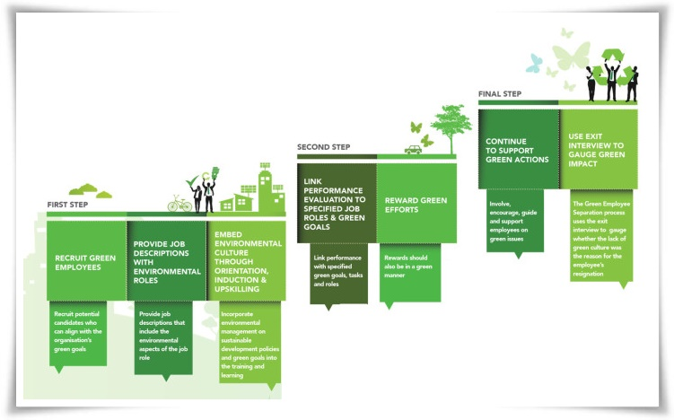

Green banking in Bangladesh
Bangladesh is at its worst vulnerable condition of climate change. The condition of the environment in Bangladesh is quickly decreasing. The Government of Bangladesh (GOB) has made some green stages for keeping nation green through lessening environmental destruction. The GOB and other common social societies have approached with the initiatives to grant organizations with great environmental and social duty. Additionally, Financial Institutions (FIs), as a go-between, can also be considered as the advertiser or influencer for a wide range of ventures for moving toward socially responsible behaviour. As per the specialists, through Green financing banking part and all other related business associations and people can be brought under the umbrella of green development. Additionally, FIs, as they have nearly a bigger offer in Bangladesh economy, should be effective in the utilization of vitality and water and the waste decrease in their inside tasks. Considering the present situation of the commitment and impact of FIs in Bangladesh economy and in accordance with government initiatives, Bangladesh Bank (BB), the national bank and various types FI's, has additionally turned out with environmental management issues of FIs. With a view to creating green banking activities in Bangladesh, Bangladesh Bank has built up a demonstrative Green Banking Policy and System Structure for the banking sector.

The Activities of Green Banking in Bangladesh.
To perform green banking activities, 43 commercial banks of Bangladesh are agreed and started GBU (Green Banking Unit). Various strategies are taken by them to provide sustainable, environment friendly Green banking procedures. All the activities of green banking performed by Bangladeshi banking sector are described below:

Banks in-house green practices:
The in-house green practices performed by Bangladeshi banks are:
- Instead of paper made statements banks are using E-statements for their clients.
- Banks are using more day-lights and reduce the work at night to save electricity.
- Maintaining communication through online in the best possible manner.
- Use of solar energy and concentrate to establish renewable energy infrastructures.
- Recruit and select employees through online communication and advertisement instead of paper made documents.
- Stores all the information related to the bank in computer memory to save the use of papers.
- Utilize electronic files, power point slides, E-mail, Voice mail to reduce the paper use.
- Create awareness in the customer by providing healthy environment inside the bank.
- Increasing mobile e-commerce and ATM booths to reduce the pressures on check books and other documents that have a negative effect on environment.

Objectives of Green Banking
The objectives of Green Banking are listed below:

Chart 1: Objectives of Green Banking

The Role of Bankers in Green Banking
Bankers are the critical professionals who have the association with alternate groups of individuals and furthermore with general masses. They can embrace diverse green activities inside their in-house environment and furthermore, can start the security of air pollution, water pollution by their customers. Bankers can finance green projects, which are environmentally friendly and demoralize projects that harm the environment. It will be mandatory for every individual to demonstrate regard to environmental issues. Something else, the environments where the concerned individual lives will be inhabitable and as entire the nation and the globe will never again be a protected place. We need to utilize resources cautiously and keep in the mind that the possession of the resources isn't boundless and its extreme use may endanger the future generation. We need to imagine that every one of our movement specifically affects the environment. As the best formation of All-powerful, we have a more prominent job to save the environment, look after biodiversity, not to jeopardize other fauna and flora or more each of the green, healthy planet for sheltered and sound living our new generations.
Since the banking business is an important institution in the monetary and business sector, bankers can't stay apathetic regarding this burning issue. A banker or a banking industry may deliver numerous issues to spare environmental degradation and monitor the ecological balance. Green banking is a decent method for making individuals mindful of global warming. Every businessperson will add to the environment and improve this world a better place to live. Moreover, it is imagined that this institution will progress in the direction of lessening the nation's reliance on foreign energy sources, fighting climate change and making extra employments through the arrangement of more advantageous energy generation benefits. Green finance may cover all the money related administrations identified with the advancement and development of green industry and a green economy where the environmental advantages as far as diminished carbon reliance or lessened ecological scarcity are the most important.
Green banking practices of banks are associated with both interior activity. A few banks are occupied with balancing the carbon-dioxide, which alludes to the exertion of offsetting the climate-changing impacts of its own greenhouse gas discharges. Banks, by utilizing their business borrowings and securities underwriting, may catalyze the fundamental change to an economy that limits greenhouse gas pollution and depends on energy productivity.
There is no doubt that the dangers related to climate change and biodiversity misfortune requires a more commitment of resources and investment from all stakeholders. In the endeavour of emission decrease and preservation, stakeholders have been contributing to various routes in various nations and areas. Green banking is only one of the activities by stakeholder - banks and monetary institutions. The environmentally responsible banks don't just enhance their very own models, yet, they influence socially responsible behaviour of different organizations. The banks should go for internet banking by reducing its paper waste, saving gas and carbon emanation, decreasing printing expenses and postage costs.

Importance of Green Human Resource Management.
The most recent years of this century have seen a unanimous consensus for the need for a practical environmental management drive everywhere throughout the world. This effort was attempted since the negative impacts of various pollutants among which the modern industries being the real criminal that has been breaking down and exhausting our natural resources has been apparent. The "Magna Carta" on Human Environment was proclaimed in the main United Nation's (International) Meeting on Human Environment held in June 1972 in Stockholm pronounced that to shield and enhance the human environment for present and future age has turned into a basic objective for humankind. The Green HRM writing is generally a western one and, given the significance of Asian financial advancement for environmental management, Green HRM is a serious topic for future examinations to diminish. Researchers including Evans, Pucik, V. and Barsoux of management around the globe are presently investigating different administrative practices that can encourage the accomplishments of the objectives of Green HRM and also significantly affect the environmental competitiveness of the industries.
(Source: Evans, Pucik, V. and Barsoux (2012). The global challenge: Frameworks for International Human Resource Management. New York: McGraw.)

HRM VS GREEN HRM
The differences between Green HRM and traditional HRM are:
HRM | GHRM
- Human Resource Management deals with the most valuable assets of an organization which is human resources using several functions. | - Green Human resource management is a concept that says while performing traditional HRM functions, an organization need to use primarily strategies for reducing the carbon footprint of each employee and talent retention.
- HRM Recruit employees through sending letters, advertise on newspaper, online, media etc. | - GHRM Recruitment mainly focuses on online applicant tracking and recruiting
- HRM Job descriptions seek to only organization’s work related eligible applicants | - GHRM suggests that an organizations job description need to seek both environmental and organizational capabilities in an applicants.
- Train employees to produce products. | - Train employees to work and produce products and service environmentally safe and healthy.
- Works only for organizational goals attainment | - Works for both organizational and environmental goal attainment.
- Doesn’t impact on creating good workplace environment. | - Highly creates a healthy and safe workplace.
- Cannot use as CSR. |  | - GHRM can used both as HRM and CSR.
Chart 2: Difference between Traditional HRM and Green HRM

Green Human Resource Management Process
The main input we get from the environment in an organization is Human resource. It is every organization’s duty to provide a positive payback to the environment. Only few implementation of GHRM procedures can create a great positive impact to the environment. The procedures are:
Input from the Environment =Employees

Recruitment
Performance appraisal
Training and Development
Employee Relations
Pay and reward

.

HR Functions

Goal Attainment

Chart 3: Green Human Resource Process

- Green Recruitment: Every organizations must choose employees who are aware of environmental issues so that in future they will be able to learn the corporate environmental issues more easily and also in a serious way. So, sustainable development issues need to join in the employee recruitment process.

- Green Training and development: Employee training and development program should include sustainable development and environmental lessons. From technical health and safety need on the shop floor to strategic sustainability issues at official administration and board level. Green orientation programs for the recently higher recruit ought to be a fundamental part of the preparation and improvement process.

- Green Performance appraisal: Communicate that green practices as a criterion for performance evaluation of employees. - While evaluating the performance of individual employees, make sure that the green performance of that employee both individually and collectively considered.

For example, TATA group of industries set some corporate standards for environmental performance measurement. These standards includes:
- Waste management
- Official behaviour of employees
- Environmental office
- Workplace environment.

- Green Employee Relations: Publish organizational policies, rules that are followed by Green HRM practices. Train employees to maintain their relations in workplace in a disciplinary system regarding the breach of environmental process. These policies can be more effectively utilize if organizations provide its Green goals in the job descriptions while advertising for recruitment. These can help:
- Creating better workplace culture.
- Improve employee’s health and safety issues.
- Reduction of unnecessary competitions
- Motivate Employees.
- Good workplace conditions improve Organizations reputation

- Pay and Reward: Successful implementations of environmental initiatives need to include in the compensation system. Every organization should give their employee benefit package that is basically a rewards for green performance. It will energise the employee towards the organizational as well as Green objectives.

Impacts of Green HRM in Organizational Development.
The Impacts of Green HRM into an organizations are:
- Creates Healthy and safe environment inside and outside of the organization.
- Reduction of using harmful substance.
- Develop healthy and safe work routines.
- Helps to get government subsidies.
- Helps to achieve Green goals as well as organizations goals.
- Build strong brand image.

Reasons for using Green Human Resource Management
The most recent years of this century have seen a unanimous consensus for the need for a practical environmental management drive everywhere throughout the world. This effort was attempted since the negative impacts of various pollutants among which the modern industries being the real criminal that has been breaking down and exhausting our natural resources has been apparent. The "Magna Carta" on Human Environment was proclaimed in the main United Nation's (International) Meeting on Human Environment held in June 1972 in Stockholm pronounced that to shield and enhance the human environment for present and future age has turned into a basic objective for humankind. The Green HRM writing is generally a western one and, given the significance of Asian financial advancement for environmental management, Green HRM is a serious topic for future examinations to diminish. Researchers of management around the globe are presently investigating different administrative practices that can encourage the accomplishments of the objectives of Green HRM and also significantly affect the environmental competitiveness of the industries.
(Source: H.H.D.N.P. Opatha & A. Anton Arunrajah, Dr. N.N.J Nawaratne (2015), Green Human Resource Management Practices: A Review, Sri Lankan Journal of Human Resource Management, Vol.5, No.1, 2015.)

Challenges of Green HRM in banking sectors of Bangladesh
The major challenges of implementing Green Human Resource Management in Bangladeshi banking sectors are listed below:

Chart 4: Major Challenges of GHRM in Bangladesh

Leadership development:
The first of the significant challenges for human resource management is leadership development which requires a genuine strategic initiative. HR experts may face the lack of basic structures, procedures, instruments, and perspectives of Green HRM to make the best choice and build up the future GHRM pioneers of the bank.

Change in Management Process:
The majority of the private business banks of Bangladesh confront the incredible test at the change of management. The World Federation of Personnel Management Associations (WFPMA) finds this may also be the motivation behind why it is referred to as the superior issue as HR keeps on attempts to enable organizations to push ahead. A focus on extensive training might be expected to provide the extra capabilities to manage the change of management. Efficient change of management is an important duty for human resource managers due to numerous inner and outer force impacts to do or not to achieve the viable change of the bank.

Adapting with HRIS:
The abbreviation of HRIS is Human Resource Information System. HRIS is one of the current challenges for Bangladeshi private commercial banks. It is the way toward empowering all human resource work like human resource planning, recruitment, and selection, training and development, compensation, promotion, performance appraisal, employee relation, and so on through the internet or computer software for helping the managers for decision making. As per the reports of Bangladesh Bank, about 69% of the challenges looked by the private commercial banks of Bangladesh are adjusting with this computerized framework that implies the Traditional HRM to e-HRM.

Recruitment and Selection Problems:
Recruitment and Selections is the way toward filling the authoritative empty position(s). So this procedure isn't a simple job for an HR Supervisor. Here, HRM considers numerous interior and outside components for hiring another employee. A large portion of the private commercial banks of Bangladesh recruits employee as Management Trainee Officer (MTO) for entry level, who are commonly viewed as progressively skilled employees of the banks. In every single other level with the exception of MTO, HR faces more challenges (58%) for hiring individuals for the banks as those individuals could possibly have the required skills and experience. The vast majority of them recruit (90%) by the employee referral and on demand of various stakeholders and social influential groups. This is the fundamental purpose behind including lower-skilled individuals in the banks and implementing Green Human Resource Management (GHRM) proves a very costly and troublesome process here.

Training and Development Problems:
Training and development is an important procedure for every single sort of association. The world is changing every day and the skill, experience, and knowledge are additionally changing every day with the changing of the world. Along these lines, the current employee of a bank needs to reshape and update with Green HRM knowledge, skills, and experience.

Green Banking and Green HRM policies followed by Citibank .N.A.
Citibank, N.A is a multinational bank, begun its activities on 24 June 1995, after taking a permit from Bangladesh bank in January 1995. The bank had its corporate office set up in the year 1987. Yet, it propelled its entire tasks in 1995 in the capital city Dhaka.
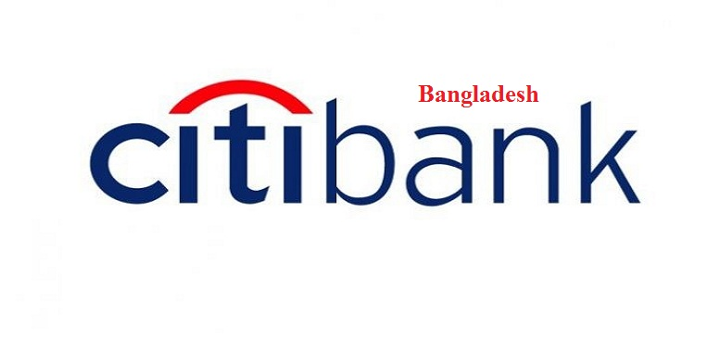
Citibank, N.A. is particularly cognizant about keeping its exercises in certain ways that are especially eco-friendly and that do no mischief to the environment. They are receiving Green policies paying little respect to departments crosswise over various nations, where it is working. Among different activities to become environmentally viable development, the most imperative one that Citibank is embracing is to be significantly more technology oriented. If there should arise an occurrence of selecting employees, they are doing each step through online from job analysis to vacancy fulfilment, Citibank is receiving both intranet and extranet that lessens the utilization of paper.
However, some of the time it is exceptionally hard to do a few businesses work without paper-pencil, as a banking organization. A few diverse training programs are offered by Citibank several times in a year to train the employees to lessen the paperwork and urge them to be the environment cautious. In Citi, culture health is viewed as a critical issue and to keep a sound and fit health different poster work, health alerts are additionally given occasionally. In Citibank, N.A., it's like developing as a family healthily towards accomplishing its objectives keeping up a nonstop arrangement which is refreshed every time consolidating Green Human Resources Management.
Citibank .N.A. pursues the accompanying policies to achieve a green environment for its improvement now and future.
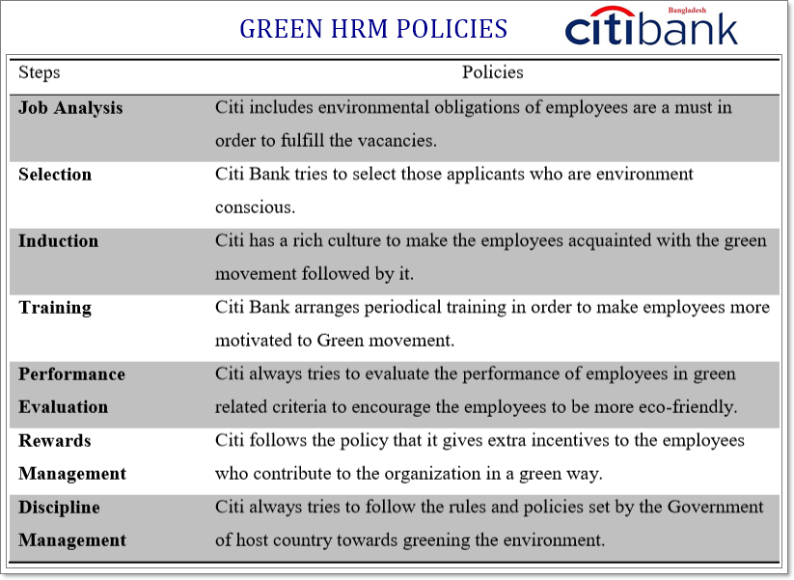
Chart 5: Green HRM Practices of Citibank, N.A.

Chapter Four
Findings of the Report

4.1 Findings of the Report

The report titled by “The concept of Green Human Resource Management for Bangladesh Banking Sector” was mainly concerned for the regular business activities that should be conducted with all the environmental friendly activities. After analysing the concept of Green banking and Green GHRM, I have found some learnings of the report. The findings are listed below:

- Business is becoming so competitive day by day that it is hard for banks to continue Green practices as the cost of implementing green banking is slightly higher.

- Most banks are generally practicing environment protection work once or twice in a year, and usually as part of Corporate Social Responsibilities (CSR).

- Everything is becoming money oriented and lack of want to bear extra cost for environments protection is hindering the green policies.

- Graduate Students are not well trained of Green Banking as well as Green Human resource management, so they can not relate of doing business with the environment protection.

- Various banks are providing Online Banking but most of the Banks are not following all the policies of Green Human Resource Management.

- Government provides less restriction to local banks to perform Green Banking than the foreign banks where Bangladesh legal system has so many rules for environment protection. For these reasons, Local banks are less aware of and do not perform Green Banking Practices.

- Green HRM generates higher impact that that of traditional HRM. All the new employees join in a company followed by Green Recruitment process, will be efficient for his job and a supporter of environment protection at a time.

Chapter Five
Recommendations and Conclusion

Recommendations
With the help of new innovative technology, banks should always reduce the pressure on paper and pencils so that less trees are being cut down and other environmental pollutions caused by the human can be controlled. However, I want to share some suggestions to implement more technological services that support green banking:
- Using green banking as a promotional strategy, banks can aware consumer to support them as well as the environment. It can reduce the competition exist among the competitor Banks.

- Banks should not practice environmental protection campaign once or twice in a year and for their Corporate Social Responsibility (CSR) activities, rather they should follow the Green Banking Practices all over the year as environment is a very crucial element to save.

- While developing infrastructures such as buildings, machines, factories and so on, banks should oblige all the rules of Green Banking. Even, when giving loan to any clients, if the purpose of the loan receiver is not friendly to the environment, the loan should not be granted.

- Universities of Bangladesh need to generate awareness and train their graduate and post graduate students to learn about the Green Banking and Green Human resource Management functions so that the future leaders can have positive empathy for the environment.

- Government of all country need to come into a strict law to use online banking and create laws to secure of the online banking activities so that bankers may feel safe to start and continue online banking in the country.

- Banks should utilize the advantage of internet, mails, and other new technology, on the other hand they should reduce the use of paper in the recruitment, selection, training and payment process to their employees. It will increase their efficiency and also reduce their cost.

Conclusion
Ecological concepts and ideas are starting to develop in the human resources space, often integrating existing initiatives based on sustainability. They bring more and more tangible benefits to society, instead of giving a boost to their brand and reputation. These new processes, policies, products and tools also help to ensure compliance and improve productivity. And now that legislation is in place to effectively formalize the need for a new entrepreneurial approach to the environment, it is time for human resources to embrace the green agenda. There are several areas in which companies can incorporate more environmentally friendly strategies, such as reducing the number of business trips, writing employee manuals, policies or other business information.
Companies can promote reduced paper consumption and focus on electronic document archiving, by providing paper recycling bins around bottles and cans in the service area. Companies focus on teleworking / homeworking programs. The institute's Ride / Share programs have also introduced a new change in the business world. Research has shown that employee participation in green programs increases dramatically as organizations designate an employee to lead the effort. In most organizations, efforts to protect the environment result from a general effort to make the business greener. When companies start recycling, opt for energy-efficient heating / cooling systems, and look for production efficiencies that save energy or reduce carbon emissions, it's natural to consider environmental benefits. The time has come to make environmental management an integral part of their way of doing things so that HR professionals can come up with a coherent program of activities.

Reference

(1) Bangladesh Bank 2017, Banking Sector Performance, Regulation and HR Guidelines for Commercial Banks. Available in: https://www.bb.org.bd/pub/annual/anreport/ar1516/full_2015_2016.pdf
(2) Baron, J.N., Hannan, M.T. and Burton, M.D. (2011) Labor pains: Changes in Organizational Models and Employee Turnover in Young, High Tech Firms.American Journal of Sociology, 106(4), 960–1012.
(3) Byars, LL & Rue, (2016). Human Resource Management, edition 8th. New York: McGraw Hill.
(4) Decenzo and Robbins, (2011). Human Resource Management, 6th edition, Wilsey.
(5) Dessler, G. (2012). Human Resource Management, Pearson Education Limited
(6) Evans, P., Pucik, V. and Barsoux, J. L. (2012). The global challenge: Frameworks for International Human Resource Management. New York: McGraw.
(7) Hargie, O. (2004). Communication Skills for Effective Management. Palgrave Macmillan, New York.
(8) Horwitz, F. M., Heng, C. T., Quazi, H. A., Nonkwelo, Carol, R. D. and Van-Eck, P. (2006). Human Resource Strategies for Managing Knowledge Workers: An AfroAsian Comparative Analysis', The International Journal of Human Resource Management 17(5), pp775–811
(9) Liz Weber, (2009) - CMC - Weber Business Services, LLC, liz@wbsllc.com
(10) Prasad, Apeejay (2013), Green HRM - Partner in Sustainable Competitive Growth, Journal of Management Sciences and Technology 1 (1), Oct – 2013.
(11) Suhaimi, Sudin (2011), Strategic Green HRM: A proposed model that supports Corporate Environmental Citizenship, 2011 International Conference on Sociality and Economics Development, IPEDR vol.10 (2011) © (2011) IACSIT Press, Singapore.
(12)H.H.D.N.P. Opatha & A. Anton Arunrajah (2014), Green Human Resources Management: Simplified General Reflections, International Business Research; Vol. 7, No. 8; 2014 ISSN 1913-9004 E-ISSN 1913-9012, Published by Canadian Center of Science and Education.
(13)H.H.D.N.P. Opatha & A. Anton Arunrajah, Dr. N.N.J Nawaratne (2015), Green Human Resource Management Practices: A Review, Sri Lankan Journal of Human Resource Management, Vol.5, No.1, 2015.
(14)Jacob Cherian & Jolly Jacob (2012), A Study of Green HR Practices and Its Effective Implementation in the Organization: A Review, International Journal of Business and Management; Vol. 7, No. 21; 2012 ISSN 1833-3850 E-ISSN 1833-8119, Published by Canadian Center of Science and Education.

