“Performance Analysis of
GlaxoSmithKline Bangladesh Limited”

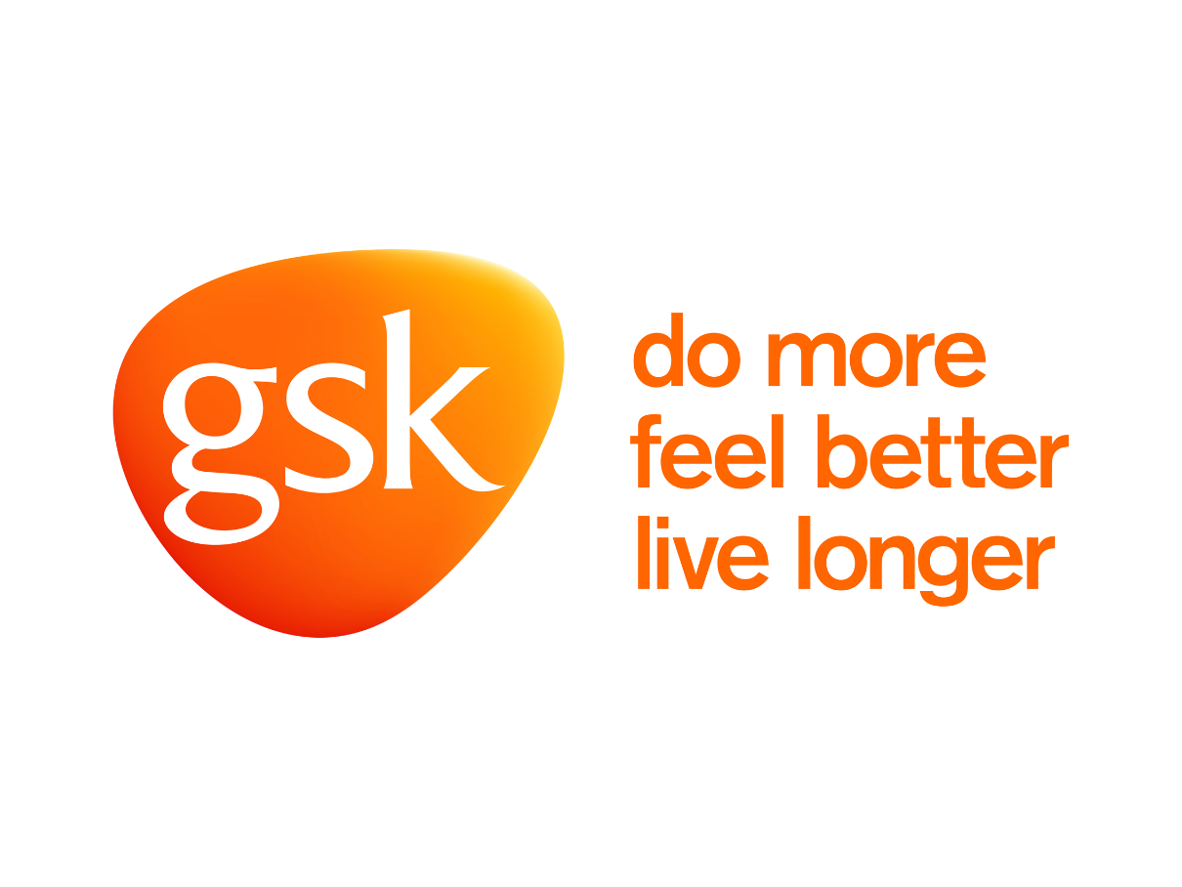
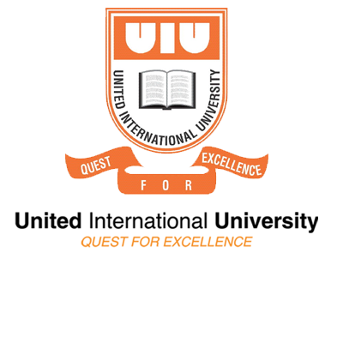
Internship Report
On

“Performance Analysis of GlaxoSmithKline Bangladesh Limited.”

Submitted to
Dr. James Bakul Sarkar
Associate Professor & Deputy Director
School of Business & Economics
United International University

Submitted by
Prithy Melody Mondol
ID: 111141192
United International University

Date of submission: 15th December, 2018

Letter of Transmittal

15th December, 2018
Dr. James Bakul Sarkar
Associate Professor & Deputy Director
School of Business & Economics
United International University

Subject: Submission of Internship Report on “Performance Analysis of GlaxoSmithKline Bangladesh Limited”
Dear Sir,
This is my honor to submit the internship report which is the mandatory part of my graduation. I have done my three months internship with GlaxoSmithKline Limited Bangladesh from Accounts and Finance department. The report title is “Performance Analysis of GlaxoSmithKline Bangladesh Limited”. In this report I have tried to define the whole work process of the department and also tried to analyze the financial performance of the company.
In this report I have tried my greatest to make this report accurate and cover all the concerned side of GSK Bangladesh Limited.
I would like to express thanks you for encouraging me in this report. Please accept my report and oblige thereby.
Thanking you.

Sincerely Yours,
.................................
Prithy Melody Mondol
ID: 111141192
United International University

Acknowledgement

At the beginning I want to express thanks my creator for giving me such good health during this report. I would like to express my sincere gratitude to those people by whom I was provided with the opportunity to complete this report. Without their contribution it will become nearly impossible for me to complete this report.
Now I want to transport gratefulness to my honorable academic supervisor Dr. James Bakul Sarkar for providing his proper guidelines to prepare this report. I am deeply indebted to him for his active support during my report.
Finally. Again, I would like to mention my gratitude to my supervisor Md. Mahmudul Islam, Accounts & Finance Manager of GSK Bangladesh Limited and senior employees- Md. Golam Mustafa, ATM Abdul Matin Meah and S. M. Sydul Arefin, Finance Executives of GSK Bangladesh Limited for their friendly and wonderful support and assistance.

Table of Content

Particulars | Page No
Chapter 01. Introduction
1.1 Background of the report…………………………………………  1.2 Purpose of the study………………………………………………  1.3 Methodology of the study…………………………………………..  1.4 Limitations of the study…………………………………………… | 08  08  09  09
Chapter 02. Company Overview
2.1 Introduction…………………………………………………………  2.2 History of GSK……………………………………………………...  2.3 Purpose, Goal, Strategy, Values & Expectations…………………...  2.4 Corporate Governance Structure …………………………………...  2.5 Functional Department of GSK……………………………………..  2.6 Organizational structure of GSK……………………………………  2.7 Product Offerings…………………………………………………...  2.8 Operations in Bangladesh…………………………………………..  2.9 Corporate Social Responsibility ………………………………….. | 11  12  12-13  13  14  14  15  16  17
Chapter 03. Performance Analysis of GlaxoSmithKline Bangladesh Ltd.
3.1Financial Ratio Analysis of GSK Bangladesh Ltd………………… | 18-29
Chapter 04. Findings and Analysis
4.1 SWOT Analysis of GSK ……………………………………………. | 30-33
Chapter 05. Recommendations and Conclusion | 34-36
References | 37

Executive Summary

Among all largest industries in Bangladesh, the Pharmaceutical Industry has gained a leading position due to current progress of this sector. This industry fill-up the 97% demand of the local market. Demand for good quality drugs is on the raise and the local market is expected to reach BDT 160 billion by 2018. Big companies are flourishing their business to expand their international market.
In the year of 1949 GlaxoSmithKline started its operation in Bangladesh as an importer of its own products and eventually emerged its role to manufacturing sector by establishing a factory in Chittagong. It has been 69 years GSK providing excellent service to pharmaceutical sector and consumer healthcare. GSK consists of a strong Finance & Department that works to achieve its mission and vision of the company. GSK Bangladesh Limited is a listed company of Dhaka Stock Exchange.
This internship report is about the "Performance Analysis of GlaxoSmithKline Bangladesh Limited". It comprises of six parts. The first part companies of background, objective, methodology, scope, and limitation of the study. The second part comprises of the information of the company like the history of the company, goals, and strategy of the company, product offerings, organizational structure, corporate governance and corporate social responsibility of the company of last years which helps to discover the existing situation of GSK Bangladesh limited. The fourth part includes the SWOT analysis of GSK Bangladesh Limited. The fifth part consists of recommendations and conclusions of the report.

Chapter 01: Introduction

  - Background of the report
Each graduate's student must have completed their internship with the determination of learning how to survive the practical work environment and increase the knowledge to do a job seamlessly. It is a prodigious practice for a student to learn the real-life work environment and perform as well. Before this, a business student only has a theoretical knowledge but almost zero practical. For having a real-world knowledge, I have completed my internship in the Finance & Accounts department of GSK Bangladesh Limited.
Among all segments that Bangladesh can feel proud, Pharmaceutical Industry is one of them. According to statistics said that this sector is the second largest sector in the Bangladeshi economy. The market size for this sector is about 30,000 million taka a year, of which is 97% of the total demand meet by the local companies.
The pharmaceutical sector is the second largest contributor to the national treasure after garments and is the largest sector of intensive employment of white; collar workers in the country. The pharmaceutical industry in Bangladesh is dominated by domestic producers. Total market share of local companies almost 87% multinational have 10% and other 3% is imported.

  - Purpose of the study

- Primary Purpose: The primary purpose of the report is to complete the partial obligation of awarding of the BBA degree from the school of business and economics, United International University.

- Secondary Objectives: The secondary objective of the study are as follows:
- To give an overview of the pharmaceutical industry and GlaxoSmithKline Bangladesh;
- Focus on the products, services, work environment and facilities provided to GSK employees;
- To identify the pharmaceutical industry’s trend and growth;
- To compare the financial performance of the companies for five years.

1.3 Methodology of the study
- Types of Information: This report contains the primary and secondary information. As it a multinational company most of the data has been.
Primary Information: Primary information was composed from:
- Casual consultation with the officials of the Finance & Accounts department of GSK Bangladesh Limited.
- Some information was collected from my duty which was assigned by my Manager.
Secondary Information: This type of information was gathered from:
- Maximum data collected from GSK Bangladesh Limited website.
- These types of data were mainly used to form the overall picture of the company and provide the basic information about it.

- Scope: The pharmaceutical section of GlaxoSmithKline Bangladesh Limited was carefully chosen due to perimeter scope of the report as reasonable as conceivable and the systematized nature of data of this production section. Bearing in mind the accessibility of information and purposes of the report, recent five year’s annual report and some other reports from website were selected for the study, three personnel were preferred grounded on their experience and proficiency concerning financial planning and management.

1.4 Limitations of the report

It should be mentioned that this report had some certain limitations. GSK Bangladesh Limited officials ware so busy with their task that they could not provide as much as data I want. Despite their effort, I have faced:
- Time limitation for which I could not make this study in more elaborately.
- The scarcity of the information.
- Due to the policy of GSK Bangladesh Limited, most of the official cannot provide more detailed data.
- Last but not the least authority was unavailable due to their duty.

Although there were many limitations, I tried to give my best effort to furnish the report.

Chapter 2: Company Overview

2.1 Introduction

GlaxoSmithKline plc is a science-led international healthcare company which works with the resolution: To help the people do more, feel better, live longer. They formed a group of experts and grow a large range of advanced medicines, vaccines, and health care products. It is a UK based company so HQ of this company situated in the United Kingdom. This company has nearly 100,000 individuals all over the world who serve to achieve their purpose and vision. It has two major areas of business healthcare products and pharmaceuticals.

Their company-wide goal is to bring excellence in healthcare to many people as they can, with their expert and sophisticated team members. All of the individuals follow three major criteria these are Innovation, Performance, and Trust. Their goal is to be the number one in worldwide. In the year 2017, they set three long-term priorities which to believe that it will deliver improved performance and more better returns in long run.

GSK Bangladesh Limited is the subsidiary of GSK plc. Its main activities are including manufacturing and marketing of pharmaceutical products, consumer and health care products and nutrition and oral healthcare products.

2.2 History of GSK
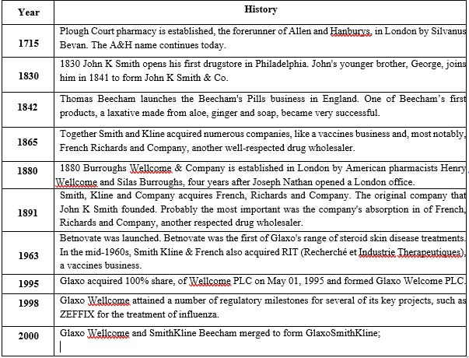

2.3 Purpose, Goal, Strategy, Values & Expectations

Purpose
Advance the quality of human life by empowering people to do more, feel better and live longer.
Goal
To be one of the world’s most innovative, best performing and trusted healthcare companies.
Strategy
Transport distinguished, high-quality and needed healthcare products to as many people as possible,
with their three global businesses, scientific and technical know-how and talented people.

Values & Expectations
Their values and expectations are at the core of everything they do and form a significant part of their principles.

Values

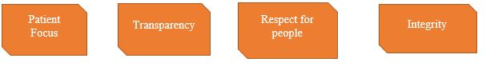

Expectations
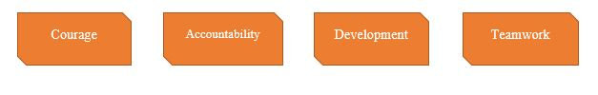

2.4 Corporate Governance Structure
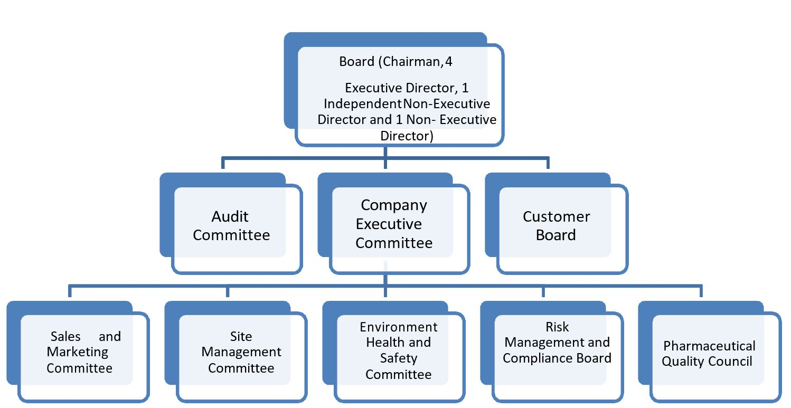

2.5 Functional Department of GSK
GSK Bangladesh Limited has six major departments. Those are as follows: -
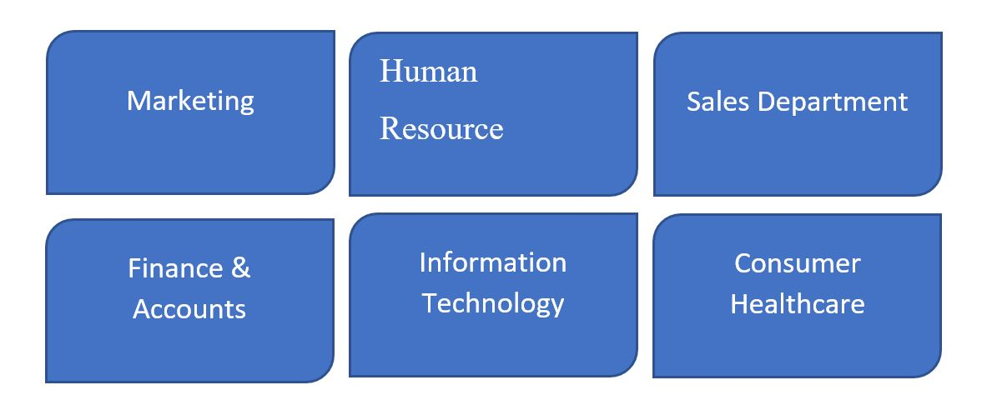

2.6 Organizational Structure of the Company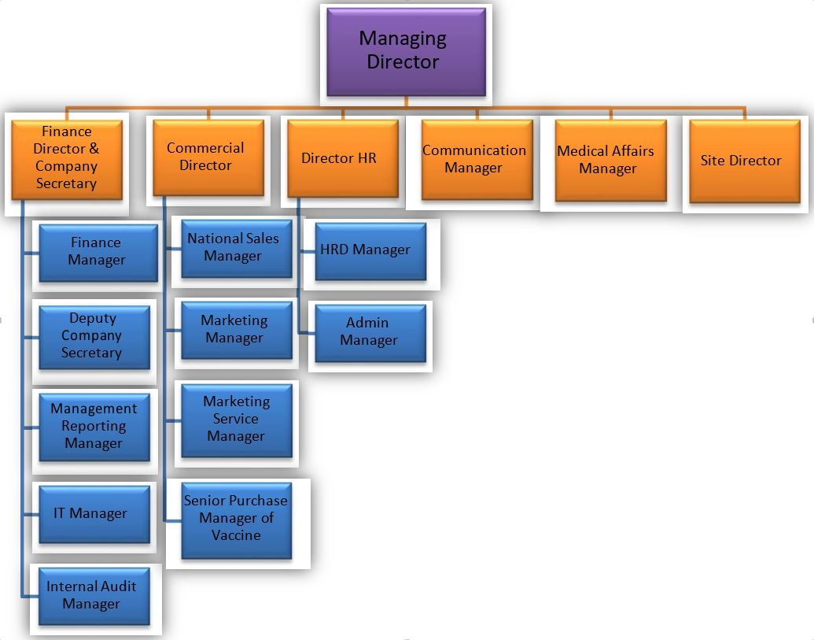

2.7 Product Offering:
A wide range of medicines, vaccines and consumer healthcare products are made by GSK. The title of the product may vary due to the country to country. Products for severe diseases such as asthma, cancer, infections, diabetes, and mental health are manufactured by GSK. The company is devoted to grow new and effective heath care products as well. In Bangladesh GSK is providing both Pharmaceutical and consumer Health care products for its consumers.
Product Overview
Pharmaceutical: GSK's Pharmaceuticals product line includes antibiotics, antidepressant, gastrointestinal, dermatological, respiration, cancer, and cardiovascular prescriptions. It has a vaccine department as well where a variety of vaccines are produced like Hepatitis A and Hepatitis B, Diphtheria, Tetanus, whooping cough and Influenza.
Consumer Healthcare: GSK has a reputation of 160 years, producing the world's number one health care products including Sensodyne, Voltaren, Theraflu, Parodontax, Panadol, Polident and Otrivin. These products are severing the world successfully. Their brands are organized into five global categories: Pain Relief, Respiratory, Oral Health, Nutrition and Skin Health.
Oral Care Product: GSK has been contributing a lot on solving oral problems by providing variety of oral healthcare supports and products. They have many worlds known oral healthcare products that people love and are loyal towards.
Nutrition Product: GSK also has a strong variety of nutrition products are considered to be phenomenon in south Asia especially in India, Bangladesh, Sri-lanka and adjacent countries. For example, in Bangladesh only, 93% market share in Health Food Drinks (HFD) is gained by Horlicks.
Skin Care: GSK is also a leader in skin care solution, delivering innovative science-based skin care products. GSK’s brands include medicated skin products recommended by dermatologists, as well as specific treatments for cold sores, itchy skin and athlete’s foot.

2.8 Operations in Bangladesh
GSK Bangladesh Limited has 12 District Marketing Offices (DMO) all over the country. These are divided in five major operation zones by which GSK's operation has been maintained.
12 District Marketing Offices (DMO) are situated in these areas below:
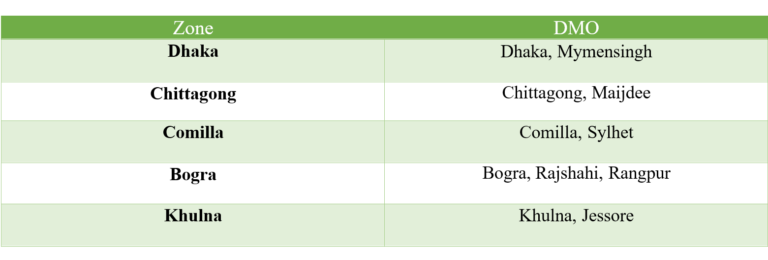

Distribution Channel
- Mutual Food- Mutual foods distributes the consumer healthcare products in Bangladesh and it also makes sure that GSK’s products are available throughout the country.
- Zuellig Pharma- Pharmaceutical products of GSK Bangladesh Lmited are distributed through it.

2.9 Corporate Social Responsibility
As a public limited company, GSK Bangladesh Limited must have performed some Corporate Social Responsibility (CSR). By doing a successful business in Bangladesh GSK offers some extra to the society. Although providing genuine health product is some kind of social activity. GSK has taken the action to re-invest 20% of its returns to build healthcare infrastructure in the LDCs. The CSR projects are described below:
- GSK-CARE BANGLADESH Community Health Worker Initiative (CHWI)
With a goal to improve motherly and child health outcomes in underserved/remote and poor communities in Bangladesh GSK has taken this initiative by increasing their access to quality health care services. Under this project, more than 1,000 Government health personnel have been reached through capacity building activities and 318 Community Support Systems (CmSS) were established to facilitate health awareness, promote accountability, and address issues of poor families’ access and timely referrals to health facilities at the community level. As a result, the initiative has demonstrated significant improvement in Maternal Health service uptake, especially by the poor in 50 remote Unions of Sunamganj district.
Based on project successes in the three years of Phase-2, representatives and officials from the local, district/sub-district health authorities and Ministry of Health and Family Welfare (MoHFW) expressed their desire to see a continuation of CARE-GSK project activities and scaling them up throughout the district. As a result of which, the GSK CARE CHW initiative was expanded till December 2018 to its third phase and scaled up to all unions of Sunamganj.
- GSK-CARE BANGLADESH Urban Health Ready Made Garment (RMG) Workers Initiative
In our country there are almost 6000 ready-made garment factories where around 4.5 million workers are employed. The majority of garments workers are woman migrated from rural areas and adversely affected by poor health and nutrition. Considering this issue, GSK with the collaboration of CARE BANGLADESH has taken following initiatives:
- GSK CARE Readymade Garment Workers Initiative (October 2014-September 2018)
- Health Access and Linkage Opportunities for Workers (Halow) Project- A project in partnership with Marks & Spencer (March 2015 -April 2016) & CARE
- Health Access and Linkage Opportunities for Workers (Halow) Plus Project- The expanded project partnership with Marks & Spencer & CARE (September 2017-September 2020)

- Myanmar Refugee Response
Two Community Health Clinics in Ukhiya in partnership with CARE and Ministry of Health & Family Welfare were introduced by GSK for Myanmar Refugees. To fight against the Diphtheria outbreak in refugee camps medicines were also contributed by GSK.
GSK along with Ministry of Health & CARE Bangladesh inaugurated Community Health Clinics and handed over one ambulance service to the local health department at Ukhiya,Teknaf for the Refugees with a view to deliver essential healthcare service.
In response to the Myanmar Refugee crisis, legislatures from GSK Bangladesh and CARE Bangladesh tendered diphtheria medicines worth of BDT 1 million sponsored by GSK plc to the director of Administration, Directorate General of Drug Administration, MoHFW, Bangladesh.

Chapter 3: Performance Analysis of GlaxoSmithKline Bangladesh Limited

3.1 Financial Ratio Analysis
Effectiveness is the key to be a financially successful business. Ratio analysis the way to understand and identify the financial condition of an organization. In addition, the third party which is the shareholder and the lenders are most often rely on the ratio analysis of a company and drive the decision whether to invest or not.
Ratio analysis is only quantitative analysis tools that can understand easily for a common public. Ratio analysis also helps to compare one organization to another and find out what is the advantage and the disadvantage compare to the competitor. It does not only show the results it also helps the decision maker to take the decisions. It is the mirror of an organization and the industry.

Following are the financial ratio analysis of GSK Bangladesh for in the year of 2013,2014,2015,2016 and 2017.

3.1.1 Current Ratio
Year | 2017 | 2016 | 2015 | 2014 | 2013
Current Ratio | 1.52 | 1.67 | 1.73 | 1.73 | 1.69

Current ratio is a measure of liquidity of a company at a certain date. From the above graph, it is seen that GSK’s current ratio has been changed over last five years. From the graph we can see that from 2013 to 2017 GSK’s current ratio has been changed. Comparing with 2013 in 2014 and 2015 current ratio was increased and remained consistent. That signifies their improved liquidity and conservative approach of working capital management. Again from 2016 and 2017 current ratio has been decreased due to increases in current asset without a conforming growth in a current liability.

3.1.2 Quick Ratio

Year | 2017 | 2016 | 2015 | 2014 | 2013
Quick Ratio | 1.24 | 1.33 | 1.37 | 1.36 | 1.04

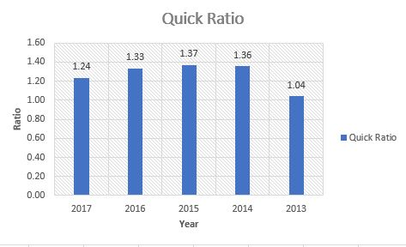

Quick Ratio, also known as Acid Test Ratio, shows the ratio of cash and other liquid resources of an organization in comparison to its current liabilities. From this graph we can see that GSK has the lowest quick ratio in 2013. Lowest quick ratio specifies the reduction in cash or accounts receivable balances, without a conforming decrease in current liabilities, or increase in a current liability without a corresponding increase in cash or accounts receivables. From the year of 2014 to 2016 it has been increased and remained consistent. And in 2017 it has been decreased again.

3.1.3 Gross Profit Ratio

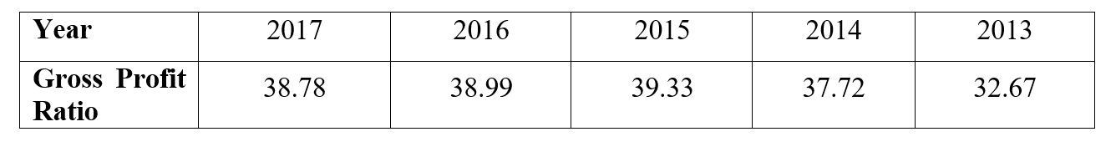

Gross Profit Margin Ratio is the proportion of gross profit comparative to the revenue earned during a period. Higher the profit margin, better the condition of the company. In this above graph, we can see that in 2013 the gross profit margin of the was comparatively lower comparing the following year indicating that reduction in selling price resultant to greater sales revenue due to price elastic demand of the company products or increase in competition forcing a decrease in selling price and reduction in market share. From 2014 to 2016 it has been increased because of growth in selling price of products with inflexible demand. In 2017, gross profit margin has been slightly decreased.

3.1.4 Net Profit Margin

Year | 2017 | 2016 | 2015 | 2014 | 2013
Net Profit Margin | 9.85 | 10.26 | 12.41 | 11.50 | 8.06

Net Profit Margin Ratio is the percentage of net profit relative to the revenue earned during a period. It refers to the proportion of sales revenue that translates into net profit. Net Profit Margin can vary significantly from business to business and can be affected by internal and external factors. From the above graph, we can see that in 2013 and 2017 the company has the lowest net profit margin comparing with these five years. In 2015 the company has the highest net profit margin among these five years.

3.1.5 Return on Asset (ROA)

Year | 2017 | 2016 | 2015 | 2014 | 2013
Return on Asset | 11.55 | 11.82 | 15.69 | 18.32 | 15.47

How proficiently a company’s management is producing earnings from their economic resources or assets can be measured from Return on assets (ROA). From the graph we can see that, GSK had the highest return on asset in 2014 that implies the efficiency company’s managements in generating earnings from their economic resources or assets. On the other hand, in 2016 and 2017 it has been decreased indicating the company’s increasing amount of debt, captivating the strength of its asset base or has a declining propensity in net income.

3.1.6 Net Asset Turnover

Year | 2017 | 2016 | 2015 | 2014 | 2013
Net Asset Turnover | 2.56 | 2.42 | 2.53 | 2.93 | 3.43

It is a measurement of the ability of management to use a firm’s net assets to generate sales revenue. From the graph, it is seen that GSK had the highest Net Asset Turnover ratio in 2013 which may indicate too little investment while the lowest ratio in 2016 indicates inefficient management compared to other years.

3.1.7 Return on Shareholders’ Equity

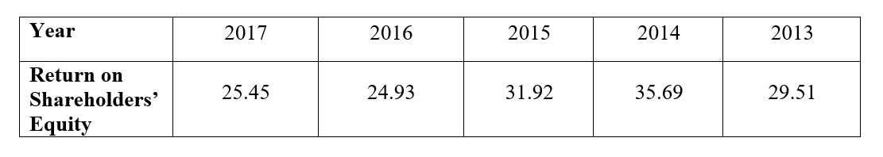

The Return on Equity ratio essentially measures the rate of return that the owners of common stock of a company receive on their shareholdings. From the graph given above, we can see that GSK had a good return on equity in the years of 2014 and 2015 compared to the other three years. This signifies GSK was good in generating returns on the investment it received from its shareholders. But in in 2016 and 2017 it has been decreased signifying that the company management was not as much of competent in returning to its stockholders’ investments.

3.1.8 Return on Capital Employed (ROCE)
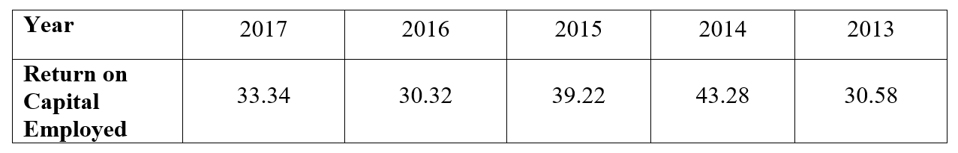

Return on Capital Employed is a financial ratio that governs a company’s profitability and the proficiency the capital is applied. Return on capital employed ratio measures the efficiency with which the investment made by shareholders and creditors is used in the business. In this graph we can see that in 2014, GSK has the highest return on capital employed compared to other four years signifying a more economical use of capital. On the other hand, in 2013 and 2016 GSK had the lowest return on capital employed.

3.1.9 Earnings Per Share (EPS)

Year | 2017 | 2016 | 2015 | 2014 | 2013
Earnings per share | 55.56 | 53.51 | 68.99 | 68.63 | 45.35

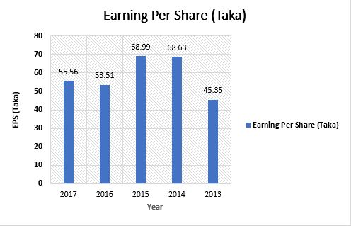

From the graph given above, we can see that GSK had the highest EPS in 2015 and 2014 compared to other three years. This implies the higher earnings, strong financial position and, therefore, a reliable company to invest money. On the other hand, in 2016 and 2017 the EPS has been decreased because of lower earnings and weak financial position in the market. The track record of EPS for several years reflects the growth rate of the company. A consistent improvement in the EPS figure year after year is the indication of continuous improvement in the earning power of the company.

3.1.10 Dividend Per Share (Taka)

Year | 2017 | 2016 | 2015 | 2014 | 2013
Dividend Per Share (Taka) | 55 | 50 | 55 | 42 | 30

The total dividend declared for every common share outstanding is known as Dividend Per Share (DPS). How much dividend an investor is going to get on a per share basis can be measured by this ratio. In the above stated graph, it is seen that GSK had paid the highest dividend compared to other three years in 2015 and 2017.

Chapter 04. Findings and Analysis

4.1 SWOT Analysis of GSK Bangladesh Limited

SWOT analysis is a procedure that scrutinize the objectivity of a clearly defined project and the acknowledgement of all factors related to the project. The SWOT analysis process includes four areas: Strengths, Weaknesses, Opportunities and Threats. Both internal and external factors are considered while making SWOT analysis because both of them have significant influence on the triumph of a company.
Following is the SWOT analysis of GSK Bangladesh Limited:

STRENGTH

- Portfolio extension for dynamic R&D: GSK has successfully established a strong research and development team. This team has already invented the cancer medicine and now they’re up to HIV antidotes. And for this GSK have already captured the largest market share.

- Robust Sales and Distribution link: GSK has an expert sales and distribution team which help to distribute the product of GSK around all the corner of the country. And also reach the customer as soon as possible with new products.

- Strong International existence: GSK has their operation over 100 countries around the globe implies the establishment of a strong global network of their own. So, they don't need to depend on some particular markets.

- GSK-Novartis JV: The joint venture of GSK-Novartis regarding consumer healthcare and vaccines that has been announced in 2015 is beneficiary for both the companies to introduce new products and enhance market share.

WEAKNESS

- Brand image affected by fraud allegation: GSK has been faced some lawsuit in some countries for overpricing, using unlawful ingredients, and failed to show the safety report data. Recently GSK faced a lawsuit in Bangladesh against Horlicks. Those incidents affect the brand value of this organization.

- Raw material restrictions: Raw materials from any source cannot be used by GSK as per their company policy though it might be low-priced than current source. In order to maintain product standard and quality they use their own source.

- Inferior buyer’s confidence: For Bangladeshi people, GSK pharmaceuticals are not that much preferable like Square and Beximco Pharma although GSK has the same variety of products. As they are Multinational, people think GSK charge more than e local companies.

OPPORTUNITIES

- Strategic extension by Acquisitions and Collaboration: In the recent past, GSK has been increasing its portfolio inorganically by collaborating with ViiV, Pfizer and Shoinogi in 2016 and acquisition of GlycoVaxyn in 2015. These activities help the company to enlarge its portfolio and intensify market share.

- New Product reinforce business: In recent years GSK Bangladesh Limited has launched many products which increase the strength of its business. Like Nucala as a treatment for refractory eosinophilic asthma in adults. New products enhance the range of the organization.

- Few substitute products: As GSK has the world's largest and best research team on pharma so they find new medicines for diseases and update the existing products by adding new value. GSK offered such products which nearly impossible for the local companies to make so this is an opportunity as an organization. All this is possible only for the experts’ team and innovative strategy and unmatched technology.
- Growing demand regarding eminence healthcare: People are getting educated day by day and they only want the quality products for their health and this theory match with the GSK's value so this is an opportunity for this organization.

THREATS

- Price controlling of Drugs: Prices control by the own country this can be bad news for the multinational organizations because the product material cost comparatively higher than the local producers. Recently India has imposed this price control in their country.

- Sturdy rivalry: In this sector, competition is comparable higher because local companies also produce almost the same types of product where the cost of production is higher than the local companies. So, making the products and the grabbing the customer is highly competitive.

- Generic competition: Sales of pharmaceutical companies are affected by introduction of generic products as generic medicines sales and accessibility increases.

- Government’s regulation: Government restriction can be another threat, sometimes government wants to grow the local companies so they put a restriction on the multinational companies or they provide the subsidy to the local companies by which the locals get advantage.

Chapter 05. Recommendations and Conclusion

Recommendations

From my understanding about GSK, it is evident that the company is very much systemized at achieving the tasks. It is doing fair-minded business under an inoffensive and approachable corporate environment. The code of conduct established by its parent company is followed by GSK Bangladesh Limited. All the personnel of finance and accounts department of GSK Bangladesh Limited are very much competent and proficiently plan and implement the financial strategies. They sincerely use the resources of the company.
In spite of being so resourceful at operations and having so much good products, GSK Bangladesh Limited is unable to take a place in a leading position. The government is concerned to encourage the local pharmaceuticals so the local firms have become the market leader.
So, the recommendations would be–
- To focus more on advertising activities and making people more conscious about their company profile and products to establish a strong brand image;
- To be more concerned to reduce the production cost of the pharma products to compete with the local products more fruitfully;
- To be very careful in maintaining the copyrights of their products as they are in alliance with some local firms like Mutual food and Zuellig Pharma.
- To make individuals clearer about their responsibilities and the workforces should follow a common process in order to complete their task
- To offer appropriate training by the company so that employees can understand how they have to perform their job

Conclusion

By engineering and delivering quality products to its customers GlaxoSmithKline Bangladesh Limited has become one of the major pharmaceutical company for many years. It has expanded its local business arena and have tried to come up with new solution for its customers. Delivering superior products and medicines to the customers is always a matter of concern for the company. This report on “Performance Analysis of GlaxoSmithKline Bangladesh Limited” demonstrations the complete scenario of both GSK’s pharmaceutical and consumer goods segment performance in Bangladesh. It gives us an idea that how well the company is operating now and also future performance of the company. A very popular technique of financial statement analysis Ratio Analysis has been used to demonstrate the calculation of statistical relationship between data. The financial strength, operational efficacy and management efficacy of GSK Bangladesh can be understood from this analysis. Being a financially solvent and well performed company, GSK Bangladesh is also facing some threats. It can regain its market position by articulating and exercising competitive business approach.

References

Research and Markets ltd. (2018). GlaxoSmithKline Plc (GSK) - Financial and Strategic SWOT Analysis Review. Retrieved from https://www.researchandmarkets.com/reports/1291554/glaxosmithkline_plc_gsk_financial_and

(PDF) NON-FINANCIAL INDICATORS FOR EVALUATION OF BUSINESS ACTIVITY. (n.d.). Retrieved from https://www.researchgate.net/publication/267791347_NONFINANCIAL_INDICATORS_FOR_EVALUATION_OF_BUSINESS_ACTIVITY

GLAXOSMITH.BD Financial Statements - GlaxoSmithKline Bangladesh Ltd. - Wall Street Journal. (2018). Retrieved from https://quotes.wsj.com/BD/XDHA/GLAXOSMITH/financialS

Bangladesh | GSK. (n.d.). Retrieved from https://www.gsk.com/en-gb/contact-us/worldwide/bangladesh

(PDF) GSK. (n.d.). Retrieved from https://www.gsk.com/media/4790/bangladesh-annual-report-2017

(PDF) GSK. (n.d.). Retrieved from https://www.gsk.com/media/3662/bangladesh-annual-report-2016

(PDF) GSK. (n.d.). Retrieved from https://www.gsk.com/media/3592/bangladesh-annual-report-2015

(PDF) GSK. (n.d.). Retrieved from https://www.gsk.com/media/3589/bangladesh-annual-report-2014

(PDF) GSK. (n.d.). Retrieved from https://www.gsk.com/media/3593/bangladesh-annual-report-2013

