Online Banking and Its Impact on Consumer Satisfaction: A Case Study of BRAC Bank Limited

Asraful Islam
Id: 124193002
Dept. of Economics
United International University

Supervisor:
Mohammad A. Ashraf, PhD
Professor
Department of Economics
United International University

Submission Date: 6 July, 2021

ACKNOWLEDGEMENT

First of all thanks to almighty ALLAH for blessing me with patience for successfully completing my Master’s Thesis research paper. I would like to express the healthful thanks to my supervisor Mohammad A. Ashraf, PhD, Professor, Dept. Of Economics, United International University, Dhaka, Bangladesh for his guidance. Skilled Supervision and more support to carry out essentially activities. His valuable suggestions were the source of my encouragements.

I would like to thanks my office colleagues, BRAC Bank Head Office, Anik tower employees for their kind cooperation.

Table of Contents

CHAPTER 1 4
INTRODUCTION 4
1.1 Problem Statement: 4
1.2 Research Question: 4
1.3 Purpose of the Study: 6
1.4 Research Objective: 6
1.5 Limitations Of the study: 7
CHAPTER 2 8
BRAC BANK LTD 8
1.6 Background of the Study: 8
1.7 Organization Profile: A Corporate Profile BRAC BANK Limited 8
CHAPTER 3 13
LITERATURE REVIEW 13
CHAPTER 4 17
RESEARCH METHODOLOGY 17
4.1 Research Framework: 17
4.2 Research Design: 17
4.3 Data Collection Processed: 18
CHAPTER 5 20
FINDING OF THE STUDY 20
5.1 Findings: 20
CHAPTER 6 32
CONCLUSION AND RECOMMENDATION 32
REFERENCE 34

CHAPTER 1

INTRODUCTION

A bank is a financial organization that is related to the monetary system. Nowadays, the banking system is digitalizing day by day and variously extending its system with the help of making so many financial events. In the meantime, Banks are progressing their banking progress faster and easy than before. At present, because coronavirus customers are interested in using internet banking to make their financial activities. Using online or internet banking customers should know some basic things such as the internet, online banking features, and so on. Internet banking makes our financial activities more smooth compare to the manual banking system or paper-based banking system. It reduces our cost besides saves our time. On the other hand, Internet banking is granting to their customer speedy services and customers are satisfied with the banking activities. BRAC Bank Ltd has started new internet banking apps "BRAC BANK ASTHA". This apps shows everything like account balance, credit card balance, money transaction history, all kinds of utility bills payment history, etc. Internet banking becoming exoteric to make money transactions among customers. Customers don't need to go to the bank for any transaction or payment because of internet banking.

Problem Statement:

By this revision, BRAC bank is a stable bank over the last few years but they are not providing good internet banking services. It can be that their online banking services are complicated or not understandable to the general people. This may be a reason for which BRAC bank losing some customers. So, I assigned to find the factors for improving the service quality of BRAC Bank Ltd.

Research Question:
This questionnaire focusing on the Internet and Online banking of BRAC Bank Ltd as like as what clients think of the facilities;

Research Questions:
- Does Reliability affect Consumers satisfactions in the context of BRAC Bank Ltd?
- Does Security and privacy affect Consumer Satisfaction in the context of BRAC Bank ltd?
- Does Service Quality affect Consumer Satisfaction in the context of BRAC Bank Ltd?
- Does Assurance affect Consumer Satisfaction in the context of BRAC Bank Ltd?
Selected Variables | Question
Reliability | BRAC Bank protect your deposits made through internet banking.
 | The Purpose of the internet banking transaction is easy to operate and trust on it.
 | You feel safe in the online transaction with BRAC Bank
Service Quality | The IB website of BRAC Bank provides satisfactory assurances to its Consumers about their online and internet service.
 | It is easy to comprehensive a operation speedily through the BRAC Bank internet banking website.
Privacy and Security | BRAC Bank Internet banking site is secure for your internet banking
 | BRAC Bank will not exploitation your given data given while doing internet banking transactions.
 | . You have enough confidentiality and safety on the information that you have given to the BRAC Bank.
Assurance | Are you satisfied with the Bank online-based service quality?
 | What is your global satisfaction with the IB of BRAC Bank Ltd?

In these 10 simple questions where every questions will have following answer with weight. Please see the below Table for question weight.
Answers | Weight of Answer
Strongly Disagree | 1
Disagree | 2
Moderate | 3
Agree | 4
Strongly Agree | 5

Purpose of the Study:

The determination of this learning is to recognize the features of internet banking (IB) that can impact holding Consumers in the perspective of BRAC Bank Limited. It will assistance the researchers to look into the whole situation of the internet banking (IB) services of BRAC Bank Limited.

Research Objective:

Prepare the report on “The Impact of internet banking on Consumer holding in the context of BRAC Bank Limited”. To complete my Master’s Thesis Program of MSECO.
Specific Objectives:
- To understand & classify the problem of the internet banking (IB) system of BRAC Bank Limited.
- To find out the problematic of consumer to amend in internet banking of BRAC Bank Limited.
- To identify the problematic in procedure of internet banking (IB) in the Banks website.
- To know the terms, rules and condition of internet banking given by BRAC Bank Limited to their clients.
- To provide recommendations for the development of the internet banking (IB) structure of the Bank.

Limitations Of the study:
Please find the some limit of undertaking the study
^ I have accomplished the paper survey within 2 weeks only. Most Probably 10-15 minutes for each person. My target was to survey at least 100 internet banking Users of BRAC Bank Ltd. But some people were not interested to express their opinion.
^ I faced some barriers to gather some data about internet banking (IB) of BRAC Bank ltd as these were not so accessible for the common people.
^ I saw the defendants were too busy to recite the questions correctly and tick the answer just for the sake of concluding the survey speedily. Thus there is no assurance that the data composed is 100% correct. In most cases, I had to ask those questions in Bengali (LOCAL LANGUAGES).

CHAPTER 2

BRAC BANK LTD

Background of the Study:

This research is shown on Online and internet banking and its result on Consumer satisfaction “Online and Internet banking User” of BRAC Bank Limited. The main key feature of internet banking is to maintain Consumers of the BRAC Bank Limited. By this study we competent to know that which features and how they impact the internet banking of BRAC BANK Limited to maintain Consumer satisfaction. It is also a requirement of my academic course under “master’s thesis”.

Organization Profile: A Corporate Profile BRAC BANK Limited
BRAC Bank ongoing its journey on 4th July, 2001 but did not start its journey comparable any extra private commercial Bank. BRAC Bank concentrated on small and Medium Enterprises (SME). The Bank has become a prominent Bank in Bangladesh by possession its core focus on SMEs. At Present, BRAC Bank Created an apps Name of that Apps “BRAC BANK ASTHA”.
Financial Services:
# SME banking
# Retails banking
#Card Services (Credit and Debit)
# BRAC Bank Limited is one of the leaders in the Bangladesh Credit card Industry. Two brand Product Visa and Master Credit cards.
# Foreign Exchange and Correlated Services
#Wholesale banking and Custodial Services.
Distribution Network:
BRAC Bank Hold dynamic network of 187 Branch, 457 SME Unit, Remittance Delivery Point 1800 and Total 447 ATM Booth.
Achievements and Recognitions:
In 20 Years of operational BRAC Bank Ltd (BBL) Has accomplished a substantial volume of esteem, honor and appreciation from Country and overseas shows assurance to excellence services as a Bank. In these years BRAC Bank has achieved:
- US$ 1 billion Market capitalization in the capital market.
- Asia money’s “Best Bank of SMEs “2017.
- SAFA Award for the best presented annual Report 2016.
- ICAB Best Published Annual Reports 2016 Awards for Private Sector Banks.
- Asian Development Bank “Most Progressive Bank on gender strategy and Implementation 2017.
- Women’s Market Champion Award from The Global banking Alliance for Women (GBA).
- ISO Certificate in information Security.
Subsidiaries:
BRAC Bank also schemes towards its divisions to discover additional some new areas of businesses seeing new obligation from its consumers. The Subsidiaries are:
- BRAC EPL Investment Ltd.
- BRAC EPL Stock Brokerage Ltd.
- Bkash (mobile banking services)
- BRAC IT Services Limited (BITS)
Internet banking Procedure of BRAC BANK Limited:
All local and non-local Consumers of BRAC Bank (Retail, Probashi, Proprietorship account holder and mutual account holder with either or survivor mode) may apply for internet banking.
At Present Automatically create INTERNET banking user name. You may call Consumer care for collecting the user Id and temporary password. When you got a temporal Password you need to change the old password.
Software Token:
Software Application which is accessible for download from Google Play Store, IPhone App store etc.
- Android
- Windows Mobile
- IOS
Getting Hardware and Software Token:
Consumers will have the appeal preference after login into the internet interface. When you making a transaction, you got an Email from 2FA. 2FA means Two Feature Verification Device, which sends an email and generates OTP (One Time Password) ,the second level of verification. 2FA Device is PIN Protected security device which casually generates OTP to get done IB Transactions. It provides the Consumer an extra level of protection for every Payment by generating e signature.
E signature is basically a six-digit safety code casually produced by a 2FA device for re-authenticating a contract on Internet banking. Consumers need to generate an e-signature for performing the transactions.
Below mentioned Services are available from internet banking:
- Account Details
- Mini statement
- FDR amounted Details
- Fund transfer (same bank account and other bank account)
- Credit Card Statement
- Credit card Bill Payment
- Utility Bill Payment
- Password change
- University Tuition fees ( BRAC University)

Daily Fund Transfer Limit:
Through internet banking daily fund transfer limit five:
Fund Transfer
Service | Min.Amount | Max.Amount
Same Cif | 100 | 1000000
Other Cif | 100 | 500000
BFTN | 100 | 500000
NPSB | 101 | 200000
Bkash | 50 | 30000
Rocket | 50 | 10000
Ipay | 100 | 50000
ok wallet | 100 | 30000
Top up | 50 | 3000
Metlife payment | 100 | 500000
Gurdian Life Insurance | 100 | 500000
BRAC University | 0 | 500000
WASA | 0 | 30000

- Consumers can transfer funds to other Bank account concluded BRAC Bank Limited Internet banking, Consumers Consumer can daily create a Maximum of one EFT Concluded our Internet banking.
Transfer Of funds From BDT Account to Foreign Currency (FCY) account:
1. Right Now Fund transfer from BDT account to FCY account or vice versa is not allowed.
2. Paying Credit card bill through internet banking:
3. When you pay Credit card Bill you got notification instantly within 5 minutes.

CHAPTER 3

LITERATURE REVIEW

Internet banking (IB)
As we know internet banking ruins one of the Low-priced and more Proficient distribution networks (Robinson: 2000, Pikkaraien 2004). The conflict such as internet banking policy has been an attractive approach to keep prevailing Consumers and call to new ones.
Profits for the end consumers are frequent mainly opportuneness of the services like save the time and globally available services.
Lower cost of Operation and Extra Frequent Observing of accounts between others (Pikkarainen -2004).
Among the various benefit to Banking feature quantity modification, more current marketing and statement at lower charges among others (Tuchila, 2000) numerous benefits of internet banking, Many People static wish to conduct their banking dealings at the Bank and unevenly that they had been an achievement for years. The frequent factors and conflict is that the people still want the traditional way for doing banking transactions. The bank as well as the customers will be beneficial to the online banking.

Privacy and Security:
A vital factor for all financial correlated internet services is Trust.
The practical study shows that based on trust clients make many online results (Avinandan and Prithwiraj 2003). It is very substantial building trust for internet banking assumption.

There are two vital factors for trust-building, which are security concern and privacy. They have been pointed as top two factors prompting user's assumption. The ability to manage and control the data is measured by Privacy (Belanger, Hiller and Smith, 2002). Security is defined as the capability to keep against probable Extortions. The e based transaction systems is accomplished

Privacy is an important measurement that can affect a user’s intending to implement e based transaction systems. Encryption equipment is a common story at all Bank places to safe data privacy. Accompanied by an arrangement of altered exceptional recognizes, for instance, a password like a mother's name and memorable date inactivity automatically log in users off the account.
Assurance:
Assurance measures to the employee’s information and manners and the service provider’s capability to inspire trust and self-assurance. (Zeithaml, 2006). Assurance may not be so significant in relation to other industries where the risk is higher and the outcome of using the service is undefined (Andaleeb and Conway 2006). Assurance is a set of manners and information of staffs along their capability to install assurance. The Assurance Measurement is occupied from a combined assurance is a set of manners and information of employees along their Capability to install confidence.
Reliability:
Reliability measures to the quality of presence reliable or consistent on something (lin and chin 2007). Reliability is measure as the capability to achieve the assured service dependable and correctly. (Zeithaml et al,2006). Since online Consumers are actually concerned about the consistency of computer-generated facility providers. We know reliability as the artefact that came was signify accurately by the website, you find what you ordered from the site. Reliability includes constancy and consistency in the act. It means the firm credits and sending the service within an suitable time limit defines the reliability of online service (Saha Zhao, 2005).
Service Quality: Service quality has become the question that business has concentrated upon with e-service that enables communication, data gathering, transaction processing and data interchange b/w online sellers and Consumers across time and space (Feather man and pavlou 2002).service quality is definite as the scope to which a website facilities proficient and operative shopping, purchasing and distribution of products and services ( Zeithml et al,2002). According to the Zeithamal at all measures some dimensions of e-service quality: like Reliability, access, price knowledge, responsibility, ease of navigation, flexibility, efficiency, ease of navigation, assurance, price knowledge, security, customization and site aesthetics. This measurement with dealing with the Consumers request, complaints quickly and questions and responsively. Handling of problems and takings through the site. For success, firms necessity to look at the viewpoint of the Consumer rather than the company's viewpoint (zeithaml et al 2006). Also, detentions the notion of Ability and flexibility to customize the service to Consumer’s needs.
Consumer Satisfaction and retention:
For a successful Consumer, preservation begin with the first communication a business has with a Consumer and remains all through the whole lifetime of a connection. Recognized the profits that Consumer retaining sends to an association. Some features consisting of higher initial costs of outcome and attracting new Consumers, a rise in both the price and no. of purchases. So that Consumers will recognize much about the loyalty of the Consumer and the time Consumers stay with the organization. At present Retaining Consumers becomes important. Importance of retaining, much research showed that durability does not alone lead to profitability (Andreassen, 1999).
It is important for every Bank management to be careful to increase Consumer loyalty. Consumer’s associate will be changing Bank with high maintenance costs in relationships of the potential sacrifice and effort included.

CHAPTER 4

RESEARCH METHODOLOGY

This Research paper includes Quantitative Research Method. It Consist of Design, Collection data and procedure, model size and Data exploration Procedures.

Research Framework:

They are Two variable: one is Explanatory and Explained variable.
Explanatory variable | Explained variable
Reliability | Consumer Satisfaction and Retention
Privacy and Security
Service Quality
Assurance

Research Design:
As the research Framework showed, there are four Explanatory plus one Explained variable. The Research Structure showed that there is a straight connection between both Explanatory and Explained variables. It’s very important to discover and concentration of this variable so that the previous mentioned persistence of the study can be met. This paper will assist the Bank to recognize the elements of internet banking that essentially help to progress consumer satisfaction and maintenance.

Hypothesis:
Ho (Null hypothesis): There is a relationship between Explanatory and Explained Variables. Client Satisfaction in internet banking of BRAC Bank Ltd and Reliability, Privacy and Security, Service quality and Assurance.
Ha (Alternative Hypothesis): There is no relation between Explanatory and Explained Variable. Client Satisfaction in internet banking and Reliability, Assurance, Service Quality and Security and Privacy.

Data Collection Processed:
For data Collected used Two Methods: Primary and secondary sources.
Primary Sources:
A regulated survey was used Research mechanism to collect primary data from the Consumer of internet banking from Head Office, Anik Tower and different Branches of BRAC BANK LTD. We create some questions that define the complete satisfaction level of Consumers in using Internet banking Services.
Secondary Sources:
The secondary data sources were websites, books, journals and BRAC BANK and Bangladesh Bank etc. Secondary data like several academic articles and books evaluated to form, simplify the type of the research. And classify the vital variables correlated to the reaction and acknowledgment of the Consumers.
Sampling Plan: The sampling structure for the research will be allowed a list of consumers in the Banks database in selected Head office, Anik tower and Sepal Platinum tower. So it will be the probability sampling. The respondents who are using Internet banking of BRAC Bank Ltd are considered as a sample. 75 simple size was taken. The Consumers were particular by mixed of suitability and random sampling method.
Data Analyzing Techniques:
- Statistical Software ( IBM SPSS )
- Microsoft Excel 2013

CHAPTER 5

FINDING OF THE STUDY

Findings:
The determination of this research is to explore the Consumers online banking satisfaction of BRAC Bank Limited in Bangladesh. In my Survey, questions I got maximum people to tick to agree and strongly agree with their internet banking (IB) Services. BRAC Bank already developed its IB Service. In my data after analysis that I have found a positive relationship between both explanatory and explained variables. We can say the question patterns almost clear to the users of IB. Their influence is another feature behind the study. But in the correlation, there is a positive relationship between explanatory and explained variables. We can’t reject to Ho Hypothesis that’s a reason we can’t accept Ha Hypothesis for any 4 explanatory variables with explained variables.
Discussion: We know Banks need to fulfill their Consumers at any cost. It will bring them decent health for the organization. BRAC Bank internet banking can be part of Banks success and good financial health. It’s very important for Consumers satisfaction already in my survey I found Consumer satisfaction possible. I mentioned some features which are beneficial for holding Consumers. List of the variable is:
- Reliability
- Security and Privacy
- Service Quality
- Assurance
The Sample size of the research maximum number of people who are agreed and are satisfied with the BRAC Bank internet service.
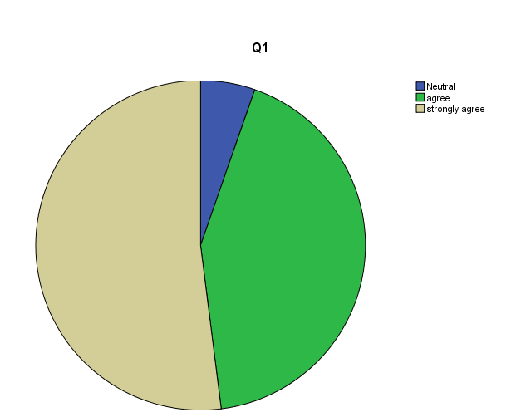
Figure1: Consumers Response Regarding question 1: 1. BRAC Bank Protect your deposits made through internet banking.

From the answer to question 1, we get the outcomes 52 % people strongly agree, 42.7 % people agree while 5.3% people are neutral Respondents. As we can say 94.7% of people are satisfied with the online banking of BRAC Bank. Some people are said to me BRAC Bank Internet banking is very helpful for transfer money, mobile banking and easily accessible. It is very reliable for collect account statements, deposits amount checking. BRAC Bank Internet banking provides the best NPSB system (instant money transfer one account to another account)
So, we can conclude that overall maximum respondents are satisfied with their service

Figure 2: Consumers Response Regarding Question 2: The Purpose of the IB transaction is easy to operate and trust.
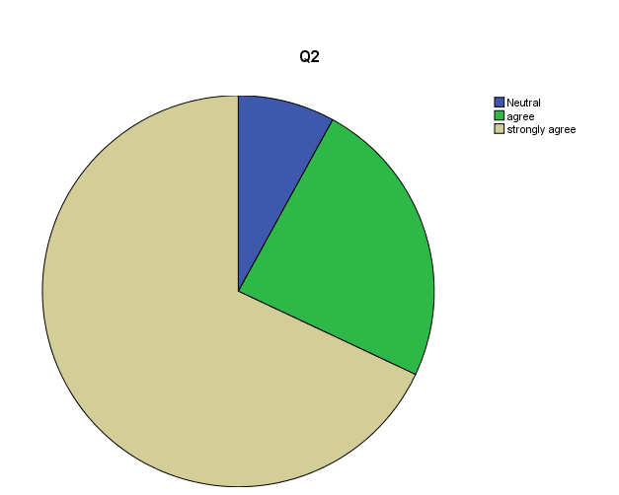

From the answer to question number 2, we get 68% of people strongly agree, 24 % of people agree while 8 % of people are neutral with their online banking services. We get the outcomes 92 % people are satisfied and 8 percent people are neutral. BRAC Bank has always tried that people can easily operate. BRAC Bank first developed a new app through CIF so that more people can easily use it. BRAC Bank also ensures that the information of the Consumers is not misused.
Maximum Respondents are easily operated and transaction from one account to another account and trust on BRAC BANK LTD. Some people are said that internet banking services better than other Bank services and some respondents are to recommend these services to others Banks.

Figure3: Consumers Response Regarding question 3. You feel safe in the online transaction with BRAC Bank.
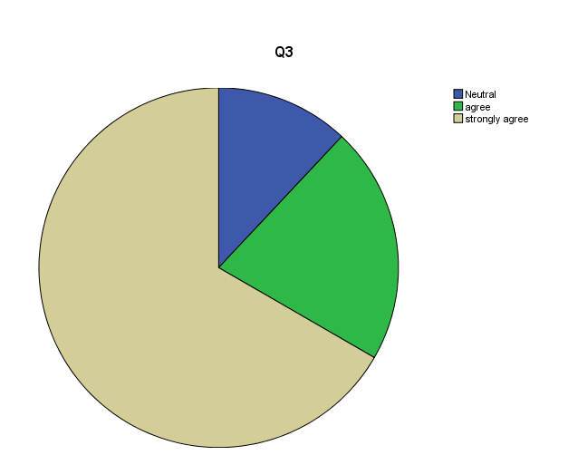

From the answer to question 3, we get the outcomes 66.7 % of people strongly agree, 21.3 % of people agree while 12 % of people are neutral Respondents.
We understood that Consumers feel safe while doing online transaction, and BRAC Bank provides the best support in case if there is any transaction fail and also try to refund the amount on 3 working days. Almost 88% of people are satisfied.

Figure4: Consumers Response Regarding question 4. BRAC Bank Internet banking site is secure for your internet banking
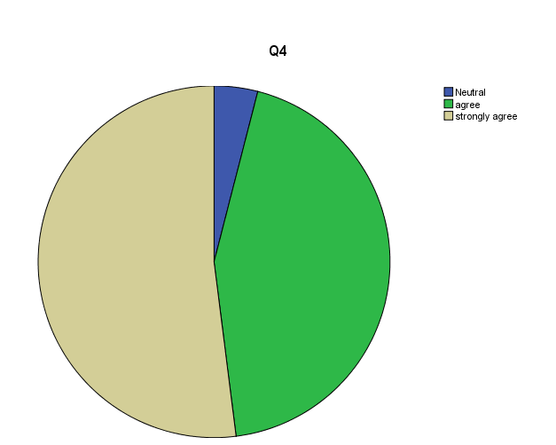

From the answer to question 4, we get the outcomes 52% of people are strongly agreed, 44% of people are agreed while 4% people are neutral Respondents. So we can say above 96 % people are satisfied with their services.
BRAC bank invests a lot yearly to secure their banking site. BRAC Bank provides OTP System that means when any Consumers want to complete a transaction need OTP for complete transaction. Also got a message instantly to the registered mobile number as well as an Email. Thus, Consumers feel secure for all their transactions.

Figure 5: Consumers Response Regarding question 5. The IB website of BRAC Bank provides satisfactory assurances to its Consumers about their online and internet service.
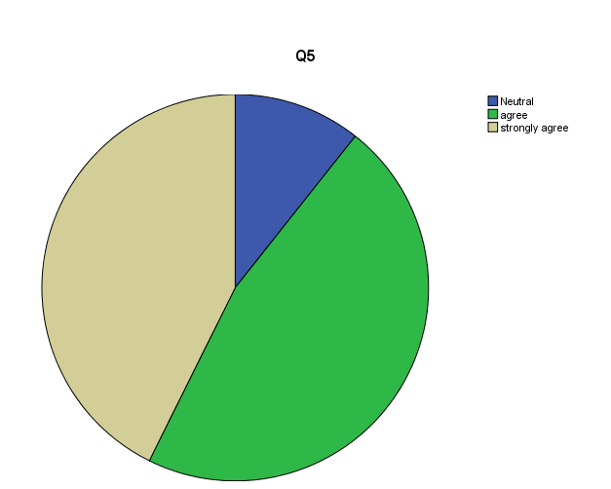
From the answer to question 5, we get the outcomes 42.7% people are strongly agreed, 46.7% people are agreed while 10.7% people are neutral Respondents. So we can say above 89.3% people are satisfied with their services.
BRAC Bank provides some sufficient promised to their Consumers. BRAC Bank websites promise to the Consumers that if somehow there is transaction fail, then the amount of money can be refunded, that is why Consumers feel relaxed to do online banking.

Figure 6: Consumers Response Regarding question 6 you have enough confidentiality and safety on the information that you have given to the BRAC Bank.
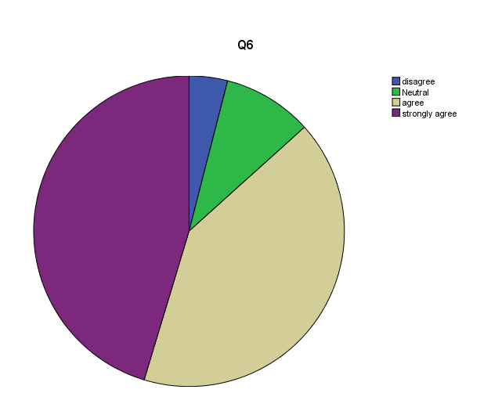

From the answer to question 6, we get the outcomes 41.3%people are strongly agreed, 45.3% people are agreed, 9.3% people are neutral Respondents while 4% people disagreed. So we can say above 86.6% people are satisfied with their services.
BRAC bank always keeps secured Consumer information. The privacy and security system of BRAC Bank is very good and Consumers are also satisfied. We know Consumers get OTP numbers to their registered number provided by BRAC Bank. BRAC Bank does not misuse the Consumers information.

Figure 7: Consumers Response Regarding question 7. It is easy to comprehensive an operation speedily through the BRAC Bank internet banking website.
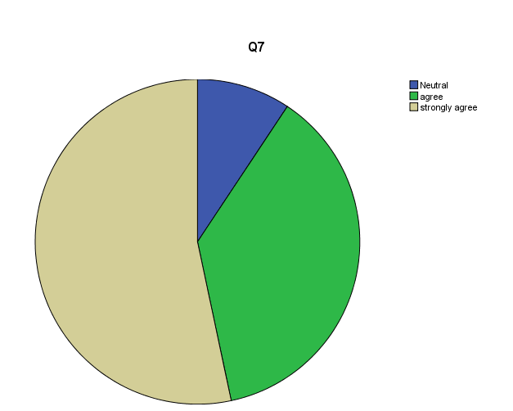
.

From the answer to question 7, we get the outcomes 53.3%people are strongly agreed, 37.3% people are agreed, while 9.3% people are neutral Respondents. So we can say above 90.7% of people are satisfied with their services.
BRAC Bank makes it easy to complete all transactions and quickly. Sometimes there are network issues for which some Consumers have given neutral answers. So now BRAC Bank trying to make so much easier for transactions.

Figure 8: Consumers Response Regarding Question 8. Are you satisfied with the Bank online-based service quality?

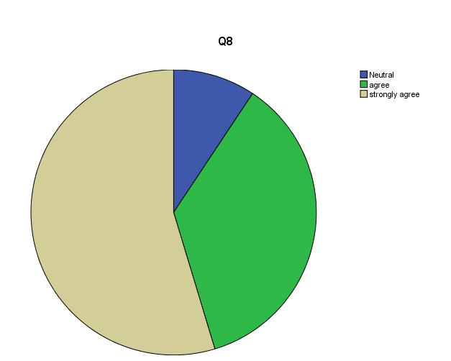

From the answer to question 8, we get the outcomes 54.7%people are strongly agreed, 36% people are agreed, while 9.3% people are neutral Respondents. So we can say above 90.7% of people are satisfied with their services.
Online banking Services because they are easily used and transferred money, bill payment from one account to others accounts. This question very important for my thesis paper. Consumer savings Time for don’t need to go Bank, don’t need to wait for transaction verification and Procedures. They can easily transaction notifications, OTP and others procedures. In this Pie chart, we can say 90.7% of people are satisfied and 9.3% people are confused but did not get any disagree ticked.

Figure 09: Consumers Response Regarding Question 09. BRAC Bank will not exploitation your given data given while doing internet banking transactions.
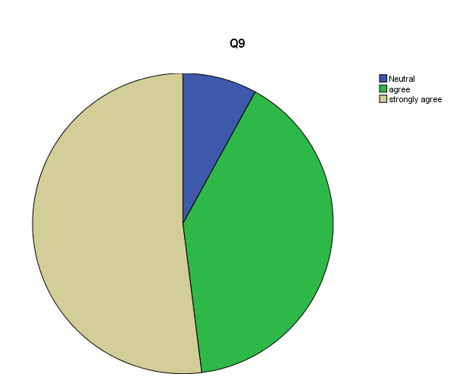
.

From the answer to question 9, we get the outcomes 52 %people are strongly agreed, 40 % people are agreed, while 8 % people are neutral Respondents. So we can say above 92 % people are satisfied with their services.
BRAC Bank always tried to information save, provide enough Security systems. BRAC BANK LTD never shared Consumers Personal information. Just 8% are neutral.
But always BRAC Bank Said to the Consumer don’t share OTP, Credit card Number, and Account Information with another person. BRAC Bank recently upgrades internet banking system so that Consumers easily used and no one collects Consumer details and transfers to others person.

Figure 10. Consumers Response regarding 10: What is your global satisfaction with the IB of BRAC Bank Ltd?

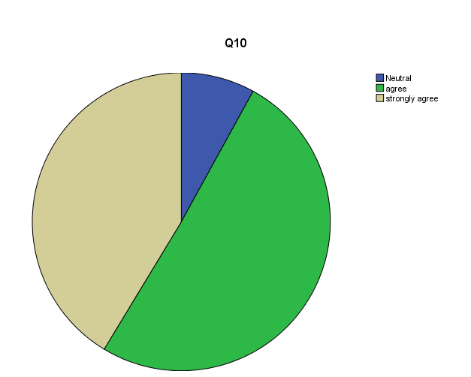

From the answer to question 10, we get the outcomes 50.7 %people are strongly agreed, 41.3 % people are agreed, while 8 % people are neutral Respondents. So we can say above 92 % people are satisfied with their services.
This is a very important question for all Consumers and Online banking satisfaction levels. Most of the respondents agree with their IB services. From The pie chart, we can get a 92 % satisfaction level but didn’t get any disagree ticked up. When I asked the concerned person they are satisfied with their IB services. From the response, it can be determined that most of the respondents are happier with existing services that’s why we can see that most of the people agree with the statement and only a few percent of respondents neutral.

Interpretation: According to my above frequency table and pie chart showed we found positive relationship between Consumer satisfaction and Reliability, Assurance and there is a good relationship. Therefore, we can reject Ha Hypothesis.

CHAPTER 6

CONCLUSION AND RECOMMENDATION

I have really enjoyed my thesis program the learning and experience.
Hopefully, this research primarily indicates the internet banking Features of BRAC Bank Limited.
BRAC Bank can be very important for Consumer satisfaction. Already BRAC Bank invented one app that apps help full for easy use. Name of the apps ASTHA APPS. I would like to improve this research and go on emerging it with a huge amount of data collection. The Consumer base of internet banking should concentration more on service quality, security and privacy, assurance and consistency structures of IB. Also, Consumers should be attentive to the unethical process. Like phishing, spoofing, sniffing which can be used by hackers. Moreover Bank more aware to make their internet banking services more quality full for their Consumers.

Recommendation:
BRAC Bank internet banking so the people of Bangladesh can be familiar with the latest and time-saving Technology. The Information and Communication Technology segment of Bangladesh is being developed day by day. We should takings the chance to develop ourselves not only in banking but also for the possible improvement of the nation. We still dream to see internet connectivity at each corner of Bangladesh. Consumer comments and experience can be a great asset to research further to bring success in not only internet banking but also different ICT fields. There should be more structures involved in Consumer satisfaction. BRAC Bank ltd may create an internet-based survey which is easier to reach internet banking Consumers. It can be compulsory once when they log in to their internet banking interface. BRAC Bank at first provides easily accessible and reliable apps (ASTHA APPS) that will definitely reduce the cost of together parties. Also, all the major Banks of Bangladesh Bank must take some necessary steps to make Internet banking more reliable, easily accessible.

REFERENCE

Annual Report 2018, 2019, 2020 of BRAC Bank Limited

BRAC Bank Ltd Website
http://www. BRACBank.com
*338294889_Analysis_of_Consumer_Satisfaction_on_Online_Banking_A_Case_Study_on_One_Bank_Limited
* https://www.researchgate.net/publication/295490969_Consumers_Satisfaction_towards_E-Banking_in_Bangladesh
* khalid A,S. ( 2012) banking Service and Consumers Satisfaction In Qatar
* Nupur,J, M (2010),E banking and Consumers : Satisfaction in Bangladesh: An analysis
* Khalid A.G (2010) Consumers Satisfaction with online banking: a Case study on HSBC

