HUMAN RESOURCE MANAGEMENT ACTIVITIES OF GRAMEENPHONE

UNITED INTERNATIONAL UNIVERSITY (UIU)

Project Report On

Human Resource Management Activities of Grameenphone

Submitted To:
Dr. Gouranga Chandra Debnath
Assistant Professor
School of Business & Economics
United International University

Submitted By:
Jamiul Alam Zim
111 161 200
School Of Business & Economics
United International University

Date of Submission: 2nd March, 2022

Letter of Transmittal

2nd March, 2022
Dr. Gouranga Chandra Debnath
Assistant Professor,
Faculty of Business and Economics
United International University

Subject: Submission of project report on the basis of Human Resource Activities in Grameenphone

Dear Sir,
This is the project report that you have assigned me as a requirement to complete all of the course of Human Resource Management studies. I have prepared the report properly. This project report is based on the Human Resource Activities of Grameenphone.

I therefore hope that my analysis in the report meet your expectation. It has been an excellent experience for me preparing the report.

Sincerely Yours,
Jamiul Alam Zim
111 161 200
BBA Program
United International University

Acknowledgement

At the beginning, I want to thank the Almighty God for all the blessings he showered upon me to come to this part of my life and I also want to thank my project supervisor Dr. Gouranga Chandra Debnath, Assistant Professor, Faculty Of Business and Economics. United International University for giving me proper guideline to complete the report properly.
In this ongoing pandemic situation it was very hard to go out in the field to collect information to collect information on Grameenphone, also Grameenphone has tightened their security measures and regulations for visitors, so, to complete the report I collected a large portion of information from online searching (like google and other websites) and some limited official documents of Grameenphone which contains some information about the organization.

Executive Summary

Grameenphone has more than 2000 employees who are working permanently and temporarily. The company always expects superior performances from their employees that’s why the company always maintains a structured and better Human Resource practice. December to January is Grameenphone working year, their HRM follows a particular process. They put great effort to their recruitment process, after completing different important steps they fulfill their employee recruitment and then they go to the employee selection step. After recruitment and selection they maintain the procedures of orientation, training and development, compensation system and performance appraisal. There different types of managers and executives for each departed of HR activities, they are in charge to execute the HR activities of Grameenphone. In this report we are going to discuss about the Human Resource Management or Human Resource activities of Grameenphone.

Contents
HUMAN RESOURCE MANAGEMENT ACTIVITIES OF GRAMEENPHONE 1
2
UNITED INTERNATIONAL UNIVERSITY (UIU) 2
Project Report On 2
Human Resource Management Activities of Grameenphone 2
Letter of Transmittal 3
Acknowledgement 4
Executive Summary 5
CHAPTER 1 : INTRODUCTION 8
1.1 Background of the report 9
1.2 Origin of the report 9
1.3 Objectives of the report 10
1.4 Methodology 10
1.5 Scope of the report 10
1.6 Limitations 10
CHAPTER 2 : COMPANY PROFILE 11
2.1 Company Profile 12
2.2 Logo of Grameenphone 13
2.3 Mission Statement : 14
2.4 Vision Statement 15
2.5 Values 15
2.6 Relation between Grameenphone and Telenor 16
2.7 Products and services of Grameenphone 17
CHAPTER 3: HR ACTIVITIES IN GRAMEENPHONE 18
3.1 HR Activities of Grameenphone 19
3.2 Importance and purpose of Human Resource Management 19
3.3 Human Resource Planning 19
3.4 Recruitment and selection procedure of Grameenphone 20
3.5 Recruitment procedure planning 21
3.6 Different types of employee recruitments 22
Regular recruitment 22
Temporary recruitment 22
Part time recruitment 23
Project based recruitment 23
3.7 Sources of recruitment 23
External Source 23
Internal Source 24
3.8 Employee Selection procedure of Grameenphone 25
3.9 Training and Development program of Grameenphone 26
3.10 Performance Appraisal System Of Grameenphone 28
3.11 Compensation system of Grameenphone 32
3.12 Leave Management Of Grameenphone 34
3.13 Human Resource Information System Of Grameenphone 36
CHAPTER 4: FINDINGS, RECOMMENDATIONS and CONCLUSION 36
Findings And Analysis 37
Recommendations 38
Conclusion 39
References: 40

CHAPTER 1 : INTRODUCTION

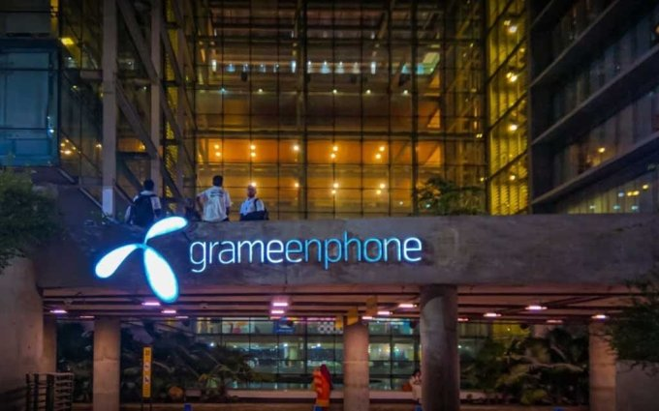

Background of the report
This report is prepared based on the Human Resource activities of Grameenphone Bangladesh. How Grameenphone do their Human Resource works, how do they manage and control their employees, how do they plan, organize, control and imply these activities etc. are inserted in this report.
In this report we will receive lots of information on how to handle Human Resource activities in an organization, how to organize the employees on the basis of HR rules and regulations, how to imply HR to an organization.
It was an excellent experience to get an opportunity to work on project report of Grameenphone. While making report of the human resource division of Grameenphone, I discovered that there Are very less differences between real life and academically concepts.

Origin of the report
Nowadays Human Resource Management is very much important for any organization. An organization can run properly because of Human Resource Management or HRM. Collecting, allocating, maintaining and controlling resources are important functions of HRM. Guiding and controlling employees or human resources for the ultimate betterment of the organization is one of the main goal of HRM. In this Human Resource Management report of Grameenphone I tried to collect the information of the organization's daily and ultimate HRM activities.

Objectives of the report
The main objectives are to get a clear idea of Human Resource Management activities in Grameenphone. There are also other important objectives, they are :
- To know the Human Resource Planning Of Grameenphone
- To Analyze the recruitment and selection process of Grameenphone
- To find the different training and development programs of Grameenphone
- To analyze the performance appraisal management methods of Grameenphone
- To review their compensation system and benefits system of Grameenphone
- To find out the problems related to the objectives
- To make some recommendations to solve the problems

Methodology
I have used secondary data collection method. So all of the information in this report is based on Internet.

Scope of the report
This report contains structured description on the Human Resource Management activities of Grameenphone. The reason of preparing this report is to gain detailed knowledge about the organization, organization's structure, it’s HRM practices, current status, how the organization applies HRM functions etc. Every important topics are explained in detail in this report.

Limitations
As my primary concern was about organization's internal data so it was not easy for me to collect Grameenphone internal data. First of all in this Covid-19 pandemic Grameenphone has hardened their restrictions on visitor policy as a result I was not able to visit the organization, second of all getting a lot of information is very hard by searching through the websites only. As I am working only based on the secondary data so it makes me working hard to get actual relevant data and it took so many time and efforts of mine.

CHAPTER 2 : COMPANY PROFILE

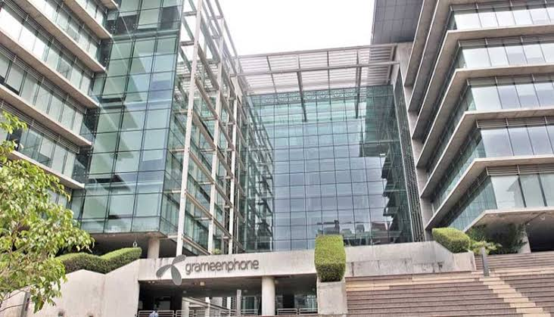

2.1 Company Profile
Grameenphone Limited is one of the most popular and leading telecommunications company in Bangladesh. Grameenphone is popular among a lot pf customers because of their amazing friendly services. Customer retention and customer satisfaction is their main focus. It is the biggest mobile phone operator in the country. Sectors like revenue, coverage, subscribers etc. in every sector Grameenphone is the largest operator in Bangladesh. Grameenphone has built their network on a national scale.
Grameenphone was founded in 1997 in Dhaka, Bangladesh. Iqbal Quadir and Muhammad Yunus was the founder of Grameenphone. Founder Iqbal Quadir was inspired by the Grameen Bank micro credit model, then he envisioned of a business structure where cellular phone network can serve as a source of income. He worked hard for three years to receive support from Grameen Bank and Norwegian telecommunications company “Telenor”.
Grameenphone was incorporated as a private limited company on 10th October, 1996.
On 28 November 1996 Grameenphone received the cellular phone operation license from the Posts and Telecommunications Ministry.
On 26 March 1997 which was the Independence Day of Bangladesh Grameenphone started their operations.
Grameenphone is successfully providing 2G and 3G services throughout the country. On 19th February 2018 Grameenphone was awarded with the license of 4G/LTE cellular mobile phone services.

2.2 Logo of Grameenphone
Grameenphone current logo is similar to their parent company Telenor's logo. It is a blue colored flower shaped logo. The color of the flower is blue and it contains three leafs and they are connected to each other in a center point, this also represents the “connectivity” among people through mobile network. It is more modern and professional logo and it represents the advanced view of telecommunications. Beside the logo there is a black wordmark which is “Grameenphone”.

Figure 1: Logo of Grameenphone Limited

2.3 Mission Statement :
“We are here to help our customers”. In this short line they actually means that their mission is to give their customers the full advantage of connectivity. Their success is determined by how lovingly the customers promote them.

2.4 Vision Statement
“Developed and a connected society”. Their vision is to provide the strength of digital communication so that people can improve their lives, society and built an amazing future for everyone.

2.5 Values
- Make it easy
- Keep promises
- Be Inspiring
- Be respectful
- Figure 2 : Values Of Grameenphone
- Make It Easy: Making a product or service which is easy to use, smooth is very crucial. If the customers can get easily access to the services and if they are able to use the service easily then the customer satisfaction will be much higher. After all Grameenphone is trying to make people's lives easier, that’s why “Make it easy” is their first value in the list.

- Keep Promises: In this competitive business world keeping promise is very much important. If a businessman or a business organization cannot keep their promises then failure will be the ultimate destination. That’s why Grameenphone is very determined to keep their promises.

- Be Inspiring: Inspiration is another important key to success in every aspect of life. Grameenphone always try to be inspired and give people inspiration through their work. That’s why they always try be creative and put the creativity in their which inspires themselves and also the millions of people of Bangladesh.

- Be respectful: Being respectful to thyself and others is also important. If we don’t respect ourselves then we will never be able to discover our true potential in life and if we don’t respect others then people will never respect us. That’s why Grameenphone is respectful to their work and also respectful to their customers. They acknowledge and respect the local cultures and also try to be the part pf local communities wherever they operate.

2.6 Relation between Grameenphone and Telenor
Norwegian Telecommunications company “Telenor” is the parent company of Grameenphone. It is a joint venture between Telenor and Grameenphone. Telenor holds 55.80% of ownership and Grameenphone holds 34.20% of ownership. General retails and institutional investors hold the rest of the 10%. Because of Telenor and Grameenphone's relationship and their joint venture telecommunication services has reached to a superior level over the years. The international shareholders from Telenor offer technological and business development support and local shareholders from Bangladesh offer their economical and management skills. Shareholders from both companies are highly determined to Bangladesh and it’s development in telecommunications industry.

2.7 Products and services of Grameenphone
Grameenphone is one of the primary service provider pf telecommunications sector in Bangladesh. It is a digital telecommunications network operator based on the GSM standard 900MHzz, 1800MHz, 2100MHz frequency bands. And the license is given by the Bangladesh Telecommunications Regularity Commission (BTRC).
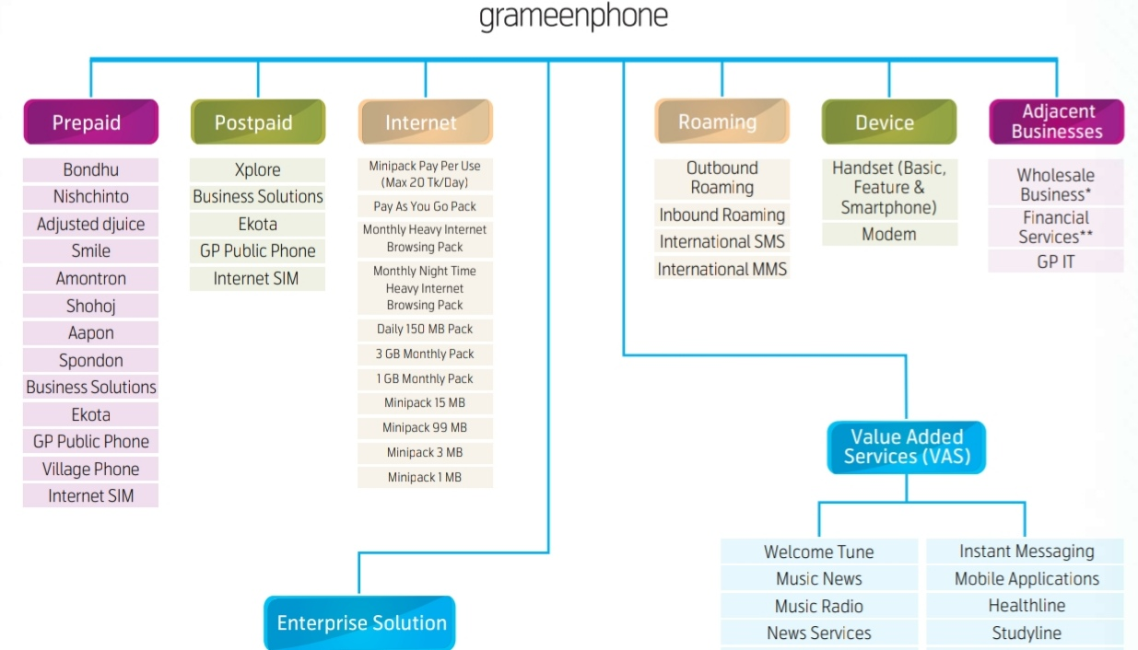
Grameenphone provide their services both in rural and urban areas of Bangladesh. They have a wide range of products and services. Products and services like Prepaid, postpaid, Internet, Business solutions etc. Their range of products and services are given below in the following

Figure 3: Products and services of Grameenphone

CHAPTER 3: HR ACTIVITIES IN GRAMEENPHONE

3.1 HR Activities of Grameenphone
Grameenphone is the leading telecommunications company of Bangladesh. Grameenphone has spent over 347.4 billion BDT to form the network base since 2018. They have formed the largest and strongest mobile phone network in the country. More than 2000 employees are working in Grameenphone. So, it means that it’s a pretty big organization and if the organization is big then the proper HR activities become very important for that organization. That’s why solid HR practices always comes first at Grameenphone. Good HR practices consist of Planning, organizing, leading and controlling. No organization can run properly without these basic functions of HR, and Grameenphone is working very hard to develop their HR practices to keep pace with the advanced world.

3.2 Importance and purpose of Human Resource Management
In this modern era of business every organization is focusing on their HR division a lot and Grameenphone is also doing the same. Because HRM or Human Resource Management is the backbone of any organization. For example, an organization has so many technical and natural resources but they don’t have proper knowledge of using those resources, the employees of the organization have no skills or the superiors of that organization don’t know how to plan, organize and execute the resources, then this organization will never be able to succeed in this world. That’s why Human resource management is one of the important sectors in this world, any person or company can properly plan, organize, lead and control the works amd manage the employees by applying proper HR activities.

3.3 Human Resource Planning
In “Human Resource Planning” phase an Organization determines their present amd future human resource needs, inventories to achieve their ultimate destination. Grameenphone always takes its HR planning process very seriously because the main success depends on this planning. In this HR planning phase Grameenphone’s HR planning phase is constructed on three questions. These questions are:
- Where are we?
- Where we want to go?
- How to reach our destination?
In this HR planning process Grameenphone analyze their organizational targets, they determine their current or present level, human resource needs, they determine their present HR inventories. Then they determine their future destination, they set their future goal, future human resource target or inventories in second step. In the last step they make an overall action plan on achieving their desired goals.

3.4 Recruitment and selection procedure of Grameenphone
Recruiting and selecting the best and suitable employee is the primary HR activities of Grameenphone. A suitable, perfect and hardworking employee can be the biggest asset of an organization. That’s why a recruitment and selection procedure is very much important. Grameenphone mainly use three stages for recruitment and selection process. These are “Entry level management”, which is used for hiring employees in entry level positions, “Mid-level management”, this stage is used to hire mid-level employees and the third step is “Internal search”, recruiters search for the right candidates from inside of the organization in this phase. This stage is mainly used for top level hiring.

3.5 Recruitment procedure planning

HR Planning
Selection
Source of recruitment
General policies
Advertisement
Manpower

Job description

Figure 4: Recruitment procedure of Grameenphone

3.6 Different types of employee recruitments
There are more than 2000 employees in Grameenphone, every year the organization hires different types of employees for different purposes and divisions. These different types of recruitments are:
- Regular recruitment
- Temporary recruitment
- Part time recruitment
- Project based recruitment

Regular recruitment
In regular recruitment Grameenphone recruits employees for general works and projects. Regular employees are hired in regular recruitments for marketing, sales, finance, auditing etc. tasks. Here the regular employees works under the general rules of the organization. They work 5 days a week, from 9 am to 5 pm. receives the compensation and other benefits which are for the regular employees.

Temporary recruitment
In temporary recruitment Grameenphone hires employees in a temporary basis. Here the temporary employees can work part time or full time based on the nature of their jobs. Temporary recruiting occurs mainly in emergency situation where one or more employees are needed temporary.

Part time recruitment
For part time recruitment Grameenphone mainly focus on university students or fresh graduates who are looking for internship. Normally they recruit fresh graduate interns in their part time recruitment. Here, the part time employees mainly work 5/6 hours per day, ¾ days per week. They also receive a remuneration and some other benefits.

Project based recruitment
Every year Grameenphone plans new projects, launches mew projects, campaigns and workshops. Sometimes for this particular projects or campaigns they need some particular employee who will only work on those projects, and this reason project based recruitments occur in Grameenphone. But it does not occur in a regular basis, it happens occasionally. Grameenphone does project based recruitment only where it is extremely needed, otherwise their regular campaigns or projects are overseen by regular employees.

3.7 Sources of recruitment
Grameenphone uses two sources for recruiting employees. The sources are “External source” and “Internal source”. This two types pf recruitment sources are discussed below:

External Source
In this external source Grameenphone uses different methods fpr recruiting. Methods like
- Job Advertisement in media: Grameenphone regularly posts job advertisements in their social media accounts (LinkedIn, Facebook etc.), also they have a decorated website where they post different types of job advertisement every time.

- Educational institutions/Campus Liaison: Grameen maintains a strong liaison with different universities for the recruitment of intern and graduate students. Universities like United International University, Brac University, East West University arranges job fair every year where Grameenphone actively participates.

- E-recruiting : Because of Covid-19 nowadays Grameenphone uses E-recruiting method as an external source where they posts job advertisement s only in social media platforms, candidates apply in online and the whole interview process occurs on a virtual platform.

- Management Consultants: Sometimes Grameenphone uses management consultants as their external source of recruitment where they male contact with third party consultancy firm who recruits and selects candidates for them. But Grameenphone uses this method a lot, nowadays they mainly rely on Media job advertisement, Campus liason and E-recruiting.

Internal Source
Internal sources are also important like External sources, because the employees who are working in the organization they are also important and capable to do other jobs which are required by the company. Grameenphone's internal sources of recruitment are:
- Promotion: Promotion is a popular and common method of internal sources. Every organization uses this method to recruit employees from their internal work space. Grameenphone regularly uses “Promotion” for their internal recruitment. The company always monitor their employee closely and evaluate the employees' performances properly so that they can promote the deserving candidates to better positions.

- Employee Referrals: In this method an employee of the organization refers his friend, familiar person or another employee as deserving candidate. Sometimes Grameenphone uses Employee referrals for internal recruitment.

- Transfer: Transfer is another method of internal recruitment. It means sending an employee from one job to another, here the transferred employee's job or duties remain same or sometimes slightly changes. Employees become more versatile, skilled and experienced because of this “Transfer” system. Grameenphone uses Transfer method for their internal recruitment, sometimes they transfer employees from one department to another to fill up position gaps and sometimes they also transfer employees to find out the right and suitable candidates for a job.

3.8 Employee Selection procedure of Grameenphone

Initial Screening
Face To Face Conversation
Written Exam

Final Selection
Medical Test

Figure 5: Employee selection procedure of Grameenphone

3.9 Training and Development program of Grameenphone
New employees or existing employees need different types of training in every organization. Training is the best way to improve an employee's knowledge, skills and dedication. Training and development program is very important nowadays, because in training employees learn how to do their job more effectively and more efficiently, they also learn about the other kinds of jobs and other ways to do their jobs properly which makes them more capable as a worker.
Grameenphone is making their business bigger and profitable every year, and a lot of people are surprised that but there are no secret ingredient behind the success of Grameenphone. The ingredient behind Grameenphone's success is very simple, it is “Good training and development programs”. Yes, Grameenphone always arranges different fruitful training and development programs for their employees that makes their employees more effective and efficient. Grameenphone mainly focus on three goals in their training and development programs. They are,
- Increasing the productivity

- Developing the employees

- Making the organization more flexible and adaptable to the employees

Now, we are going to discuss different training methods of Grameenphone below:
- Orientation Training: This orientation training is the basic level training of Grameenphone. When a new employee or some new employees join the company, the HR department arranges an orientation program or orientation training. In this training program the new employees are taught about the basic company rules and regulations, they are informed about what to do and what not to do, in this program some demo works or presentations are conducted which gives the new employees a clearer idea about the company overview.

- Training in different institutions: Sometimes new and existing employees are sent to different training institutions for training in some particular sectors. Sectors like supply chain management, finance etc. But normally the professional trainers of Grameenphone handles the training programs most of the time.

- Training in overseas: Sometimes Grameenphone sends their selected employees to overseas of advanced training. The company borne the expenses of this overseas training.

- Corporate culture training: This training is mainly for new employees. In this training new employees are taught about the total corporate culture, ethical codes. Here the employees are also taught about the dress code which is formal for male from Saturday to Wednesday and Smart casual in Thursday, for female there is nor particular dress code but it must be “Modest”.

- Product and service training: Product and service training is mandatory for new employees who are working in customer service or product service department. In this training the employees are taught about different types of products and services of Grameenphone and they are also taught about using those products so that they easily inform the customers about the products and how to use them properly.

- On the job training: A bigger portion of Grameenphone's training is “on the job training”. That means the employees get hands on experience on different tools machines and topics. Employees learn about a lot of things during their different works and projects.

- Off the job training: Sometimes the company arranges different off the job training programs. Trainings like Code of conduct training, overseas training, corporate culture training, orientation training etc.

So, here we can say that Grameenphone always keeps in mind that training and development program is very important for employees and the organization itself. That’s why there are various types of training programs occur in the company every year so that existing employees can develop themselves more and the new employees can make themselves a better human resources for the company.

3.10 Performance Appraisal System Of Grameenphone
Performance appraisal is the procedure to identify, evaluate, appraise and develop the performance of employees to reach the desired destination of the organization.
Performance appraisal is very much important for any organization. If the performance appraisal does not occur properly or gets neglected then the employees performance won’t be measured as a result everyone will be unlearned about their performance level and the company will not be able to achieve the ultimate success.
Grameenphone uses “Graphic Rating Scale” method as their performance appraisal system. For evaluating the performance of the employees it is a very effective method. In this Graphic rating scale method the suitable traits and works are listed for every role and then the employees are rated on those traits on a numbered scale.
An example of their performance appraisal method “Graphic rating scale” is given below:

Employee Name : Arafat Islam Position : HR Executive

Employee Payroll Number : 01256

Department : Human Resources

Type Of Review : Annual

Date The employee started work in this position : January, 2021

Last Performance Review : December , 2020 Scheduled Appraisal Date : January – December

Here, we can see that the company's working is set from January to December. And the set a particular for every employee from January to December. The reviewer, reviewed and the manager sign in this form to validate the performance appraisal.

Key Performance Indicator of Grameenphone:

Level – O (Outstanding)

- Employees completed all the task perfectly
- Employees fulfilled the job targets properly
- Employees contributed on a large scale in company’s achievements
- Performance is outstanding in every aspect of the job

Level – V (Very Good)

- Employees fulfilled most of the job targets
- There were almost no mistakes in their performance
- Performance is in company standard level

Level – G (Good)

- Performance is satisfactory but there are some scope of improvements

Level – U (Unsatisfactory)

- Performance is very poor
- Failed to achieve almost every job targets
- Performance is totally below company standards

Here, we can see that Grameenphone review their employee performance in four categories or levels. Level O is means top level performance, Level V means performance is very good and company standard, Level G means performance is good but there can be improvements amd Level U means performance of the employee is really weak.

3.11 Compensation system of Grameenphone
Compensation system is the system where total rewards or salary package is given to the employees for their work in the organization.
The compensation system of Grameenphone is prepared in a way where attracting, retaining and benefitting skilled and efficient employees is very much easier. The company always compensate their employees based on the Internal and external equity, direct cash (salary) and non-cash (other benefits, incentives) compensation. The materials included in the company's compensation system are:
- Fixed salary
- House rent
- Overtime allowance
- Medical allowance
- Performance bonus
- Other bonuses
- Provident fund
- Gratuity

- Fixed salary: Grameenphone has a general fixed salary for their employees. Employees in different positions has a different levels of fixed salaries. The salary range depends on the employees' position, work, efficiency and capability. When the company prepares an employee's salary range they always consider some important factors, they are :

- Competitive salary range in the industry
- Affordability of the company
- Company growth
- Economic welfare of the individual
- Equality and equity

- House rent: Grameenphone has a house rent allowance system under their compensation system.

- Overtime allowance: Overtime allowance is another important compensation under their compensation system. If an employee does overtime or work more than his fixed office hours then he/she gets an overtime allowance. Their overtime rate is an employee's hourly rate of his monthly salary multiplied by 2.

- Medical allowance: Medical allowance is one of the most important allowance of Grameenphone's compensation system. The company provides a competitive medical allowance for their employees who works in different positions and departments. If any employee gets sick or needs a major medical attention then they can use their medical allowance in time of need.

- Performance Bonus: Performance bonus is also included in their compensation system. Performance bonus depends on employees' performance. If an employee perform consistently well or if an employee fulfill job target then he/she receives a fair amount of performance bonus.

- Bonus: There is a bonus payment for the employees in different occasion. Employees gets festival bonus (depending on Eid, Puja or Christmas or other religious festivals or national festivals).

- Provident Fund: There is provident fund system for the employees. 10% of the employee’s basic salary is granted in the provident fund.

- Gratuity: There is also a gratuity for the employees under Grameenphone's compensation system. Here, if an employee has completed 5 years of his service in the company then tantamount of his 1 month's basic salary is granted in the gratuity fund. If an employee has given 5 to 10 years’ service in the company then tantamount of his 1.5 month's basic salary is granted in the gratuity fund. And if an employee has given more than 10 years of service in the company then tantamount of his 2 month's basic salary will be in his gratuity fund in each year.

3.12 Leave Management Of Grameenphone
Leave Management system or Employee leave management means the procedure, rules and regulations of processing employee leave or time off applications. In this system employee's application for vacation or time off from work is controlled and tracked.
Leave management in Grameenphone is very strict and flexible at the same time. A lot of employees work in this company, so managers have to keep good eyes on tracking and controlling the leave management system. There are various types of leaves which the employees can apply for. They are:
- Earned Leave

- Maternity Leave

- Paternity Leave

- Sick Leave

- Emergency Leave

Earned Leave
Earned leave is the type of leave which an employee earns by working in the organization. An employee mainly earns 20-23 days of leave in a year. If an employee works 5 days a week then he/she earns 20 days of leave. If an employee works 6 days a week or does overtime or extra work a lot then he/she earns 23 days of leave.

Maternity Leave
Employees are given maternity leave when they are expecting child or already gave birth of a child. In Grameenphone female employees are given 6-9 months of maternity leave, the employees who are working in the company at least for 8 months – 1 year receives maternity leave.

Paternity Leave
Male employees of Grameenphone receive paternity leave. Employees who worked for a year in the company can take this paternity leave for 15 days. Also they receive a monetary benefit during this leave.

Sick Leave
Another type of leave in Grameenphone is “Sick leave”. More than two thousands employee work in this company, so the managers and HR department always put the safety and health issues of the employees at first. That’s why employees receive a sick leave if necessary. If an employee is sick then he/she can take 15 days of sick leave. Depending on the health condition of the employee this leave can be increased from 15 days to 21 days.

Emergency Leave
Sometimes an employee can face some kind of emergency situation in his/her personal life. Situations like family problem, unexpected accident etc. In that case an employee can take emergency leave with the permission of HR manager and the branch director.

3.13 Human Resource Information System Of Grameenphone
Grameenphone take care of their HR activities regularly. Managing more than 2000 employees is not an easy task, Grameenphone maintains and collects all of the employee information and their HR tasks in a digital HR server. Their HR server is a computerized network which run through a computer software. In this server the HR managers and executives maintain their daily HR activities, HR planning, employee information, work schedules, employee performance appraisal files etc. everything is recorded in their HR server.
Every month the HR manager updates the company's HRIS (Human Resource Information System) with various types of new and updated work files and information so that everything which is related to HR gets maintained properly.

CHAPTER 4: FINDINGS, RECOMMENDATIONS and CONCLUSION

Findings And Analysis

Findings in Training and Development
In Grameenphone's training and development we found that there is different types of socialist trainer for their different training phases. But there are a slight problem in their training programs. They don’t have enough logistical support for the overseas training. Training in overseas is a bit much expensive and it requires lots of technical and technological support, but in recent years Grameenphone couldn’t support their overseas training programs properly.
Findings in Turnover rate
Grameenphone's turnover rate is very low because of their beautiful work environment. But from March 2020 – July 2021 their turnover rate increased. The reason behind their increased turnover rate is corona pandemic and some less skilled workers who weren’t fit for the pressurized job during pandemic.

Recommendations

Grameenphone is doing an amazing job in the telecommunications and media field. They are working effectively and efficiently in their marketing, human resource, finance etc. But I think there are some suggestions which will help them to become more developed. That’s why I have given some recommendations below:

- To decrease their recent turnover rate Grameenphone needs to organize a “Talent Games” or “Talent Hunt Games” for new employees as a part of their interview or selection step. As a result the selection process will be more entertaining, new recruits will feel more comfortable and it will be easier for the recruiters to find out the great talents for their organization. As a result selecting the best and more skilled employees will be much easier.

- Grameenphone must increase their logistical support for overseas training. They need to increase their training budget and technological support for overseas training.

- Grameenphone's most of the training is off the job training, some or few training sessions are on the job training. But they should increase their on the job training sessions. They can organize “Work and Training” programs regularly where employees will do their office jobs as well as they will learn new things about the job and receive trainings.

Conclusion

I have learned a lot about Grameenphone and their Human resource management system while preparing this report. I have learned about their strategic human resources, recruitment system, selection system, training and development programs, compensation system, human resource information system etc. I have learned that Grameenphone achieved their grand success in telecommunications industry for many reasons and one of them is their strong and updated Human resource management practices. In this era of globalization considering the workers or employees as “Resource/Human resource” is very much important. Because if the employees are treated properly, compensated properly for their hard work and if they are considered as “Assets or Human resource” then the employees will give their best to get the job done and they will also help the organization to reach their destination of success. And Grameenphone is doing the exact same thing. They always consider their employees as human resources and try their best to maintain that resources as a result their Human resource activities are in a great shape.

References:

1. About Grameenphone. (n.d.). Retrieved from Grameenphone: https://www.grameenphone.com/about
2. GrameenPhone HRM Salaries in Dhaka, Bangladesh Area. (n.d.). Retrieved from Glassdoor: https://www.glassdoor.com/Salary/GrameenPhone-HRM-Dhaka-Salaries-EJI_IE405018.0,12_KO13,16_IL.17,22_IM1237.htm
3. Human Resource practices in Grameen Phone Company. (n.d.). Retrieved from UKESSAYS: https://www.ukessays.com/essays/management/human-resource-practices-in-grameen-phone-company-management-essay.php?fbclid=IwAR3IOQQsDN_558QtV0CzPXdkeEyQvGbpujY7uS4lAExfSzV0SAR8NGXfgcg

