United International University

Internship Report
On
Outsourcing of Retirement Provident fund (RPF)
(A Study on DATA-PATH limited)

Internship Report
On

“Outsourcing of Retirement Provident fund (RPF),
A Study on DATA-PATH limited”

Course title: Internship

Submitted to:
Mofijul Hoq Masum
Assistant Professor
School of Business & Economics
United International University
Submitted By:
Md Jaman Sharif
ID: 114 133 014
BBA IN AIS

Letter of transmittal
22 May, 2018
Mofijul Hoq Masum
Assistant Professor
School of Business & Economics
United International University

Subject: Submission of the Internship Report.

Dear Sir,
I am really delighted to submit the internship report on the “Outsourcing of Retirement Provident Fund (RPF), A Study on Data Path Limited.” which is a part of my Internship Program at Data Path Limited as a requirement of the BBA program.
To set up this report, I attempted to commit my best exertion and led broad diagnostic work to discover the investigation pertinent materials. I trust that the experience I have procured from this, will be a significant resource in my vocation. Amid the procedure of arrangement, because of different imperatives there might be a few missteps. I would be appreciative in the event that you consider those from passable point.
Finally, I hope that, you will enjoy going through this report as I have felt great pleasure to prepare it. I shall be pleased to answer any sort of query you may have regarding this report.

Sincerely yours,
………………………………..
Md. Jaman Sharif
ID: 114 133 014
BBA in AIS
United International University

Acknowledgement

To attain any task successfully, the help of others is a must. Without the help of the number of persons the prosperity remains tacit. I am very much well off to get the sincere steerage and overseeing from a number of people.
Firstly, I want to deliver my gratefulness to almighty Allah for the preparation of the report successfully. Then, I would like to thank my supervising teacher Asist. Pro. Mofijul Hoq Masum for giving me to complete in all parts on the process of arrangements of the internship paper.
It is very hard to complete such work without the backing of others. From the very beginning, my seniors, colleagues, Team leader and Manager helped me by giving their valuable time to provide me suggestions, answering my questions and helping me with different documents and materials.
My thanks goes to Mr. Jim Hudson (President, Data Path Limited) for giving me the opportunity to do my internship in the organization. I also like to acknowledge Mr. Ashfaqur Rahman, Managing Directors and Mr. Khandaker Fazle Rabbi, Manager of Human Resources in Data Path Limited for their precious support all the time. My specials thank goes to Mr. Md. Mahabubur Rahman, Manager of work-flow Department who help me with my research and gave me valuable suggestions to prepare this report. Finally, I would like to thank my friends for their support and valuable suggestions.

Executive Summary

Outsourcing is a practice used by different companies to reduce costs by transferring portions of work to outside suppliers rather than completing it internally. Outsourcing is an effective cost-saving strategy when used properly
Social security systems in the United States are very strong. The government as well as the citizen is very much respecting about the retirement benefit. The government makes it masterful for the employer to give the retirement benefit to their employee at their retirement. The Internal Revenue Service (IRS) and the Department of Labor (DOL) instruct the employer to set up the retirement benefit plan to give their employee retirement benefit which is known as “Plan” in the retirement industry.
Every employer in the United States who has the retirement benefit plan mandatorily follows the IRS rules and regulations while preparing the report. As a part of maintaining the rules and regulations the employer has to prepare the allocation report and fill up the form 5500. As TPA Third Party Administrator (TPA) this company’s responsibility is to prepare the allocation Report and prepare the Allocation Letter on behalf of the client. The Allocation Report take on the Plan Specification Report, Census Report, Summary of accounts Report, and Plan totals report, Trust Accounting Report, ADP/ACP Testing Report, and Top Heavy Testing Report. My main focus will be on the rules and regulations which is mandatorily maintained by the employer for preparing the Allocation Report which prepared by the third-party administrator on behalf of the client.
The Bangladesh government is also concerned and sincere about protecting the right of the retired people. US and Bangladesh retirement policy differs in some important points. Bangladesh has policy for the government organization and very for private sector. And the government rules, people’s right, contribution to the economy, dependency, benefit amount etc. also differs. The employees are getting insufficient amount, no strict policy to reduce discrepancy between highly and non-highly compensated employees, no responsible organization for retirement policy etc. are the subject to modify. It may be possible to bring in a structured policy if govt. changes or reshape the policy. This report will help Bangladesh to improve their retirement provident fund as well.

Table of Contents
SL NO | Particulars | Page NO
1. | Letter of transmittal | iii
2. | Acknowledgement | iv
3. | Executive Summary | v
4. | Table of Content | vi
5. | Introduction | 1
6. | Literature Review | 2
7. | Rational of The Study | 3
8. | Objective | 3
9. | Background | 4
10. | Overview of BPO Industry In Bangladesh | 5
11. | Overview of Data-Path Limited  - Data-Path LTD.  - History  - Getting Started  - Vision  - Mission  - Core Value  - Departments | 7-10
12. | Defined Contribution Plan | 11-12
13. | Services | 13-26
14. | Learning | 27-28
15. | Finding & Analysis | 29-33
16. | Recommendation & Conclusion | 34-36
17. | Appendix | 37
18. | Bibliography | 38

Introduction

Rationale of the study:
In Bangladesh, retired population has become an important social concern because, like many other developing countries, there is no social security system. In view of the size of population, scarcity of resources, existing poverty, insufficient health facilities and absence of social security, retired sector is going to be a major problem in Bangladesh.
Unlike other segments, the elderly has not been subjected to demographic research, which partially accounts for low attention to retired issue in Bangladesh society. After a decade, severe problems with regard to retired will occur in the country which will affect the economic sectors. As the retired process increases the elderly people will experience diminishing capabilities.
To facilitate them, the retirement benefit system in Bangladesh should be much more organized both in the public sector and also in the private sector. The government rules and regulations are not well organized to protect the employee benefit. Their employees are not aware about their retirement benefit. The regulatory body to protect the employee benefit is not taking the necessary steps to protect the employee right and benefit. The rules regarding the employer contribution is not up to date with the time. The nature of retirement benefit is not specifically defined or determined in the private sector whether the benefit will be the defined benefit or the defend contribution. There is no specified benefit plan in the most of the organization which can give the old age security to their employee. There is no step taken by the employer to reduce the discrimination among the highly compensated employee and non-highly compensated employee.
The US government is very concerned and sincere about protecting the right of the retired people and securing them financially in retired life. To gain tax benefit advantage and to attract employees most of the organizations adopt retirement plan. The rules and regulations and the reporting procedure of American retirement plan are very complex. To understand all the things and act accordingly is very difficult even for US organizations. And it is very expensive to keep in house retirement plan reporting department. That’s why they hire Third Party Administrators (TPA) to prepare year end reports. This difficult nature of the work makes it more difficult to train new employees to prepare allocation reports. Both the trainees and the trainers face different problems during and after training period.

Literature Review

The concept of outsourcing originate the outsourcing technology “Outside-resourcing” interpretation to get resources from the exterior. The term was used in the economic terminology to indicate the use of external generation to develop the business (Victor, Dumitru, 2012).
According to Entrepreneur Magazine, outsourcing is “the practice of having certain job functions done outside a company instead of having an in-house department or employee handle then; functions can be outsourced to either a company or an individual”.

The purpose of outsourcing aimed at providing companies with more robust cost containment and more revenue-generating tools. As outsourcing becomes more “commonplace,” companies are looking to outsourcing as means to revitalize their business processes and methodologies, reduce costs, and transform their organizations (John, K. and Barbara, 2007).

Lacity and Hirschheim (1993) stated that Outsourcing consists in conducting one or more organizational activities, using external agents.

Rothery and Roberson (1996) “The act of turning to an external organization to perform a function previously performed in-house. It entails the transfer of the planning, administration and development of the activity to the third party.

Bryce and Useem (1998), Outsourcing can be described as the contracting-out of the company’s major functions and activities to an external service or goods provider.

Today, outsourcing involves either Information technology outsourcing (ITO) or Business Process Outsourcing (BPO). ITO involves a third party who is contracted to manage a particular application and includes all related server networks and software upgrades. BPO generally features a third party who manages the entire business process such as accounting, procurement or HR (Ghodeswar and Vaidyanathan, 2008).

Rationale of the study

Internship Program is a post-graduation requirement for all the MBA students. Internship program has been included MBA curriculum for producing talent, up-to-date, smart and efficient executives. Internship means gaining supervised experience. Internship program offers an opportunity to know the environment of a particular organization. Theoretical knowledge is not enough to be perfect. To implement the academic knowledge to practical field internship is important. Internship program for me is a perfect adjustment between theory and practice in the correlation of neoteric business world. Internship program provides a platform for students to gain real life experience about professional work and learn new things and develop new skill in the process. In this report I am going to describe my knowledge and experience I have gathered form Data path Ltd.

Objective

Broad Objective:
The Broad objective of this report is to get an idea about the American retirement benefit plan and gather knowledge about the rules and regulations regarding the retirement benefit plan. Gain experience in the Bangladeshi corporate world and also gain knowledge by completing this affiliation report. I can relate my academic preparation with the work I have done at the organization as well.

Specific Objectives:

- To acquire a clear knowledge about all the division and departments of Data Path Ltd.
- To know the practical work on the “workflow and form 5500” of the Retirement plan.
- To get detail idea of about Relius, TPA, FT William and other software and websites related to the retirement plan.
- To apply theoretical knowledge in the practical field.
- To achieve the practical knowledge of corporate strategy.
- The problems involved in training new employees and

Background

Datapath Ltd. is a registered outsourcing company owned by Jim Hudson and John Humphrey. July Business Services is the mother company of Datapath Ltd. July Business Services is a professional services firm committed to delivering focused retirement plan and other administrative services to business clients. It works closely with employers and financial partners to build customized services to meet their unique goals. Its consultants provide solutions for plan implementation and ongoing plan operation. It has many years of industry experience with clients ranging from small, closely-held businesses to large corporations competing in the global economy. July Business Services is one of the leading names in retirement plan industry in the United States of America. July Business Services partners with financial advisors and employers to provide retirement plan, recordkeeping and administration with integrated cafeteria plans and payroll. Founded in 1994, July delivers exceptional service with uncompromising accuracy to approximately 3,300 clients in all 52 states.

Datapath Limited was established in 2006 with a small office at Uttara, with very limited operations as experimental basis. At the beginning it was providing supportive operations for July. In the starting days it worked to hire talented employees who can understand the work with a total number of six employees. Later on in 2010, Datapath moved to Gulshan as it grew in numbers to 50 employees. Already then July was totally dependent on Datapath because they were doing all the work from Bangladesh and July decided to downsize their employees in the United States. In 2015 Datapath was growing rapidly, had to hire tons of people and moved to Mahakhali in a15’000 square feet house because more Third Party Administrators wanted to outsource their business process to Datapath, as they are now experts in the retirement plan industry. Now Datapath has eight different clients other than July Business Services and foreseeing many more in the future.

Overview of BPO Industry in Bangladesh

BPO Industry in Bangladesh:

In Bangladesh, there is a good number of BPO working on different field every day. BPO has become a popular sector which is growing very fast in Bangladesh. There are some reasons for this growth like

- Very lower rate in human resource

- Available manpower

- Good government support

- Attractive infrastructures

- Skilled employee

- Overall lower cost

- And strong reliability

According to BASIS survey, there are over 800 registered software and ITES (IT Enabled Service) companies in Bangladesh. There is another few hundred of unregistered small and home-based software and IT ventures doing business for both local and international markets. Figure 3 shows number of enterprise, revenue, total human resource employed in the industry and industry revenue proportion of Bangladeshi Software and ITES
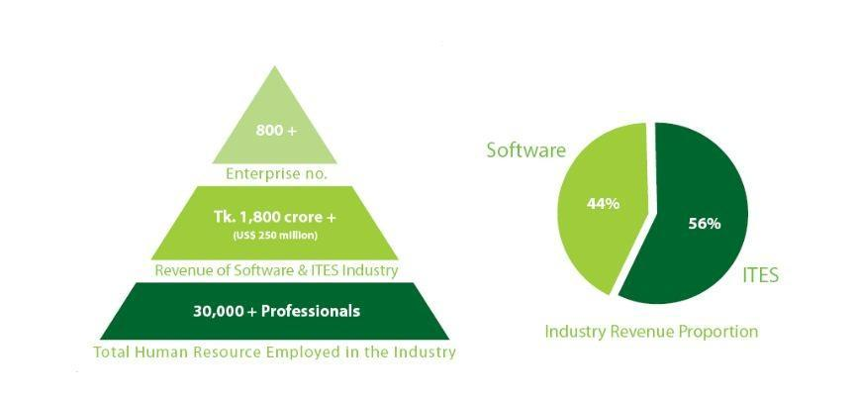

Figure 1: Bangladesh Software and ITES Industry (Source: BASIS)
The total industry size is estimated to be around Tk. 1,800 crore (US$ 250 million). Approximately 30,000 professionals, majority IT and other graduates are employed in the industry. Though, compared to other traditional mainstream industry, the contribution for overall employment creation is not significantly high, but if considered in terms of creating high quality employment (average monthly compensation over Tk. 15,000 per month), software and IT service industry is surely one of the top graduate employment sectors in the country.

Another survey by BASIS on three hundred of its member companies done on business nature, business volume and size of companies. Over 70% of the companies (Figure 4) are found to be involved in development and maintenance of software for their clients. A number of those are simultaneously engaged in providing different IT enabled services for their clients as well. In total, almost half of the surveyed companies are involved in providing range of IT enabled services (data/form processing, graphic/web design, content management etc.) a significant number of companies (18%) have developed software products or productized services; most of those have been developed over time after repeated installations for multiple clients. A number of companies are in digital content development and delivery business, mainly providing content services through mobile platform
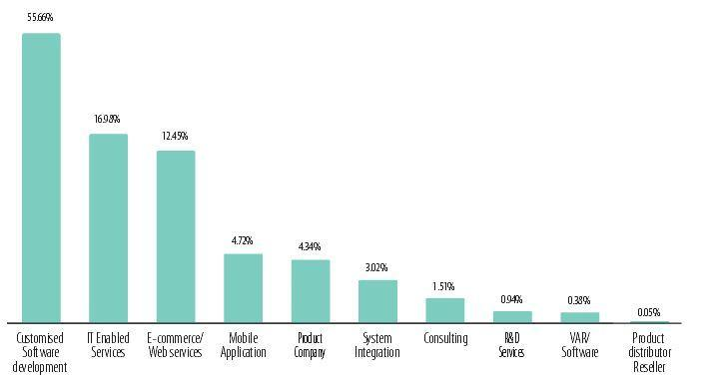

Figure 2: Business Specialization of BASIS Member Companies (Source BASIS)

Overview of Data-Path Limited

Data Path Limited

Data Path Limited is an outsourcing company working for July (a business provides service on retirement plan and payroll) in Bangladesh. We work closely with employers and financial partners to build customized services to meet their unique goals. Our consultants provide hands-on solutions for plan implementation and ongoing plan operation. We have many years of industry experience with clients ranging from small, closely-held businesses to large corporations competing in the global economy.

History

Jim Hudson began his retirement plan specialization in the early 1980s while pursuing his career as a Certified Public Accountant. During this time, Jim became known as a specialist in this highly technical field. He was directly responsible for developing and managing a large retirement plan practice before founding July in 1994.
John Humphrey also began his career as a Certified Public Accountant, providing tax consulting services with a large accounting firm before specializing in retirement plan administration. John co-founded July Business Services in 1994

Getting Started:
July Business Services began operations in 1995, with no clients and a small professional office suite. During the early years, management worked to develop strategic business partnerships, hire key employees, and create business processes and procedures. The firm's marketing efforts resulted in important referral relationships, including investment advisors, mutual fund companies, banks, and brokerage firms. These relationships helped to create modest growth over the first several years. By the end of 1996, JBS had more than 250 retirement plan clients and 5 employees. Today its management team brings has over 40 combined years of industry experience, and its employees include experienced consultants with certifications from leading industry organizations. It currently serves more than 3,900 Retirement Plans in 48 states and to do these plans on a timely and efficient

Manner it included complete Plan administration outsourcing for national retirement plan providers, including conversions of large numbers of existing client relationships.
Data-Path Limited is working as Branch Office to give the full working support to July Business Services to meet its goal successfully.

Vision:
‘Its vision is to obtain the leading position in the outsourcing industry and to evolve from a traditional BPO to the next Generation BPO.’

Mission statement:
‘Data Path Limited mission is to serve clients effectively with the help of latest technologies. Transformation and innovation is core to the organization.’

Core values:
‘Core values encourage behaviors throughout our company that will help us fulfill our mission, vision and goals’ (Jim Hudson, CEO, July Business services).
It believes that following these core values are keys to success:
- Accountability
- Celebrate success
- Commitment to excellence
- Commitment to people
- Creative solution
- Effective communication
- Embrace diversity
- Focus on pro-active solution
- Integrating outstanding service
- Positive attitude
- Results-oriented change
- Team work

Departments:

Accounting Department:
In Accounting department, accounting team provides all the accounting and financial support for Data Path. This department works on different issue like billing all the works other department, records of inventory, salary for the employees, financial statement etc.

Allocation Department:
The purpose of allocation department is to allocate each plan participants money for every year and provides information to workflow 5500. As July is the mother company, all of their works are retrieved by allocation team and prepare different files to provide all the necessary information to other department.

Distribution Department:
Distribution department deals with the disbursement of the money for each employee when he/she is in the stage of retirement or transferring money from one plan to another. For doing this type of work, they required a software called RELIEUS. This department ensures the money transfer to their clients.

ERISA Consulting/ Plan Documents Department:
ERISA department prepares plan document from the information provided by the sales and installation department. Plan documents are like Profit sharing plan, 401 (k) plans, Safe Harbor Plan, Safe Harbor 401 (k) plan which usually content 40 or more page with law, rules and regulation and how these will affect the plan. They ensure the right information which will be followed by other departments.

Workflow 5500 Department:
In Data Path, workflow 5500 prepares „Form 5500‟ for each plan for July. The Form 5500 is the Annual Return/Report of Employee Benefit Plan for submitting to the department of labor. According to Department of Labor, any administrator or sponsor of an employee benefit plan subject to ERISA must file information about each benefit plan every year.

Human Resource Department:
In Data Path, HR department maintain the environment of the organization. HR department always required to ensure the safety of the organization or its employees. Besides that, all the recruitment procedure, communicating with each department and providing training support to the employees by HR.

IT’S Department:
As Data Path limited provides service through latest technologies, it also requires IT support every day. IT department maintain the network of the organization and maintenances of the electronic devices.

New Business/Installation:
New Business or Installation department updates all the information into the database and ensure the accuracy of the information. All the information’s are provided by the sales department of Data Path.

Outsourcing Department:
In Data Path, most of the departments are related with July but outsourcing department works are different TPA rather than July. Each team of outsourcing department works with different TPA by providing different service like plan review, plan process, reconcile etc. Currently this department has 9 TPA clients.

Recordkeeping Department:
Recordkeeping is the trading house working in Data Path for July. The job of this department is to track who’s in the plan, what investments they own, and what money is going in or ou

Defined Contribution Plans
A defined contribution plan is sometimes known as an individual account plan because a separate account is maintained for each individual participant. These types of plans define the contribution amount to be deposited into the participant’s account. For example, a plan may provide that every eligible participant will receive an allocation, or share of the total plan contribution, equal to 5 percent of his or her compensation. Or, the plan may define a participant’s contribution as a specific dollar amount, such as $1,000
Example: Defined Contribution Amount. Mary works as a graphic artist for XYZ Corporation and earns $45,000 during the year. If the plan provides contributions equal to 5% of compensation, Mary will receive an allocation of contribution for the year in the amount of $2,250 ($45,000 x 5%). This amount will be deposited into her individual account under the plan.
The participant bears the investment risk in a defined contribution plan because there is no requisite or promised amount paid to the participant at retirement. The participant’s total benefit from the plan will be the accumulated value (total contributions plus total earnings) of the participant’s account at retirement or termination of employment. Although the participant’s contribution amounts will be invested under the plan with the intent of increasing in value, investment results are not guaranteed and do not affect the employer’s cost. Rather, the employer’s defined contributions are the extent of the employer’s commitment to the participant’s retirement income. In this manner, the participant will reap the rewards of positive investment earnings but also bear the brunt of any investment losses.
Generally, employees readily understand a defined contribution plan as it is easy to see how much has been added to their accounts for the year. Each participant regularly receives a statement of his or her individual account that displays the participant’s share of contributions and plan earnings or losses for the reporting period.
There are many types of defined contribution plans. These plans maintain a separate account for each individual participant. Each of these plans defines the contribution amount to be deposited into the participant’s account. The participant bears the investment risk because there is no promised benefit to be paid at retirement like in a defined benefit plan.
Different types of Defined Contribution Plans are:
- Profit Sharing and 401(k) Plans;
- Safe Harbor 401(k) Plan
- SIMPLE Plans;
- Money Purchase;
- Stock Bonus and Employee Stock Ownership Plans; and
- Other types of tax-advantaged arrangements.

Retirement Plan Fundamental training:
Right after my joining at Datapath, I have been given training on the American Retirement Plan Fundamentals so that I can understand the industry that I would be working in. The first 2weeks I had training which covered book “Retirement Plan Fundamentals 1”.
The department I am working with is the “Workflow Team”. Workflow department works on processing of different forms (such as SSA 8955, form 5500) which needed to be submitted to DOL. After the training of RPF1, I had training on how to fill up and submit SSA 8955 form. During the internship program, my primary task was to fill up SSA 8955 form for the retirement plan. This task is completed by using the help of three systems (software/web such as; TPA, Relius, and FT William).The work process of SSA form fill up is given bellow.

Services

July Business Services and on their behalf Data-path Limited is providing the following services to its US business clients
- Plan design
- Plan setup
- Plan Administration
- Participant Services

- Plan Design:
It creates retirement plans to meet the unique goals of each employer. Whether the objective is employee recruitment and retention or maximizing benefits for key employees, it has the expertise to design the best plan for clients.

- Plan Setup:
It provides all of the services to efficiently setup retirement plan or to convert existing plan from current provider.

- Plan Documents: It offers comprehensive plan documents prepared by experienced ERISA consultants. Its capabilities include
- Prototype Plan Documents
- Volume Submitter Documents
- Summary Plan Descriptions
- Loan Policies
- QDRO Procedure
- Other Required Forms

- Plan Setup & Conversion: Data-path’s dedicated setup team provides hands-on services to coordinate all aspects of plan setup or conversion. Our services include
- Prepare Enrollment Materials
- Coordinate Enrollment Meetings
- Prepare Setup Paperwork
- Contribution Submission Procedures
- Coordinate Transfer of Assets

- Plan Administration: Data-path’s consultants have over eight years of plan administration experience and are experts in this highly technical field. A dedicated account representative serves client’s plan, supported by a team of experienced professionals.

- Plan Operation Support: It provides everything client needs to maximize the value of plan, including telephone and e-mail access to its consultants. Its services include the following
- Eligibility Calculations
- Contribution Allocations
- Vesting Calculations
- Distribution & Loan Processing

- Compliance Testing: Its account representative provides complete compliance testing services to maintain the integrity of client’s plan. Its testing services include the following
- Top Heavy Testing
- ADP & ACP Testing
- Minimum Coverage Testing

- Tax Compliance: Data-path’s consultants deliver signature-ready tax returns to fulfill all tax filing requirements. Its services include the following
- Form 5500
- Form 1099-R & Form 945
- Form 5330 (when needed)
- Form 5310 (for plan termination)
- Recordkeeping: Data-path and July provide automated recordkeeping services through their alliance partners and through July’s daily valuation recordkeeping platform.
- 24 Hour Internet Access
- Daily Valuation of Accounts
- Plan Sponsor Account Access

- Participant Services: Through its alliance partnerships with financial providers, July makes available high quality tools for participants to plan for and achieve a secure financial future.

- Investment Advice: Many of the retirement products also include participant access to online investment advice and guidance. The ability for participants to receive online investment advice increases their chances of achieving a secure financial future, and as a result, can help to reduce plan sponsor fiduciary liability.

Organizational Structure:
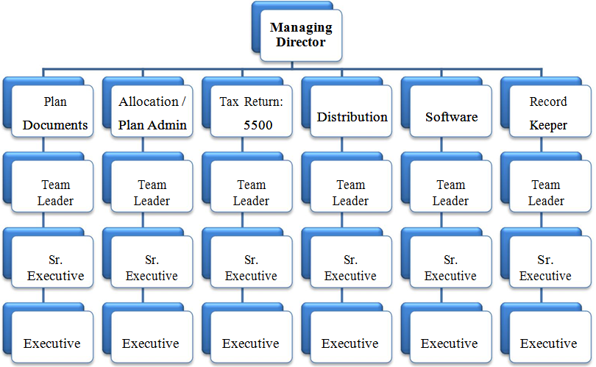
Fig 1: Organization Structure.

An overview of work related software and websites:
- TPA:
The full form of TPA is third-party administrator is a company who handles insurance claims or certain aspects of employee benefit plans for another company. It is an outsourcing process because the task of retirement plan administration is processed by TPA. July service itself is a TPA and Datapath is also a TPA. Datapath not only handles the activities of July service but also outsource many other plans.

- Relius: It is a major provider of software and services for employee benefit professionals who manage recordkeeping, administration, compliance, document generation, testing and reporting of qualified retirement and health benefit plans.
- FT William: It is web Portal for EFAST 2 e-filing. Their innovative web portal allows clients to sign 5500 forms for EFAST 2 with the click of a button.

- Form 8955 SSA: If the plan is subject to ERISA, the plan is required to report separated plan participants who have deferred vested benefits on Internal Revenue Service (IRS) form 8955-SSA. The information is provided by TIAA-CREF to complete Form 8955-SSA filing. Form 8955-SSA, the designated successor to Schedule SSA (Form 5500), is used to satisfy the reporting requirements of section 6057(a). Form 8955-SSA is a stand-alone reporting form filed with the IRS.

Process of filling up “Form 8955 SSA:
Retirement plan has to go through various steps in its lifecycle. Submitting SSA 8955 form for the retired participants is one of them. The required steps of filing and submitting form SSA 8955 are given bellow.

Fig 2: Process of filling up “Form 8955 SSA”.

- Search Plan in TPA:
First I need to search the plan in TPA and see if the allocation status of the plan. Allocation is the calculation of the participant’s contribution. If the status is “GONE” then I proceed to the Form 8955 task of the plan.
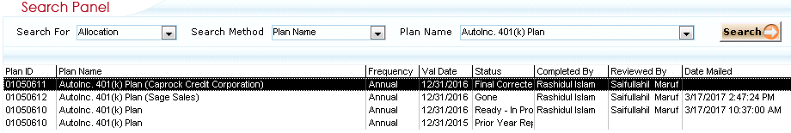
Fig 3: Search Plan in TPA.

I open the Form 8955 task of the plan from TPA and the assigned/pending tasks are needed to be completed. The tasks are
- Download Relius Report and Save in Project Files
- Configure report for import to FT William
- Prepare 8955 SSA
- Save 8955 SSA in Project Files
- Assign Project to Review

Here is a screenshot of the Project of form 8955 SSA window. It contains all the tasks that are need to be completed.
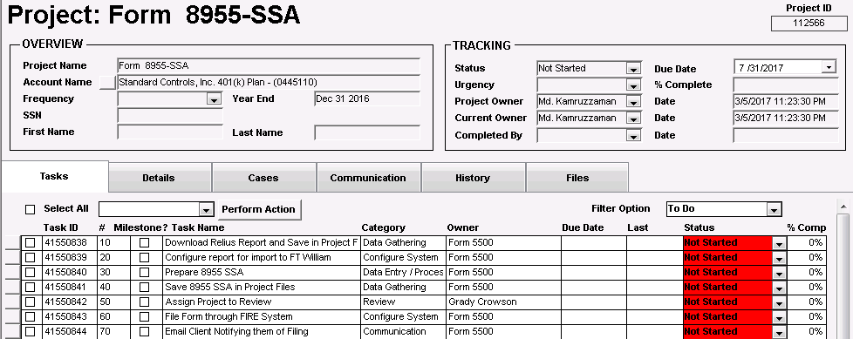
Fig 4: TPA task list for SSA 8955

- Download Relius Report:
I get the Relius id of the plan from the retirement plan form in TPA. Then I open Relius and search the plan with ID to download Form 8955 SSA.I also select correct date of the plan.
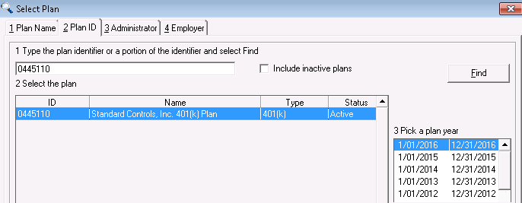
Fig 5: Searching plan in Relius.
Saving participant list as excel format: I have select “effective date” from drop down menu and select “all participants with no balance” from “account data tab”. Then I print the file in excel format. After printing the file I have to copy the file in local desktop.
Configure the file for FT William: The file is not formatted to upload in FT William. After saving the file need to configure the file. I need to run macro and change the value 1 to 0 in the “INC_REC_IND” column.
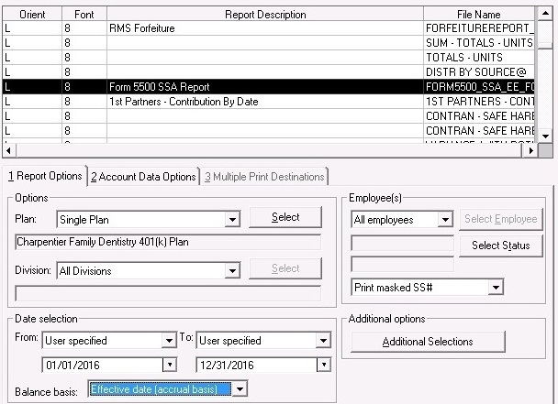
Fig 6: Downloading file form Relius.

- Selecting plan in FT William:
My supervisor has registered an account in FTwilliam website for me. I Login to FTwilliam and search the plan. Then I Select 5500 under plan name and then select year.
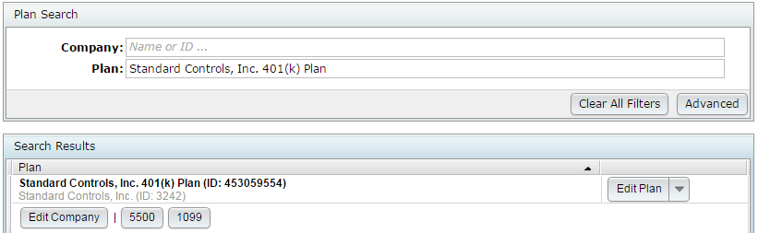
Fig 7: Selecting Plan in FTwilliam website.

- Fill up SSA 8955 form:
After selecting the plan, it opens a page containing many options for plan. From there I add Form 8955 SSA for the plan.
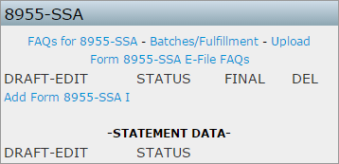
Fig 8: Creating Form 8955 SSA.
I need to collect the information of Plan name, plan number, plan sponsor and EIN number from plan document. Plan document can be found in TPA. If the information are already in the form than I need to check if they are correct. If there is any change in this information then I need to verify them with previous years plan SSA 8955 form as the plan sponsor can change this information.
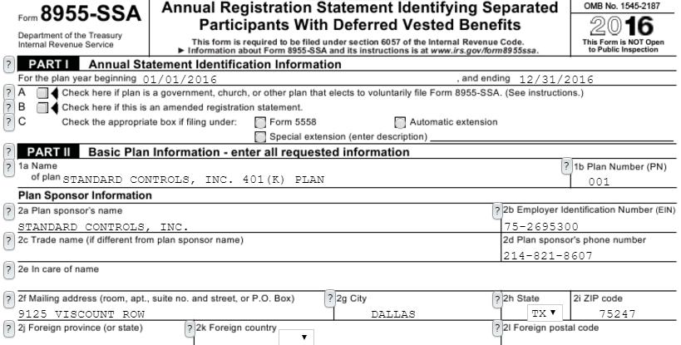
Fig 9: Form 8955 SSA Part 1 & 2.
Filling up address: Then I fill up the address which can be collected form TPA. From 5500 signer in contact list of the plan, I can get the address of street, city, state and zip. If the 5500 signer is not available, I use the decision making contact. Decision making contact is available for every plan. Here is a screenshot of contact form of a plan.
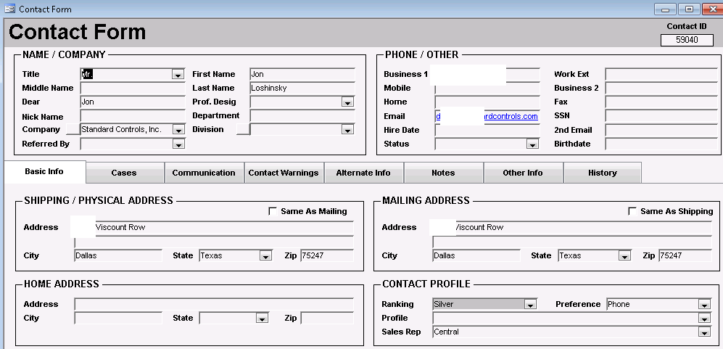Fig 10: Contact form of plan in TPA.
After this information is filled up, I need to write “Same” in the first line of plan administrator information. The 6a part of the form contains the number of the participant with “A” code. This can be found in on the excel file which was downloaded from Relius. The 6b is always filled up with 0.
Error checking: After all the information of the form is filled up, I need to upload the configured excel file in FTwilliam. I select upload in home and upload the configured excel file. During upload I need to manually enter the number of excel rows. The final step of Ft William is error checking. Ft William can check error in the form if I mistakenly skip any field in the form.
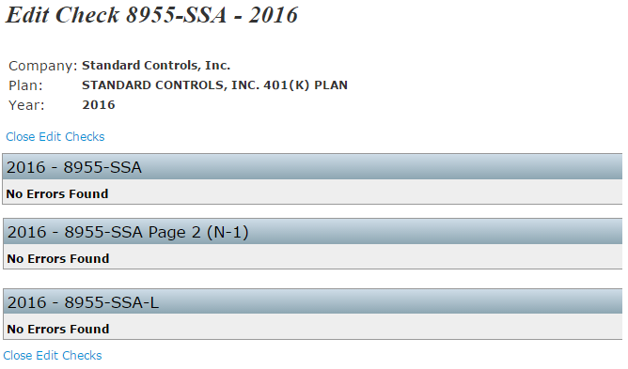
Fig 11: Error checking in form.
- Download SSA form and save in project files:
The Next step is to download the form and save in project files. I also need to save the excel file with the form.
- Assign project to review:
After saving the files, I mark all the sub tasks to “completed” and finally I assign the task to “In review” and write ready for review in the description of change. This means the file will be checked by another employee at Datapath for any error in the form.
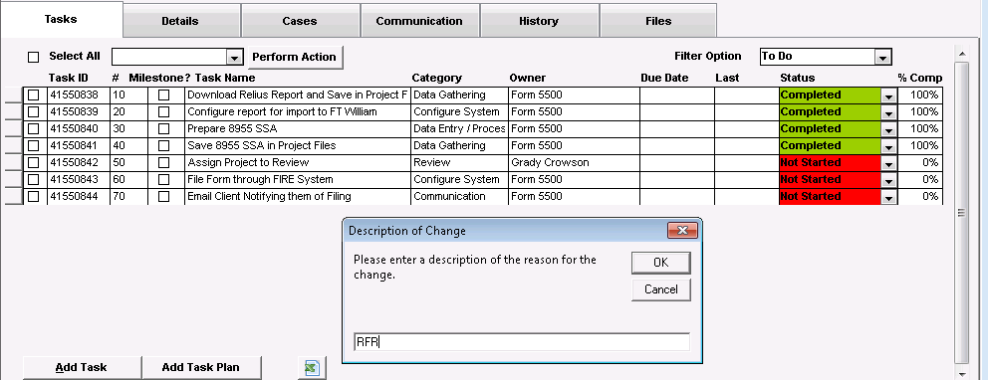
Fig 12: Changing status of the plan in TPA.

Other Relevant Activities:
    - Getting training when required.
    - Completing task of TPA “My Work”.
    - Preparing letter for US client.
    - Making corrections to reviewed forms.
    - Giving daily update to supervisor.
During my internship period at Datapath Ltd, I have faced the following challenges and constraints:

Observed in the Organization
- Activities of Datapath Limited:
At first I had no knowledge about the activities of Datapath. I search in the web and went to their website but I did not understand their activities. I only knew that Datapath is a USA based outsourcing company. But outsourcing covers a lot of areas. So I was very confused about what they actually do. After joining at Datapath and training session, I understood some parts of the activities of Datapath.

- Retirement Plan Industry of United States:
A retirement plan in USA can vary in so many ways and employer can put so many conditions in allocation which increase the complexity of the plan. The retirement plan is not obliged for any employer as they offer as a benefit to the employees. It was a challenge for me to understand the whole US retirement industry and how it works.

- Examination and training:
I had numerous training sessions on retirement plan fundamentals and I had to give examination to prove myself as an eligible intern. First I have completed training on how to prepare form SSA 8955. After one month when I was ready for more complex work, I had training on how to prepare form 5500. Those training were very important and I feel more confident in my work areas.

- Too many components of Retirement Plan to memorize:
At first it was very difficult for me to understand the retirement plan system of the United States because there were so many components that I had to remember. I had no experience of such activities before so I took me about a month to cope with the work/activities. A retirement plan in USA can be complex in so many ways and Employer can put so many conditions in allocation which increase the complexity of the plan.

- Working days and Office hours:
Datapath is USA based company so they follow the working day of use which is Monday to Friday. I don’t think any other organization in Bangladesh follow the US routine. At Datapath Limited the office hours are from 9AM until 6PM. I live in Razabazar, Firmgate and the distance is not far from office in Mahakhali. But in the morning the traffic gets very busy in Dhaka city. For that reason, I have to leave my house at 7.30 AM so that I can reach at the office on time.

- Working environment:
Datapath has very organized cubical for employees and I have not worked in a cubicle before. In the office there is always pin drop silence. This kind of environment keeps employee refreshed and motivated towards work.

- Communication through Skype:
People at Datapath communicate with each other through Skype instead of going to them directly which I disliked at first a lot. I like to go to the people directly if I have any questions. Here at Datapath I have to write that person on Skype at first before going directly. For any problem first I used Skype to communicate with supervisor. But if the problem is too complex to solve through Skype, I communicated with supervisor directly.

- Slow server network:
As I am working from Bangladesh and the main servers are stationed in USA, the processing time is very high. If I want to copy anything from the July Server I have to wait some time which interrupts the work flow. Also the Relius software that is used to enter all the information of the plans needs to be opened from the July Server.
- Login in Relius:
Most of the work depends on Relius as all the data and information of plan is maintained in Relius. But Relius has limitation and a limited number of users can use it at a time. Sometimes I did not get login in Relius and had to pass time without doing any work.

- Inconsistent Workload:
Generally there are two types of plan year followed by a retirement plan. One is regular plan year and another is fiscal plan year. A plan has several process and some of them have specific deadline for completion. So when the deadline comes, work load increases.

- Game room:
One of my favorite things about Datapath is they have a game room which includes Foosball, Cycle and a treadmill. The flow of work can be boring sometimes for employees. So this is very unique and innovative idea to make employee feel relaxed during work. Datapath is also concerned about the entertainment and fitness of its employees.

Academic Preparations:
Major in Operation and Supply chain management:
I have completed major on Operation and supply chain management. Datapath is a service oriented organization and the primary activities do not depend on supply chain management. Employee is performing their own responsibility within an automated system. Beside this there is no task of physical supply chain management in organization because core task of the organization is online based. So I did not get the opportunity to apply the knowledge of supply chain but still I enjoyed working at Datapath Ltd because I always have a passion for learning something new and develop skills.

Learning

- Knowledge about the US Retirement Plan industry:
As Datapath Limited is an outsourcing company working on US retirement plans, I have learned the differences between our retirement plan industry and the United States. Also I am able to compare those and in my opinion the US retirement plan industry is much more complicated than any other retirement plan industries.

- Corporate Knowledge:
I have also gathered some knowledge about how an organization does its regular work. I saw how to record the documents. How they manage the schedule and complete their daily work. I have developed a sense of corporate environment.

- Corporate Behavior:
For any kind of job, behavior is really important. So I also learnt how to behave with other people of the organization. The employees of the organization are very friendly. So it was very easy for me to cope up and learn corporate behavior.

- Time management and priority setting:
Having workload and deadlines to meet helped me to learn how to manage time and set my priorities so that I could meet my deadlines. Priority is the most important thing to finish my work on time. And this is what I learned during my three months of internship period.

- Improved personal skills / decision making:
During my internship tenure, I have improved a lot on my skills including the knowledge of fulfilling a task and my desired career path. Not only I have improved my existing skills but have gained some new skills as well, which will help me further in my career, such as critical thinking during tough situations.

- A greater sense of professionalism:
Working in a new environment was a challenge for me. First it was difficult to get used to. But I learned how to navigate the working world in real life as I completed my studies in Master’s degree. Now I have a better knowledge to act as a professional in the corporate world and adjust accordingly.

- Confidence about Responsibilities:
I fell more confident to deal with different kind of people because there are different kinds of organization, different kinds of participants together in one floor at Data Path Ltd. So in future I will more confident at job place because of my internship.

- Communication:
My office was at Mahakhali and I am living in Firmgate. Every working day I had to go to office within 9am. Although it’s a short distance but it’s more complex in Dhaka city to reach office at office hour. So in future I will not face any problem regarding my office. So my internship helps me a lot to improve my communication skills.

- Being more careful and sincere:
The work of Datapath does not depend on any physical document. Every document is uploaded on Datapath and July server and organized by Relius and TPA. So I learned to be more careful about work because those files are very sensitive.

- More proficient in Microsoft Excel:
In this internship program I had many training sessions on Microsoft Excel because to process a plan I had to operate in Excel with ease. This expertise will help me in further career as Microsoft Excel is a very important tool to make life easier.

Findings & Analysis

Problem Statement:

The retirement benefit system in Bangladesh is not so organized both in the public sector and in the private sector. The government rules and regulations are not well organized to protect the employee benefit. There employees are not very aware about their retirement benefit.

Pension system in Bangladesh is mainly observed in government services. The pension issues are settled according to the rules of the Public Servants (Retirement) Act of 1974. The retirement benefit system is not so structured both in the public sector and also in the private sector. The government rules and regulations are not well planned to secure the employee benefit. The regulatory body is not taking the necessary steps to protect the employee rights and benefits
The awareness of US government on protecting the privileges of the retired people is very high and in retired life govt. makes them financially secured. To expand the tax benefit advantages and to draw the attention of employees many organizations implement retirement plan. The rules and regulations and the reporting procedure of American retirement plan are very tricky.

Findings:

After structuring all the information from US and Bangladesh, have got some differences between those retirement plans. Some of them are mentioned below:
- Government Rules Regarding Retirement Plan:
US Department of Labor has provided a number of retirement plans. Beside the government organizations, each and every non- government organizations also have to adopt at least one of those plans. The sole proprietorship businesses also have to adopt the retirement plans. Whereas Bangladesh government have some rules but those rules are not executing properly in here.

- Rules for Highly Compensated employees and Non-Highly Compensated employees:
The HCE cannot contribute more than the allowable percentage of their compensation into the plan. In this way, US can minimize the discrimination between HCEs and NHCEs. But in Bangladesh retirement plan at here are no issues for HCE and NHCE.
- Employees right to know:
The participants of any plan have the right to know where their contribution is going and from which source they are getting benefit. Not only that, as US has the strict rules on deferring and getting contributions so that participants has the clear idea how much they are going to get after retirement. In Bangladesh, it’s really difficult to know about the retirement fund for the normal employees.
- Contribution to the national economy:
The money accumulated from various retirement plans is invested in various ventures especially in the share market. As almost all the people is covered under the retirement plans, the accumulated amount is very high, and the return is also high from the invested amount. In general, our retirement funds money did not have that much contribution in economy.

- Contribution to the homeland economy:
There are a good number of immigrants in US those who are serving various US organizations. They are also covered under various retirement plans. In these cases, they can invest their contributed amount any venture of their homeland.
- Increase Self-dependency:
At old age, they don’t depend on their children. They can’t think living with all in a family. These savings, benefits are the main instrument to make them self-dependent. In Bangladesh, a retired person is usually depending on their children.
- Government and Private sector:
Pension system in Bangladesh is mainly observed in government services. The pension issues are settled according to the rules of the Public Servants. In Bangladesh, the retirement policy is not applicable in private organizations. Still there is no example of adopting any retirement policy by any sole proprietorship.

- Insufficient amount:
The Retirement due to old age makes the elderly people very insecure and vulnerable. Government doesn’t give any benefit or profit sharing amount to the people so that the amount that one person getting after their retirement is very insufficient to live future life. Government has recently introduced Old Age Allowance Programmed which covers small fraction of elderly people in the country who are not covered by pension system. Although limited in coverage, this is a healthy beginning of providing security to vast majority of the elderly people who are not covered by the existing pension system.

- Some services are off from pension policy:
Not all public services are pensionable. Only the pensionable services are entitled to pension. Generally speaking those who draw salaries from the general revenue head of the government are usually allowed pensions on retirement. The services for which pay is paid from local autonomous bodies, trust funds and nationalized organizations or from commission and fees are not pensionable services.

- Terminated employee:
If a public servant is removed or dismissed from service on account of misconduct, insolvency or invalidity, his/her previous service is confiscated and as such not considered for pension. In USA terminated employees get their due contribution as their rules. Whatever they performed for their pension fund they will get the portion of contribution up to termination date.

- Suspended Employee:
If a public servant is temporarily suspended from his/her post against allegation of offence and is reinstated in the said post and if any part of his/her pay is confiscated for the suspension period, then the period of temporary suspension shall not be counted or considered for pension. This suspension time may be long. In that time, they are not able to add more for pension.

- Not aware about their contributions:
The amount they are contributing or saving for provident fund is kept in a bank. This amount is invested in other sources. They don’t have any idea that where is going or invested their money. Only they get a fixed interest on their principle amount.

- No Scheme for Private sectors:
Most of the people of Bangladesh are working in private organization. There is no uniform retirement benefit scheme for private sector workers. They only receive some gratuity at retirement. Govt. implies no pension rules for them.

- No Specific Organization for retirement policy:
The pension policy of Bangladesh is maintained by the department itself. No other organization is assigned to do this policy whereas USA’s every organization depends on Third Party Administrator.

- Transparency:
US retirement plans are more transparent than our country. Over their employer and employees both know about their retirement condition every day. Whereas in Bangladesh it’s really difficult to know the actual condition because of bureaucracy.

- No recordkeeping company:
In US, there are thousands of record-keepers are working for retirement plan. But in Bangladesh there is no recordkeeping company.

- Discrimination:
Bangladesh government does not have any rules for minimizing the discriminations between highly compensated employees and non-highly compensated employees.
- Types of contributions:
US retirement plan allow different types of employees and employer contributions. Such as: Match, Profit Sharing, Non-elective Contributions etc. But in Bangladesh it’s rare to find any employer contribution.
- Tax Return:
For the US citizen, it’s mandatory to pay the tax in every year. Retirement plan money is exempt from tax calculation. So, US government also set so many rules for this. Tax return is mandatory in Bangladesh also, but actual scenarios are different from rules.
- Government Involvement in Auditing:
In US, if government found any sort of discrepancy then DOL audit committee will check all records for this company, which is the worst case for an employer life. But in Bangladesh we did not have this practice.

Recommendation & Conclusion

Recommendation:

From the realization of pension policy during the whole period of practical experience in Data Path Limited, some differences and lacking of Bangladesh pension policy have been founded. To improve this state of affairs some suggestions are recommended in very confident way. I believe that my realization will be in agreement with most of the policy makers.

For Data-path:

Right person in the Right Place:

Right person in the right place at the right time should be the policy of recruitment. Data-path should recruit perfect and merit person for their duty. To have the efficiency and quality it should be maintained. Employees should have literacy to understand the retirement pension benefit of USA. So that training should be done perfectly. For this reason, Data Path should choose the right person who can adjust with all the situations. Quickly understanding and analyzing is the stairs to be a specialist in allocation.

Should carry on the faith:

At first Data Path do some supporting duties for July Services. After a long time, they got the permission for making report for the client of JBS by building the trust. Here privacy and security is the main fact to make report. Some sensitive information we came to know at the time of making report. These enable us that we are trustworthy. It should be our proud that a country like USA trusts us and make their pension report by us. So, we should continue this policy. It represents our national personality. If we carry on this then the number outsourcing will increase. It will also increase our national income.

For Bangladesh:

Should have a responsible organization
Every public organization maintains pension policy by them. It would be better if Bangladesh have specific organization or third-party organization for pension policy. To maintain the pension policy Bangladesh should have specific organization which is only responsible for pension policy. As USA has TPA for allocation Bangladesh should also have this type of organization. To make a pragmatic policy, contribution, deferral Bangladesh may settle a very responsible, trustworthy organization. It will be helpful for the people and it won’t be burden for others.
Should introduce in private sector:
The private sector may have their policy for the provident fund. But it is slight different from govt. rules. If govt. introduces pension policy or govt. makes pension policy free for all the sectors of Bangladesh. It will also helpful to all. For the private sector govt. may make extra rules for retirement benefit plan. As an employee of Bangladesh, they must have the right to get some facilities from the govt. in pension fund.
Should motivate for provident fund:
Not all the employees are having provident fund. So, Government should motivate their employees for the provident fund by offering new incentives or facilities. Family support is the basic security of most elderly people in Bangladesh.
Should increase self- dependency:
In the old age children are the shelter for the people. This tendency makes them disable. If they become active in work life and maintain provident fund properly then self- dependency will increase in our country. If the policy maker improves their pension policy or follow some effective rules of US pension policy then it will increase the self-dependency. So, in the old age they don’t need to depend on their child or don’t need to live in the old home.

Changes in Rules and Regulation:
Rules regarding retirement plan in our country are very poor and backdated. To cope up with the new world we have to changes our rules in order to develop the overall economic condition in Bangladesh.
Should implement nondiscrimination testing:
In our country, general employees face huge discrimination with highly compensated employees. So, government should implement some testing method so that the discrimination can be minimized.
Reduce Bureaucracy and improve Transparency:
Employer should be more transparent with the employees in regards to their retirement fund contributions and the bureaucracies have to minimize form all sector.

Conclusion:

After exploring the IRS rules and regulations it may be conclude that the American retirement benefit plan is encouraging the American citizen to save money for their old age. The smooth functioning of a, industry depends upon the activities of the institution which over sighted the function of the industry. For all types of retirement benefit plan reporting the IRS and DOL has the separate dead line to submit the report which must be maintained by the plan sponsor. The IRS not only impose penalty for non-compliance with the regulations but also give incentives to those plan sponsor who are always complied with the IRS and DOL guidelines. The employer who has retirement benefit plan can get the tax benefit from the federal government. The employer profit sharing and matching contribution which is contributed by the employer is fully tax exempted.

So, set up the retirement benefit plan has twofold benefit. One is the employee satisfaction to work because they have the financial security at their old age and another one is tax benefit from the central government. The American retirement benefit plan is making contribution to their stock market and makes people interested about the stock market and contributing the overall economy. This report may help to improve the retirement benefit system of Bangladesh

Appendix

Abbreviation:

ACP Average Contribution Percentage
ADP Average Deferral Percentage
ASPPA American Society of Pension Professionals & Actuaries
DOL Department of Labor
ERISA Employee Retirement Income Security Act
IRS Internal Revenue Services
IRC Internal Revenue Code
RPF Retirement Provident Fund
SIMPLE Savings Incentive Match Plans for Employees
TPA Third Party Administrator
LPR Leave Preparatory to Retirement

Bibliography:

Books & Documents:
- Retirement Plan Fundamentals-1, Published from ASPPA, edition 2008
- Retirement Plan Fundamentals-2, Published from ASPPA, edition 2008
- IRS (Internal Revenue Service) Reporting Guidelines for Retirement Benefit Plan, Published from IRS, edition 2008
- Guidelines for Retirement Benefit Plan, Published from DOL (Department of Labor), edition 2008
- Application Xtender- Software Manual
- Relius Administration- Software Manual
- TPA Manager- Software Manual
- ASPPA Allocation Procedure Manual
- DataPath Ltd. (2008). About DataPath Ltd. Retrieved From the DataPath Ltd. Website: http://www.data-path.net
- FTwilliam. (2007). EFAST 2. Retrieved From the FTwilliam Website: https://ftwilliam.com/product5500.html
- July Business Services. (1994). Company Profile. Retrieved From the July Business services Website: https://www.julyservices.com/about-us?post=5&page=company-profile

Websites:
- www.julyservices.com
- www.data-path.net
- www.jhancockpensions.com
- www.firstmerc.com
- www.hartfordlife.com

