Internship Report on

Online Marketing Practices of Daraz

Submitted to:
Muhammad Hasan Al-Mamun
Assistant Professor
School of Business & Economics
United International University

Submitted by:
Sanjida Islam
ID: 111 161 072
BBA Program
School of Business and Economics
United International University

Date of submission: May 29, 2021

Letter of Transmittal

May 29, 2021
Muhammad Hasan Al-Mamun
Assistant Professor
School of Business & Economics
United International University

Subject: Submission of Internship report on “Online Marketing Practices of Daraz”
It is my pleasure to inform you that I have finished my internship study on “Online Marketing Practices of Daraz” and would like to submit it as part of the internship program's requirement. I tried to the best of my capacity to finish the report according to the guidelines and specifications, and I did my best to make it relevant and specific.
I gathered data using my analytical skills, and my near insights from working at Daraz assisted me in organizing the information into the appropriate segments.
I sincerely hope that it will receive due consideration and proper evaluation from your end.

Sincerely yours,
Sanjida Islam
ID: 111 161 072
Bachelors of Business Administration
School of Busines and Economics
United International University

Acknowledgement
First and foremost, I would like to express my gratitude to Almighty Allah for his blessings, which enabled me to complete the report in a safe and sound manner during this difficult time of Corona pandemic.
I'd like to express my heartfelt appreciation to my interternship supervisor Muhammad Hasan Al-Mamun, of United International University's School of Business and Economics.Throughout the research, sir provided me with constant feedback as well as many important and constructive observations.His inspiration, guidance, and willingness to share ideas and issues have helped me finish my report.

Executive Summary
The use of the Internet to advertise a company's products or services is referred to as "online marketing."The buying and selling of products and services over the internet is known as ecommerce. Daraz Bangladesh was founded by the Rocket Internet Group in 2015. Daraz is an online B2C product whose business model seems to have generated positive customer reviews. It is a shopping space with a wide range of products, including clothing for men, women, and children. In May of this year, it became a part of the Alibaba Group's ecosystem.
Daraz is an online B2C product, and its business model seems to have received favorable feedback from consumers. It is a location where shoppers can conveniently locate vendors. Daraz Bangladesh promotes its goods through social media channels. They have a Facebook page where they share updates on new campaigns and products. They also use YouTube and Instagram to advertise their stuff. Daraz Bangladesh posts advertisements on a variety of blogs on a regular basis.

Daraz is a big believer in using social media to advertise your business. Daraz publishes four commercial posts a day on their Facebook page and other platforms on average. On a regular basis, Daraz runs advertisements such as web portal advertising, Google Display Network (GDN), and association with different sites (both local and international) to increase traffic to their website and APP users. They have a Facebook Fan Club page where customers can discuss their grievances and issues with authorities.
Daraz Bangladesh has a well-thought-out SEO policy. Since email marketing is practically free to start, it has a strong return-on-investment opportunity. Daraz will then use a short newsletter to entice return visitors to its website. The method of optimizing a website for search engines is referred to as SEO. It's critical for increasing the popularity of a search engine or website, as well as improving functionality for human visitors. Trigger alerts are now part of Daraz's automated strategy. A push notification is a warning that occurs on a mobile device. They can be used without having to be in the app.
Daraz Bangladesh is a corporation that doesn't manufacture anything. It's an online marketplace where a number of different sellers will sell their wares. Customers can use Daraz's portals to perform searches before making a purchase. They advertise on YouTube and Instagram. They also use telemarketing to deliver SMS to consumers informing them of new Daraz deals. They can also be found reasonably easily when looking for keywords in Google, the most widely used search engine. The business advertises itself on Facebook, and they have a Facebook profile where they promote new items available on their websites. They have an online marketplace where sellers can sell their wares over the internet. There is no booking charge for Daraz arrangements. The seller set the price on the Daraz website, and the seller must follow the rule and terms in order to avoid charging an illogical fee. Daraz receives a commission for each product sold, and this is how the company makes profits. As an online marketplace, the Daraz marketplace directs customers to their websites and directs them to the official website page.
Daraz is a well-known online retailer in Bangladesh. There is a lot of competition, but Daraz stands out for the quality of their online market. In this kind of emerging economy, Daraz's customer-centric approach will be ideal. In the coming days, the group will take advantage of economies of scale to outperform their competitors. Daraz currently has a high amount and a steady influx of revenue, but if a cheaper alternative becomes viable, buyers will undoubtedly switch and sales will drop. Daraz needs to improve its service offerings and it also needs to create a loyal customer base now. Since the market is fast changing and volatile, it is wise to plan ahead.
Key Words: Online Marketing, Daraz

Table of Contents
1. Introduction 7
2. Organizational Background 8
3. Methodology 9
4. The objective of the study 10
5. Online Marketing Practices 10
5.1 Social Media Marketing: 11
5.2 Content Marketing: 12
5.3 Influencer Marketing: 12
5.4 Search Engine Optimization (SEO): 13
5.5 Email Marketing: 15
5.6 Push Notification Marketing: 15
5.7 Affiliation Marketing: 16
5.8 Google Display Network (GDN): 16
6. Online Marketing Tools 16
6.1 Facebook Ads Manager: 16
6.2 Olympus: 16
6.3 C360: 17
6.4 Twitter/Instagram App & YouTube: 17
7. Marketing Mix 17
7.1 Product: 17
7.2 Place: 18
7.3 Price: 18
7.4 Promotion: 19
7.5 People: 20
7.6 Physical Evidence: 20
7.7 Process: 22
8. Competitors Analysis 23
9. Recommendation 26
10. Conclusion 27
11. References 28

Introduction

The term "online marketing" refers to the use of the Internet to promote a company's goods or services. To reach customers, online marketing uses blogs or newsletters, and it is mixed with e-commerce to make business purchases easier. It is measurable. You will find out how many people saw the internet advertisement and how many people bought the items. It isn't troublesome. The customer can attend online advertisements at his or her leisure and according to his or her preferences. It has the ability to provide as much detail as possible about the product or service, as well as deals and purchases. Websites, blogs, email, social media, forums, and smartphone apps will also be used to advertise goods and services in internet marketing.
Ecommerce, also known as electronic commerce or online commerce, is the purchase and sale of goods and services over the internet, as well as the financial and data transfers used to complete these transactions. Ecommerce is commonly used to refer to the online selling of physical items, but it may also refer to any form of commercial activity that is made possible by the internet.
Online marketing only deals with business transactions carried out through the internet, e-mails, and search engines, while e-commerce deals with business transactions carried out through various electronic mediums such as the internet, mobile phones, fax machines, ATMs, and credit cards.
Rocket Internet Group launched Daraz Bangladesh as a start-up. It started operations in Bangladesh in 2015. Daraz Group became a part of Alibaba Group's ecosystem in May of this year. This transfer comes two years after Alibaba purchased Lazada Group, another startup. Daraz helps its customers to enjoy incredible shopping opportunities by having their orders delivered to their doorstep. It is a shopping center that offers a variety of offerings, such as fashion items for men, women, and girls. Daraz is an online B2C product, and its business model seems to have received favorable feedback from consumers.

Organizational Background
Daraz expects and desires to become the world’s largest e-commerce platform, outside the USA and China. They offer every kind of products, they inspire other people to hop on their platform and sell products as a seller with new business models and entrepreneurs.
They want to make it easier to do business anywhere in the world. Muneeb Maayr (Founder) and Farees Shah (Co-Founder) founded Daraz as an online apparel store in Pakistan in 2012. Muneeb Maayr was working at Rocket Internet at the time. Daraz received its initial financing and work from Rocket Internet, but in 2015, as it expanded into Bangladesh and Myanmar, it switched to a general marketplace approach and business model. In 2016, Daraz expanded its market more in Nepal and Srilanka by acquiring Kaymu. In 2018, Alibaba group acquired Daraz for an undisclosed amount.
In 2019, Daraz won the “Asia One Fastest Growing Brands and Leaders” award. Daraz Bangladesh also won Super Bands award for the year 2020-2021.
Daraz has been rapidly growing and gaining a firm hold on the top spot in this industry. Employees at Daraz Bangladesh are young, ambitious, and entrepreneurial, they are keen to share innovative web concepts with the Bangladeshi industry, which is constantly evolving. Daraz has been one of the top pioneers of introducing online marketing, online business, and e-commerce platform trend in Bangladesh. People were highly reluctant to make a purchase online but Daraz has served everyone patiently, they tried to make their presence felt and trusted and after a couple of years, they were already ruling the online marketplace in Bangladesh. Daraz not only benefitted themselves by introducing this marketplace in Bangladesh but also they have created job opportunities for many people, they have created a business place for many sellers as well.
Daraz is a B2C marketplace, where all buyers get to visit the marketplace as long as they want and check out whichever products they want, this has been taken a positive side for consumers where they feel comfortable making a purchase. Customer also can give their review on the app and they can rating the sellers. Daraz has introduced sellers of all kinds in their marketplace, from men’s collection to ladies collection and everything including gadgets, accessories, etc.

By introducing all kinds of sellers, Daraz has been increasing their market range, consumer range and they are gradually taking overall market share in Bangladesh. All kinds of payment systems are accepted in Daraz, like bKash Payment System, Card Payment System, Cash on Delivery, etc. Daraz recently acquires a food delivery start-up “HungryNaki”. They urge to make all the consumer feel as comfortable as possible.

Methodology
Two sources of collecting data are:
- Primary source
- Secondary source
To gather data for this study, both primary and secondary sources were used. Some data are collected directly from the organization and work experience. Some data are collected from relevant websites.

Primary data:
- Gathered data directly from employees of Daraz and work experience. Some data are raleted to the work and some collected from different teams of the organization.
Secondary data:
- Online journals & articles
- Reports and research papers
- News
- Online websites

The objective of the study
This research was conducted to determine where Daraz Bangladesh lies in the minds of consumers. This article aims to investigate and assess Daraz's online marketing tactics, as well as their efficacy. The basic goals of this study are outlined below;
- To analyze the online marketing practices
- To evaluate the historical background
- To evaluate the development and implementation of the marketing program
- To examine the service components of the marketing mix
- To evaluate various online marketing competitor comparisons
- To come up with some specific suggestion that can be recommended to improve the overall online marketing performance of Daraz

Online Marketing Practices

Daraz Bangladesh. primarily operates as an ecommerce platform. As a result, they concentrate mostly on internet ads to increase sales. The below are some of the online marketing tools they employ: Daraz Bangladesh. uses social media platforms to promote its products online.
They have a Facebook page where they post updates on their products and new campaigns on a daily basis, Twitter is used by Daraz Bangladesh. for online marketing , they promote their products on YouTube, They do their branding on Instagram channel. Daraz Banglades. constantly places ads on various websites. If a visitor clicks on such ads, they will be taken to the Daraz Bangladesh website. They post their content on social media with a link bye click the link customer can easily purchase that specific products or grab that offers.

Social Media Marketing:
The most critical thing for an online marketplace like Daraz Bangladesh is social media marketing. Facebook, Instagram, Twitter, SnapChat, and other social media platforms are the most common. It's a type of media that allows you to effortlessly attract large audiences. Daraz is a major proponent of social media marketing. Social networking accounts for a significant portion of their revenue. Daraz runs campaigns on these channels on a daily basis. Especially on Facebook. On average, Daraz publishes three commercial posts a day on their Facebook page. They also pay Facebook to increase the visibility of their content. They still have a Facebook Fan Club page where consumers can talk to officials about their complaints.
In social media marketing they promote their offers, information about their organization and educate people about the app or organization new features. People share these content, interates and comments their queries.
They evaluate the reach, engagement and clicks of the contents, so that they can share content that people likes.

Total Page like: Increasing the total page likes is very important for social media marketing. So that the contents can reach more people.
Reach: The number of people who have seen the content of the page. When a content reach more people it gets more engagements and clicks.
Page Engagement: The number of people who react, comments and responds to the contents. Its very important to know how customers are reacting to the content and if they are satisfied with the information.
Clicks: Daraz share a link with every content so that people can go to the app and enjoy the offers or people can know more about the information. Facebook counts the link clicks and it helps to track which content is perfoming better.

Content Marketing:
There are several types of content promotion, and depending on the technique used, it can accomplish a variety of objectives. We can use eBooks, posts, and other long-form content to

encourage signups, conversions, and downloads, or we can use an on-site blog to draw more inbound traffic.
Daraz runs various promotions such as web portal ads, Google Display Network (GDN), and affiliation with various sites (both local and international) on a daily basis in order to boost traffic to their platform and APP users.

Influencer Marketing:
Influencer marketing is one type of social media marketing. A high amount of people trust the social media influencers. In every campaign daraz makes some promotional content, videos with the influencers. Influencer promote daraz from their facebook, Instagram channel and youtube cahnnel. They review the products from daraz and motivate people to purchase. They introduced daraz campaigns and special offers. They share the offer links as well. Daraz invites them on Facebook live program where the influencers goes live ad interacts with the customers. Influencer marketing is getting more trustable day by day. As you can see in figure 1 given below Instagram influencer is promoting daraz 11 campaign. The views of this video was more than 19k and people interactions in this posts is more than other posts.

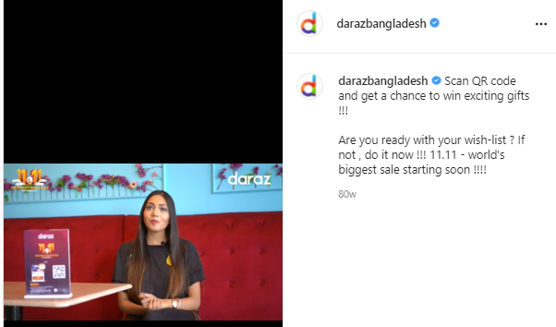
Figure 1: Influencer promoting daraz

Search Engine Optimization (SEO):
It's crucial for boosting a search engine or website's visibility and ensuring improved accessibility for human visitors. The term SEO refers to the process of optimizing a website for search engines. SEO will help you increase the number of visitors to your website. Daraz Bangladesh has a solid SEO strategy in place. When you look for the "best online shopping place in Bangladesh," you will be shown a ranking of the top 15 online shopping sites in Bangladesh. (Figure1). When you search for online shopping in bangladesh Daraz Bangladesh shown in the first place ( Figure 2).

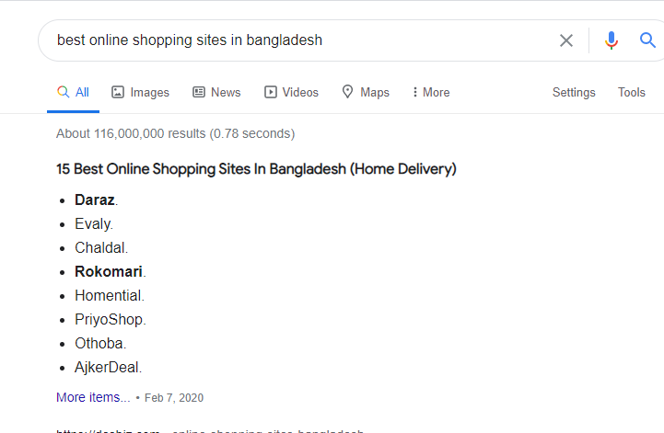
Figure 1: SEO Ranking

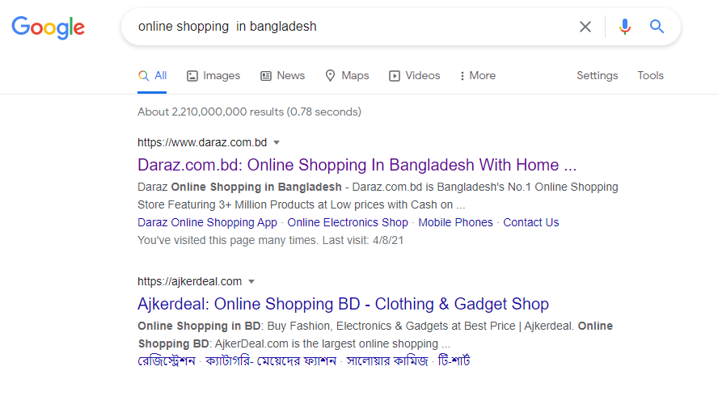
Figure 2: SEO Ranking

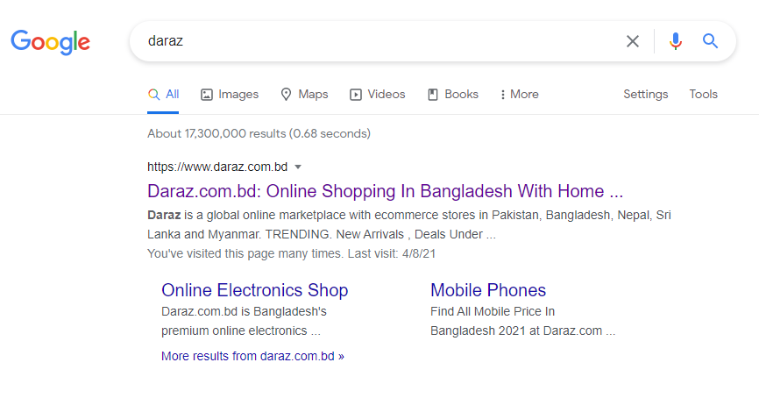
Figure 3: SEO Ranking

Email Marketing:
Daraz's email marketing approach, which involves sending newsletters to current and prospective clients, is another internet marketing strategy. Email marketing has a high return-on-investment potential since it is virtually free to introduce. It aids in the collection of social media fans, existing customer base users, and other potential prospects, and Daraz can then use a quick newsletter to attract repeat traffic to its platform.

Push Notification Marketing:
Daraz's digital policy also includes push notifications. An alert that appears on a mobile device is known as a push notification. App publishers can submit them at any time, and users do not need to be in the app to access them. That's just what Daraz does, they deliver relevant promotional text and advertisements about various offers, campaigns, and other topics to reach consumers' mobile devices.

Affiliation Marketing:
It's also a significant role-playing technique. In this approach, Daraz seeks out marketing partners with a large number of fans or supporters who are involved in promoting Daraz in exchange for a commission on orders placed via their websites.

Google Display Network (GDN):
The Google Display Network (GDN) is a fascinating and important aspect of managing Google Adwords campaigns. You can target websites based on keywords in their topics or content and put advertisements on them using the Google Adwords marketing console. In a nutshell, GDN is a list of websites that view Google ads. Daraz will use this to create a variety of advertisements, including pictures, text, and immersive video ads. Daraz may put certain advertisements on websites that are important to their products. It also exposes such commercials to the people that are most likely to be involved.

Online Marketing Tools

Facebook Ads Manager:
This is the mechanism that is most often used. Daraz invests heavily in Facebook promotion because the majority of its buyers are on the social media platform. They use the Facebook page manager APP to handle everything on Facebook. They also use smartly for promote their online posts.

Olympus:
It's an online tool that allows daraz to create trackable links (short links and deep links). This trackable link helps daraz to determine the number of App downloads, Daily app visit, monthly app visit, everyday order placement, App stickiness and other promotional activities. They use those links in social media promotion, when a customer click that link, they can track the customers activity. It helps them to evaluate the performance of each social media posts and it give them a idea og everyday overall performance of the company.

C360:
It's another online platform that the marketing staff uses to keep track of customer orders. Since too many order-related questions come from Facebook, the online team would need to use this platform to react.

Twitter/Instagram App & YouTube:
To handle those platforms, the Daraz online marketing team uses Facebook, Instagram, and YouTube applications.Where they promote their everyday commercial posts, OVC, campaign offers and discounts. They also try to follow the marketing social media trends which will help them to reach more people.

Marketing Mix
Product, place, price, and promotion, as well as people, process, and physical evidence, are all part of the marketing mix. Marketing Mix is the main part of a company. One part of the marketing mix complements the others; if something is off and imbalanced, the company will lose their sales. Below is a discussion of Daraz's marketing blend,
It consists of four significant business factors that can be used to assess a company's competitive edge in the industry.The four elements are referred to as the 4ps.

Product:
Daraz is first and foremost an online shopping mall. Daraz Bangladesh. is a company that does not produce any goods.It's an online auction where a variety of retailers can sell their goods. Daraz.com is a website where customers can buy the things they want.
It is available in a variety of categories, including Men's Fashion and Women's Fashion. TVs, Audio & Cameras, Phones & Tablets,Clothing, Footwear, Jewelry, Watches, Mobiles, and Accessories are among the categories that can be searched. Customers will conduct searches on Daraz's websites before deciding what to buy. Customers may view product details such as price, shipping statistics, and payment methods. They will find what they're looking for by using keywords in their search. You must register as a Daraz seller if you need to offer as a business. Daraz has an online market center where Sellers can distribute something over the internet.

Place:
Any virtual location where a company operates over the internet is referred to as an online business location. Daraz is an online marketplace, operates online and guides customers to their websites and mobile App. Their official website link: https://www.daraz.com.bd/
Sellers open a seller account and they put the details of the products on the website with the products pictures. In the web site there are many sellers page where people can follow them, ranking them, gives review, also they can chat ith the seller before buying the products and ensure the products details. Seller also gives their products photos, products size, weight, colors etc. Customers can select the color, size and weight in the app. This is a place where people can find many brands and sellers with many discounts and offers. Customer also can use filter to find the specific products for them and they can set their budget as well. For marketing place create a very important impact, in this digital world now website and app is more easy to reach the customers. For this types of business place online marketing is more effective than offline but daraz maintain both marketing statrgies, Online and offline.
It’s a virtual place for shopping but the feature of this website is much better then the physical store because on daraz app or website people can give their reviews and ranking.

Price:
As an online retailer, pricing is the most important part. In this case, the price was fixed by the seller on the Daraz website. As a result, the seller must adhere to the law and terms and cannot charge an illogical fee. Whenever a sale is made, Daraz will get a fee for the commodity sold. In diffirent campaign selles sell their products on a discount price.
During the campaign time the products prices changes. When the lunch a campaign the seller participate on the campaign can give many discounts and offers.
Daraz gives many exciting and unique offers for the customer such as double taka voucher, shake shake, mega voucher, I love voucher and many more. When a customer participate on this offers they get discounts and they can purchare their desired product in a discount price.

Promotion:
Daraz, as an online retailer, does a reality good job of promoting itself, especially on Facebook. They have a Facebook page where they advertise new products that are available on their websites. They have more than 13 million followers on their faceboook page. They also use YouTube and Instagram to promote themselves. They have 263k followers on Instagram and 90k subscriber on youtube. They push their daily commercial post on their channels and campaign offers as well. They produce and upload material and promotional videos on their facebook page and other channels. They are properly utilizing their pages and other online channels to reach the target customers. They are also creating a connection between the online marketing and offline marketing. They promote the offline activites on the online. Daraz organize many contest to create excitement and giveaway some exciting gifts to motivate the customer to buy.
Daraz Bangladesh boost their special offers to reach more people and to educate the people about their offers and discounts. They promote the Influencers videos where the influencers are talking about benefits of using daraz app.
They also use telemarketing to inform customers about new Daraz offers by sending SMS. Daraz can also be found fairly quickly by searching keywords in the most common search key app, Google.
Since service-centric and product-centric companies are so dissimilar, it's only natural that they have separate marketing considerations. Services, unlike goods, are intangible and perishable, and their manufacture, procurement, and use are often done at the same time. The 3P’s of service marketing are;

People:
Daraz employees more than 3500 people. They're getting bigger every year. They have their own distribution service. They use a third-party distribution service “Daraz Express”. They are affiliated with distribution firms. Sundarban Poribahan, Bidyut, 5 star, and so on. They have set up 60 hubs across the country. As Hungry Naki is a part of daraz now, so daraz is hireing more employee to ensure the better service.
Now Daraz delivering their product all over the Bangladesh. There are huge numbers of delivery men, some of them are permanent and some are part time job holder. The numbers of delivery man are increasing day by day to ensure the fastest delivery. Some major departments of daraz Bangladesh :
- Administration
- Business Development
- Comercial

- Marketing
- Human Resource
- Customer service
- IT
- Finance
There are many more departments to ensure the best service. The numbers of employee in those departments are getting bigger.

Physical Evidence:
Daraz is an online marketplace, so they do not have a physical store, but the brand that sells their products on their websites has their physical store (some mentioned below). The brands have their own store in the website, customers can follow the store and when the brand offer any discounts customer get the notification. If a customer “add to cart” any brand’s products they get the notification to buy the products. In daraz website or app customer can visit many store, search their desired products and can select the brand by evaluate the reviews and raking. However, the following brands are available for purchase via the website:

- Bata
- Apex
- Realme
- Huawei
- Sony
- Puma
- Timezone
- RB
- P&G
- Samsung
- Redmi
- Noir
- Walton
- Emami
- Focallure
- Sports World
- Ugreen
- Wiresto
- Sara and many others.
Customers can follow the store in the app and they will get the notification of offer and doscounts. The brands offers special offer on their brands day. Daraz promote the brands day on their facebook page and other channel to motivate people to avail the discounts. it will .

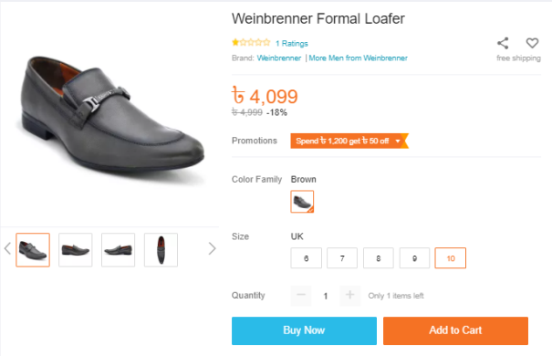
Figure 2: Bata selling shoes on Daraz

Process:
The online purchasing process is distinct from that of going to a store, but it is simpler and takes less time. The following is a summary of Daraz's online purchasing procedure: They use a variety of tools to keep the machine running smoothly. Seller Center, CRM, Warehouse Module, and Delivery Module are only a few examples.

- Seller Center: This app aids sellers in updating their stock and prices by communicating with Daraz's seller center. It also aids Daraz's market growth and sales teams in coordinating offerings and keeping track of sales, stocks, and inventory management.

- CRM: This platform aids customer support departments in effectively handling inbound and outbound calls. Other software is also used for internal and agent-to-customer correspondence, such as Zendesk, LMS, and ZOHO. They also have separate team for social media query solving.

- Warehouse Module: There are warehouse and order processing system to make inventory pick-up, stock management, and distribution processes for faster delivery. The sellers drop off their products to the Hub then the hu management distribute the products.

- Delivery Module: It assists the third element in providing the company with monitoring of deliveries made and their status. Daraz express deliver the products to the consumers. They collect the products from the hub and deliver all over the country. Now daraz delivering their products in 64 districts in Bangladesh

Competitors Analysis

Evaly:
Evaly is a locally owned and operated business. They have a sizable and diverse product range. From safety pins to toys to motorcycles, they market it all. Seasonal campaigns, cashback, and enticing discounts are popular at Evaly. Lifebuoy, Xiaomi, Toyota, Motorola, Bashundhara, Garnier, among other brands have collaborated with them.
Their products are varied in nature and they market a wide variety of products. They sell a variety of goods, including food, clothing, appliances, groceries, automobiles, and more. Customers who want to sell their items will register as merchants on their app. Evaly does not have a set release date in mind.
Daraz also acquired a food distribution start-up called “HungryNaki” to deal with the rival. Evaly already has a food delivery app.
Daraz.com.bd ships orders within 2-4 days in Dhaka and 5-8 days outside of the city. If a customer is unhappy with their purchase, they should refund it within 7 days of delivery, or 14 days if it was purchased from Dmall.

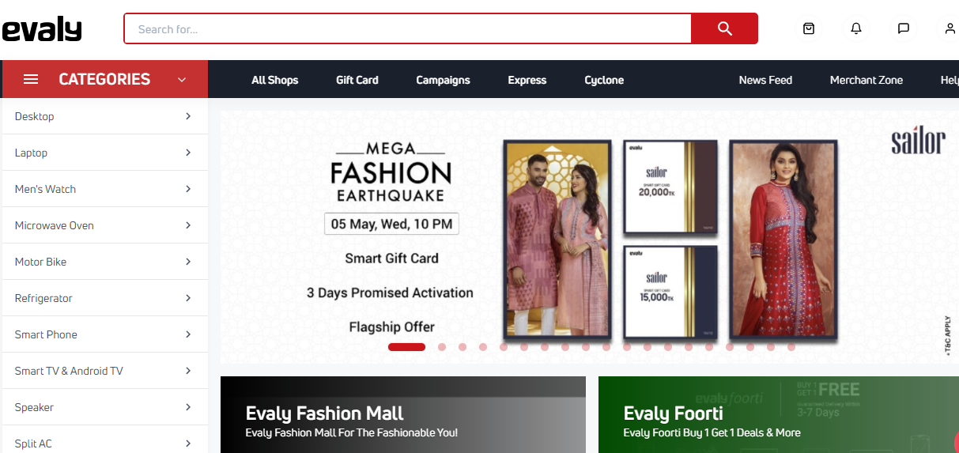

Chaldal:
Chaldal is a convenience store that operates online. Chalal.com is now one of Bangladesh's most popular online grocery stores. Fruits, vegetables, beef, fish, cooking assistance, drinks, home appliance and cleaning, pest control, and other products are available at Chaldal.

On your Android or iOS devices, download the Chaldal.com app. Customers can pay using credit cards, bKash, or cash on arrival.
There is a Dmart division of the Daraz app where they sell food items as well as drugs (Dpharma).

Rokomari:
Rokomari.com is Bangladesh's first enriched online bookstore. You will find the right genre for you, ranging from science fiction to art, history to religion. Within 3 days of receiving an order, Rokomari.com offers a pleased return and refund policy. Customers can find books and other items in the "media, music & books" category of the Daraz app.

Ajkerdeal.com:
Ajkerdeal.com is a e-comerce platform of Bangladesh where customers can find their everyday desired products. There are many catagories in their website such as men’s fashion, women’s fashion, gadgets, jewelry, home decor and many more.

Recommendations
In this dynamic market, it is critical for businesses to outperform their competitors while still establishing a level that cannot be readily surpassed by new enterprises. So far, the findings suggest that if a large and well-known corporation develops itself in Bangladesh, Daraz would have a very slim chance of stopping its revenue decline.
Daraz has to have a loyal and satisfied client base in order to ensure a long-term future. Daraz is already the established company in online shopping in Bangladesh, so there isn't anything to recommend them, but they promote their brand more efficiently that will be beneficial for both the company and the customers in the long run. Here are some suggestions:

- First and foremost, they must educate the customer more about their website and their benefits. That will motivate people to purchase from the website or the mobile App.
- They should slove the customer query as quickly as possible. In this case they can use their social media platform or can create a platform where the customer can complain and direcly can contact with the aouthority.
- As it is a marketplace and many seller al over the country are selling their products, so customers can raise their trust issue. Daraz should gain the customer trust by doing a massive marketing and they should monitor the sellers as well.
- They mostly promote their commercials on their facebook page and other social media channels, they should try other promotion platforms such as Digital billboards.
- They should promote their trusted brands to gain customer trust.
- They would place ads in the country's daily newspapers on a regular basis.
- They would air TV commercials on a daily basis on television outlets.

Conclusion
Daraz is one of Bangladesh's most popular online retailers. There is a lot of competition, but Daraz stands out for their online business efficiency. Their growth in Asia is notable, and they intend to expand even further in the near future. Daraz's product quality management is commendable, and they provide the highest possible quality. Daraz also provides career opportunities and encourages newcomers. Daraz's customer-centric approach would work well in this kind of emerging economy. About the fact that there is room and potential, they must do more to strengthen their position in the online retail industry. Digital marketing is one of the few fields that has seen explosive growth in recent years. Bangladesh has 65 million Internet users, or around 40% of the country's total population. Daraz has a lot of potential to win the demand and expand their industry with their new marketing approach. It just happened as a result of their successful marketing tactics. Daraz has a lot of potential to capture the market with their new business approach. Competitors such as Evaly, Chaldal.com, Pickaboo, and others pose a threat. However, they will take advantage of economies of scale in the coming days to outperform their rivals. Finally, we can conclude that Daraz has a high volume of revenue at the moment and there are no better options. However, once a cheaper option becomes available, consumers are likely to turn and sales may decline. The explanation for this is that the majority of Daraz's customers are disappointed with the company's results. Many people do not believe it is trustworthy or accurate. There are few and negligible reasons to return to Daraz. As a result, it's past time for Daraz to boost its service offerings and build a loyal customer base. So that if a large corporation, such as Amazon, wishes to set up shop in Bangladesh, Daraz will have a dedicated customer base. Since this industry is rapidly evolving and volatile, it is therefore prudent to plan for the long term and establish a trustworthy, positive brand presence in the minds of customers.

References
Adams, R. (2017, April 27). Forbes. Retrieved from Forbes: https://www.forbes.com/sites/robertadams/2017/04/27/what-is-online-marketing-the-definitive-guide-to-internet-visibility/?sh=456aa2f9377f
Chen, J. (2020, September 17). SproutSocial. Retrieved from SproutSocial: https://sproutsocial.com/insights/influencer-marketing/?fbclid=IwAR2o8BSjtkCym5ImKx9PJriQTGqWVUcBRRZR7555-ZI0cGeEbWzC04-ciIo
daraz. (n.d.). Retrieved from daraz: https://www.daraz.com.bd/
Dzhingarov, A. (2020, September 1). atanasdzhingarov. Retrieved from Difference between Ecommerce & Digital Marketing: https://atanasdzhingarov.com/what-is-the-difference-between-e-commerce-digital-marketing-and-why-should-you-care/
Online Marketing Introduction. (n.d.). Retrieved from Tutorialspoint: https://www.tutorialspoint.com/online_marketing/online_marketing_introduction.htm
Shopify. (n.d.). Retrieved from What is Ecommerce: https://www.shopify.com/encyclopedia/what-is-ecommerce
Staff, A. t. (2020, February 07). Deshiz. Retrieved from Deshiz: https://deshiz.com/online-shopping-sites-bangladesh/?fbclid=IwAR3BXw9czbwPr_801bgeDNUuvMsJViPYJtkC1qa4jo5KtQBAGtypse5trzo#1-2-evaly-

