Analysis of Loan Portfolio of IDLC Finance Limited

Md. Nazmus Sakib
ID: 111 153 146
School of Business and Economics
United International University

This report is submitted to the school of Business and Economics, United International University as a partial requirement for the degree fulfillment of Bachelor of Business Administration

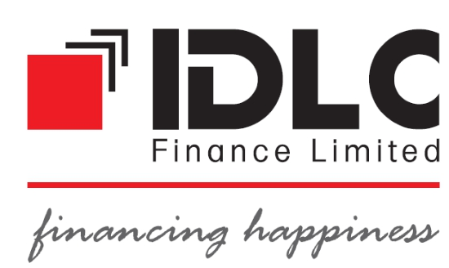

Internship Report
On
Analysis of Loan Portfolio of IDLC Finance Limited

Supervised By
Muhammad Enamul Haque
Assistant Professor,
School of Business & Economics (SOBE)
United International University

Prepared By
Md. Nazmus Sakib
ID: 111 153 146
School of Business and Economics
United International University

Date of submission: 22/01/2020

LETTER OF TRANSMITTAL
22nd January, 2020
Muhammad Enamul Haque
Assistant Professor,
School of Business & Economics
United International University
Subject: Submission of my Internship Report.
Dear Sir,
With due respect and humble submission, you will be very pleased to know that I have completed my Internship report on “Analysis of Loan Portfolio of IDLC Finance Limited”.
It gives me immense pleasure to inform you that I have completed my report under your kind hearted direct supervision. Hope that I have done a satisfactory job considering my level of experience and capability and have been able to relate the fundamental things with realistic applications.

This report also provides base insight on the IDLC Loan activities. I tried my level best and worked with most sincerity and tried to make it as well structured as possible. The full report is based on my practical experience in IDLC Finance Limited. I have found the experience quite interesting and the guidance of my supervisors and with the help of all the members of the department.

I would be grateful for any clarification when required and highly obliged if you approve this report and provide your valuable judgment on it.

Thank you.
Sincerely yours,

--------------------------
Md. Nazmus Sakib
ID: 111 153 146
School of Business and Economics
United International University

STUDENT’S DECLARATION

I advocate that the Internship Report on “Analysis of IDLC Loan Portfolio of IDLC Finance Limited”. Personify the outcome of my own research works, pursued under the supervision of Muhammad Enamul Haque, Assistant Professor, School of Business and Economics, United International University.
I further inform that the work reported in this report is original and authentic no part or whole part of this report has been submitted to, in any form, any other University or Institution for any degree or any other purpose.

-------------------------------
Md. Nazmus Sakib
ID: 111 153 146
School of Business and Economics
United International University

LETTER OF ENDORSEMENT

The Internship Report entitled IDLC Loan Portfolio has been submitted to the Office of Placement & Alumni, In partial fulfillment of the requirements for the degree of Bachelor of Business Administration (BBA), Major in Finance, Faculty of Business and Economics school on , 2019 By Md. Nazmus Sakib, bearing ID: 111 153 146. This report has been accepted and may be presented to the Internship Defense Committee for evaluation.

……………………………………….
Mr. Ahsanuzzaman
Assistant Manager
Corporate Division, IDLC Finance Limited

Acknowledgement
First of all, I would like to express my deep gratitude to the almighty Allah for fruitfully preparing this report. It was a great pleasure to prepare a report on the “Analysis Loan Portfolio of IDLC Finance Ltd”. I would like to thank and convey my gratitude to honorable Faculty, Muhammad Enamul Haque, Assistant Professor, Schools of Business & Economics, United International University, for letting me to prepare this report. His valuable advice has helped us a lot in writing this report. I am immensely thankful to him for the supports he has provided during our preparation period of this report.
After that, I must show my thankfulness to my supervisor of IDLC Finance Limited Mr. Ahsanuzzaman who serves as Assistant Manager at Corporate Division. He willingly took my responsibility and gave me a quality amount of time and shared his working experiences. His guidelines not only made me aware of the office culture but also taught me how to deal with employees.
Then there is the person of actions and motivation, Mrs. Shahela Afroz the Associate Relationship Manager of IDLC Finance Limited’s Corporate Division was a pure inspiration and she helped me directly a lot. I learned a lot more than I expected from this great person and I will remember each and every lesson I learned from her. Furthermore, I would like to express my sincere thanks to all the employees of Corporate Division who helped me during my internship time and made my experience a memorable one.

Executive Summary
The main objective of this report is to evaluate the analysis of IDLC Loan Portfolio of last four financial years. IDLC has diversified portfolio of loan products and services.
This report also gives clear idea about IDLC Finance Limited's history and background, their various types of products and services and their working divisions. This report is basically prepared to measure the analysis of loan portfolio of IDLC Finance Limited. Here you can find diversified loan portfolio analysis on the basis of IDLC’s concern and their overall implications.
In this report, the main objective is to show the analysis of loan portfolio of IDLC Finance Limited and their significant implications. I analyzed the classification of loans and advances on the basis of overall concentrations, industrial and geographical aspects. Among the overall classification based on concentration, I found that majority of loans provided by IDLC to SMEs, which is 35 percent followed by real estate finance with 31 percent. On the basis of industrial segmentation, highest loan is provided to IT sector. The second and third sector to which loan is given are Textile and power sectors. The maximum loan provided according to geographic classification is the Dhaka division. The next geographic area where IDLC given loan is the Chottogram division. The least loan given by them is Barishal division. The study furnishes the framework of loans allocation made by IDLC and its overall impact to devise the necessary mechanism to improve the level of loans.

Table Of Content
Acronyms 11
Chapter 1 - Introduction 12
1.1 Introduction 13
1.2 Origin of the Report 13
1.3 Objective of the Report 14
1.4 Scope of the Study 14
1.5 Methodology 14
1.6 Limitations of the Study 14
Chapter 2 - Company Background 16
2.1 IDLC Finance Limited: 17
2.2 The reason behind preferring IDLC Finance Limited (NBFI) over Bank 21
Chapter 03 - 22
Analysis of IDLC Loan Portfolio Segments 22
3.1 Classification of loan on the basis of significant concentration 23
3.1.1 Loans provided to the directors: 23
3.1.2 Loans provided to the executives: 23
3.1.3 Loans given to the real estate finance: 24
3.1.4 Loans provided to car loan: 25
3.1.5 Loans given to personal loan: 26
3.1.6 Loans provided against deposit: 27
3.1.7 Loans given to SMEs: 27
3.1.8 Loans provided to special program: 28
3.1.9 Loans given to the staff loan: 29
3.1.10 Loans contribute to industrial sector: 30
3.1.11 Loans provided to other loans: 31
3.2 Classification of Industrial Loans 32
3.2.1 Loans contribute to agricultural industries: 32
3.2.2 Loans given to textiles sector: 32
3.2.3 Loans provided to foods and beverage: 33
3.2.4 Loans given to pharmaceuticals: 34
3.2.5 Loans given to leather and chemical sectors: 35
3.2.6 Loans contribute to power, energy and engineering: 35
3.2.7 Loans given to real estate & home appliances: 36
3.2.8 Loans given to IT & Services: 37
3.2.9 Loans given to transportation: 38
3.3 Classification of Geographical Loan (Inside Bangladesh) 39
3.3.1 Loans given to maximum geographical area: 39
3.3.2 Loans given to minimum geographical area: 40
3.3.3 Loans contribute to overall geographical area in Bangladesh: 41
3.4 Classification of Unclassified and classified loans 41
3.4.1 Unclassified Standard including staff loan: 41
3.4.2 Unclassified SMA loan: 42
3.4.3 Classified Sub-standard loan: 43
3.4.4 Classified Doubtful loan: 44
3.4.5 Classified Bad/Loss loan: 45
Chapter 04 - Conclusion 46
4.1 Conclusion 47
Chapter 05 - Reference 49
Reference: 50
Bibliography 50

Acronyms

SME: Small & Medium Enterprise
NBFI: Non-Bank Financial Institutions
IFC: International Finance Corporation
DEG: German Investment and Development Company
IFC: International Finance Corporation
CDBL: Central Depository Bangladesh ltd
IPO: Initial Public Offering
CAGR: Compound Annual Growth Rate
NPL: Non Performing Loan
RPO: Repeat open offering

Chapter 1 - Introduction

1.1 Introduction
Bangladesh is a still a developing country. Where middle class and lower class people are the common phenomenon of this country. In this situation, banks and non-bank financial institutions play important track for the improvement of the people, customer, consumer and nation. Moreover from Middle class to higher class families consider deposit for future purposes. Based on different angles and genres of life style and need bank and non-bank institutions play an important role. This report is about one of the largest non-bank brand of the country and there is a feel good factor to know a non-bank pioneer company and work for them. Besides banks, non-bank financial institutions are going concern to our economic and financial criteria to make our country a good financial trust among customers. This report is about the IDLC Finance Limited’s basic core ideas and their overall loan portfolio analysis.

1.2 Origin of the Report
This report has been prepared as a requirement of the Bachelor of Business Administration (BBA) Internship program of United International University under the supervision and direction of Muhammad Enamul Haque, Assistant Professor, School of Business and Economics. As part of Internship program, my internship supervisor has assigned me to analyze the loan portfolio of IDLC Finance Limited’s last four years. In this situation, this report has been intended to break down the loan segments of IDLC Finance Limited. I have figured out the analysis of its loan segments and implications of it.
I was very much honored to finish my temporary job from IDLC Finance Limited, the leading Non-Banking Financial Institution which gave me a perfect experience to know that how monetary firms are operated and executed. During my Internship time, I have to make some important assessments and had gained some practical knowledge about it. In this report, I tried my best to show the perfect analysis of loans and its implications of four years. This will give clear idea about IDLC Loan improvements and its future outcomes.

1.3 Objective of the Report
The main objective of the report is to find out the “Analysis of the Loan Portfolio of IDLC Finance Limited.” Besides this, there are some supplementary objectives which are related to the main objective of the report. Those supplementary objectives are:
- To find the loan performance analysis of IDLC Finance Ltd.
- To evaluate the future outcome of this company.
- To make judgment about their current status.
- To make decision regarding to this analysis.

1.4 Scope of the Study
The scope of this study is very much necessary that where I worked for. In Corporate Division of working, there is an overall knowledge of loan portfolio management and corporate culture system. This type of loan management is related to corporations and customers for their need. So, toward the report part the scope of my conducting to IDLC historical background, their products and services, their different loan dimensions and the analysis of their loan portfolio.

1.5 Methodology
To make this report I used both qualitative and quantitative information. There are two types of sources that I had used for making this report, which are the primary sources and secondary sources. Primary sources are shortly called for raw sources that I collected from direct interview with my supervisor of Corporate Division. Most of the resources of this report I basically collected from secondary sources. Those are the annual report of IDLC Finance Limited 2016, 2017, 2018 and IDLC Finance Limited’s official website.

1.6 Limitations of the Study
The study has been conducted to be made an observation of the IDLC Loan portfolio. On the study in this field some problems were created, which may be termed as limitations of the study. These are as follows:
- There are some official restrictions to collect internal data.
- I carried out such a study for the first time, so inexperience is one of the main obstacles of the study.

Chapter 2 - Company Background

2.1 IDLC Finance Limited:
In 1985, IDLC Finance Limited started with a single leasing product. IDLC Finance Limited has gradually expanded its capacity and stated as the largest Non-Banking Financial Institution of the country. Today, IDLC Finance Ltd serves from a diversified portfolio consisting of products from Corporate Finance, SME Finance, Consumer Finance and Capital Market segments. In serving these products to our valued customers, efforts of 1500 people are dispersed through 41 touch-points spread over 24 cities across the country.
IDLC finance limited is at present the largest non-bank financial institution in this country with an estimated profit of BDT 2,171 million in 2018. IDLC states as a brand of this country. This is the highest profit by any non-bank financial institution of the country. Be the leading is not that easy and IDLC had to go to through with lots of challenges and a proper history lies behind the journey. It was the year 1985, when collaboration took place. International Finance Corporation (IFC) of the World Bank, German Investment and Development Company (DEG), Kookmin Bank and Korean Development Leasing Corporation of South Korea, the Aga Khan Fund for Economic Development, the City Bank Limited, IPDC of Bangladesh Limited, and Sadharan Bima Corporation combined their shares together and IDLC Finance Limited was formed. Initially Lease financing was the core product of IDLC. They have equal focus in Corporate, Retail and SME sectors.
IDLC Finance Limited has enormous loan portfolio. The value of the loan portfolio depends on the principal amount and interest owed and the average creditworthiness of the loans. IDLC improves their overall loan portfolio significantly over the year. In 2015, they have loan portfolio of 55,212 BDT amount. In 2018, they earned 83,934 BDT amount. In future, IDLC will generate more significant loan portfolio.
IDLC Finance Limited also generates Return on equity (ROE). Return on equity is an evaluation of a company’s overall financial performance. In 2015, IDLC generate ROE of 20.39%. Next two years they maintain same percentage which is greater than financial year 2015. But in 2018, IDLC has decreased their overall ROE to 16.55%. This measure that IDLC has lower improvement of their return on equity section as well as their overall financial performance.
IDLC Finance Limited has average Return on assets over the last four years of analysis. Return on assets of a company shows that how the company is using its assets to generate sufficient earnings. In 2015, IDLC has 2.20% ROA. The majority of ROA has gained in 2017 which is 2.60%. But in financial year 2018, IDLC has generated lower ROA which is 2.12%. This is not good for the company.
Like every financial institution IDLC has also NPL sector which is very much important sector for them. NPL refers that a loan in which the borrower has not made any type of schedule payments of principal or interest of some time. In financial year 2015, IDLC has 3.06% which is accounted as greater among next three years. In 2017, IDLC has a stable NPL of 2.77%. In 2018, IDLC has accumulated for 2.20% in contrast to the previous year. This is still good for the company.
IDLC Finance Limited offers products and services to their client and customers. Figure 2.1 stimulates the summary of the products and services.
Figure 2.1 Loan Products and Services
Loan Products
IDLC Finance Limited has various types of loan products and services that they offer to their client and customers. Their main concentration was to give loan to the industrial sector. But over the year it has enormous capacity to give loan to the consumers and SMEs sector. They always offer to their consumer and clients to give lease finance, domestic factoring loan, real estate finance loan, personal loan, business loan, home equity loan, term finance loan, invoice discounting management, corporate real estate loan, home loan, car loan, machinery loan. To give these loans IDLC has some terms and regulations to maintain their operative activity of loan process. By giving these loans IDLC has make legal relations with their consumers and customers. They also give loan to the basic significant concentration area, they also provide their loans to the industrial sectors, they contribute their loan segment to the geographical area. They also provide their loan to unclassified and classified sector.
IDLC also offers merchant banking and portfolio management system:
- Initial Public Offering (IPOs).
- Maximum Capital Investment.
- Issue management system.
- Investment advisory.
- Capital Investment.
- Underwriting management.
- Placement of cheque, equity, debentures and bonds.
IDLC generates Corporate Services with:
- Working capital arrangements.
- Product finance appraisal.
- Refinancing arrangement.
- Personal support to SME.
- Securitization to receivables.
Investment Products of IDLC:
- Bonds.
- Common equity investment.
- Preferred equity investment.
Liability Products of IDLC:
- Term deposit schemes.
- Debentures.
- Securitized bonds.

SMEs Division:
IDLC Finance Limited's SME division is a need business portion for the Company. They pursues centered client procurement endeavors, great administration for the customer and a predominant hazard balanced hunger empowered SME portfolio CAGR of 45% in the course of the most recent eight years, plainly one of the quickest development rates in the business. This SME Division gives heaps of administrations like terms credit, Working capital advances and rent financing to the customers prerequisites. This Division additionally works and backings ladies business visionaries by giving advance.
It offers to the consumers:
- Small Enterprise Finance.
- Medium Enterprise Finance.
- Supplier Finance.
- Commercial Vehicle Loan.
Corporate Division:
IDLC's Corporate Division has made huge advances into the confederation of nearby corporate combinations, expansive corporate houses and multinationals. This was made conceivable by our incorporated relationship administration approach, solid client introduction, creative item contributions and predominant administration conveyance. Continuously, the division has additionally enlarged its geological inclusion, developing its specialty showcase containing built up corporate houses and up and coming ventures.
It offers to clients:
- Lease Financing.
- Working Capital Financing.
- Term Loan Financing.
- Project Financing.
- Commercial space procurement.
Consumer Division:
IDLC's Consumer division is one of the key drivers of support-ability. The division appreciates a decent reputation in Bangladesh's shopper fund industry and appreciates a high review for its better administration models than the clients, large amounts of straightforwardness, devoted deals constrain and hearty client encounter. The division's two-expand capacities incorporate finances activation for the organization according to prerequisites and develop the benefit business reasonably. By and by this customer division has the most astounding pieces of the overall industry and development rates inside the land credit industry of Bangladesh.

2.2 The reason behind preferring IDLC Finance Limited (NBFI) over Bank
The real reason that IDLC offers is quick response with their customers as to don't acknowledge money stores however it additionally gives budgetary administrations aside from ledgers. Furthermore, we know that the bank needs to manage the issues with store, Checks, pay-requests or request drafts, remote trade financing and so forth the real disadvantages for which they can't impart as quick as IDLC Finance with their customers. However, IDLC can authorize a credit task inside 1/2 day while customer needs to sit tight for 10 to 15 days for endorsing an advance in a Bank. Another offices of IDLC Finance Limited is that it generally offers higher loan cost of FDR than other Bank since it has higher expense of assets thus they gives higher financing costs to their customers. Generally these are the principle motivation behind why a client ought to pick IDLC Finance Limited. Overall, in future IDLC as well as non-bank financial institutions will lead the financial stake positions over the country. Because it has a good economic and financial future.

Chapter 03 -

Analysis of IDLC Loan Portfolio Segments

3.1 Classification of loan on the basis of significant concentration

3.1.1 Loans provided to the directors:
A loan is the borrowing of money while a lease is a term rental agreement for the use of specific equipment. As a means of financing, loans and leases have different benefits. Below are some major considerations affecting your decision.
Year | 2015 | 2016 | 2017 | 2018
Loans, advances and leases to the institution in which directors have interest | 0.08% | 0.02% | 0.01% | 0.00%

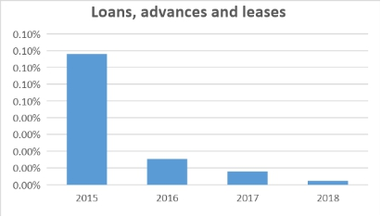
After analyzing the 4 years data we’ve found that the actual percentage of “Loans, advances and leases to the institutions in which Directors have interest” has decreased a lot. In the year 2015 IDLC had heavy amount of loans, advances & lease. On the other hand, in 2018 it became less than .01%. So, now we can say that people are less interested in IDLC loans, advances and lease.

3.1.2 Loans provided to the executives:
A loan is the borrowing of money while a lease is a term rental agreement for the use of specific equipment. As a means of financing, loans and leases have different benefits for the chief executive and other executive.
Year | 2015 | 2016 | 2017 | 2018
Loans, advances and leases to Chief executive and other senior executives | 0.060% | 0.052% | 0.042% | 0.032%

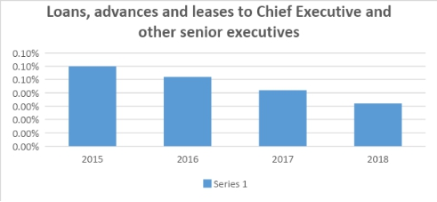
After analyzing the 4 years data we’ve found that the actual percentage of “Loans, advances and leases to Chief Executive and other senior executives” has decreased Day by day. In the year 2015 IDLC had high amount of income from loans, advances and leases to Chief Executive and other senior executives loan. In 2018 it became lower compare to the rest of the period. So, now we can say that the customers are losing interest from this feature.

3.1.3 Loans given to the real estate finance:
A commercial real estate loan is a mortgage secured by a lien on commercial property as opposed to residential property.

Year | 2015 | 2016 | 2017 | 2018
Real estate finance loan | 31% | 29% | 30% | 30%

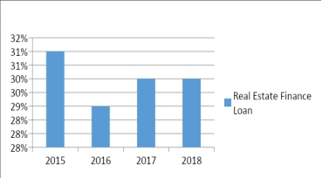
After analyzing the last four years Real estate finance loan of IDLC we can see that it remains approximately the same in the last 4 years. In 2015 IDLC has made 31% real estate finance loan, which is the highest among these four years. In 2016 it is lowest, but In the last two they maintain the same real estate finance loan which is 30%. By giving Real estate loans IDLC generates income based on interest rates. If interest rates are the same in these four years then IDLC generates highest income in 2015 and lowest in 2016.

3.1.4 Loans provided to car loan:
A car loan is a sum of money a consumer borrows in order to purchase a car. Generally speaking, a loan is an amount of money that is lent to an individual, a business, or another entity.
Year | 2015 | 2016 | 2017 | 2018
Car loan | 5% | 4% | 3% | 2%

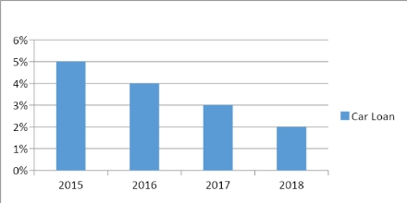
From the last four years of IDLC we can find that the Car loan given by IDLC decreased from years to years. The highest portion of car loan given by IDLC is in 2015 and the lowest in 2018. IDLC decreases the portion of money to be given in the car loan sector. In short term auto loans the interest rate is lower than the long term auto loans. IDLC charge a monthly payment to their clients based on interest rate, loan terms and the size of the loan. The lower interest rate in short term car loans turns IDLC into lower profits. IDLC provides 5% car loans in 2015 and only 2% in last year. It indicates that IDLC produces lower profit from that sector.

3.1.5 Loans given to personal loan:
A personal loan is an amount of money you borrow from a bank, credit union or online lender. Personal loans can be secured, meaning individual need collateral to get approved, or unsecured.

Year | 2015 | 2016 | 2017 | 2018
Personal loan | 0.22% | 0.14% | 0.11% | 0.16%

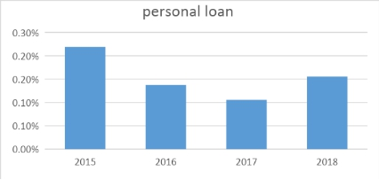
After analyzing the 4 years data we’ve found that the actual percentage of “personal loan” has decreased compared to the 2015. In the year 2015 IDLC had high amount of personal loans compared to the rest of the period. On the other hand, in 2018 it became less than 2015’s amount but higher than 2017. So, now we can say that people were losing their interest on personal loan but now it is becoming a little bit attractive to the customers.

3.1.6 Loans provided against deposit:
Loan against deposit is given by banks as an overdraft facility to customers. Overdraft or OD limit backed by fixed deposit is lower than the deposit amount whereas the interest charged is higher than the applicable deposit card rate.
Year | 2015 | 2016 | 2017 | 2018
Loan against deposit | 1.04% | 0.89% | 0.64% | 0.97%

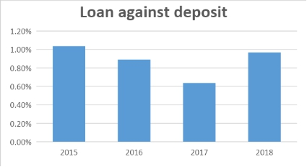
After analyzing the 4 years data we’ve found that the actual percentage of “personal loan” has decreased and increased eventually compare to the 2015. In the year 2015 IDLC had high amount of loan against deposit compared to the rest of the period. On the other hand, in 2018 it became less than 2015’s amount but higher than 2017 & 2016. So, now we can say that people were losing their interest on loan against deposit but now it is regaining its attractiveness to the customers.

3.1.7 Loans given to SMEs:
Small and medium-sized enterprises (SMEs) are non-subsidiary, independent firms which employ less than a given number of employees. IDLC gives loan to this type of SME.
Year | 2015 | 2016 | 2017 | 2018
Small and Medium enterprises | 35.77% | 38.44% | 41.12% | 40.33%

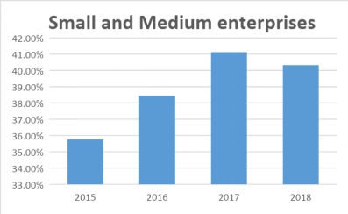
After analyzing the 4 years data we’ve found that the actual percentage of “Small and medium-sized enterprises” has decreased compared to 2017. In the year 2015 IDLC had low sector of Small and medium-sized enterprises compared to the rest of the period. On the other hand, in 2018 it became less than 2017’s amount but higher than 2015 & 2016. So, now we can say that IDLC can still get their income from SME loan.

3.1.8 Loans provided to special program:
Special financing is a term often used to describe auto loans for consumers with bad credit, which can include people who have been through bankruptcy or repossession, and those with limited credit histories. IDLC offers special program loan to its customers.
Year | 2015 | 2016 | 2017 | 2018
Special Program Loan | 7.23% | 5.24% | 3.28% | 2.33%

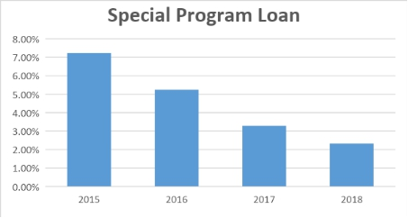
After analyzing the 4 years data we’ve found that the actual percentage of “Special program loan” has decreased compare to the 2015. In the year 2015 IDLC had high amount of income from special program loan. In 2018 it became lower compared to the rest of the period. So, now we can say that IDLC can still get their income from special program loan but this is not very attractive to IDLC’s customers. The customers are losing interest from this feature.

3.1.9 Loans given to the staff loan:
A loan to an employee is money advanced by the company to assist the employee. If the employee is expected to repay the loan within one year of the balance sheet date, the loan balance is a current asset of the company. IDLC provides this type of loan to staff.

Year | 2015 | 2016 | 2017 | 2018
Staff Loan | 0.26% | 0.17% | 0.24% | 0.25%

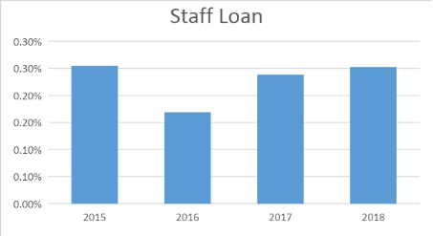
After analyzing the 4 years data we’ve found that the actual percentage of “Staff Loan” has increased compared to the previous years. In the year 2015 IDLC generated high amount of income from staff loan. In 2018 it became higher compared to the rest of the period. So, now we can say that IDLC can still get their income from staff loan. It is very attractive to IDLC’s customers. The customers are interested in this type of loan.

3.1.10 Loans contribute to industrial sector:
An industrial loan is a loan that is usually used for long term basis which have interest based on the LIBOR or Prime rate. IDLC offers this type of loans to the industrial loans and advances.
Year | 2015 | 2016 | 2017 | 2018
Industrial Loans, advances and leases | 19% | 22% | 20% | 24%

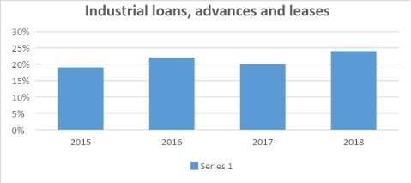
After analyzing the 4 years data we’ve found that the actual percentage of “Industrial loans, advances and leases” has increased eventually compare to the 2015. In the year 2017, there was a little bit losses compare to 2016, but 2018 it belongs to the height point. So, now we can say that IDLC can still get their income from Industrial loans, advances and leases.

3.1.11 Loans provided to other loans:
Behind those various types of loans and advances IDLC provide some extra loans and advanced to some specific person or company for some specific circumstances. IDLC offers other loans and advances.
Year | 2015 | 2016 | 2017 | 2018
Other loans and advances | 0.43% | 0.43% | 1.74% | 0.00%

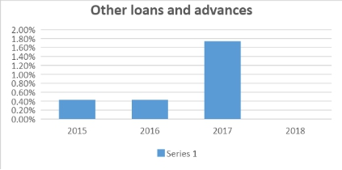
After analyzing the 4 years data we’ve found that the actual percentage of “Other loans and advances” has increased eventually compare to the 2015. In the year 2017, there was a higher percentage compared to the 2015 & 2016, but 2018 it belongs no percentage point because of their lower percentages. So, now we can say that IDLC can still get their income from Industrial loans, advances and leases.

3.2 Classification of Industrial Loans

3.2.1 Loans contribute to agricultural industries:
Agricultural industries are very much important for a country to develop overall economy. That is why IDLC offers agricultural loan to various types of industry. IDLC offers agricultural industries loan.
Year | 2015 | 2016 | 2017 | 2018
Agricultural Industries | 4% | 1% | 8% | 7%

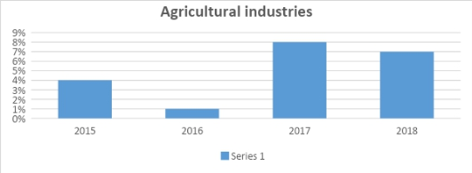
After analyzing the 4 years data we’ve found that the actual percentage of “Agricultural industries” has ups and downs. In the year 2015 IDLC had 4% of income from Agricultural industries. In 2018 it became lower compare to 2017. So, by seeing this chart we can say that IDLC can still get their income from Agricultural industries but this is not very attractive to IDLC’s customers.

3.2.2 Loans given to textiles sector:
The textile, textile product, and apparel manufacturing industries include establishments that process fiber into fabric and fabric into clothing and other textile products. IDLC provides this type of loan.
Year | 2015 | 2016 | 2017 | 2018
Textiles, Apparels & Accessories | 20% | 28% | 26% | 27%

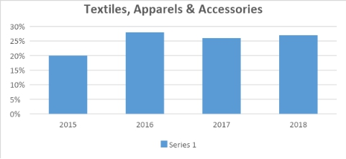
After analyzing the 4 years data we’ve found that the actual percentage of “Textiles, Apparels & Accessories” has good condition. In the year 2015 IDLC had high amount of income from Textiles, Apparels & Accessories. Day by day it shows more successful. So, now we can say that IDLC get their income from Textiles, Apparels & Accessories and this is attractive to IDLC’s customers. The customers are getting interest from this feature.

3.2.3 Loans provided to foods and beverage:
The food and beverages industry is all companies involved in processing raw food materials, packaging, and distributing them. This includes fresh, prepared foods as well as packaged foods, and alcoholic and nonalcoholic beverages. IDLC offers this type of loans to food and beverage.
Year | 2015 | 2016 | 2017 | 2018
Food & beverage | 8% | 7% | 5% | 6%

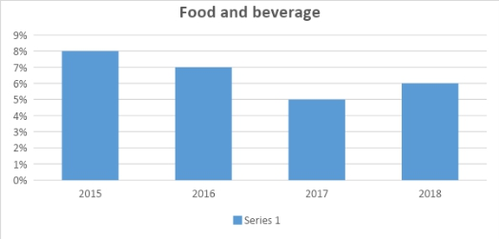
After analyzing the 4 years data we’ve found that the actual percentage of “Food and beverage” has decreased compared to the 2015. In the year 2017 it looks very bad condition. In 2018 it became lower compare to the 2015 & 2016. So, now we can say that IDLC can still get their income from Food and beverage loan but this is not very attractive to IDLC’s customers.

3.2.4 Loans given to pharmaceuticals:
The pharmaceutical industry discovers, develops, produces, and markets drugs or pharmaceutical drugs for use as medications to be administered to patients. IDLC provides loan to Pharmaceutical industries.
Year | 2015 | 2016 | 2017 | 2018
Pharmaceuticals | 5% | 3% | 5% | 4%

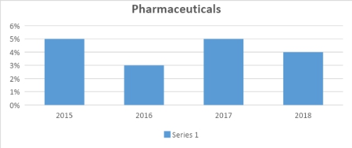
After analyzing the 4 years’ data we’ve found that the actual percentage of “Pharmaceuticals” which is in very critical condition. Some time it looks good, sometimes looks bad. After seeing this chart, I can say that IDLC should serious about this sector. This sector has good potential customers. If these customers get satisfaction it will be helpful for the company.

3.2.5 Loans given to leather and chemical sectors:
Leather industry is a major industry in Bangladesh and the Government of Bangladesh has declared it as a priority sector. IDLC offers loan to this sector as much as possible.
Year | 2015 | 2016 | 2017 | 2018
Leather & leather products, chemicals | 0.47% | 0.19% | 0.03% | 0.20%

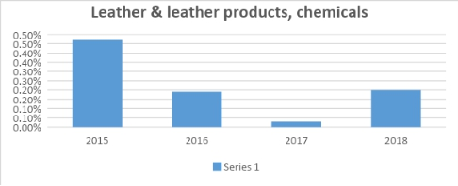
After analyzing the 4 years data we’ve found that the actual percentage of “Leather & leather products, chemicals” has decreased compared to the 2015. In the year 2015 IDLC had high amount of income from Leather & leather products, chemicals loan. In 2017 it became lower compared to the rest of the period. So, now we can say that IDLC can still get their income from special program loan but this is not very attractive to IDLC’s customers. The customers are losing interest from this feature.

3.2.6 Loans contribute to power, energy and engineering:
The power, energy and engineering sector is one of the most powerful sectors of the country. These sectors help a country to grow up and overall improvement of a country’s economy. IDLC offers huge loans to this crucial sector.
Year | 2015 | 2016 | 2017 | 2018
Power, energy & engineering | 17% | 13% | 15% | 16%

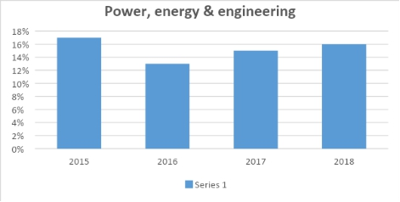
After analyzing the 4 years data we’ve found that the actual percentage of “Power, energy & engineering” has in a good condition. In the year 2016 IDLC had some little amount of income from Power, energy & engineering loan. In 2018 it became better position compared to the 2016 & 2017. So, now we can say that IDLC can still get their income from Power, energy & engineering loan.

3.2.7 Loans given to real estate & home appliances:
The major types of businesses that are involved in real estate are either operational: property management, asset management, loan servicing. Or transnational: brokerage, title and underwriting. IDLC offers loan to this sector.
Year | 2015 | 2016 | 2017 | 2018
Real estate & Home appliances, cement, ceramics | 12% | 10% | 8% | 10%

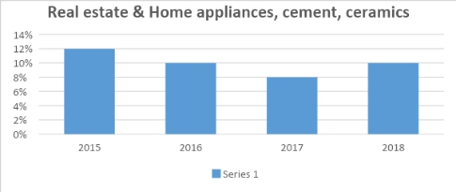
After analyzing the 4 years data we’ve found that the actual percentage of “Real estate & home appliances, cement, and ceramics” has in a good condition. In the year 2017 IDLC had some little amount of income from Real estate & home appliances, cement, and ceramics loan. In 2015 it has highest income compare to 2016. So, now we can say that IDLC can still get their income from Real estate & home appliances, cement, and ceramics

3.2.8 Loans given to IT & Services:
This sector contains businesses revolving around the manufacturing of electronics, creation of software, computers or products and services relating to information technology. IDLC offers a wide range of products and services for both customers and other businesses.
Year | 2015 | 2016 | 2017 | 2018
IT & Services | 27% | 31% | 26% | 20%

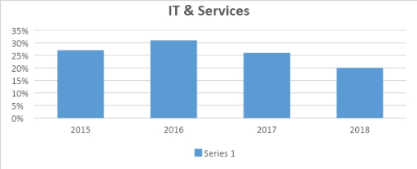
After analyzing the 4 years data we’ve found that the actual percentage of “IT & Services” has in a good condition. In 2016 it had generated the highest income compared to 2015. It had comparatively going lower in 2017 and in 2018 it had a little bit of income from IT & Services.

3.2.9 Loans given to transportation:
The transportation industry is a vast ecosystem which covers everything related to the major modes of transport, namely, road, rail, marine, and air transport. IDLC offers different types of loan for this sector to make this sector fruitful.
Year | 2015 | 2016 | 2017 | 2018
Transportation | 2% | 2% | 2% | 4%

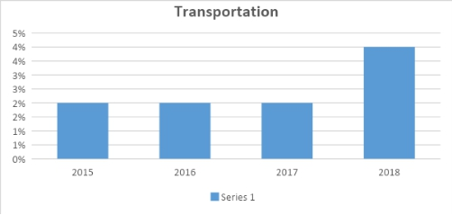
After analyzing the 4 years data we’ve found that the actual percentage of “Transportation” has increased in 2018. In the year 2015, 2016, 2017 IDLC had the same amount of income from Transportation loan. In 2018 it became higher compared to the rest of the period. So, now we can say that IDLC get their income from Transportation loan but this is very attractive to IDLC’s customers.

3.3 Classification of Geographical Loan (Inside Bangladesh)

3.3.1 Loans given to maximum geographical area:
After analyze the geographical location inside the Bangladesh we found “Dhaka” which is consisting of maximum percentage. The percentage of Dhaka is given below in a graphical way-
Year | 2015 | 2016 | 2017 | 2018
Loans, advances and leases-geographical location-wise Inside Bangladesh (Maximum) | 63% | 61% | 59% | 71%

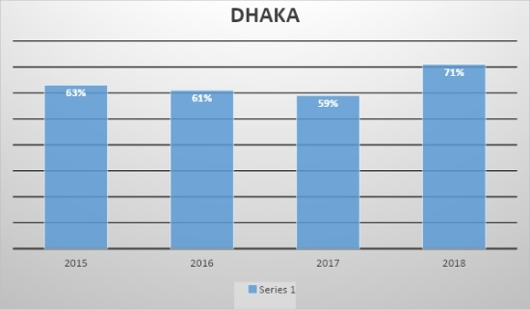
After analyzing the 4 years data we’ve found that the actual percentage of “Loans, advances and leases-geographical location-wise Inside Bangladesh (Maximum)” which is considered the Dhaka, has a little bit of ups and downs over the time. In 2018 it is the maximum amount among the period. So, now we can say that the customers of Dhaka are getting interest from this feature.

3.3.2 Loans given to minimum geographical area:
After analyze the geographical location inside the Bangladesh we found “Barishal” which is consisting of minimum percentage. The percentage of Barishal is given below in a graphical way-
Year | 2015 | 2016 | 2017 | 2018
Loans, advances and leases-geographical location-wise Inside Bangladesh (Minimum) | 0.00% | 0.00% | 0.08% | 0.38%

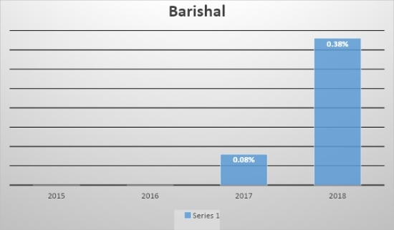
After analyzing the 4 years data we’ve found that the actual percentage of “Loans, advances and leases-geographical location-wise Inside Bangladesh (Minimum)”which is considered the Barishal, has very low rate of percentage over the time. In 2018 it is the maximum amount among the period.

3.3.3 Loans contribute to overall geographical area in Bangladesh:
After analyze the geographical location inside the Bangladesh we try to found a overall scenario of this sector. The overall scenario of this sector is –
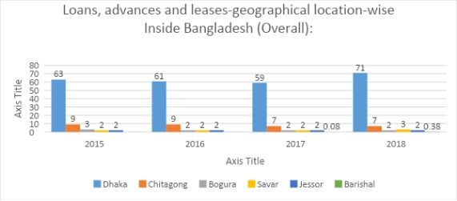

3.4 Classification of Unclassified and classified loans

3.4.1 Unclassified Standard including staff loan:
If the employee is expected to repay the loan within one year of the balance sheet date, the loan balance is a current asset of the company. IDLC has a huge portion of Standard Staff Loan.
Year | 2015 | 2016 | 2017 | 2018
Standard including staff loan | 95% | 95% | 96% | 96%

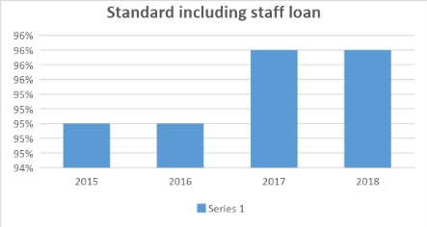
After analyzing the 4 years data we’ve found that the actual percentage of “Standard including staff loan” has same in 2015-2016 & 2017-2018. In the year 2018 it became higher compare to the rest of the period. So, now we can say that the customers are getting interest from this feature.

3.4.2 Unclassified SMA loan:
The Special Mention Account identification is an effort for early stress discovery of bank loans. Special account created for reporting Standard Accounts moving toward Sub-Standard. IDLC offers SMA loan to its client and customers.

Year | 2015 | 2016 | 2017 | 2018
Special Mention Account | 2% | 2% | 1% | 1%

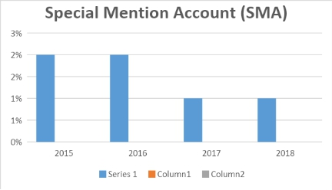
After analyzing the 4 years data we’ve found that the actual percentage of “Special Mention Account” has decreased Day by day. In the year 2015-2016 IDLC had high amount of income from Special Mention Account loan. In 2017-2018 it became lower compared to the rest of the period. So, now we can say that the customers are losing interest from this feature.

3.4.3 Classified Sub-standard loan:
Sub-standard loan is the amount of past due installment which is equal to or more than the amount of their installments due within three months tenure. This loan is known as Sub-standard Loan. IDLC offers this type of loan portion.
Year | 2015 | 2016 | 2017 | 2018
Sub-Standard | 2% | 2% | 1% | 1%

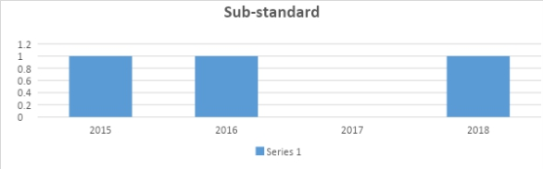
After analyzing the 4 years data we’ve found that the actual percentage of “substandard loan ”. It looks same amount rest of the three years without the year 2017. In 2017 , the amount is 0%. I think IDLC should more concern about this sector.

3.4.4 Classified Doubtful loan:
A loan is classified as doubtful loan which has all the portion of a substandard loan and has credit weak point. This will make full collection as questionable and improbable. IDLC also has some doubtful loans.
Year | 2015 | 2016 | 2017 | 2018
Doubtful | 1% | 0.49% | 0.31% | 0.42%

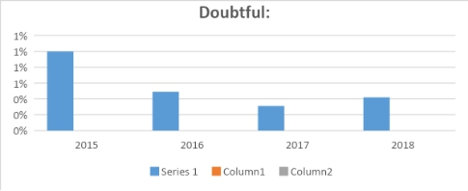
After analyzing the 4 years data we’ve found that the actual percentage of “doubtful loan” has decreased Day by day. In the year 2015 IDLC had high amount of income from doubtful loan. In 2018 it became lower compare to the 2015 & 2016. In 2017 it is the minimum amount among the period. So, now we can say that the customers are losing interest from this sector.

3.4.5 Classified Bad/Loss loan:
Bad debt losses that arise in the course of the taxpayer’s business are treated as ordinary losses. In general, ordinary losses are fully deductible without any limitations. So there are also bad debt losses in IDLC Finance Limited.
Year | 2015 | 2016 | 2017 | 2018
Bad/Loss | 2% | 2% | 2% | 1%

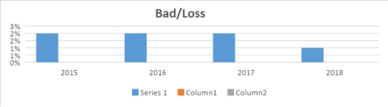
After analyzing the 4 years data we’ve found that the actual percentage of “Bad debt loan” has maintained their equal percentage in 2015, 2016, 2017. In the year 2018 IDLC had low amount of income from bad debt loan. So, now we can say that the customers are not losing interest from this feature.

Chapter 04 - Conclusion

4.1 Conclusion
Throughout the report we see that our main objective is to find out the analysis of Loan Portfolio of IDLC Finance Limited’s last four financial years. This report is an overall classification of loan segments and their significant implications.
This report is basically prepared to measure the analysis of loan portfolio of IDLC Finance Limited. In this report, the main objective is to show the analysis of loan portfolio of IDLC Finance Limited and their significant implications of last four years. They have classification of loans and advances on the basis of overall concentration. In this section, they provide loan to the directors which is minimally low capacity, they provide loan to the executives who is same as given to the directors. They give loan to real estate finance, majority of this loan is given here in 2015 over the year it is still a stable position over the year. They give car loan, majority of this loan is given to 2015 but over the year it is decreasing. They give personal loan, most of the loan is given to year 2015, later they improve this section in 2018 by giving higher loan. They provide loan against deposit, in 2015 they had high amount of loan against deposit compared to rest of the period, and still they are growing interest to their customers. They give SMEs loan, in year 2015 they had lower amount of SMEs loan, but in year 2018 they have improve the loan portion significantly. They give SPL loans, in 2015 they have high amount of SPL loan but over the year it is decreasing. They give loan to their office staffs; in 2015 IDLC generated high amount of income from staff loan but in 2018 it became higher compared to the rest of the period. They have higher portions of industrial sectors and other extra loans; that are improving over the year.
They have classification industrial loans and leases. In this section, they provide agricultural industries loan; in 2015 IDLC had 4% of income from this sector, in 2018 it became lower compared to 2017; but still it is very attractive to the customers. They provide textiles and other accessories loan; in 2015 it generated high amount of income from this sector; over the year it is becoming more successful. They give loan to the foods and beverage; in compared to 2015 rest of the periods have very low condition among them in 2017 it looks very bad condition. They generate pharmaceuticals loan; it is a very critical condition, sometimes it looks good condition or sometimes it looks bad condition. They give their loans to leather and chemical industries; in compared to 2015 rest of the period is decreasing and had bad condition in this sector. They have power, energy and engineering loan; it has a good condition over the year, it is still a stable position throughout the four years. They provide real estate and home appliances loan; it is in a good condition over the year, in 2017 it had low amount compared to 2015 and rest of the period. They generate huge loan to the IT & Services sector; IDLC can generate more income from this sector over the four years and future. They contribute to the transportation loan; which is very minimal, majority of this loan is given to the financial year 2018.
They have classification of geographical loans and leases over the year. They generate majority of their loan portfolio to the Dhaka division. Secondly, they provide loan to the Chittagong division. Thirdly, they provide loan to the Bogura and Savar division. They have lower impact of Barishal division. They have unclassified standard staff loan; they have generated huge portions in this sector, over the four is contributed to the same as they given loan to 2015. They give loan to the unclassified SMA; this sector is decreasing day by day in compared to 2015. They give loan to the classified sub-standard sector; this sector is looking same among the financial year of 2017; I think IDLC should more concern about it this sector. They provide loan to the doubtful sector; in compared to 2015 IDLC has lower amount of income from this sector from rest of the period. And lastly their loan portion is given to the bad debt losses; in this sector IDLC maintain equal amount over the four financial years.

Chapter 05 - Reference

Reference:

Bibliography
Annual Report 2018. (2018, June 30). Retrieved December 20, 2019, from IDLC Finance Limited: https://idlc.com/sustainability-reports.php
Annual Sustainability Report 2016. (2016, June 1). Retrieved December 20, 2019, from IDLC Finance Limited Web site: https://idlc.com/sustainability-reports.php#flexible-deposits
Annual Sustainability Report 2017. (2016, June 1). Retrieved December 20, 2019, from IDLC Finance Limited Web site: https://idlc.com/sustainability-reports.php#flexible-deposits
IDLC Finance Limited. (n.d.). Retrieved Demeber 20, 2019, from IDLC Finance Limited Web site: https://idlc.com/our-story.php
IDLC Finance Limited. (n.d.). Retrieved December 20, 2019, from IDLC Finance Limited Web site: https://idlc.com/consumer.php
Jebun Nesa Alo. (2017). Good governance drives growth of IDLC Finance. The Daily Star .

