INTERNSHIP REPORT ON CUSTOMER SATISFACTION EVALUATION OF AL-ARAFAH ISLAMI BANK LTD

©United International University i

INTERNSHIP REPORT ON CUSTOMER SATISFACTION EVALUATION OF AL-ARAFAH ISLAMI BANK LTD.

Rampura, Branch Dhaka.

Authorized By:

SK Gausur Rahman Taki
Officer
Al-Arafah Islami Bank Ltd
Rampura Branch, Dhaka

Submitted by: |  | Submitted To:
Raina Islam Euna |  | Mr.S.M. Asif-Ur-Rahman
ID: 111142174 |  | Assistant Professor
United International University |  | United International University
Date of Submission: 09th November,
2019.

©United International University
ii

Letter of Transmittal

09th November, 2019

To

Mr.S.M. Asif-Ur-Rahman

Assistant Professor

United International University

Subject: Submission of Internship Report.

Dear Sir,

With due respect, I would like to let you know that it is a matter of great pleasure and privilege for me to present the Internship report titled “Customer Satisfaction Evaluation of Al -Arafah Islami Bank ltd Rampura Branch” which was assigned to me as a requirement for the completion of BBA program by BBS.

Throughout the study, I have tried to provide proper and adequate information as possible and tried to maintain the instructions that you have suggested. I put my best effort to make this report as much detailed as possible. I sincerely believe that this report would satisfy and meet the requirements and will serve the purpose of my dissertation.

I am very grateful to you for your guidance and cooperation at every step of my endeavor during preparing this report. It would remain very grateful to you if you examine my report work and give me further suggestions to make it more better report.

Sincerely yours

Raina Islam Euna

ID: 111142174
United International University

©United International University
iii

Acknowledgement

Firstly, I would like to pay my deepest gratitude to the almighty Allah who has helped me through all the hardships in my life and showed me the right path. It is Allah and my parents who has helped and my journey into the vast sea of knowledge making it smoother and easier.

All my sincere and honest gratitude also goes to my respected supervisor, Mr.S.M. Asif-Ur-Rahman, Assistant Professor, United International University, who has guided me from the very beginning of my Internship program. Her inspiration and encouragement has made me truly confident and self-dependent. Her utmost efforts and appreciation has immensely contributed to my report. All the shortcomings and weakness of this report, however are incurred by me.

My heartfelt thanks go to all the officials of Al-Arafah Islami Bank Limited who were involved into my report. Firstly, would especially like to thank SK Gausur Rahman Taki (officer) for allowing me to do my internship in his branch. Also I would like to thank other collogues and staffs for providing me support and courage throughout my Internship program and helping me to accumulate necessary information. Also for giving me time and sharing their thoughts and insights about customer satisfaction level of AIBL. I am very grateful to them as I got required information to commence this report and for providing the permission to do the required research work.

Lastly, my heartiest gratitude goes to others who were involved and helped directly and indirectly in completion of internship and preparing this report.

©United International University
iv

STUDENT’S DECLARATION

I thus reported that the internship presented entitled Customer Satisfactionof Al-Arafah Islami Bank Limited is submitted to United International University under the curriculum of BBA program.

I declare that the reports is only prepareds to meet my academics needs as a part of BBA program, not for any other purpose.

Raina Islam Euna

ID: 111142174
United International University

©United International University
v

Executive Summary

The report emphasize on the “Customer Satisfaction of Al-Arafah Islami Bank Limited” which highlights products and services offered by the bank to its customers, ranges of these services, related shortcomings and suggestions how to overcome. Customer satisfaction evaluations are used for several different purposes and important for the bank that wishes to continuously monitor and improve the customer experience they provide. In my report , I tried to evaluate AIBL’s customer satisfaction which has helped me to provide recommendations regarding to find solution to fix meaningful problems that have occurred for customers with the bank’s products or service, assess the performance of its customer-facing units (branches, ATM booths, online facility and staff) and to improve its processes and standards for delivery and finally to understand customers’ needs as they use the AIBL’s products or services so AIBL can help them to have a better overall experience. As a part of my academic requirement for the completion of my BBA program I needed to complete my internship program with the duration of three months in Al-Arafah Islami Bank Limited, Rampura Branch. In this phase of my education, I received the practical knowledge related with my courses I learned at university. At AIBL, I was assigned to work as intern in two different sections such as General Banking and in Foreign Exchange Division. Mainly I worked at General Banking Section. Data collected for the report in two different modes namely primary and secondary. Face to face conversation with the respective officers of the branch was the main mode to collect primary data and for secondary data various publications and related body are observed. Al-Arafah Islami Bank Limited is basically a scheduled commercial bank which was registered by the Bangladesh Bank. The services of AIBL cover a wide range of banking and functional activities to individuals, firms, corporate bodies and other multinational agencies. The main goal of the bank is to provide best quality and swift service to its customer and increase their satisfactory level. Even though they are doing a satisfactory job but according to my perception they need to focus more on the overall management system and consumer behavior which should be as cooperative as possible with the main branches as well as with other branches to ensure r a smooth flow of work. I tried to make some necessary recommendations to be adjusted to maintain the organizations journey to the excellence according to my viewpoint.
In brief, this report basically emphasizes on how to satisfy and minimize dissatisfaction of the customers and to improve their satisfaction level by providing the best services and qualities in comparison to other banks.

vi
©United International University

Table of Contents

SL. NO. | Table’s Title | Page no
1 | Chapter- 1: Introduction | 1
1.1 | Introduction | 2
1.2 | Purpose of Study | 2
1.3 | Methodology of study | 2
1.4 | Limitations | 4
1.5 | Literature Review | 4
2 | Chapter- 2: Company Overview | 5
2.1 | Al-ArafahIslami Bank Limited | 6
2.2 | Historical Background | 6
2.3 | Products/Service Offering | 6
2.4 | Special Feature Of AIBL | 7
2.5 | Structure of AIBL | 8
3 | Chapter- 3 Analysis & Findings | 9
3.1 | Satisfaction | 10
3.2 | Customer Satisfaction | 10
3.3 | The Need to Measure Customer Satisfaction | 10
3.4 | Demand of Customer | 10
3.5 | Service Quality And Satisfaction | 11
3.6 | Customer’s Importance & Level of Satisfactions & Analysis | 11
3.7 | Reliability | 12
3.8 | Responsiveness | 15
3.9 | Care & Empathy | 19
3.10 | Tangibles | 21
3.11 | Some Other Analysis | 24
4 | Chapter 4: Major FINDINGS RECOMMENDATIONS & | 29
 | CONCLUSION
4.1 | Major Findings From The Observations | 30
4.2 | Recommendations | 30
4.3 | Conclusion | 31
4.4 | Reference | 32

©United International University

vii

List of Tables:

Table No | Table's Title | Page NO.
3.5 | Service Quality and satisfaction | 11
1 | Provides services within the time periods | 12
2 | Employees give appropriate solution to problems | 13
3 | Errors and mistakes correctly promptly | 14
4 | Employee gives your prompt service | 15
5 | Employee always searches for solution | 16
6 | Friendliness & Courtesy of the employees | 18

©United International University viii

Chapter-1

Introduction

©United International University
Pag-01

1.1 Introduction:

The word 'bank' most likely started from the word 'seat' in antiquated occasions. The first of the Jews in Jerusalem, who presented a sort of banking before the introduction of Christ, as a credit advance. The Jews exchanged cash and credits on a long seat. Islami Banking has thought of thoughts like benefit sharing (Mudharbah), supervision (Wadia), joint endeavor (Musharqah), cost in addition to (Murabahah), and renting (lease).).

1.2 Purpose of report:

1.2.1 Broad Objective:

The principle reason for this investigation is to decide the degree of fulfillment of clients of Al-Arafah Islami Bank Ltd., Rampura Branch.

1.2.2 Specific Objectives:

The particular goals of this

- Assess the staff's capacity to perform ward benefits and rely upon appropriately

- Helpful banking hours, surveying consumer loyalty to get care and individual consideration.

- To survey the necessities of representatives and to gives prompts administrations.

1.3 Methodology:

1.3.1: Types of Researches:

In this examination, insightful research was done to decide the absolute banking of Al-Arafah Islami Bank Limited are the work and certain highlights of the administrations of this bank.

©United International University
Pag-02

1.3.2 Preparation of Q & A:

The whole work need to arranged are the dependent on the circle scale. There are five assistance quality levels dependability, input, confirmation, compassion and effects. To widen the base of Islamic Banking in the rustic culture. I have chosen 21 inquiries that emphasis on these 5 levels.

1.3.3 Target Group

Al-Arafah Islami Bank Ltd's. own client.

1.3.4 Sources of Information

1. Primary Data

In the meeting of representatives of Al-Arafah Islami Bank Limited, I gathered the underlying data in any case. Meeting with Al-Arafah Islami Bank clients in the meeting.

- Secondary Data

I have extended different kinds of auxiliary information in my examination. The accompanying optional information sources can be characterized as: Internaly Sources and Externaly sources

1.3.5 Method and Size

Method

For good outcomes, I have received non-imminent intention procedure in this venture study where clients were given duplicates of inquiry paper and were posed to fill them. Number of populace:

At this examination arrange I have chosen a gathering of 100 individuals

1.3.6 Information Analysis and Results:

Gathered information examination is finished with the assistance of measurable instruments. The responsiveness of the review, including the degree of significance and the view of the client, is long in the first place and the weighted reactions of those responses are readied.

Pag-03
©United International University
1.4 Limitations of the Report:

- Misfortune to Dutch quarterly and counselors:
- Self-cash was kept up at the air terminal.
- Just compensate for the Copperberchers bankhouses.
- As a rule, later and most recent data has not been distributed.

1.5 Literature Review:

This audit will have writing on client adherence and conduct, consumer loyalty and observation levels.

Hartl (2006) will carry on that conduct yet set the most significant thing. In the investigation of Al-Bros (1999) with regards to Washington, USA, bank clients engaged with every single geological region and bank resources. Research includes posing different inquiries identified with their fulfillment with the bank.

1.5.1 Cultural elements:

Accordings to Kotler et al (1999) societies influencess the persone's desires and conduct. They accept that kids end up in the public arena, they can gain from the principles of various associations

1.5.2 Personal Factors:

A different choice to purchase a huge amount is affected by its correct characteristics.

©United International University

Pag-04

Chapter 2 Company Overview

©United International University | Pag-05

2.1 Al-ArafahIslami Bank Limited

Al-Arafah Islami Bank Ltd started its operations on 18 June 1995 as a commercial bank, according to the rules and regulations of the Bangladesh Bank. It provides all kinds of commercial banking activities to potential had to used properly customers within the Bank's Companies Act, 1991 and maintains mandate and policy guidelines prescribed by the Bangladesh Bank. By 2016, the banks participated in CSR activities with have to financial assistances way in various fields such as education, trainings, healthcare, sports, natural disasters etc.

2.2 Historical backgrounds:

Islam means 'peace'; It indicates a completely pure and dangerous free lifestyle. The main goal of Islamic life is to succeed in our lives as well as immortal life. So in every aspect of our life, we follows the doctrines of al-Qur'an and the life of Prophet Muhammad (peace be upon him) in order to achieve the greatest success.

2.2.1Vision:

Keep a significants contributions to the advancements of Islamic banking in Bangladesh and to improvement the national economy.e national economy.

2.2.2Mission:

- Here, both here and later, to achieve Allah Almighty satisfaction. Sharia-based banking practice spreaded.

- Business business maintains high standards of ethics.

- Balanceing increase.

2.3 Products / Services Offering

- Involving more in Micro and SME financing.

- Monthly profit based term deposit (MPTD).

- Al Arafa Month Haj Amant

- AlArafah savinges bonding

Pag-06
©United International University

2.4 Specials Featuress of AIBL:

AIBL is totally committeds to the welfare-baseds banking systems as well as the developments of low-incomes groups of people in economics welfares, creatings employments opportunitiess.

2.5 The investments method of AIBL

Bai-Salam: The term bay-salam is used to define a sale where the buyer prepares money. Delivery is delayed for a while in the future. Usually the seller is a person or business and the buyer is in the bank. In spite of the five dimensions, some other questions were also asked to the customers for better understanding of their satisfaction or dissatisfaction and the reason behind this. These questions and their analysis.

Goal:

To facilitate rural entrepreneurs

To develop socio-economic condition of rural people

To save rural people from usury

To facilitate the growth of agro-industries

To create employment scope

To broaden the base of Islamic Banking in the rural society

©United International University
Pag-07

2.6 AIBL's structure:

The AIBL is governed by the board of directors including 15 member. The Board is responsibles for appointings and Executives Committees comprisings sponsored directors (Chairman, Vice Chairmans), its members, shareholdingr directors, formers officers, directors and companys departmentes. The Committees is authorizedy to observe and review day-to-day activities includings investments plans, budgetes and other investments activitiees. Moreover, the Boards is responsible for establishings companys policiess and reviewing they company's operationals performances with the approvals of major investments transactiones and major fundraising. In additions, the board is responsible for managing the company's overall operations in the frameworks of the companyes policies and is responsibles.

©United International University | Pag-08

Chapter-3

Analysis & Findings

©United International University | Pag-09

3.1 Satisfaction:

Definition 1: Satisfaction mean that one feels the feeling of one when fulfilling one's desires, needs or expectations.

Definition 2: When compared to a product approval staff performances levels of with its expectations to approvement.

3.2 Customers Satisfactions:

Gaining high levels of customers satisfactions is extremely importants for a business because satisfaction is most likely to be loyals to customers and is likely to uses a repeats ordered and a wides ranges of services offered by a business.

- Definition 1: To ensure customer satisfaction productand service performance meets customer's expectations are equivalents.

3.3 The Need to Measure Customers Satisfactions:

The erea of globalizations, managements of companiess is more concerneds about customers satisfactions, which makes profits. Satisfactory customer centrale to the best performances andAIBL should arrange training are the facilities and other seamier to skilled their mans power.

Increase the ATM booths as per customer needed. AIBL have to evaluate risk management to avoid fake deeds. How come up with possible ways of improving service are quality and efficiency that financials incomes.

3.4 Demand of Customers:

Befor starting to building tools tothe measures satisfactions levels, it is importants to develops a clear are understanding of exactly what a customs wonts.

are two types of customers expectations,

Publication, Implicit

©United International University
Pag-10

3.5 Services Quality and Satisfactions:

It is difficult to generally define two words "satisfaction" and "quality", and the authorss usees those conditions to intervenes

Credibility
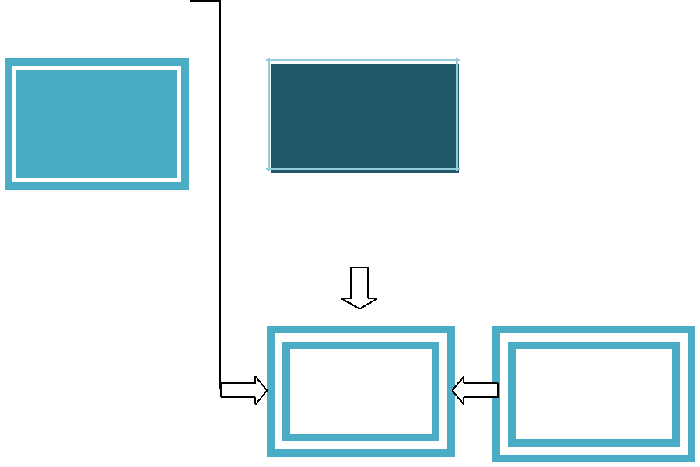

Situationaly
_{Sensitivity} ^{Services} Factors
Quality

Assurances
Empathy
 |  |  |  |  |  |  | Products |  |  | Customer |  | Customerd
 |  |  |  |  |  |  | Qualitys
Tangibles |  |  |  |  |  |  |  |  |  | Satisfacti |  | Loyalty

 | Price |  |  | Personal
 |  |  |  | Factors

Figs: Service Quality and satisfaction

Source: Office File

3.6 Customer’s Importance & Level of Satisfaction & Analysis:

Customers importance and level of satisfaction at AIBL showns brieflys. The results are produceds accordings to variouss services qualitys levels. Eac levels have its owns specifics questions. The results of the surveys was presented on the basiss of theses questions, which was asked by respondents with a protected questionnaire. The results of these research are as follows:

©United International University | Pag-11

3.7 Reliabilitys:

These questions arefollows:

- Q1: Employees give appropriate solution to problems.

- Q2: Errors and mistakes correctly promptly.

Q1: Provides services within the time periods

The respondentses placed a highty importances in this characteristic of these servicess. The 2% customers are highly satisfied, 20% customers are satisfied 60% well as 18% negative with those statement.

Satisfactiones Scores | Satisfactiones Percentages (%)
1 | 2%
4 | 18%
3 | 60%
5 | 18%
2 | 0%
Table 1: Provides services within the time periods

Source: Annual Report.
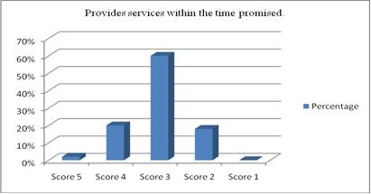

©United International University | Pag-12

Chart 1: Provides services within the time promised.

Source: Annual Report.

Q2: Employees give appropriate solution to problems.

Customer always tries to get appropriate solution to problem. The majorityes of the respondentses or negative with this statement. 15% customers hasbeen satisfieded, 40% customerses has indifferent and 45% customerss of disagreeing with this statement.

Satisfactions Score are | Satisfaction Percentage are (%)
5 | 1%
4 | 15%
3 | 40%
2 | 45%
1 | 1%

Table 2: Employees give appropriate solution to problems.

Source: Annual Report.
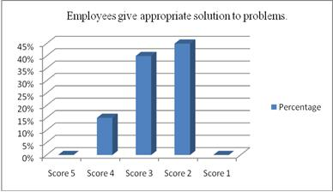

Chart 2: Employees give appropriate solution to problems.

Source: Annual Report.

©United International University

Pag-13

Q3: Errors and mistakes correctly promptly.

The this characteristic of the servicees. The 5% customers are highly satisfied, 25%

cunsumers are openly satisfieds 40% and 30% customers are negative thuse statement.

Satisfactiond | Satisfactionds Percentaged (%)
Scoresd
1 | 5%
4 | 25%
3 | 40%
5 | 30%
1 | 0%

Table 3: Errors and mistakes correctly promptly.

Source: Annual Report.
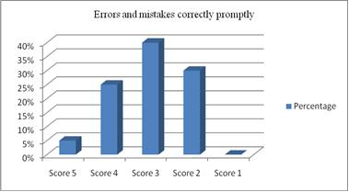

Chart 3: Errors and mistakes correctly promptly.

Source: Annual Report.

©United International University
Pag-14

3.8 Responsiveness:

Three attributes were

- Q2: Employees are always willing to help.

- Q3: Employee always searches for solution.

Q1: Employee gives your prompts services.

Percentage of Satisfaction satisfied. 2% customerss or highly satisfieds, 40% customerse or satisfieds with are statement, 30% customers are indifferent as well as 28% customerss or negatively with are this statemented. The results are as follows:

Satisfactiones Scoreds | Satisfactionss Percentageed (%)
1 | 1%
4 | 40%
3 | 12%
5 | 28%

Table 4: Employee gives your prompt service.

Source: Annual Report.
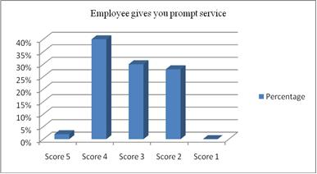

Chart 4: Employee gives your prompt service.

Source: Annual Report.

©United International University

Pag-15

Q2: Employees has always willings to helps.

where the satisfaction percentage is high. Employees are always willing to help the majoritys was the respondentss were satisfieds. 10% customerss were highly satisfieds, 45% customers or satisfieds were this hestatemented, 25% T results are as follows:

Satisfactionsd Scoreds | Satisfactioned Percentagess (%)
1 | 10%
4 | 20%
3 | 25%
2 | 20%
5 | 1%

Table 5: Employees are always willing to help.

Source: Annual Report.
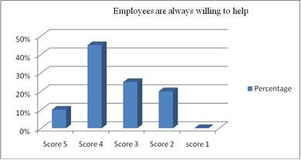

Chart 5: Employees are always willing to help.

Source: Annual Report.

©United International University Pag-16

Q3: Employee always searches for solution.

In indifferent while expressings were satisfaction towards this aspect. The satisfaction percentages of this attributed have dissatisfactorys. 35%and 40% and 20% customers are disagreeing with this statement and 5% process.
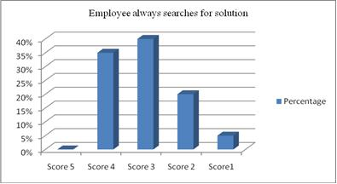

Chart 6: Employee always searches for solution.

Source: Annual Report.

 | Satisfactiond Scored |  |  | Satisfactiond Percentagde (%)
 | 1 |  |  | 2%
 | 4 |  |  | 35%
 | 3 |  |  | 50%
 | 2 |  |  | 20%
Table6: |  | Employee | always | searches | for | solution.

Source: Annual Report.

Q1: Friendliness & Courtesy of the Employee

25% customers are disagreeing of these with this statement and 3% customers have not are highly disagreeing designing with this statement.

©United International University | Pag-17

Satisfactiond Scoreds | Satisfactiond Percentaged (%)
1 | 1%
4 | 32%
3 | 50%
2 | 25%

Table 7: Friendliness & Courtesy of the employees.

Source: Annual Report.
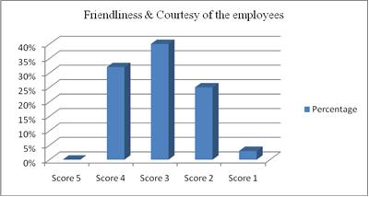

Chart 7: Friendliness & Courtesy of the employees.

Source: Annual Report.

Q2: You feels safely in your transactiones with AIBL.

With this statement, 35% customers are indifferent.

The results are as follows:

Satisfactionsd Scoreds | Satisfactionsd Percentaged (%)
1 | 25%
4 | 45%
3 | 20%
2 | 0%

Source: Annual Report.

Pag-18

©United International University

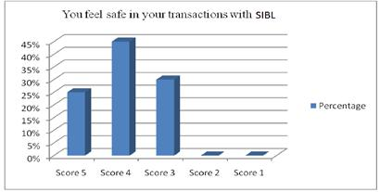

Chart 8: Source: Annual Report.

3.9 Cares & Empathys:

The variouss aspects are shown below:

- Q1: AIBL giveed attention to every individuals

- Q3: your best interest at hearts

Q1: Gives attention to every individual

With thosed statement and 8% customers are highly disagreeing with this statement.

Satisfactionsd Scoreds | Satisfactiones Percentaged (%)
5 | 1%
4 | 20%
3 | 42%
2 | 20%
Table 9: AIBL gives attention to every individual.

Source: Annual Report.

©United International University

Pag-19

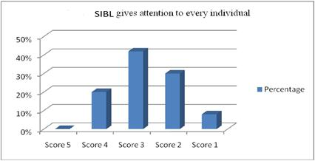

Chart 9: AIBL gives attention to every individual.

Source: Annual Report.

Q2: Employees of AIBL understands your specific needs

25% 55% customerss were indifferents, and 20% customs are disagreeing with taew statementys

Satisfactionsd Scoreds | Satisfactionsd Percentaged (%)
5 | 1%
4 | 25%
3 | 55%
2 | 20%

Table 10: Employees of AIBL understands your specific needs.

Source: Annual Report.

©United International University | Pag-20

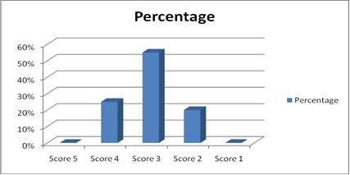

Chart 10: Employees of AIBL understands your specific needs.

Source: Annual Report.

Table 11: AIBL has your best interest at hearts.

Source: Annual Report.
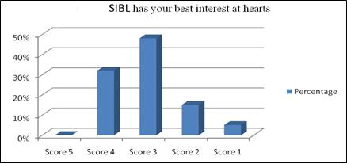

Chart 11: AIBL has your best interest at hearts.

Source: Annual Report.

3.10 Tangibles:

4 question relating was shown belows:

- Q2 AIBL has convenient hours of operation

- Q3: Statements are easily understood, reliable and accurate

©United International University
Pag-21

Q1 AIBL are visuallys appealings facilities

25% 22% 8% customers were highly disagreeing with this statement.

Satisfactiond Scoreds | Satisfactiond Percentaged (%)
1 | 8%
2 | 25%
3 | 45%
4 | 22%
Table 12: AIBL has visually appealing facilities.

Source: Annual Report.
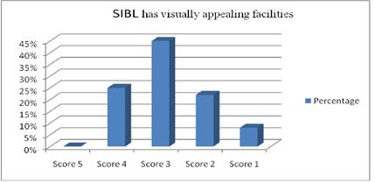

Chart 12: AIBL has visually appealing facilities.

Source: Annual Report.

Q2: AIBL are convenients or operations

The results are as follows:

Satisfactions Scoredd | Satisfactionss Percentaged (%)
3 | 1%
2 | 22%
1 | 30%
4 | 26%
5 | 0%

Table 13:AIBL has convenient hours of operation.

©United International University
Pag-22

Source: Annual Report
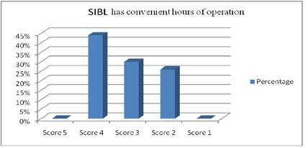

Chart 13: AIBL has convenient hours of operation.

Source: Annual Report.

Q3: Statements are easily understood, reliable and accurate

The results are as follows:

Some other questions were also asked to the customers for better understanding of their satisfaction or dissatisfaction and the reason behind this

Satisfactions Scoreds | Satisfactions Percentageds (%)
5 | 10%
4 | 55%
3 | 15%
2 | 8%
1 | 2%

Table 14:Statements are easily understood, reliable and accurate.

Source: Annual Report.

©United International University | Pag-23

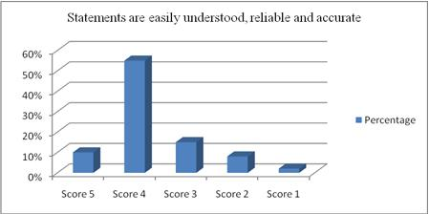

Chart 14: Statements are easily understood, reliable and accurate.

Source: Annual Report.

Source: Annual Report.
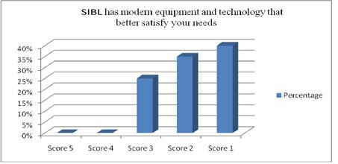

Chart 15: AIBL was moderns equipmentd and technology the betterd satisfys aer need.

Source: Annual Report.

3.11 Some other Analysis:

In spite of the five dimensions, some other questions were also asked to the customers for better understanding of their satisfaction or dissatisfaction and the reason behind this. These questions and their analysis are given below:

- Q1: AIBL has strong brand name and reputation

- Q2: Quality of service is high that are provided by the personnel

- Q3 AIBL has sufficient ATM booths

©United International University | Pag-24

- Q4 AIBL has suitable branch location

- Q5: AIBL gives average bank service and facilities

Q1: AIBL has strong brand name and reputation

Different customer views products and services indifferent way. The reason for taking service

or buying products from organization is different among the customers.

Satisfactions Scored | Satisfactions Percentaged (%)
2 | 1%
1 | 28%
2 | 42%
4 | 20%
5 | 2%

Table 16: AIBL has strong brand name and reputation.

Source: Annual Report.
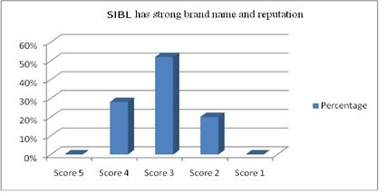

Chart 16: AIBL has strong brand name and reputation.

Source: Annual Report.

Q2: Quality of service is high that are provided by the personnel

More the qualified people the organization have more the efficiency and effectiveness in the service provided by those personnel. Efficient and effective work reduces the lead time of performing job that will satisfy the customers.

©United International University
Pag-25

Satisfactiond scored | Satisfactiond Percentaged (%)
2 | 1%
4 | 15%
1 | 25%
2 | 35%
5 | 25%

Table 17: Quality of service is high that are provided by the personnel.

Source: Annual Report.
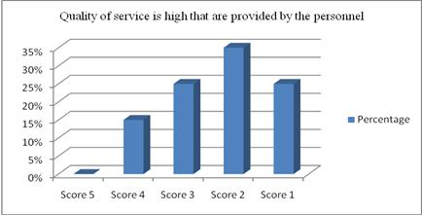

Chart 17: Quality of service is high that are provided by the personnel.

Source: Annual Report.

Q3: AIBL has sufficient ATM booths

In recent days ATM service has become vital for the customers and banks. The banks are willingly to achieve competitive advantage through superior flexibility.

©United International University
Pag-26

Satisfactiond Scored | Satisfactions Percentaged (%)
1 | 2%
4 | 15%
3 | 25%
2 | 35%
5 | 25%

Table 18: AIBL has sufficient ATM booths.

Source: Annual Report.
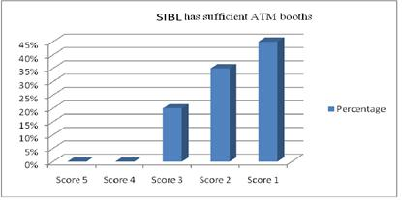

Chart 18: AIBL has sufficient ATM booths.

Source: Annual Report.

Q4: AIBL has suitable branch location

10% customs are disagreeings was those statements

Satisfactiond Scoreds | Satisfactiond Percentaged (%)
2 | 25%
4 | 45%
3 | 20%
2 | 10%
5 | 2%

©United International University | Pag-27

Table 19: AIBL has suitable branch location.

Source: Annual Report.
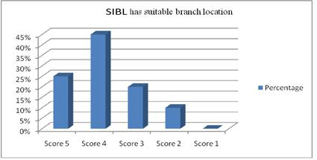

Chart 19: AIBL has suitable branch location.

Source: Annual Report.

Q5: AIBL gives average bank service and facilities

More the qualified people the organization have more the efficiency and effectiveness in the service provided by those personnel. Efficient and effective work reduces the lead time of performing job that will satisfy the customers.

Satisfactioned Scored | Satisfactions Percentaged (%)
3 | 15%
4 | 42%
5 | 28%
1 | 20%
2 | 3%

Table 20: AIBL gives average bank service and facilities.

Source: Annual Report.

©United International University
Pag-28

CHAPTER-4 MAJOR FINDINGS RECOMMENDATIONS &

CONCLUSION

©United International University Pag-29

4.1 Major Findings from the observation:

Besides the formal questionnaire survey. Those fact were the three monthes of period. Such facts reflex the customer’s expectation regarding the service provided by the bank. Such facts are as follows:

- Quality the AIBL, these doing not give qualitys ful services. So it is very necessary to improve their service quality.

- AIBL do not gives individuals attentions had the customs.

- The customers have to pay charge to get second copy of bank statement. If it is for last six months then the bank provides it instantly, but they seek for more than six months, statements are delivered on after two or three days.

- Most of the customers feel safe in transactions with AIBL. So that it is one of the most vital or strong part for AIBL.

4.2 Recommendations:

These are given below:

- Use of Marketing Research

- Focus on customer relationship strategy.

- Clarity of the Banking statements.

- AIBL should arrange training facilities and other seamier to skilled their man power.

- Increase the ATM booths as per customer needed.

- AIBL should evaluate risk management to avoid fake deeds.

- How come up with possible ways of improving service quality and efficiency that will lead to bring more customer satisfaction for Al-ArafahIslamiBank Ltd.

©United International University
Pag-30

4.3 Conclusion:

This studys provided some interestings insights into what kinds of services they provides from Al-arafahIslami bankLtd and what quality services they receive. It is very clear from the study those the customer's requirements to have not been fully met and they are very dissatisfied with of work.

It is not possible to make any profitable business with customer conveniences. AIBL is a great local bank. To achieved the desireds positions in the markets, the services is essentiald for timely improvements.

©United International University | Pag-31

References

▪  Shah,R.(2017).HowtoCalculateaCustomerSatisfaction

Score

with

QuickTapSurvey.QuickTapSurveyBlog.Retrieved7April2017,from

- http://www.quicktapsurvey.com/blog/2015/08/25/how-to-calculate-a-customer-satisfaction-

score/Arlen,C.(2017).The 5 ServiceDimensionsAllCustomersCareAbout.Serviceperformance.com.

- Retrieved7 April2017,fromhttp://www.serviceperformance.com/the-5-service-dimensions-all-

customers-care-about/Ara,E.(2017).MasterCardLaunchesFirstIslamicCardwith Al-ArafahIslamiBankin Bangladesh.

- MasterCardSocialNewsroom.Retrieved

7April2017,fromhttp://newsroom.mastercard.com/asia pacific/press-releases/mastercard-launches-first-islamic-card-with-al-arafah-islami-bank-in-bangladesh.

- AnnualReport2012. (2013) (1stEd.).Dhaka,Bangladesh.Retrieved from http://www.al-arafahislamibankltd.com

- Kotler, P. and Armstrong, G. (1999). Principles of marketing. 4th ed. Scarborough, Ont.: Prentice Hall Canada.

- Malhotra, N. (2008). Marketing research. 5thed. New Delhi: Prentice Hall of India.

- Murphy, P. and Meadhra, M. (1999). Banking online for dummies. 2nd ed. Foster City, CA: IDG Books Worldwide.

- Robbins, S. and Judge, T. (2013). Organizational behavior. 15th ed. Boston: Pearson.

- Shekhar, K. and Shekhar, L. (2010). Banking theory and practice. 21sted. New Delhi: Vikas Pub. House Pvt. Ltd.

Websites:

- https://www.alarafahbank.com

- https://www.bb.org.bd/?p=6931

©United International University | Pag-32

