Report on LankaBangla Securities Limited and Overall Capital Market Preview | Nishargo Meghela  ID: 111 152 005

Internship Report on LankaBangla Securities Limited and Overall Capital Market Preview

Submitted To
Shakila Aziz, CFA
Assistant Professor, Finance
School of Business and Economics

Submitted By
Nishargo Meghela
ID: 111 152 005
Major: Finance
Trimester: Fall’19

School of Business and Economics

Date of Submission
07 December, 2019

Letter of Transmittal

07 December,2019
Shakila Aziz, CFA
Assistant Professor,
School of Business & Economics
United International University

Subject: Internship Report on LankaBangla Securities Limited and Overall Capital Market Preview.

Dear Madam,
With due honor, we are wishing to inform you that it was a matter of great pleasure as well as learning to prepare a Report on LankaBangla Securities Limited and Overall Capital Market Preview for my internship. Actually, I have enjoyed in preparing this report. My Senior Manager, supervisor and other office members have helped me so well to prepare this report. So, I would highly oblige if the content of the report has been acceptable to you.
Though I have put my best efforts, it is very likely that the report may have some mistakes and omissions that are unintentional. So, I hope that the report will be worthy of your consideration.

Sincerely yours,

_______________
Nishargo Meghela
ID: 111 152 005
BBA in Finance

Declaration of the Student

I, Nishargo Meghela, therefore give add up to and complete affirmation that the report entitled "LankaBangla Securities Limited and Overall Capital Market Preview". An Analysis is set up by me with the rules that have been given by my boss and through keeping up the guidelines of the establishment also. Alongside that, I likewise guarantee that the report is authentic and real from each measurement. What's more, it is additionally arranged for scholastic prerequisites of BBA program not for some other reason.

Sincerely yours,

_______________
Nishargo Meghela
ID: 111 152 005

Acknowledgement

I would like to convey our thanks to a number of people who helped us in completing this dissertation. The endeavor and strain undertaken by those cannot be left without recognition.

First of all, we are immensely grateful to our respective teacher Shakila Aziz, for her guidance, valuable & thoughtful comments, and suggestions. I am very grateful to her for giving us inspirations and encouragement throughout my study. Her untiring patience & attention to details enabled us to complete this dissertation and get it into its present form. However, all its limitations are considered.
Secondly, I would like to convey our thanks to the people who provided us with valuable information that was very much needed for the completion of this report. Specially my Senior Manager, Md. Abid Khan and supervisor of organization Mahmuda Akter.

Finally, my sincere gratitude goes to our friends and classmates who helped me whenever I needed.

Despite my sincere efforts, there may appear some shortfalls in the report. My apologize for any such unintentional errors.

Executive Summary

This report has attemted to feature the review of LankaBangla Security Limited and in general Bangladesh Capital Market. LBSL is one of the main Brokerage house in the nation. As an understudy from business discipline, I got the chance to work with this association and attempt to put my push to make a profundity study. I attempted my best to give a reasonable thought regarding LBSL and for this I have gathered the most utilized Information.
The first chapter is the introductory chapter. Here I’ve discussed about the origin, objective, limitations and methodology of the report.
In the second and third chapter I tried to give the preview of LangkaBangla Securities Limited and Bangladesh Capital Market. These chapters are the main part of this report.
Forth chapter is all about my internship experience and the last chapter, there is some recommendations for LBSL and conclusion of the report.

Table of Contents

Letter of Transmittal i
Declaration of the Student ii
Acknowledgement iii
Executive Summary iv
List of Abbreviations vi
List of Figures vii
List of Tables viii
CHAPTER 1: INTRODUCTION 1
1.1 Brief History of LBSL 2
1.2 Origin of the Report 2
1.3 Objective of the Report 3
1.4 Limitations of the Report 3
1.5 Methodology 3
CHAPTER 2: COMPANY PREVIEW 5
2.1 Overview and history 6
2.2 Trend and growth 12
2.3 Customer 14
2.4 Service/Product Mix 15
2.5 Operational and Complaisance related Activities: 21
2.6 An Overview of SWOT Analysis: 22
CHAPTER 3: INDUSTRY ANALYSIS 27
3.1 Capital market 28
3.2 Size of Capital Market 28
3.3 Performance analysis of Bangladesh capital market 2018 30
3.4 Key Highlights of the Capital Market in 2018 32
3.5 Outlook of Major Sectors in the Capital Market 33
3.6 External economic factors: 36
3.7 Porter’s Five Forces 39
CHAPTER 4: INTERNSHIP EXPERIENCE 42
4.1 Introduction 43
4.2 Work Description 43
4.3 Learning Outcome 44
CHAPTER 5: RECOMMENDATIONS AND CONCLUSION 45
5.1 Critical Findings 46
5.1 Recommendation 47
5.2 Conclusion 48
REFERENCES 49
References 50

List of Abbreviations

LBSL: LankaBangla Securities Limited
LBFL: LankaBangla Finance Limited
DSE: Dhaka Stock Exchange
CSE: Chittagong Stock Exchange
CAD: Credit Administration Department
SME: Small & Medium Enterprise
COM: Credit Operation Management
NBFI: Non-Bank Financial Institutions
DEG: German Investment and Development Company
CDBL: Central Depository Bangladesh ltd

List of Figures

Figure 1: Trend of Total Revenue of LBSL
Figure 2: Trend of Cost of Service of LBSL
Figure 3: Trend of Gross Profit of LBSL
Figure 4: Total Number of DSE Listed Company (1993-2018)
figure 5: DSEX vs Turnover
Figure 6: Capital Market Performance in 2018
Figure 7: Equity Market Performance in 2018in Bangladesh and Peer Countries

List of Tables

Table 1: Gross Profit Calculation
Table 2: Trend Percentage Analysis
Table 3: Capital Market Company Category and Characteristics
Table 4: Change in Mcap of Major Sectors in 2018

CHAPTER 1: INTRODUCTION
  - Brief History of LBSL
  - Origin of the Report
  - Objectives of the Report
  - Limitations of the Report
  - Methodology

1.1 Brief History of LBSL
Two decades back LankaBangla Finance Limited started its voyage in 1997 as a joint-experience cash related establishment in worldwide composed exertion with a license from Bangladesh Bank under Financial Institution Act-1993. Today, LankaBangla is that the country's driving consolidated reserve organizations supplier that join organization financial Services, Personal money related Services, SME fiscal Services, Liability Management, Stockbroking, organization consultatory and Wealth Management Services.
LankaBangla is the market head in the capital market benefits and has been giving a full scale effort to develop a powerful, exuberant and direct capital market in Bangladesh. Its assistant, LankaBangla Securities Limited is giving top of the line business organizations and standing apart with forefront trading, first class investigate information, and customer care.
LankaBangla practices participatory organization and holds quick to industry's recommended techniques in the whole of its endeavors. Extending accomplices' worth is a trademark primary purpose for the people at LankaBangla. Their long-standing viability tries are making natural and social beneficial push ahead. By getting a handle on high good checks, organization, and straightforwardness, LankaBangla dreams to go further and get more prominent. Its ethos is direct. The association envisions its thriving lies in transforming into the improvement assistant of its goal-oriented clients. LankaBangla is centered around empowering lives and move changes in organize.

1.2 Origin of the Report
In this day and age's just scholastic training doesn't make an understudy impeccable to get aggressive with the outside universes. Temporary job is profoundly expected to increase commonsense thought, information and experience. As an understudy of BBA program I need to fill in as an interne and present a report on this temporary position work. I have worked LBSL on Business Development Department.

1.3 Objective of the Report
The goal of this report is to break down the presentation of the LBSL. There are additionally stay different destinations:
- To know in insights concerning LBSL.
- To Gain hypothetical and handy learning
- To know the hierarchical structure of LBSL.
- Find out the Services that given by LBSL.
- To investigating the reserve, the executives’ procedure.
- To dissecting the LBSL protections and observing procedure.
- SWOT examination of LBSL.
- Suggest a few proposals to improve the presentation

1.4 Limitations of the Report
In preparing this report some problems and limitations were encountered which are as follows:
- Data collection process was irregular
- Some data are not disclosed due to security and other corporate obligations
- Lack of knowledge about report
- Information may be biased and not fully transparent

1.5 Methodology
Sources of Information
We have collected the information/data from the following sources which have helped us to make this report. The source is divided into two parts:
a) Primary Source
b) Secondary Source

- The “Primary Sources” are:
A primary data source is an original data source, that is one in which the data are collected firsthand. The methods used to collect such data include:
- Face-to-face conversation with the respective officers and staffs of the Branch.
- Observation
- Interviews
- The “Secondary Sources” are:
The secondary data sources are annual reports, manuals, and brochures of LBSL and different publications of brokerage houses. To identify the implementation, supervision, monitoring and repayment practice- interview with the employee and extensive study of the existing files.
Methods used to collect secondary data include:
- Annual Report of LBSL.
- Internet.
- Different strategic tools

CHAPTER 2: COMPANY PREVIEW
2.1 Overview and History
2.2 Trend and Growth
2.3 Customers
2.4 Products and Service Mix
2.5 Operations
2.6 SWOT analysis

2.1 Overview and history
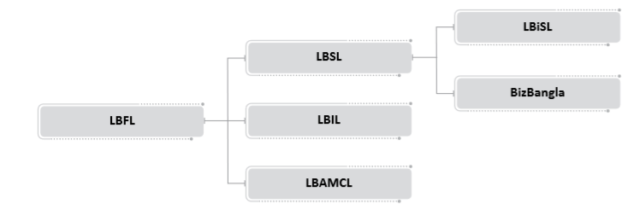
LankaBangla Securities Limited (LBSL) is focused on giving first class business administrations and coming out on top with front line exchanging, top of the line research and client assistance. LankaBangla Securities started as Vanik Bangladesh Securities Ltd in 1997 with their exercises restricted uniquely to the Chittagong Stock Exchange (CSE) Ltd. After a year, they made a stage ahead and acquainted themselves with the Dhaka Stock Exchange (DSE). It rebranded to LankaBangla Securities Ltd. in 2005 after a rebuilding of the organization. The organization is 90.91% possessed backup of LankaBangla Finance Limited (LBFL) which is one of the main recorded non-banking money related establishments in Bangladesh occupied with Leasing, Credit Card Services, Merchant Banking, Corporate Financing, and Financial Consultancy. LBFL is claimed by a gathering of exceptionally effective nearby business people of Bangladesh-Sampath Bank Limited of Sri Lanka, One Bank Limited of Bangladesh, and the overall population. With all these on the back, our home LBSL is without a doubt a worldwide one which knows customers' inclinations, follows up on their decision, and ensures the most agreeable speculation condition while putting resources into Bangladesh.

LankaBangla Securities Ltd. is the pioneer in client exchanges. The capacity to fulfill the needs thinking about each customer's time skyline, objectives, and hazard resilience have made the organization settle relations with a great many retail and institutional customers everywhere throughout the globe. This is reflected in the way that the business house is delegated as the biggest as far as exchange an incentive for the ninth back to back time in DSE and tenth in CSE in 2014.
At LBSL, individuals represent considerable authority in building up the nation's most productive stock financier workforce with unrivaled abilities and consummate hairsplitting. Likewise, in whichever corner of the nation the clients are, LBSL gets them secured with their 10 branches spread in the main urban communities and towns.
Quality, accommodation, and dependability are a few things that LBSL gives the clients at the most elevated level and which the clients can anticipate from their representatives. This is the key as LBSL has a solid system of key customers everywhere throughout the world. Moreover, the nearby and worldwide acknowledgments from money related organizations, caretaker banks, companies, universal store directors, and other individual intermediaries for its polished methodology has established the framework of solidarity and further achievement.
Aside from NITA exchanging, LankaBangla Securities Ltd. (LBSL) is offering exchanging offices to remote institutional customers involving various assets, global dealers, banks, and so on who are keen on exchanging Bangladeshi securities. All through the world, any customer of a worldwide representative can exchange the Bangladesh Capital Market through LBSL. To improve it, LBSL remote exchange execution group has a Bloomberg terminal on its devoted outside exchange work area which associates the group with each store supervisor around the world guaranteeing 100% consistent exchanging for the outside customers.
Having a solid value base, LBSL centers around the broadening methodology following which LBSL has made a value interest in BizBangla Media Limited which is distributing the nation's first Bengali business day by day 'The Daliy Bonik Barta'. In addition, LankaBangla Securities Limited is one of the executives of MIDAS Financing Limited, an eminent money related establishment. LBSL has just started building up an autonomous IT auxiliary LankaBangla Information Systems Ltd.
LankaBangla Information System Limited
LankaBangla Information System is a main information innovation specialist co-op in the nation. LBIS began its adventure on May, 2013. LBIS's solid base of mastery and specialized expertise is based on the firm conviction that "Innovation Serves the Business". This conviction empowers us to convey IT benefits that match and develop with your necessities as they advance. LankaBangla Information System is an IT Manage Services redistributing and counseling organization giving IT arrangements, venture the board and thorough foundation backing and observing. With well comprehension of the interchanges business, access to present and rising advancements, develop improvement forms, worldwide assets and a demonstrated reputation, LBIS makes total answers for help customers succeed. In this day and age, associations should rapidly re engineer themselves and be increasingly receptive to changing client requests. LBIS is all around situated to be an accomplice and coinnovator to organizations in their change venture, recognize new development openings and encourage their endeavor into new divisions. The worth is in the unification of demonstrated encounters, talented aptitude and characterized thought administration.
Items and Services of LankaBangla Information System:
- Virtual Office Dynamics
- Market Data Service
- Project Management
- Consultancy
- Cloud Services
- Outsourcing
- Mobile Application Development
BizBangla Media Limited:
BizBangla Media Limited is an 80% claimed backup of LankaBangla Securities Limited, a main financier administration organization in Bangladesh. BizBangla Media Ltd. is focused on distributing the nation's first Bengali business day by day 'The Daliy Bonik Barta'. Since 2011, Bonik Barta (BB) has been guaranteeing economic development in quality business announcing and enormous customers base, in this manner prompting a solid market situating in the market.
Today this exceptionally respected business day by day has a broad system of flow over the significant activity for example business center points/outlets the nation over. In the ongoing years with a solidified exertion and reasonable Management authority, BizBangla has endeavored to situate itself inside the top performing (Bengali) business papers in Bangladesh. This has come about into rising as one of the significant Department of Film and Publications (DFP) agreeable associations. This rating by the DFP gives a significant sign of the uprightness and quality of the association and
The concerned Newspaper and is especially important to its definitive pursuers/buyers and different partners, for example, the key accomplices, investors and loan specialists.

Worth including exercises for BizBangla Media are as per the following:
- Placing the exchange and trade division's advantage and fulfillment as first need by giving refreshed, full confirmation, examined information
- Adding incentive to the partners through accomplishing greatness in day by day activity
- Maintaining high moral standard and straightforwardness in production
- Being a consistent establishment through holding fast to every single administrative necessity
- Contributing fundamentally to the advancement of the general public
- A responsibility to be an accomplice to the development of the country
Solid and dependable association with the exchange and business network, the Government Sector, the MNCs has prompted a more extensive chance to serve the market. Through the broad degree of news inclusion arrange, center around Generalized News, Telecom and Technology, the Editorial, International Trade, the Global Business, the Commerce and Industry and the Financial Institutions Industry, Life Style, Talkies, the Commodities Market, the Stock Market, Sports and the Domestic Market, BizBangla Media Ltd. offers a smooth assistance over all the major working centers any place there is an authority present. This is flawlessly done by the effective representatives of the organization.

Vision, Mission and Core Values
Vision:
Growing together with our partners by executing the most complete, effective and cutting edge financier stage to keep up the greatness and boost the wealth of investors.
Mission:
- Providing Quality Product and Services
- Ensuring the Use of State of the Art Technology
- Being the Hub of International Investment
- Demonstrating Comprehensive Integrity with Market
- Maintaining Corporate Governance
- Promoting Research and Analysis
- Involving in Continuous Process Improvement
Core Values:
- Accountability: Ensuring obligation and similarity
- Diversity: As comprehensive as our administrations
- Integrity: Being genuine with assignment and work power with most noteworthy moral models and decency in each occasion
- Leadership: The boldness to shape a superior future
- Quality: Ensuring the administration with responsibility
- Respect: We respect the rights and convictions of our individual partners, us speculators, key partners and our locale. We treat others with the most noteworthy level of pride, fairness and trust.
- Teamwork: We advance and bolster a differing, yet bound together, group. We cooperate to meet our shared objectives.

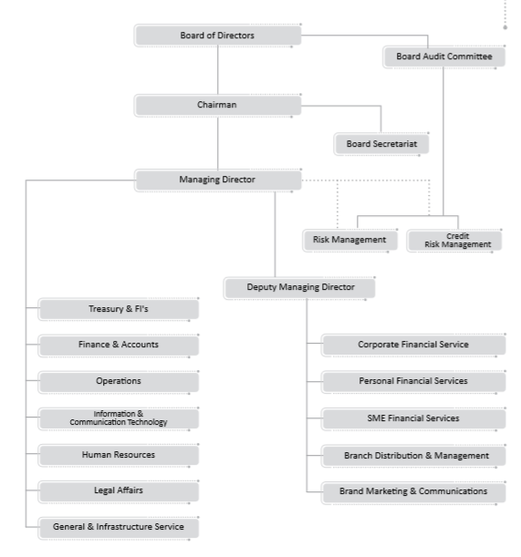
Organogram of LBFL

2.2 Trend and growth
Here the analysis is done dependent on the trend percentage analysis, by which we'll have the option to comprehend where the market is going and simultaneously the development identified with the organization.
Trend percentages are like horizontal analysis aside from that examinations are made to a chose base year or period. Trend percentages are helpful for contrasting fiscal summaries more than quite a long while in light of the fact that they reveal changes and trends happening through time.
Trend percentages, likewise alluded to as record numbers, help you to contrast monetary information after some time with a base year or period. You can figure trend percentages by:

- Selecting a base year or period.
- Assigning a load of 100% to the sums showing up on the base-year budget reports.
- Expressing the comparing sums on the other years' fiscal summaries as a percentage of base-year or period sums. Figure the percentages by Analysis year sum/base year sum and afterward increasing the outcome by 100 to get a percentage.

Table 1: Gross Profit Calculation
Particulars | 2014 | 2015 | 2016 | 2017 | 2018
Total Revenue | 1,487,096,807 | 1,243,649,906 | 1,232,997,619 | 2,115,040,272 | 1,824,261,261
Cost of Service | 542,009,822 | 600,963,073 | 487,182,588 | 443,010,888 | 516,010,560
Gross Profit | 945,086,985 | 642,686,833 | 745,815,031 | 1,672,029,384 | 1,308,250,701

Table 2: Trend Percentage Analysis
Particulars | 2014 | 2015 | 2016 | 2017 | 2018
Total Revenue | 100% | 84% | 83% | 142% | 123%
Cost of Service | 100% | 111% | 90% | 82% | 95%
Gross Profit | 100% | 68% | 79% | 177% | 138%

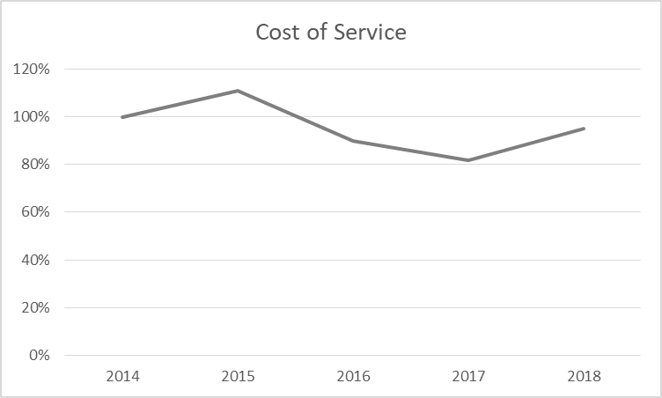
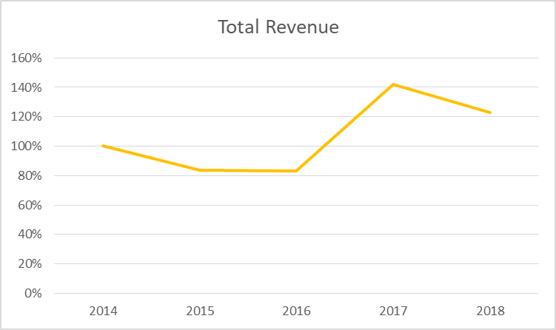
Graphs for Trend Percentage Analysis
Figure 1: Trend of Total Revenue of LBSL Figure 2: Trend of Cost of Service of LBSL

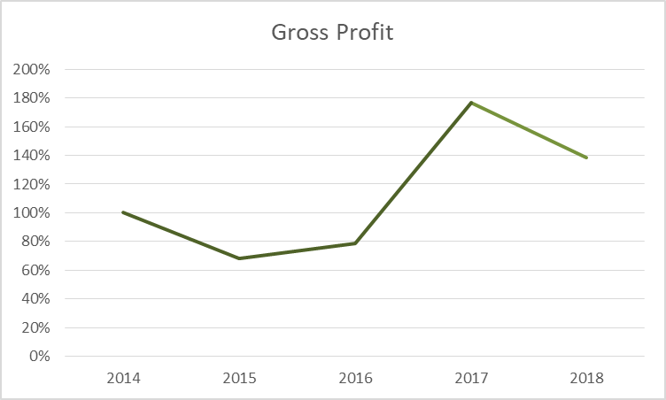

Figure 3: Trend of Gross Profit of LBSL

Here, the base year is 2014. That’s why on the table we can see that all the data of 2014 is 100%. In 2015, we can see that the cost of service grows 26% higher than the sales revenue. That’s why the gross profit is lower. Its isn’t negative, but due to the increase in cost of service and the decrease in total revenue the gross profit goes down in that year and that’s why the percentage is just lesser than the base year, not negative. Same scenario we can see in 2016. Here, the cost grows 7% higher than the revenue. In 2017 and 2018, we can see that the gross profit is higher than the total revenue. In these two years the company manages its cost really well. So, in the graphs given, we can see the growths, the company made in 2017 and 2018.

2.3 Customer
Clients are the most significant partner for any association. They are the assets whereupon the accomplishment of our business depends. When contemplating esteeming the clients we think about after focuses:
- LBSL is reliant upon their clients. On the off chance that we don't create client steadfastness and fulfillment, we could lose our clients.
- Without clients the presence of LBSL would not be advocated.
- The reason for LBSL is to satisfy the requirements of the clients.
- The client makes it conceivable to accomplish our business points.
Our Customers
- The full range of individual socioeconomics in Bangladesh from section level to high-total assets people
- Various lawful substances from trusts, non-legislative associations and relationship, to private ventures up to the biggest corporates and the open part
- Those who are draw in with us even on single item classes, for example, advance, store, resource the executives and speculation or finance arrangements.
- Foreign dealers who exchange the optional market of Bangladesh
Requirements and desires for our clients
- Offering creative arrangements and administrations.
- Growing and securing customer speculations and riches.
- Financing the desires of customers, while ensuring against over obligation.
- Providing advantageous access to LBSL's money related administrations with less unpredictability and improved adaptability.
- Protecting customers and their advantages through verified IT systems and framework.
- Providing esteem included administrations that are aggressive and straightforward in estimating
- Providing sound money related counsel and budgetary instruction.

2.4 Service/Product Mix
Services:
Brokerage Services: The proficient exchange the board procedure and keen pool of merchants, LBSL limits concealed exchange costs which go from advertise effect to defer expenses to botched exchange chance expense. LBSL gives "Trade Execution Service" for its customers in Dhaka and Chittagong Stock Exchange. It exchanges the portfolio accounts kept up with LankaBangla Investments Limited and IDLC Finance Ltd just as giving custodial services to customers to safe authority of protections. What's more, broadened credit offices are given through edge exchanging services. Pertinent data to survey the expenses and dangers of exchanging is given to invigorate the customer of purchasing and selling interest.
LBSL isn't just a specialist of a customer's structure. Aside from speaking to request to the market, the organization consistently deals with each significant exchange. This is reflected in the conviction "Brokerage is more than Commission."
LBSL effectively aids square exchange whereby the contrary side of the exchange is effectively looked for.
NITA (Non Resident Investors’ Taka Account): LBSL has been effectively giving administrations of NITA Trading through which Non-Resident Bangladeshis (NRBs) can execute under Non-Inhabitant Investor's Taka Account (NITA). The organization is additionally devoted to utilize broad assets to offer new items and administrations to the current customers and furthermore to draw in new customers. The decision of an article arranged methodology and utilizing the most recent innovation has given them the adaptability to expand their item and administration run just as guaranteeing execution, security and versatility.
Internet Trading Services: LBSL has embraced web exchanging offices for its separation customers for exchange execution. LBSL's progression toward web exchanging isn't just enhancing the entryway of potential customer base yet additionally guaranteeing the organization's support in the general advancement of Bangladesh Capital Market. With a comprehension of the need of data as wellspring of faster basic leadership, LankaBangla Securities Ltd. is the first to dispatch an undeniable financial portal in Bangladesh. LankaBangla Financial Portal is intended to carry all conceivable data to the customer's doorsteps. From showcase news to DGEN diagram and from Economic Indicators to different Analyst Tools, everything is accessible in this data hive. As the portal is refreshed consistently, one can never fall behind. The portal is proposed to give a quick and savvy path for an organization to convey investor esteem, over and past desires, and remain in front of BSEC enactment. LankaBangla Financial Portal is giving "Speculator Relationship Pages" with the goal that organizations can increase the value of their organization sites by fortifying the speculator relationship segment. LBSL gives the important arrangements by conveying complex financial information and news effectively and reliably to every one of the partners of an organization simultaneously.
Financial portal: The web-based interface goes about as a center point of data of the capital market, with copious wellsprings of data of the capital market and large scale monetary experiences for the speculator, business person, academician and strategy creators. Out Internet Trading Department is primarily answerable for giving on the web based exchanging offices to the customers of LBSL on both Chittagong Stock Exchange and Dhaka Stock Exchange stage. There are two online based stages for the two exchanges which are given as pursues:

Trade Express: This is the web trading stage which is equipped for trading in multi exchanges at the same time. Right now, it is associated with Chittagong Stock Exchange as it were. The stage could be utilized by customers in work areas and every single cell phone. The trading requests could be put whenever and the legitimacy is for 24 hours. The stage is additionally accessible for download in both Google and Apple application stores.
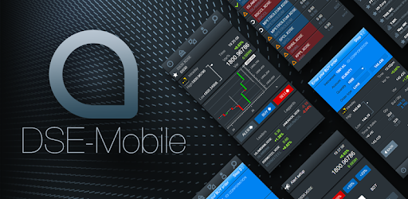
DSE Mobile: The stage is owned by Dhaka Stock Exchange and is given to all the stock business houses in Bangladesh to encourage internet trading in Dhaka Stock exchange. LBSL likewise encourages its customers by giving DSE portable administrations. The stage is likewise accessible for download in Google and Apple application store. Under the wing of out portal administrations we have presented different administrations like-

I-Broker: This is alluded to as the online back office for LBSL customers with the goal that they can utilize iBroker for the accompanying purposes:
•Online IPO application
•Access portfolio explanations and customer record subtleties
•Fund demand demands online

Stock Paathshala: The Virtual Trading Platform is the online/virtual trading game test system which enables a person to appreciate the constant trading in CSE for all intents and purposes. This application has been propelled for the novice financial specialist for encountering and adapting ongoing stock market trading. The trading could be directed through the virtual cash gave by LBSL to the client.
Foreign Trading Services: LBSL has set up world-class value trading stage for outside institutional speculators. It has committed outside trading group with discrete stall particularly for remote exchange with access to Bloomberg terminal on the trading work area. The group remains associated 24X7 with outside customers guaranteeing smooth correspondence, proficient execution and effective settlement by keeping up most extreme classification. Satisfying the customers' needs has consistently been the top most need for the organization.
CDBL Services: LBSL works as a Full Service DP at both DSE and CSE. Aside from their BO Account Opening and Maintenance administrations, they furnish their customer base with De-appearance and Re-emergence administrations. They offer safe exchanges and transmission through CDBL just as they give their clients modified administrations identified with Pledging, Un-promising and Confiscation of Securities.

Research Services: LBSL solidly puts stock in the information based interest in the capital market to keep pace with the propelled market and modern customers. Aside from productive and compelling business administrations, LBSL is sponsored by the quality of an exhaustive Research Unit, which gives a scope of administrations from organization, industry and nation research to corporate valuation. One of the significant elements of LBSL is to complete capital statistical surveying for themselves and their esteemed clients. Their Research and Analysis Department is one of the most significant offices exclusively committed to these capacities. The Capital Market Research Department is constantly creating information put together reports with respect to the general capital market, the full scale economy, and the individual organizations recorded on the stock exchanges. The group puts its push to investigate the capital market alongside the central and specialized pointers of recorded protections of DSE and CSE. The methodology is to comprehend the brain research and pattern history of the market, and in particular the activities of financial specialists. The leader magazine "Market Pulse" distributed from the Publication Department has kept drawing consideration and gratefulness from perusers here and outside the nation. Different endeavors include distributing Daily Market Report, Weekly Market Report, Macro Economic Review, Sector Updates, Specific Company Valuations, and IPO examination

Products:
LBSL IPO: On account of the online interface gave by LankaBangla Securities Ltd., interest in IPO is currently a simple movement. A financial specialist doesn't need to experience the problem of sitting tight in line for quite a long time with application. Or maybe, venture can be made in IPO online, independent of the area. For putting resources into IPO online, an enrolled client simply needs to choose the IPO, and the IPO will be prepared consequently. As it were, LBSL assumes full liability once the IPO application structure has been submitted. Then again, LBSL enables the alternative to physically go to its office and round out the IPO application structure.
LBSL Easy Investment Plan (EIP): Despite age, pay and experience, similar to a store benefits conspire, Easy Investment Plan (EIP) encourages a basic and helpful method for putting resources into the stock market.
LBSL Premium: To esteem its superior customers, LankaBangla Securities Ltd. gives a suite of elite value venture benefits and administrations not accessible somewhere else. With LBSL premium record, a financial specialist will consistently stay over his ventures.
LBSL Beginner: Value is a significant resource class to take an interest in the fundamental development story of the nation, business and friends. In any case, interest in value requires inside and out information and examination about various factors which a financial specialist discovers hard to process. LankaBangla Securities Ltd. gives a speculator the vital data and information, and gives certainty to contribute.
LBSL Halal: LBSL Halal has been intended to oblige the estimation of a customer's uncommon conditions. Numerous financial specialists need to make the stock market speculation sharia agreeable and in this manner LBSL encourages the speculator with a rundown of Sharia Compliant Companies (Baskets) remembered for DSE sharia list where fundamental venture can be made.

2.5 Operational and Complaisance related Activities:

- Ensure smooth branch operation by effective and efficient daily activities. Verify all clients buy sale order and preserve the order book. Follow up the trade during trading period and act accordingly.
- Compliance: Maintain all regulatory correspondence with DSE & CSE on behalf of branch in charge. Ensure 100% compliance as per LBSL rules and regulations. As a BAMLCO member, ensure that there is no money laundering and terrorist financing in branch level.
- Accounts Management: Ensure proper maintenance of accounts on regular basis. Sign all cheque and payment Voucher as bank signatory. Approve accounts related transaction from LEADS.
- Resource Management: Solving IT related issues. Ensure effective and maximum utilization of LBSL's both financial and non-financial resources.
- Report Generating: Work as a helping hand of branch in charge for preparing performance report, Branch Manager Report, Departmental Reports etc.

2.6 An Overview of SWOT Analysis:
It has consistently been significant for a business to know and see how it fits in and connects with the encompassing condition on both an inward (office/processing plant/workplace) and outer view (how the business works with the outside world).
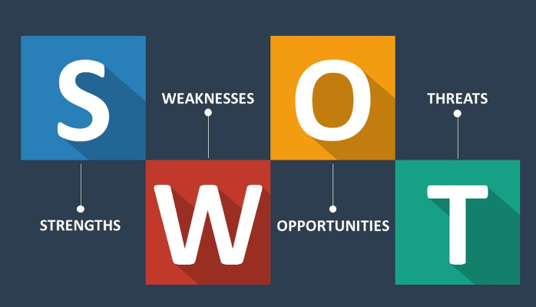
Inquiring about nature will profit the association as well as supervisory crew by setting in a place to build up a methodology for both longer and shorter term.

Analyzing the Business:
The most compelling method for doing this is to play out a SWOT investigation of the organization. It is a typical stage used to contract Strengths, Weaknesses, Opportunities and Threats. Everything is a heading for discrete examination of the business however they can be connected as observed beneath:
Strengths give an understanding to your business Opportunities and
Weaknesses in the business can cause quick Threats
Know that the SWOT examination is just founded on data that is known by the assessor and is viewed as maybe the more fundamental methodology of breaking down a business position. In any case, SWOT is as yet a useful asset when searching for quick advantages.
Strength
Strong Corporate Identity:
LankaBangla Securities started as Vanik Bangladesh Securities Ltd in 1997 with their exercises restricted distinctly to the Chittagong Stock Exchange (CSE) Ltd. After a year, they made a stage ahead and acquainted themselves with the Dhaka Stock Exchange (DSE). It rebranded to LankaBangla Securities Ltd. in 2005 after a rebuilding of the organization. The organization is 90.91% possessed backup of LankaBangla Finance Limited (LBFL) which is one of the main recorded non-banking financial establishments in Bangladesh occupied with Leasing, Credit Card Services, Corporate Financing, and Financial Consultancy. LBFL is claimed, by a gathering of profoundly fruitful nearby business people of Bangladesh-Sampath Bank Limited of Sri Lanka, One Bank Limited of Bangladesh, and the overall population.
Solid Employee Bonding and Belongings:
LBSL representatives are one of the significant resources of the organization. The workers have an unyielding energy towards the association and furthermore feel glad and a feeling of belongingness towards the organization. The solid hierarchical culture of the organization is the primary purpose for this strength.
Productive Performance:
LBSL gives bother free client support to its customer contrasting with other financial foundations in Bangladesh. In this respects customer administration is amazing.
Engaged Work Force:
HR of LBSL is very much idea and splendidly oversaw. As from the absolute first the top administration put stock in quite a while, where they asylum to place their fingers in all aspects of the pie. This engaged condition makes LBSL a superior spot for representatives. The representatives are not choked with the power yet they can develop as the association develops.
Exacting Adherence to Compliance Standard:
The association submits to all standards and guidelines gave by the administrative bodies. It has demonstrated notoriety in serving clients by keeping up solid consistence practices and nearness in the market. This severe adherence to consistence standard is a phenomenal strength for the association.
Present day Equipment and Technology:
LBSL claims the cutting edge data innovation in Bangladesh with respect to working financial administrations. Its ultramodern framework beginning from terminal PCs to HUB depend on worldwide norms. IT framework is well prepared and oversaw which is likewise kept up with elevated level of polished methodology.
Generosity:
LBSL has colossal altruism in the market. There is no single claim against its administrations in the market. Its generosity may make the organization progressively focused in the market.
Weakness
Increasingly Innovative Service must be advertised:
So as to be progressively focused in the market LBSL should think of all the newer and appealing bundles and administrations.
Low settled up capital:
The settled up capital of the organization is generally low. For augmenting the activity system and administrations increasingly capital is required. Over the long haul this may transform into a negative issue.
Inadequate limited time exercises:
They do their limited time initiates not exactly other Brokerage house.
Disguised Employee:
This has likewise become developing issue at LBSL. There are individuals who are just drawing pay rates toward the month's end yet making a base or no commitment towards the association.
Opportunities
Countrywide system:
LBSL has a decent system of branches in the nation however quantities of branches are not many. By using the generosity and broadening system LBSL may build its benefit just as tapping the market and verified its reality over the long haul.

Gigantic Market:
Among the Non-banking financial organizations LBSL has colossal probability. World class segment of the individuals of Bangladesh has excellent connection with LBSL. The individuals who are enormous in the financial market they are its institutional investor. Numerous MNCs and huge gathering of organizations are its corporate customers.
Market Growth:
The market is developing step by step. At this point land advertise has become quickly. Therefore, Project financing business sector and home advance market has grown a huge scale. By methods for immense generosity and market notoriety LBSL gets an opportunity to get the significant portion of the market.
Build up a center Research:
Going to build up a center Research, Planning, Training Division containing gifted individual from the very beginning of the protections.
Threats
Losing Customers:
This is an issue and a threat being looked by the entire security part of Bangladesh. Because of the current monetary lull, there is a barely any new customer as there scarcely any ventures by a jogging articulation. Thus the financier houses are not having the option to pull in completely new customer.
Entering contender:
New contender entering the capital market with new advancement approach is a major threat for the LBSL.
New guidelines:
CDBL, DSE and CSE made new decides and guideline that are difficult to keep up. New guidelines from administrative body is become an issue for the all Brokerage house and it's likewise become a major issue for LBSL.

Negative value:
Presently a day’s LBSL is week from the market that make a negative picture in the client mind. Powerless structure the Market makes Negative value
Political distress:
Political distress is likewise a threat being looked by the entire security division of Bangladesh.
Down pattern:
Long time down pattern nature of Bangladesh Market is a threat for the LBSL.

CHAPTER 3: INDUSTRY ANALYSIS
3.1 Capital Market
3.2 Size of Capital Market
3.3 Performance Analysis Bangladesh Capital Market
3.4 Key Highlights
3.5 External Economic Factors
3.6 Porter’s Five Forces

3.1 Capital market
Capital market is where purchasers and dealers take part in exchange of budgetary protections like securities, stocks, and so forth. The purchasing/selling is embraced by members, for example, people and foundations.
Capital markets help channelize surplus assets from savers to foundations which at that point put them into profitable use. For the most part, this market exchanges for the most part in long haul protections.
Capital market comprises of primary markets and secondary markets. Primary markets manage exchange of new issues of stocks and different protections, while secondary market manages the trading of existing or already gave protections. Another significant division in the capital market is made based on the idea of security exchanged, for example bond market and security market.

3.2 Size of Capital Market
One of the significant pointers of the capital market is the quantity of recorded organizations. The method of reasoning of including this measure is that as the quantity of recorded organization increments, accessible protections and exchanging volume additionally increments. In premise of the properties of the organizations, the organizations are separated into five gatherings; A, B, G, N and Z. The properties of these organizations are appeared in the table underneath.
Company | Properties
A | Holding Annual Meetings (AGM) and have declared dividend at the rate 10 percent or more in a calendar year
B | Holding Annual Meetings (AGM) and have declared dividend less at the rate 10 percent or more in a calendar year
G | Greenfield companies.
N | All new listed companies except Greenfield companies
Z | Have failed to hold the AGM or fail to declare any dividend or which are not in operation continuously
Table 3: Capital Market Company Category and Characteristics

As indicated by 2012's exploration, the quantity of recorded organizations has developed from 149 to 268 with a normal yearly development pace of 2.99 and a standard deviation of 43.39 from monetary year 1990-91 to FY2010-11. In FY 1990-91 the quantity of recorded organizations of DSE was 149 while in FY 200102, the quantity of recorded organizations was expanded to 248 lastly in FY 2010-11, the recorded organizations of DSE remained at 268.
Figure 4: Total Number of DSE Listed Company (1993-2018)
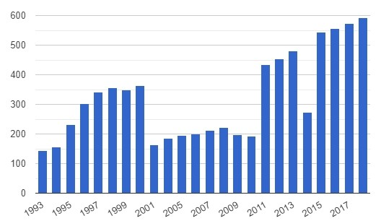

The World Bank gives information to Bangladesh from 1993 to 2018. The normal incentive for Bangladesh during that period was 321 organizations with at least 143 organizations in 1993 and a limit of 593 organizations in 2018.
Recorded organization implies, recorded residential organizations, including outside organizations which are solely recorded, are those which have shares recorded on a trade toward the year's end. Venture reserves, unit trusts, and organizations whose lone business objective is to hold portions of other recorded organizations, for example, holding organizations and speculation organizations, paying little respect to their legitimate status, are rejected. An organization with a few classes of offers is checked once. Just organizations confessed to posting on the trade are incorporated.
The quantity of recorded organizations on the stock trade in Bangladesh is a marker of the improvement of the financial exchange. A higher number implies that more organizations use value financing in their business. Obviously, the quantity of recorded organizations in Bangladesh and different nations likewise mirrors the size of the economy, bigger economies have more firms.

3.3 Performance analysis of Bangladesh capital market 2018
Capital market of Bangladesh spent a difficult year in 2018. In the wake of posting an excellent return of 24% in 2017, expansive file DSEX declined by 13.8% in 2018, clearing out USD 4.3 bn of market capitalization (Mcap). Normal every day turnover added up to USD 65.6 mn, somewhere near 37.0% than that in 2017. (Figure: 5)
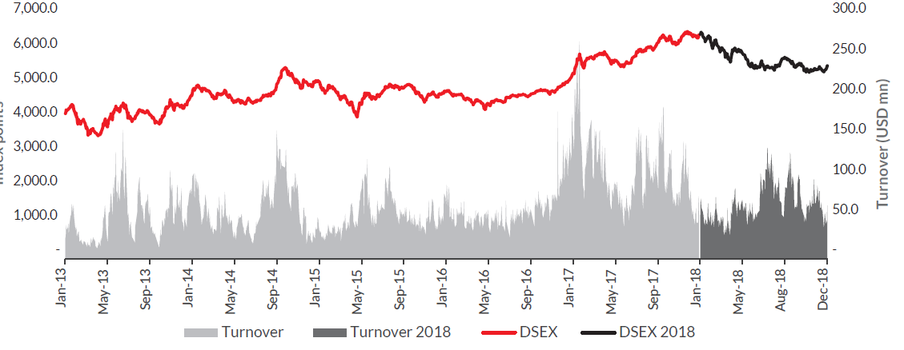
Figure 5: DSEX vs Turnover

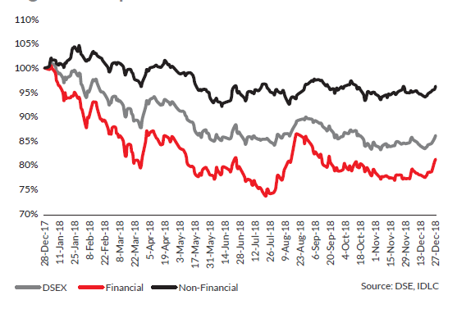
The market adjustment was to a great extent driven by decrease in budgetary part scrips. In 2018, money related division was unfavorably influenced by rising loan fee and developing NPL issues which ruled its financial exchange execution. Money related composite which incorporates Bank, NBFI, and Insurance declined by 18.6% against in general market decay of 13.8%. Then again, outflanking the market in 2018 (Figure: 6). Figure 6: Capital Market Performance in 2018
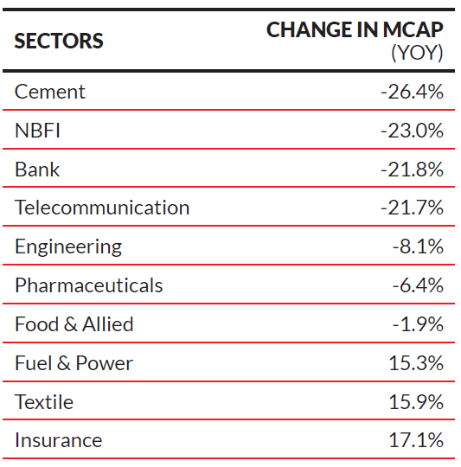
Large scale factors ruled in 2018. Desires for cash downgrading provoked outside reserve administrators to book benefit, somewhat selling their stakes in nearby blue-chips. Huge top ruled Telecommunication and Pharmaceuticals were hit the hardest by this wave and declined altogether, regardless of strong basics. Bank and NBFI lost over 20% of Mcap in 2018, experiencing resource quality and financing cost concerns. (Table 4). Table 4: Change in Mcap of Major Sectors in 2018
Full scale factors were sure for Textile Sector, which revitalized practically 16%. Material business came back to a development force after quite a while, profiting by US-China exchange war and less expensive BDT. Fuel and Power division likewise flooded, supported by income development originating from the administration's capacity plant gorge. Bangladesh was the most noticeably terrible entertainer among the friend developing and boondocks economies in this area (Figure 7). Rising US loan fee and money activated net outpouring of outside portfolio speculation over the locale. Local financial power India declined by 7.3%, while Bangladesh's nearby rival Vietnam shed 9.3% in 2018.
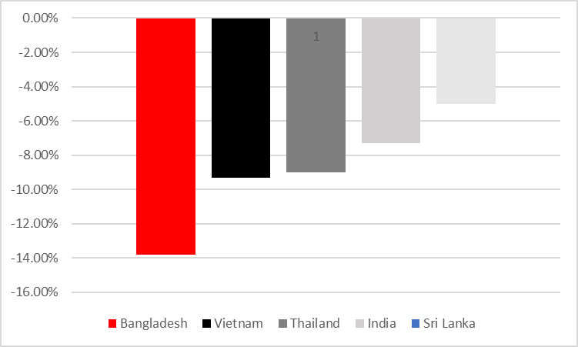

Figure 7: Equity Market Performance in 2018 in Bangladesh and Peer Countries

3.4 Key Highlights of the Capital Market in 2018
Interest Rate Hike: Interest rate climb was the key driver of market execution in a year ago. Following quite a while of continuous decay to an agreeable level, interest rate shoot-up in mid-2018. Contrast between bank store rates and hazard free rate offered by National Savings Certificates (NSCs) extended as the previous consistently declined for a significant stretch until 2018, and the later stayed unaltered out of synchronize of market.
Progressively negative hazard premium boosted people and organizations to occupy their assets from capital and currency market to NSCs. Liquidity was along these lines fixing for some time and arrived at a basic point in mid-2018. As banks mixed for assets to keep up their AD proportion, interest rates shoot up. Controllers interceded to relieve rates with crisis measures. For whatever length of time that NSCs rates are not connected with market and interest in NSCs are not checked, and NPL issues are not tended to, showcase interest rates can't stay low for the medium-long haul.

Current Account Deficit and pressure on Exchange rate: Current account deficiency of Bangladesh arrived at its chronicled most noteworthy at USD 9.8 bn in 2018. High import development emerging basically from one–time flood in nourishment grain import because of flood and sharp increment in oil-based commodities import applied huge weight on current account. Unobtrusive execution in fare and settlement ended up being inadequate to improve it. Therefore, USD gets dearer. National bank bolstered the cash consistently, absorbing further
BDT liquidity from the market. Fully expecting money downgrading, outside reserve supervisors brought down their presentation from capital market of Bangladesh. Enormous tops were influenced the most by this and pulled list down with them. Corporate benefit was likewise hit as cost of imported crude material rose.

Banking Sector Turmoil: Effectively debilitated by macro weight, weakness of banks resource books was additionally uncovered in 2018. As on September 2018, banking part NPL remained at 11.5%, which would go up to 17%, whenever rescheduled and rebuilt credits were considered. NPL in Bangladesh is one of the most noteworthy in this district (Figure 4). Issue with a fourth era bank arrived at a basic point in a year ago, prompting an administration directed administration change. The frail condition of its books brought delicate financials of the other fourth era banks into spotlight. Then, resource nature of open division banks didn't improve. A couple of the private business banks likewise uncovered to be in desperate waterways. Such state dissuaded financial specialists causing a defeat that shed nearly USD 2 bn of Mcap from the division.
Political Environment: Alert over world of politics was an obvious impetus of 2018's market. Market members were cautious as political decision drew closer. Be that as it may, contrasted with past races, world of politics was somewhat quiet as the political race drew nearer and passed.
Capital Market Outlook in 2019
The lawmaking body of Bangladesh expects that GDP advancement would stay at 7.8% YoY in 2019, while growing would be 5.6% YoY. Money related Intelligence Unit foreseen Bangladesh to be the consequent best performing economy on earth in 2019, creating by 7.9% YoY. In concurrence, United Nations foreseen Bangladesh to be third speediest creating economy with an improvement pace of 7.4% YoY.6 We acknowledge post-political race stable universe of legislative issues will attract nearby and outside adventure and lift advancement. As both charge and repayment gives sign of imperative improvement while import advancement moved back, current record equality should similarly improve, encouraging weight on money. Bangladesh Bank expects Trade Deficit to be USD 17.2 bn, and Current Account Deficit to come down to USD 6.4 bn, while BOP condition to remain for all intents and purposes unaltered at an insufficiency of USD 0.6 bn 7. In any case, money market may remain stressed until NSC rates safeguard, NPL improvement, such helper issues are tended to.

3.5 Outlook of Major Sectors in the Capital Market
Banks: The year 2019 is depended upon to be a predominant one for Bangladesh economy. We foresee that present record lack should coordinate at 2% of GDP from 3.6% of GDP (setback) in 2018. This is likely going to encourage the money debasing weight. In addition, political constancy is depended upon to continue after the serene arrangement of 2018. In any case, high NPL is up 'til now going about as the precise threat of the business. We are yet to see any course of action of this issue in spite of the way that the new reserve serve is cheerful about chopping down the NPL extent. In like manner, higher money stream in the NSC instruments is also a real stress for banking industry.

Telecommunication: By and large point of view of media transmission section is apparently positive in 2019 with continued with business improvement driven by rising enthusiasm of data. Bangladesh is up 'til now waiting behind on some noteworthy parameters like web penetration (36% as on 2017) and PDA entrance (31%8 as on 2017), showing gigantic space for improvement for MNOs. On a substitute note, the advancing regulatory progressions in the business should be recollected which may have influence on the introduction of the recorded associations.
Pharmaceuticals: Pharmaceuticals section is depended upon to do well in continuation of its progressing history. Disregarding the way that general productivity advancement was low in 2018, reasonable measured players advanced outstandingly. As economy of Bangladesh grows, lifestyle of its family changes, so would its ailment profile. We acknowledge the force long stretch difference in private infection profile from exceptional to relentless, would remain in play. Pharmaceutical associations that position itself the best in changing patient needs would pass on gigantic impetus for the two patients and the budgetary masters.
One of the key issues to look for in 2019 would be whether expenses of fundamental prescriptions are re-fixed. A reasonable re-fixation can fill customers need and lift pharmaceutical associations in contributing more on such meds. Toll execution of noteworthy pharmaceutical associations are to be observed eagerly. While, responsibility of toll to signify business is still low.
Fuel & Power: Our cheerful huge scale wants can't show up without better return from Fuel and Power region. The part is basic for financial headway and stays at the purpose of combination of government's thought. We envision that advantage of the part should augment in the coming quite a while as power age and subordinate organizations grows rapidly.

Consumer: Purchaser part in Bangladesh is in a standard upswing. As our purchasing power rises, and salaried class people expands, purchaser business are set to rise. Purchaser staples are depended upon to hold fast to its suffering advancement, while discretionary may get a lift on a post-political choice spending flood.

Construction: A mind blowing aggregate of USD 2.1 bn has been dispersed for Annual Development Program (ADP) in spending plan of FY2019 out of which a total of 835.8 mn would be spent for structure headway in correspondence and imperativeness division. These persistent and orchestrated structure improvement adventures are depended upon to drive the business advancement of the associations related with improvement materials. Likewise, the cabin part has gave some sign of recovery starting late, dictated by factors like broadening regular workers masses, long stretch house credit office at low financing expenses for government agents, etc. Regardless, instabilities in cost of the imported unrefined materials like clinker, iron metal, billets and oil may influence the primary worry of these associations.

Engineering: The associations under designing division are busy with groupings of business. Among them, business vehicle industry is depended upon to create with quick industrialization and correspondence system headway in the country.

Textile: Textile division ought to continue with its vitality from 2018 using extended solicitations as a result of increasingly delicate money and trade war. Extended the most minimal compensation allowed by law would construct work cost for the division, yet that is likely going to be offset extended solicitation stream. Holding power cost under tight restrictions is a fundamental for productivity of the region.
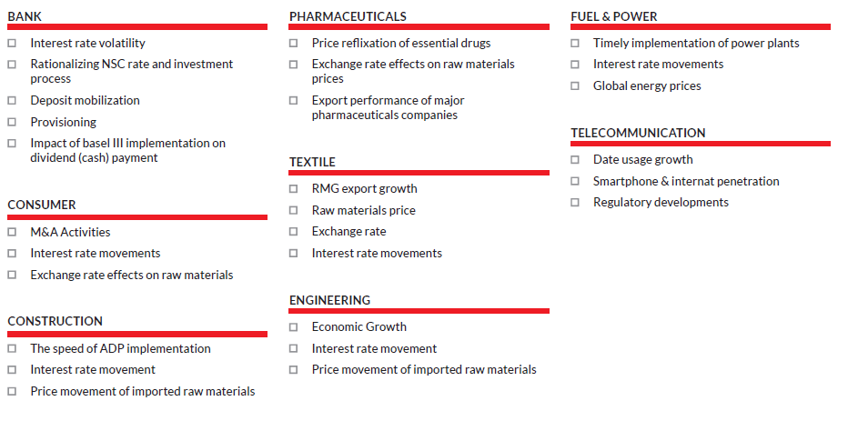

3.6 External economic factors:
The economic development of a nation to a great extent relies upon the advancement of its money related area. Securities exchange is an imperative on-screen character of monetary area and gives a stage to the clients and providers of the money related assets for venture reason in the supplies of organizations. A well-working and sound financial exchange inclines toward the supplies of fruitful organizations and qualities more than those of ineffective organizations. The portions of a fruitful organization are believed to be identified with different organizations recorded in a similar financial exchange. The normal profit development and the costs of the offers are very much reflected in the securities exchange. The financial exchanges show the unpredictable conduct after some time. In unpredictability, the costs of offers go all over in an extremely brief timeframe. Inordinate unpredictability is an obstacle in the smooth working of money related markets and unfavorably influences the economies as experienced previously. This unpredictability may force the speculators to move their ventures to chance free resources instead of putting resources into more dangerous resources. Thusly, it is vital for monetary investigators, macroeconomists and arrangement producers to comprehend the dynamic conduct of securities exchanges. Generally imperative to note is that the financial specialists are keen on understanding the idea of securities exchanges conduct as their venture spending is guided by these unpredictability designs. The different economic exercises of a nation impact the profits in the securities exchange. There is a long history of determinants of stock returns in the writing. Various factors are conceivably increasingly significant in clarifying the varieties in the stock returns than a solitary market factor.
Economic Factors that impacts the capital market and their present examination is talked about beneath.
Gross Domestic Product (GDP)
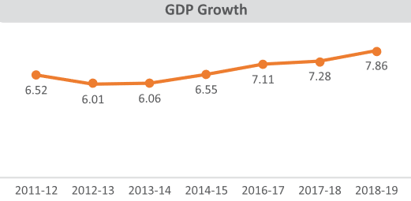
Gross domestic product development arrived at 7.86 percent, altogether higher than the development of 7.28 percent in the previous financial year. It is occurred on back of enormous government spending and interest in uber ventures. Among the wide divisions of GDP, the commitment of agribusiness and administration area to GDP descended by 0.51 rate point to 14.23 percent and by 0.74 rate point to 52.11 percent which was balanced by an expanded portion of industry by 1.24 rate point to 33.66 percent in connection to the previous year.
Import
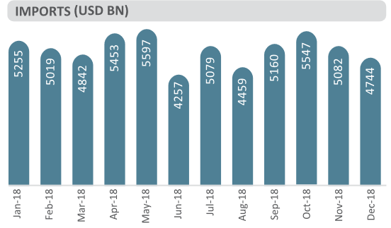
Nation's import expanded by 25.23 percent in FY2017-18 than earlier year. All out-import installments remained at US$58,865 million in FY2017-18, which is 25.23 percent higher than the import installments of US$47,005 million of the first year. In the span of FY2017-18, China has verified the first position for our import in quite a while of estimation of all out imported items. All through this period 27.07 percent of the all-out imported items originated from China. India was the second biggest wellspring of import (15.19%) while Japan held the third position (4. 11%). Bangladesh imports for the most part oil and oil (11 percent of the allout imports); material (10 percent) and nourishment things (9 percent). Others include: iron and steel (7 percent), eatable oil (4 percent), synthetic compounds (4 percent), yarn and plastic and elastic articles (4 percent). In 2018, imports of rice grains diminished significantly primarily because of sufficient local inventory.
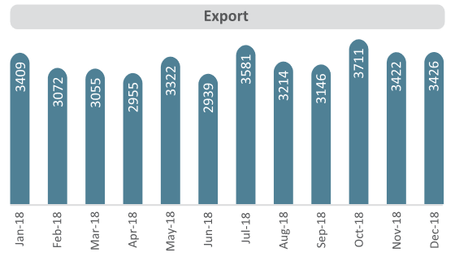
Export
Bangladesh's product trade income indicating a hopeful upward pattern in FY2017-18 remained at US$ 36,668 million in FY2017-18. It is 5.81 percent higher than the fare income (US$ 34,656 million) of FY2016-17. Classification savvy sends out profit in FY2017-18 shows that fare income from agrarian item and clay items have expanded by 38.55 percent and 32.70 percent individually in the course of the last financial year. In addition, expanding pattern of fare income energized by certain components, for example, increment of fare of farming item, fired items, handiwork, cotton and cotton items, knitwear, home material, jute merchandise, concoction items, woven pieces of clothing and so forth. Then again, mostly as far as oil by item, designing items tea, plastic item, cowhide and calfskin merchandise, crude jute and solidified nourishment indicated diminishing fare profit.
Remittances
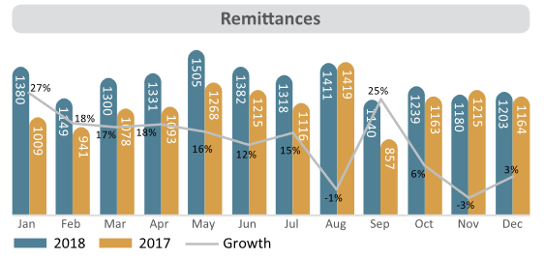
A huge bit of residential work power is utilized in the Middle-East and numerous different nations of the world. Notwithstanding diminishing the movement rate, Bangladesh has earned enormous measure of settlements in FY2017-18. About 8.8 lakh Bangladeshi workers traveled to another country in mission of occupations in FY2017-18, which was 2.8 percent lower than the earlier year. Bangladesh accomplished settlements of US$14,981.69 million in the FY2017-18 which was 17.32 percent higher than US$12,769.5 million in the FY2016-17.

3.7 Porter’s Five Forces
The substance of Porter's idea is that there are five forces that decide the focused force and allure of an industry. Appeal in this setting alludes to by and large industry benefit. An "ugly" industry is one in which the mix of these five powers acts to drive down by and large gainfulness. An alluring industry is one in which the powers improve industry productivity. Three of Porter's five powers allude to rivalry from outer sources. The rest of inward dangers. Every one of those five powers lay on a lot of premises.
LBSL is a piece of capital market industry. As per the five powers, how LBSL can deal with those is talked about underneath
Threats of New Entrants
New participants in Financial Services brings development, better approaches for getting things done and put pressure on LBSL through lower evaluating system, decreasing expenses, and giving new offers to the clients. LBSL needs to deal with every one of these difficulties and manufacture compelling boundaries to shield its aggressive edge.
How LBSL can handle the Threats of New Entrants
• By improving new items and administrations. New items carry new clients to the crease as well as give old client motivation to purchase LBSL items.
• By building economies of scale with the goal that it can bring down the fixed expense per unit.
• Building limits and burning through cash on innovative work. New participants are more averse to enter a unique industry where the built-up players.
Bargaining Power of Suppliers
All most every one of the organizations in the Financial Services industry purchase their crude material from various providers. Providers in prevailing position can diminish the edges LBSL can acquire in the market. Ground-breaking providers in Financials division utilize their arranging capacity to extricate more significant expenses from the organizations in Financial Services field. The general effect of higher provider haggling power is that it brings down the general benefit of Financial Services.

How LBSL can handle Bargaining Power of the Suppliers
- By building proficient production network with different suppliers.
- By exploring different avenues regarding item structures utilizing various materials so that if the costs go up of one crude material then organization can move to another.
- Developing devoted suppliers whose business relies on the firm.
Bargaining Power of Buyers
Purchasers are frequently a requesting part. They need to purchase the best contributions accessible by following through on the base cost as would be prudent. This put weight on LBSL gainfulness over the long haul. The littler and all the more dominant the client base is of LBSL the higher the haggling intensity of the clients and higher their capacity to look for expanding limits and offers.
How LBSL can handle the Bargaining Power of Buyers
• By building an enormous base of clients.
• By quickly developing new items. Clients regularly look for limits and contributions on set up items so on the off chance that LBSL continue thinking of new items, at that point it can restrict the dealing intensity of purchasers.
• New items will likewise decrease the abandonment of existing clients of LBSL to its rivals.
Threats of Substitute Products or Services
At the point when another item or administration meets a comparative client needs in various manners, industry productivity endures. The danger of a substitute item or administration is high in the event that it offers an incentive that is particularly not the same as present contributions of the business.
How LBSL can handle the Treat of Substitute Products/Services
• By being administration situated instead of just item arranged.
• By understanding the center need of the client as opposed to what the client is purchasing.
• By expanding the exchanging cost for the clients.

Rivalry among the Existing Competitors
On the off chance that the contention among the current players in an industry is exceptional, at that point it will drive down costs and diminishing the general gainfulness of the business. LBSL works in an exceptionally aggressive Financial Services industry. This challenge takes cost for the general long-haul gainfulness of the association.
How LBSL can handle Intense Rivalry among the Existing Competitors in Financial Services and capital market industry
• By building a manageable separation
• By building scale with the goal that it can contend better
• Collaborating with contenders to build the market size instead of simply going after little market.

CHAPTER 4: INTERNSHIP EXPERIENCE
4.1 Introduction
4.2 Work Description
4.3 Learning Outcomes

4.1 Introduction
As an intern I had begun my internship program from first October at the LankaBangla Securities Limited, Dhanmondi branch. The internship time frame is for 3 months. During my internship program, I have performed numerous responsibilities or tasks as appointed by my supervisor. Regularly the association doesn't give me any fixed tasks to perform on the grounds that there are no particular undertakings for interns. Consequently, I have done vastly different kind of tasks in various work areas. I am thankful to my supervisor that she let me do various obligations. By this I could enhance my down to earth information and furthermore has given be a corporate presentation.

4.2 Work Description
I was doled out under Business Development Department for my internship. I however got the chance to work with the all officials and with the managers. Client support comprises of various kinds of record opening, as BO accounts, Give Deposit passage in blue chip, Portfolio proclamation given, check the equalization, and Give the record data. As an intern of LBSL I was additionally answerable for the "BLUE CHEIP" Machine Management for the initial 15 days. At the point when a client goes to a branch, it's an intern's duty to give the client data that they need and guide the person in question to the correct help.
Client care region of LBSL is partitions into various segments, for example, Deposit book assortments, Deposit book given, Requisition slip, purchase request slip, sell request slip give, advance from flip, and so forth.
I was additionally doled out for information gathering exercises for both the Head Office and my branch. I've gathered information pretty much all the recorded organization in DSE for my association director, which was utilized to set up an introduction on organization's present circumstance and future chances. For Head Office I helped in quarterly premise information assortment for the recorded NBFI's and Banks.
On the primary day of my internship, Senior manager of the branch clarified pretty much every one of these segments work. He clarified me how the absolute functions done in the branch. He likewise made me acquainted with the different application structures and additionally gave me data about the different terms and devices of these application strategies.

4.3 Learning Outcome
From this three months' internship involvement with the LankaBangla Security Limited, I have adapted heaps of things. Subsequent to joining as an intern, first I become familiar with a representative ought to in/out the workplace opportune. I figured out how each area functioned efficiently just as cautiously and furthermore find out about the security strategy for each segment. There are some taking in results from my internship experience-
- Experienced about the corporate life and work eight hours consistently
- Experienced work under strain and how to handle the basic circumstances
- Given full fixation on work and finish it on due time
- Observed how an association play out its tasks as indicated by its arrangement
- Learned how to assemble a solid association with clients and proceed with it
- Learned how to function with associates and keep up co-activity with them while doing a work
- Learned how to talk and deal with the clients who want administration.
- Build fearlessness to work in an enterprise

CHAPTER 5: RECOMMENDATIONS AND CONCLUSION
5.1 Critical Findings
5.2 Recommendations for LBSL
5.3 Conclusion

5.1 Critical Findings
There are numerous issues existing in the Dhanmondi branch-
- The present arrangement of the association is tedious for both the officials and customers. For looking through the subtleties of an antedated exchange, the officials need to experience a ton of documents and the clients need to hold up quite a while until the record found.
- When the officials are experiencing a bustling hour, they can't give legitimate consideration to the clients which makes a negative circumstance.
- Sometimes clients don't get appropriate consideration and for that the negative informal hampered the branch's picture of value administration and the bank's generosity.
For a long haul administration business, these discoveries will adversely influences the generosity over the long haul which is by all accounts dangerous.

5.1 Recommendation
In this aggressive market, the LankaBangla protections restricted must be conscious about the eliteness and uniqueness chance of the security area. The association needs to give more concentration to the clients as the clients have increasingly decision to pick. There are tremendous foundations that are giving heavenly client assistance to the clients. To guarantee this kind of client support, LBSL needs legitimate data framework. To give right administrations client input is a lot of significant. It can make an incentive to expand reliability, trust and fulfillment of clients and can construct a solid connection with them. LBSL needs to find a way to guarantee a smooth support of the clients.
• Should Modernized the trading system.
• Organization can make token framework to Buy-Sell client request in open exchanging that can lessen presser of the open dealer.
• Should give more fixation to the VIP broker, exceptionally their conduct.
• Employee should increasingly proficient.
• In Dhanmondi part of LBSL, there should give representative in client care Department. Presently Trader, Accounts official, entomb or whoever is free are giving this support of the client yet this isn't sufficient, in light of the fact that they have their works as well.

5.2 Conclusion
LankaBangla Securities Limited is the top most Brokerage House in Bangladesh. Today there are intense rivalries in the security parts and the security are more spotlight on doing remarkable execution, so present day individuals are currently needed a more verified, high caliber and convenient assistance.
LankaBangla Security Limited has an intelligent corporate culture. In contrast to other neighborhood association, LBSL's workplace is well disposed, intuitive and casual. The earth is likewise exuberant and since the idea of the financial activity itself is dreary and schedule, lBSL's energetic workplace supports up the soul and inspiration of the representatives. At LBSL mid-level and lower-level administration, there are regularly group works. Numerous employments are performed in gatherings of a few so as to lessen the weight of the remaining burden and upgrade the procedure of consummation of the activity. LBSL has satisfactory physical offices and gears to give better support of the clients. The house has modernized all activities under the product called "Blue Chip". Automated proclamation for clients just as for the interior utilize are additionally accessible.
So now the LBSL needs to sort out their activities all the more carefully and do their tasks and administrations as per the market needs. Securitas segments are getting progressively focused and to make due in the market protections need to proficiently work their tasks by effectively dealing with its advantages and liabilities.

REFERENCES

References
(2015). Annual Report. Dhaka: Lankabangla Finance Limited.
(2018). Annual report. Dhaka: Lankabangla Finance Limited.
(2018). Annual Report IDLC Finance Limited. Dhaka.
(2018). Lankabangla Securities Limited. dhaka.
Reasearch. (2019, November 22). Retrieved from Lankabangla Securities: http://www.lbsbd.com/SitePages/Home.aspx
Research. (2018, November 30). Retrieved from Lankabangla Asset Management Company Limited: http://lbamcl.com/research/

