Internship Report

Internship Report
on
Adventure Tourism in Bangladesh
Submitted To
Mr. S.M. Asif –Ur –Rahman
Assistant professor
United International University

Submitted By
Sharmin Islam Tonny
ID 111 131 491
BBA program
Schoolof Business & Economics

Date of Submission : 24 August, 2019

Letter of Transmittal
24 August 2019
To
Mr. S.M. Asif –Ur –Rahman
Assistant professor
United International University

Subject : Submission of Internship Report
Dear sir,
I would like to submit my internship report on adventure tourism in Bangladesh. This report will have to be prepare to finish my BBA program of United International University. For preparing this report I have tried my level best to include all the relevant information and the explanation to make the report informative and comprehensive.

I gave my best effort to make it a worthy one and I have tried my best to give you a unique report.

Sincerely yours,
Sharmin Islam Tonny
ID: 111 131 491
BBA Program, School of Business and Economics
United International University

Acknowledgement

I express my deep gratitude and sincere thanks to Almighty Allah for providing me sufficient strength to make this report successfully and also my supervisor for his valuable guidance interest and consistent encouragement me to preparing this report. The success of this report require a lots of guidance and assistance so I would like to thanks my thanks my supervisor Mr. S.M. Asif –Ur –Rahman who gave me opportunity to do this project on Adventure Tourism in Bangladesh. Who also help me to completing this project.

Contents
1. Introduction 6
2. Origin 7
3. Objectives 7
4. Primary objective 7
5. Secondary objective 7
6. Background 8
7. History of adventure tourism: 8
8. Motivation for tourism: 9
8.1.Physical motivation: 9
8.2.Social motivation 9
8.3.Interpersonal motivation 9
9. Future of adventure tourism 10
10. Economical impact of adventure tourism 10
11. Importance of adventurer tourism 11
12. Adventure tourism place in Bangladesh 11
Coxs bazar: 11
Sundarban 12
Sylhet 12
Bandarban 13
St.martins island 14
13. Scope of the report 15
14. Limitation of this report: 16
15. Methodology 16
16. Data type 16
16.1.Primary data: 17
16.2.Secondary data: 17
17. Data collection method 17
18. Data presentation method 17
19. Findings and analysis of adventure tourism 18
20. Conclusion 30
21. Appendix 31
Reference 34

Executive Summary

Adventure tourism is a type of tour where people are doing something different that is not so easy to do. They want to do something very different and difficult things in their travel like, they want to go high hills that is very difficult. They want to jump from high fountain. They go to the sundarban want to see royal Bengal tiger from nearby. This types of adventure give them pleasure and happiness. Those who want to do the adventure must be have same special skills. They need to know how to swing, they should walk very much they have to know that they can not be afraid of the high places.
Adventure has some good aspects too. We have overcome a lot of fear for adventure, we can learn new thing from new people, they can go new places and meet new people and know about their culture.
Adventure has some bad sides too. We know adventures are very risky because when many people rise to high mountains that time they can slip their legs and they can fall down from the hills. When they jump from the big fountain, they are getting much pain,. Many people are suffering from headache, many people are breaking their feet. Adventure tourism is not so easy.
Our economic has been improving a lot for adventure tourism. Many people are coming from far away for adventure and many people are coming from outside of our country for adventure and it helps a lot for our economy.
There are many places for adventure in Bangladesh such as, Sundarban, Ratargul, Baklain Waterfall, Coxsbazar, Nafakum Waterfalls, Sajek.

1.Introduction:
Adventure tour is a type of tour where a people are involving exploring a certain degree of risk, which may require special skills and physical exertion. Bangladesh have also the scope of adventure tourism like the neighboring countries of Bangladesh. Now Bangladesh has many travel agencies who go on adventure tour, so now it is very easy to go for an adventure tour. Within the population of Bangladesh,60% of the population is in the category of youth. Nowadays young people like to travel, they like to go to new places to discover new things to get acquainted with new people to know about their culture and religion.
For traveling, tourism is for all age groups of people who are young at heartland want to explore and experience Bangladesh in a different and a unique way. There is a different types of adventure tour such as horseback riding , jumping from the mountain swimming, boat cruises, rise uphill.
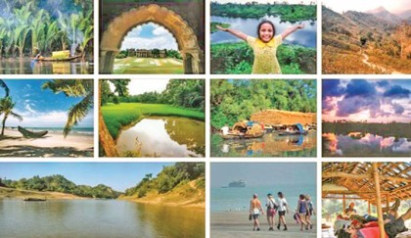

2.Origin:
To preparing an internship report is a requirement of completing the BBA program. i am assign to complete this report under the supervision of respected facility Mr. S.M. Asif –Ur –Rahman .
3.Objectives:
The core objective of this report is to know the problems and prospects of adventure tourism of Bangladesh.
4.Primary objective:
- Completing the report for finish my BBA program
- Know about the adventure tour
- Know about the place that people are choose for adventure
- To know why people are going for an adventure tour
- Source of information about the adventure tour
5.Secondary objective:
Talking people about adventure tourism and take their interview.

6.Background:
Various types of tourism have different types of characteristics. Many people are go for travel, but there are some people who are traveling to the excitement for the sake of peace or not for the feeling of nature, they go to new places to experiment with something new. There are different expectation and experience of different people on the tour, but the core elements that they want are excitement. Sometimes it is very difficult to understand that it was a adventure tour or non adventure tour because of the excitement and experience of the tour.

7.History of adventure tourism:
The people of the past used to travel from one place to another places only for their survival. People just searched places for where they could survive. When people are searching for a society at the end of this quest, where civilization is found. The people started sharing different types of transactions, for business purpose. First they start business with goods transaction. Given that they gradually business with other countries, they had to travel from one place to another. So they had to travel to a strange place and where the idea of adventure began. Modern adventure began 35 years ago when people travel from one country to another country for the purpose of enjoyment, excitement and view to interesting places. Adventure tourism is related to the tours that have many difficulties and risks.
The people of today’s day have a lot of tendency to learn about unknown things, so they want to explore the places where there are many excitement and risk. Adventure tourism is becoming increasingly popular day by days and so many of our natural adventurer tourism places are needed to development specially those places where many tourist go.
The adventures of today’s adventures are no longer the same. Now there are many companies who offer adventure tours to guide their adventures. If you are in the adventure tour with these agencies you are less risk. Now there are many agencies in our country for adventure tours and which is very good for our country economics. Every year many people come from foreign countries for adventure tourism and that is very important for the development of our country.

8.Motivation for tourism:
Nowadays people are very busy in their life. To get ride of such busyness, people are going to the adventure tour. A tour is very important for busy peoples mental relax. When people go around, they do many unexpected activities; they work very different from their regular activity. Some different types of tourism motivation are given below:

8.1Physical motivation:
If people go away they fill refresh. People are better at the tour because they go to the tour and activate the different types of activity and that is very helpful for theme.
8.2Social motivation:
When people go for a tour they meet a lots o people. Their different types of people they are introduced to their culture and society, their society is very different from each other. They want to know about their culture and society.

8.3Interpersonal motivation:
They went to the tour and got acquainted with the new people and they makes new friends.

9.Future of adventure tourism:
The rise of adventure tourism has escaped a lot of impact on our global economy. The adventure tour is a double before, which is a big advantage of us. –advantage tour is going to growing very fast and day by day adventure tour will becoming very popular. In future, it will increase further and this is a big advantage for the development country like us. This growth is not only for our tourism but also for our environment and development.
Future adventure will be more different and their activities will have many differences from today. In future people might go to the travel to the space. If people go to a space tour then it will be a great opportunity for people. Maybe we cannot think of what kind of adventure the people will do in space.
10Economical impact of adventure tourism:
Bangladesh has faster growing economical growing rapidly and adventure tourism is playing a major role to this economical growth. adventure tourism is playing a great role of tourism industry. Every year many people came from abroad to Bangladesh for adventure tourism. Now there are many new travel agencies opening in Bangladesh for foreigner people and they need a lot of employee . This is reducing the unemployment rate in our country and increasing the employment rate. For adventure tourism there is a lot of improvement in our country. Tourist also contribute to our sales , transportation, hotels, foods and income as well. Its effects all most every economical sectors of our country.

11.Importance of adventurer tourism:
Tourism is an playing a important part of our economical growth. Through tourism people get an opportunity to know about different people their culture their food habit and their local language also. We can earn foraging currency through tourism industry. We also reducing our unemployment rate through tourism industry.

12.Adventure tourism place in Bangladesh:
Bangladeshi tourism places including different types of historical places, beaches, forest, and wildlife of various spices. Adventure tourists are doing different types of activities such as: angling, river cruising, rowing, water skiing, hiking, yachting, parasailing and sea bathing.

Coxs bazar:
Coxs bazaar is the longest sea beach in the world, the length of this beach is 125km. it is the most visited place in Bangladesh. Except beach there are many places in coxs bazaar such as: there is himchhari national park where it is raised in a very high mountain and there is a fountain also. In coxs bazaar you can parasailing. Many people here come only for parasailing.
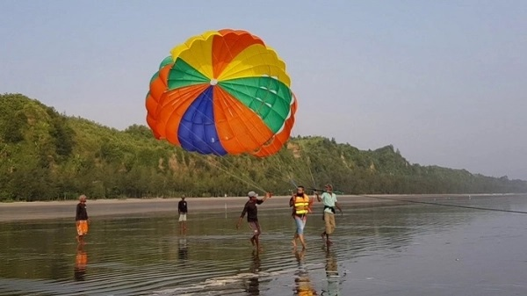
Sundarban:
The largest mangrove forest in the world. It is cover by 10000 km. 60% of the forest is under Bangladesh and the remaining 40% is under india. In sundarban there are many places such as: hiron point where people go for watching royal Bengal tiger, deer and crocodiles and different types of birds. Katka kachikhali (tiger point) where people got the opportunity for wild tracking.
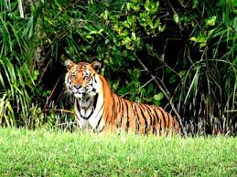

Sylhet:
Sylhet is a place where you can experience different types of natural beauty. Madhabkunda waterfall where you can enjoy the fountain. Lawancherra rain forest is one of the forest of Bangladesh. Jaflong is one of the most attractive place in shylet it is near the Indian border. Ratargul swamp forest is a freshwater swamp it would seems like to small amazon forest.
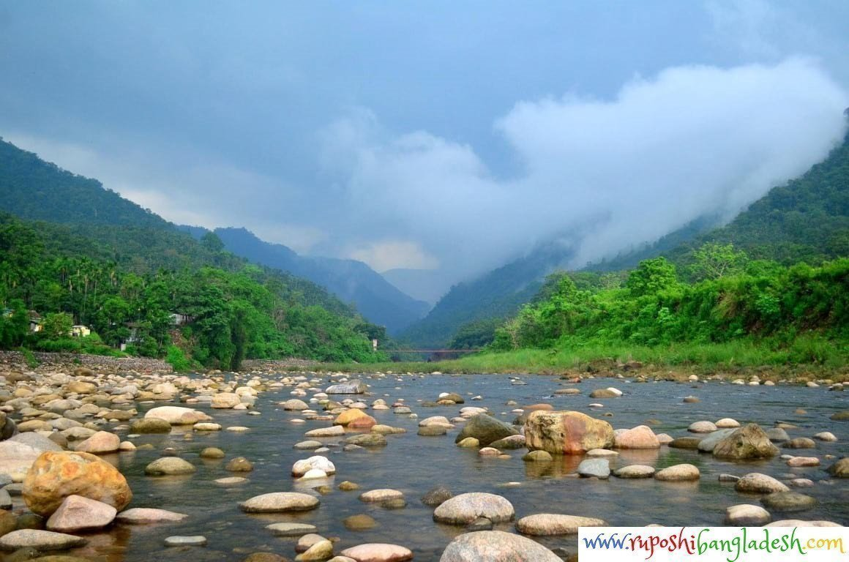

Bandarban:
There is the better place where to experience the magic of the hill tracts. Most attractive place of bandarban are nilachal, nilgiri mountain, nafakum, sangu river, keokradong, bogakain lake, Buddha dhatu jadi, amiakum, chimbuk hill, meghla parjatan complex shoilo propat. The journey of bandarban within the jungles, river alongside the hill areas is thrilling from beginning till the end of journey. Nilgiri is the highest mountain in the bandarban this place is always coveres with clouds. Nafakum is one of the largest waterfall in Bangladesh. This place is so came and wild.

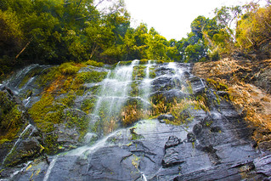

St.martins island:
St.martins island is a beautiful coral island of bengaline bangladesh. People who loves beach st.martins island is best place for them. It is a very small islamwhich is around 9km. There is a small adjoining island that is separated at high tide, called chera dwip.

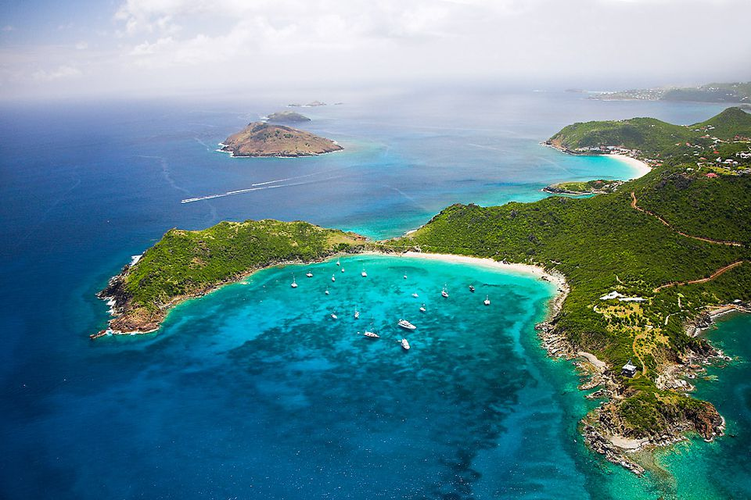

13.Scope of the report:
I am preparing this report for my internship. When I am preparing this report, I get the opportunity to learn and understand the adventure tourism. From here I learned a lot about the natural beauty of my country that I had never know before. I have interviewed many people to this report as well as I also take interview of same travel agencies. In addition to doing this report I collect some public papers, articles , journal and some information from the news that is available in internet.

14.Limitation of this report:
I was not able to collect a lot of peoples interviews and did not visit anywhere myself. Since adventure tourism has not yet become very popular in Bangladesh, there is not much information available in internet and some other articles and journal. When I went to the survey , I found out that 100% of the people inside had 20% people are going to the adventure tourism. I tried my best to get as much information as I could.

15.Methodology:
For preparing this report I made some Questionnaire. I needed same more information about this topic so I collect those information from two sources one is primary sources and another is secondary sources.

16.Data type:
Here I have to used two types of data one is primary data and another is secondary data

16.1Primary data:
- Survey with questionnaire
- Face to face interview
- Collect information from agency

16.2Secondary data:
- Browsing internet
- Articles
- Journal

17.Sample size: Sample size of this report is 33.

18. Data collection method:
Basically here we use primary data to complete our report with that we have same secondary data help. Here we have talked to various type of people and interviewing them, we observe their behavior and expression then we have taken their statement about this topic. Along with that we have been browsing the internet and gather some information from different types of articles, newspaper and journal.

19. Data presentation method:
Here we use two types of chat for data presentation method one is bar charts and another one is pie chart. This two charts are using for showing the result of the survey.

20.Findings and analysis of adventure tourism:
Adventure tourism is a basically a type of tour where you can do different types of activity that is not like the usual tour. You can experience different types of activity. So for doing this report I communicate some people and ask them about their experience of their tour. The questions and their answers are given below:

1.Gender?
🚩Male 🚩Female
ANSWER:
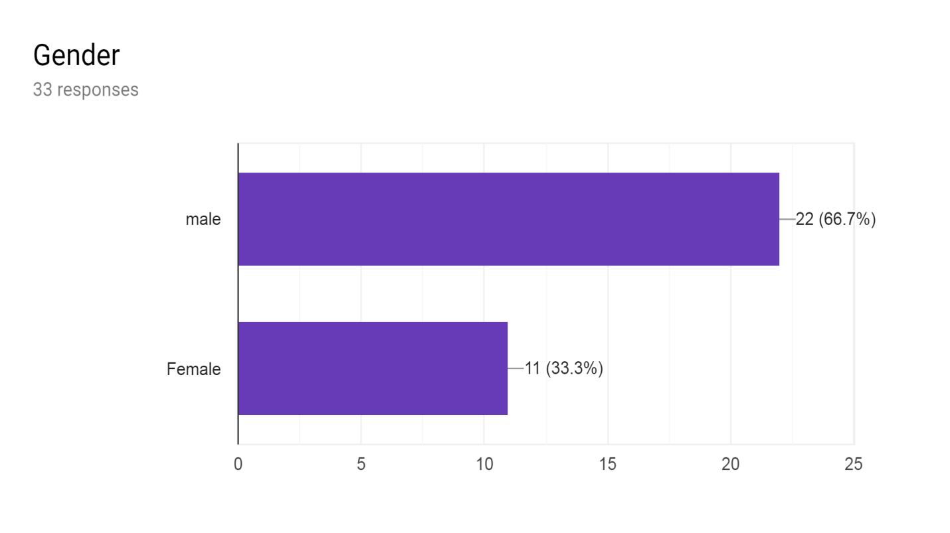
This survey result shows that among the 33 response, 66% are female and the remaining 11%are male. That means men have more adventures than women of our country.

2. Age range?
🚩18 −30 🚩31−40 🚩41−55
ANSWER:
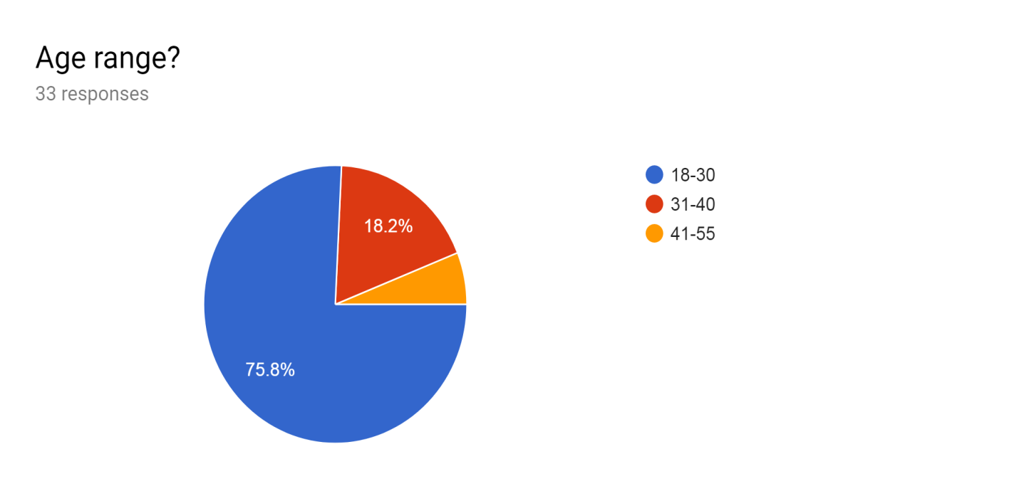
When the age range is surveyed, it turns out that teenagers are more adventurous than middle ages. Teenagers are much more inclined than the middle ages. Teenagers love to explore new things and those who are middle aged have many kinds of family bonds.

3. What is your monthly income level?
🚩0−10000 per month 🚩10000−30000 per month 🚩30000−50000 per month 🚩50000−100000 per month
ANSWER:

The survey found the result of monthly income level, while the public is among 33 people who make income of 0−10000 per month ,which means that teenagers who are more adventures. This survey result shows that 16% people earn 10000 per month, 11% people earn around 30000 per month,5% people earn around 500000 per month remaining 1% people earn 100000 per month.

4. When did you go to adventure tour last time?
🚩Within last month 🚩Within last 3month 🚩Within last 6month 🚩Within last 1 year
ANSWER:
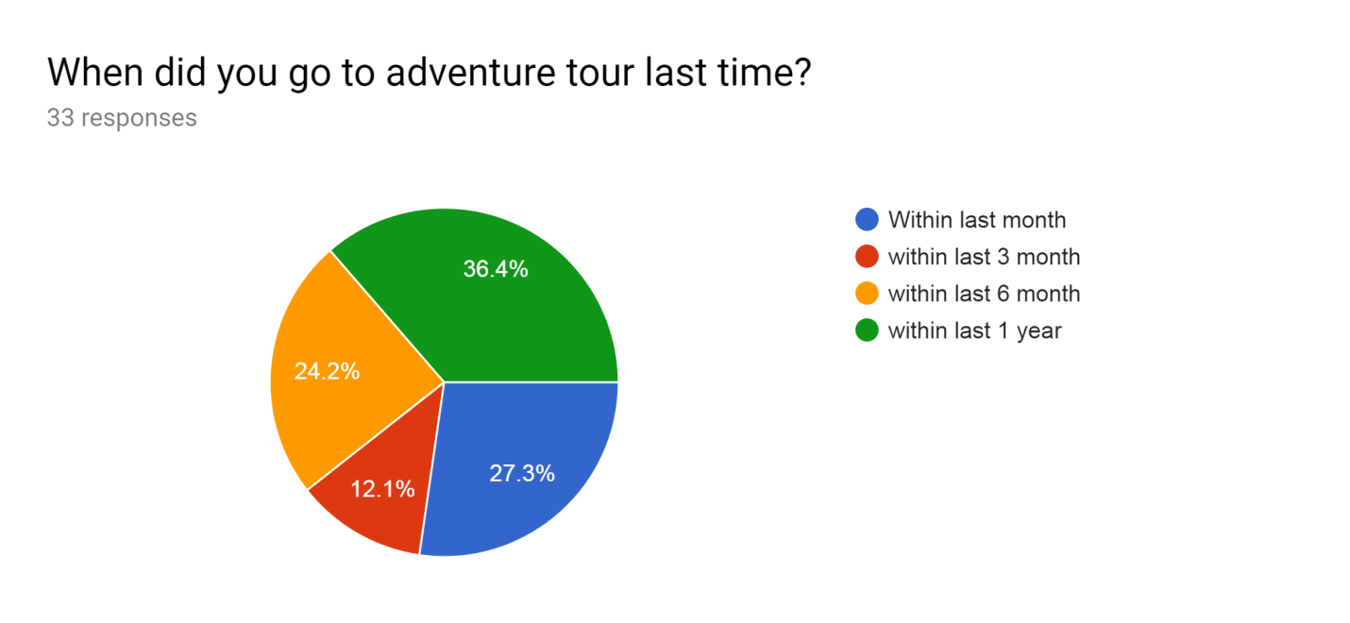
Survey result shows that most of the people are gone a adventure tour in a year ago. 33 people response for survey and the result shows that 33% people have gone for a tour within last one year and 27% of people have gone in last month and 24% people gone within last six month and remain are gone within last three month.

5. Where did you go to the last tour?
ANSWER:
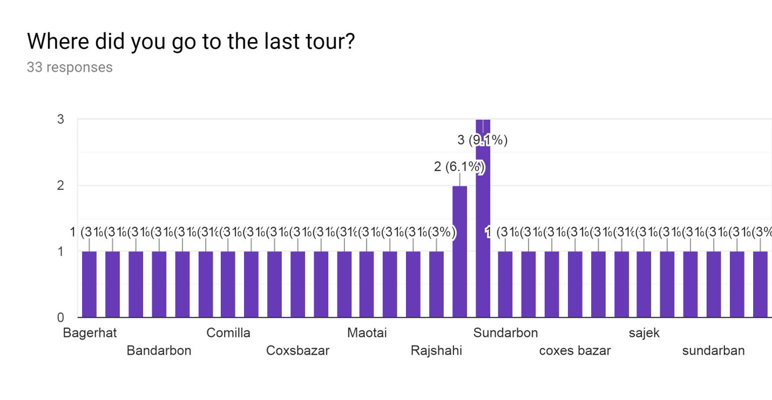
When 33 people were asked where they last visited, different people answered different places. From the name of those places where they go for adventure tour we know that which places people choose for adventure tour. These result shows that people are choosing sundorban more for adventure tours.

6. You have gone to some other places?
ANSWER:
Survey result about 16% of the people visited the tour at one place, except the rest went to two places at a time. To answer this question, it is understood that most of the people have gone to three places, this three places are shylet, coxs bazaar and sajek.

7. Who influenced you for adventurous tourism?
🚩Friends and family 🚩web site 🚩Colleague 🚩Tourist groups
ANSWER:
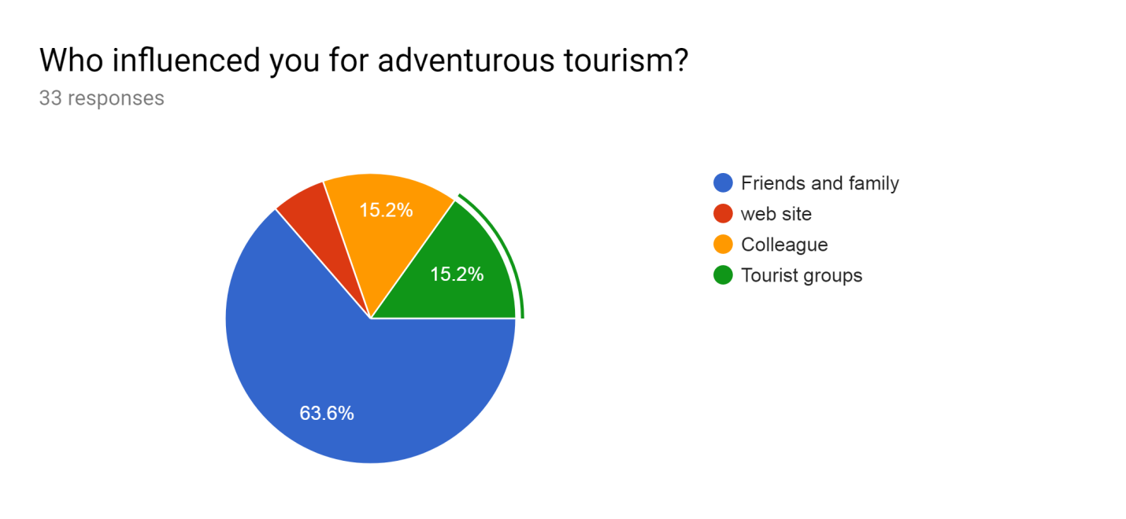Survey result shows that most 63% are influenced by their friends and family for a tour, when they come from a tour and tell the story of the tour , they wish they also go for a tour. 15 % people are influenced by colleague and remaining 15% people influenced by many kinds of tourist agencies.
8. What kind of obstacles did you experience during the tour?
ANSWER:
When people go for a tour different types of people face different kinds of obstacles but people are having more problems with money, weather and network. Some people say that they have lots of problem with transportation, they often make car reservations, but later, when the car does not come it has to be a lot of trouble. People get into many problems even when the weather is bad and the waves are high.

9. Which adventure tourism activities did you enjoy the most?
🚩Hill based 🚩Forest based 🚩Sea based
ANSWER:

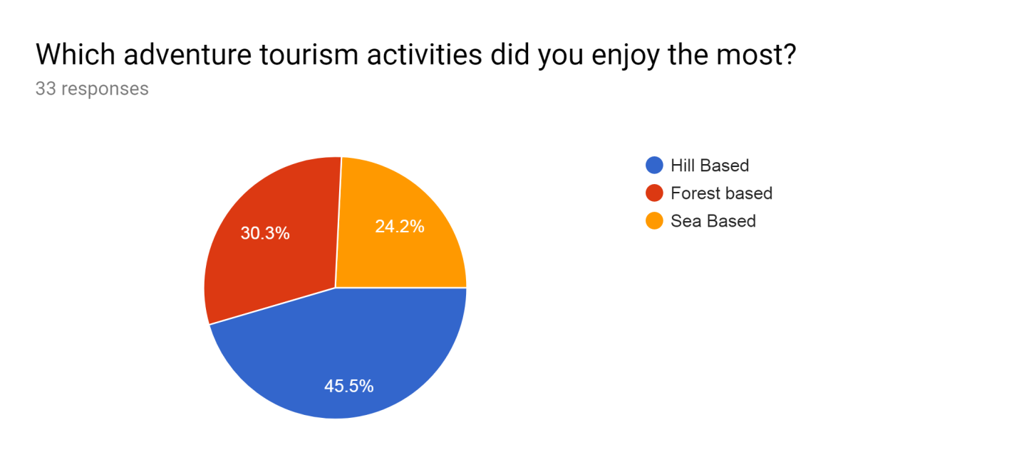
When people are asked what kind of tours they like most, they respond that they like hill based tour more. People love climbing mountains with curved roads and climbing mountains in the middle of a fountain. Of the surveyed, 15 people preferred hill based tour. Those who go on tour in forest like to camping in the middle of forest because there is a lot of risk and this is a thrill for theme. This survey result found that 45% people enjoyed hill based tour, 30% enjoyed forest based tour, remaining 24% people enjoyed sea based tour.

10. You got available food and drinking water during tour?
🚩Completely Agree 🚩 Agree 🚩Neutral 🚩Completely Disagree
🚩 Disagree
ANSWER: 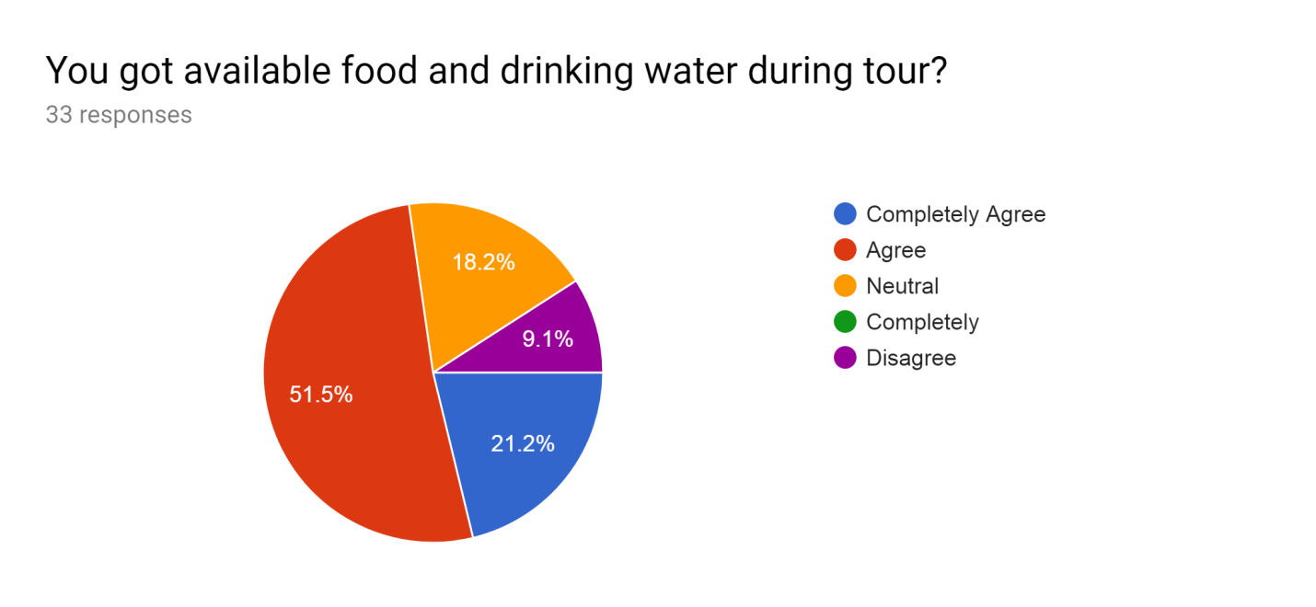
There are 51% people who have no problem with food when they go around because there are different kinds of food in different places and they like to eat them. There are 21% people who are so accustomed to eating at home that they have a lot of problem eating in a tout and can’t eat outside.

11.Would you like to go adventure tour again?
🚩Yes 🚩No
ANSWER:
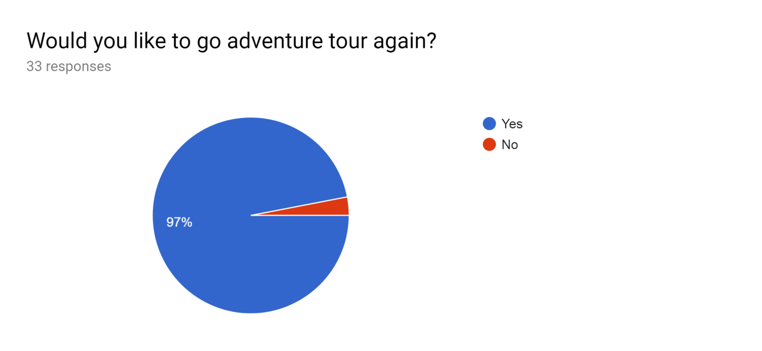
This survey result found that 97% of people have agreed to on a adventure tour again and remaining 3% people don’t want to go for an adventure tour again.

11. A. If yes then where?
ANSWER:
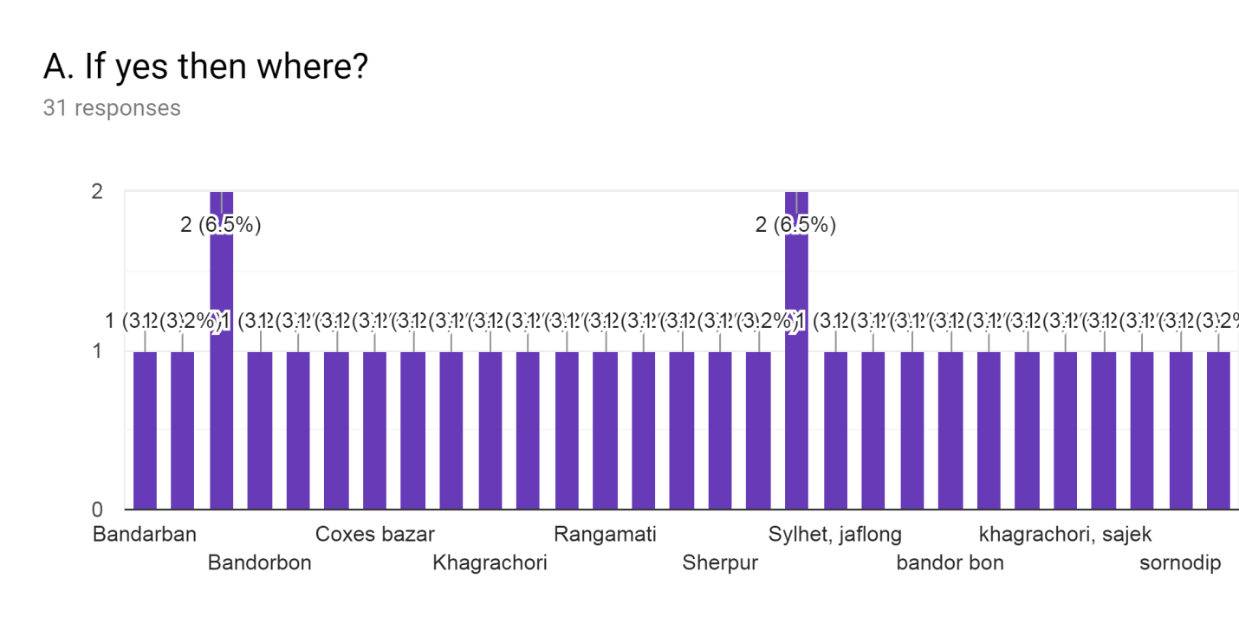
Most of the people who have agreed to turn around again want to go to bandarban and sylhet jaflong. Apart from these they alson visit many places like coxs bazaar ,khagrachari , rangamati and sornodip. The place most people want to visit is bandarbon.
11. B. If no then why?
ANSWER:
One of problems that people face on tour is communication because of that many people do not to go again in a adventure tour.

12. You recommend someone to go on an adventure tour?
🚩Completely Agree 🚩 Agree 🚩Neutral 🚩Completely Disagree
🚩 Disagree
ANSWER:
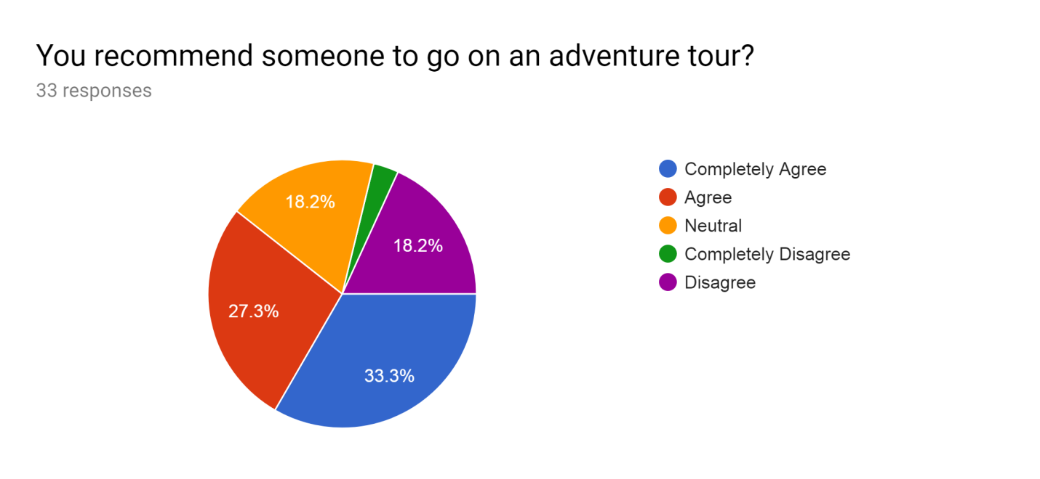
This survey result explain that 33% people are completely agree to recommend other for an adventure tour, 27 % people are agree to recommend other for an adventure tour, 18% people are neutral to recommend other for an adventure tour, and remaining 18% people are completely disagree to recommend other for an adventure tour.

13. Your experience of adventurous tourism?
🚩Good 🚩Average 🚩Bad

ANSWER:
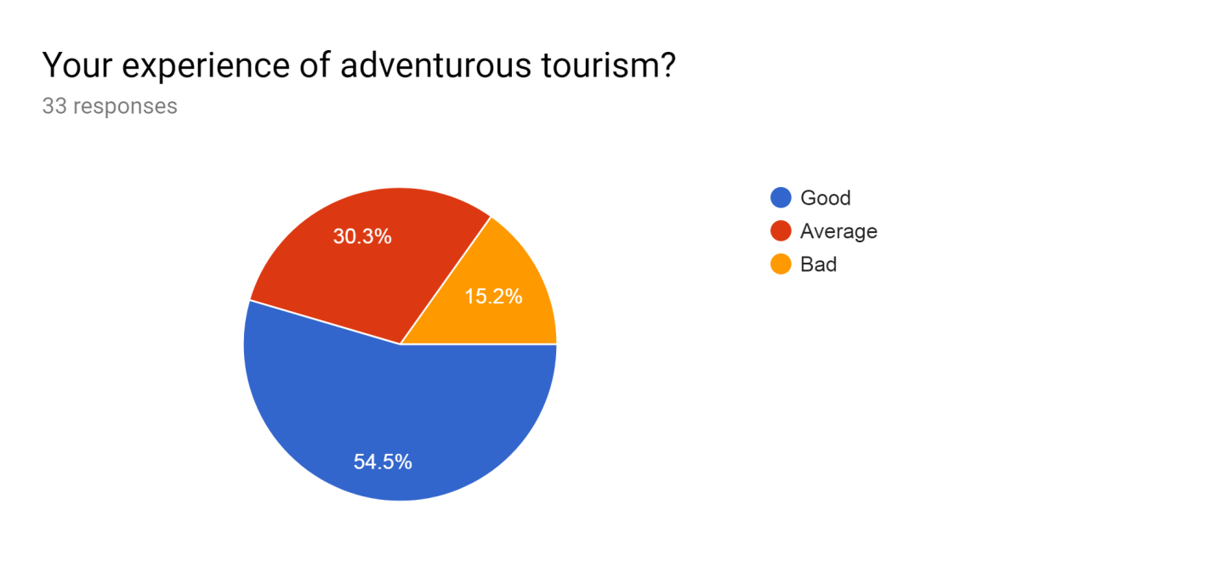

The survey result shows that 54% people have a good experience in a adventure tour and they and to go for an adventure tour again, 30% people have a average experience in a adventure tour and remaining 15% people have bad experience in a adventure tour.

21.Conclusion:
The future of Bangladesh tourism industry is very good it is possible that they make economic development in Bangladesh through this adventure tourism. This is right time to take adventure tourism forward. There are many places for adventure in Bangladesh such as: ratargul, sajek, bandarbon, boga lek, coxs bazaar, sundorban. The main purpose of this report is know how many people are interested to going for an adventure tour and scope of adventure tour in Bangladesh. When I am doing this report I find many interesting thing about our tourist industry. The main purpose of this report is finding a new way of entertaining people throughout tour.
This report represents our nature in a different and a unique way. People can overcome their fair and doing some different thing that is not usual. They take risk to know some different places in a different way. The adventure tour is a place where they can do a lot of challenging activity.
With some rules and regulation, Bangladesh can improve Bangladesh economy through adventure tourism. If Bangladesh adventure tourism improving, it is good for developing economy in our country because we have huge unemployed people in our country, if they join adventure tour then they can do good things to reduce their unemployment and they can act as a guide in tour agency.

22.Appendix:

Questionnaire on adventure tourism
Dear sir/madam, I am a final year student in the university of UNITED INTERNATIONAL UNIVERSITY. I am doing my report on adventure tourism so I am surveying why people go on adventure tour. For that reason I will need some information from you so please help me with some information.
- Gender?
🚩Male 🚩Female
- Age range?
🚩18 −30 🚩31−40 🚩41−55
- What is your monthly income level?
🚩0−10000 per month 🚩10000−30000 per month 🚩30000−50000 per month 🚩50000−100000 per month
- When did you go to adventure tour last time?
🚩Within last month 🚩Within last 3month 🚩Within last 6month 🚩Within last 1 year
- W here did you go to the last tour?
=
- You have gone to some other places?
=
- Who influenced you for adventurous tourism?
🚩Friends and family 🚩web site 🚩Colleague 🚩Tourist groups
- What kind of obstacles did you experience during the tour?
=

- Which adventure tourism activities did you enjoy the most?
🚩Hill based 🚩Forest based 🚩Sea based

- You got available food and drinking water during tour?
🚩Completely Agree 🚩 Agree 🚩Neutral 🚩Completely Disagree 🚩 Disagree
- Would you like to go adventure tour again?
🚩Yes 🚩No
10. A. If yes then where?
=
10. B. If no then why?
=
- You recommend someone to go on an adventure tour?
🚩Completely Agree 🚩 Agree 🚩Neutral 🚩Completely Disagree
🚩 Disagree
- Your experience of adventurous tourism?
🚩Good 🚩Average 🚩Bad

THANK YOU

Reference
https://en.wikipedia.org/wiki/Tourism_in_Bangladesh
https://www.theseus.fi/bitstream/handle/10024/102878/Ahammed_Md%20Tanbir.pdf?sequence=1&isAllowed=y
https://nijhoom.com/best-places-to-visit-in-bangladesh/
https://msu.edu/course/prr/840/econimpact/pdf/ecimpvol1.pdf
http://www.viewsontourism.info/wordpress/wp-content/uploads/2010/06/20100621-Prospect-of-Sustainable-Tourism-in-Bangladesh.pdf
https://researchleap.com/tourism-in-bangladesh-present-status-and-future-prospects/

